S4 Fig. Comparison-adjusted funnel plots
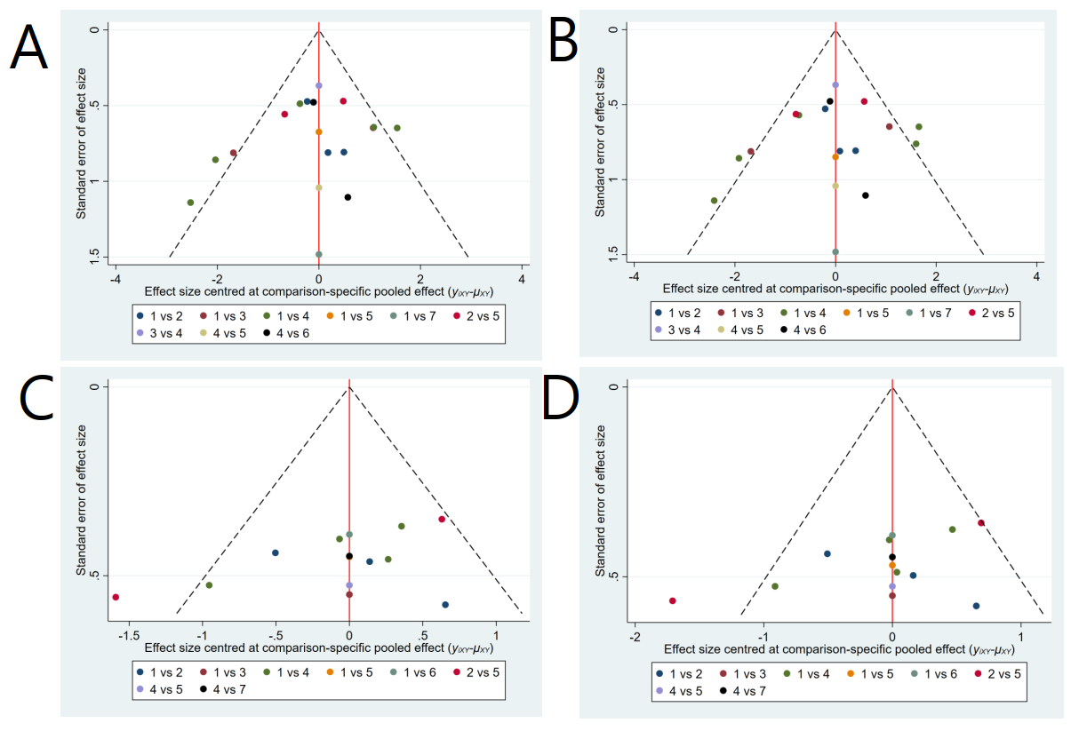
S4 Fig. Comparison-adjusted funnel plots. A. Overall success rate of unassisted intubation by ITT; B. Overall success rate of unassisted intubation by PP; C. Success rate of first attempt by ITT; D. Success rate of first attempt by PP. ITT, intention to treat; PP, per protocol. 1=single-use LMA-Fastrach; 2=CobraPLA; 3=Air-Q; 4=LMA-Fastrach; 5=i-gel; 6=Ambu-Aura; 7=LMA-CTrach

