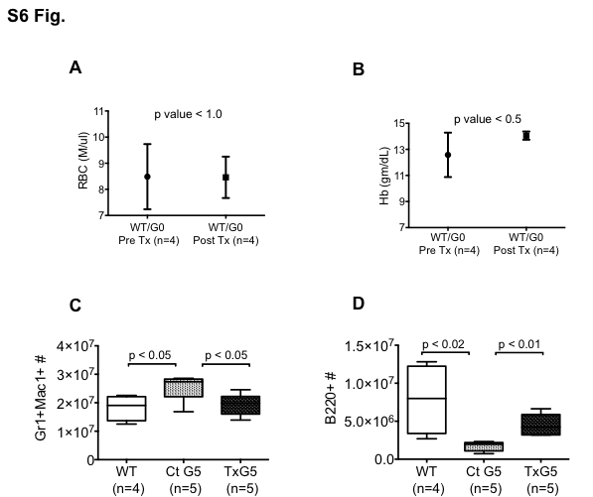

S6 Fig. Tamoxifen Treated Control Mice and Myeloid Cell and B Cell numbers after Telomerase Reactivation
(A and B) Comparison of RBC numbers and hemoglobin levels in the peripheral blood in tamoxifen treated wild type (WT) and G0 Tert +/- mice before and 3 months after treatment. (C and D) Number of myeloid (Gr-1+Mac1+) and B (B220+) cells in WT, G5 Tert-/- and tamoxifen treated G5 (TxG5) Tert-/- mice. Bars indicate standard deviation and p values are based on a 2-tailed t test.

