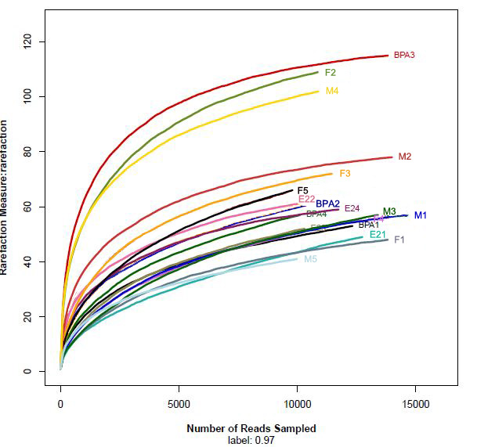
S3 Fig. Rarefaction analysis of Group M (n=5), Group F (n=5), Group BPA (n=4) and Group E2 (n=4).

