Figure S1A. Agilent profiles: total RNA from cell lines, MDA-MB-436 and UHRR in undegraded and manually degraded forms.
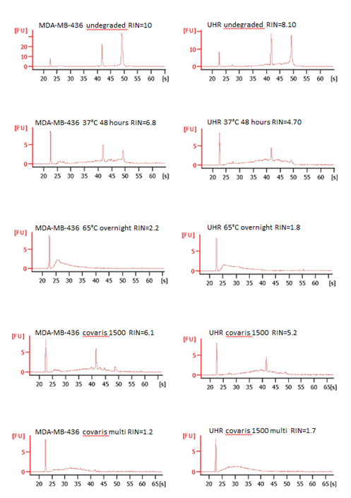

Figure S1B. Agilent profiles: total RNA from nine FFPE samples and nine matched fresh-frozen tissue samples.
