SUPPORTING INFORMATION FILE – Figure S1

Structures | Examples of utterances used for the assessment of listening (LC) and reading (RC) comprehension | Examples of picture  (LC or RC)
Active sentences | LC- La fille pousse le cheval.  [The girl pushes the horse]  RC- La dame pousse la vache.  [The woman pushes the cow]  Mean % (RC [45]): 93.30 (Range: 91.75 and 94.84) | 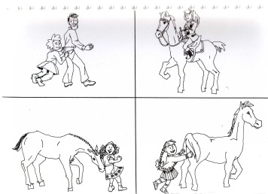LC
Passives  sentences | LC- La fille est poursuivie par le cheval.  [The girl is chased by the horse]  RC- Le garçon est poursuivi par le mouton.  [The boy is chased by the sheep]  Mean % (RC [45]): 78.35 (Range: 72.16 and 84.54) | 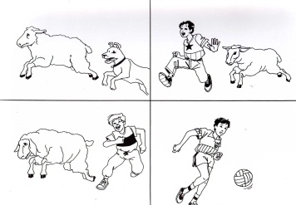RC
Pronouns | LC- L’éléphant les porte.  [The elephant carries them]  RC- La vache les regarde.  [The cow watches them]  Mean % (RC [45]): 92.78 (Range: 91.75 and 93.81) | 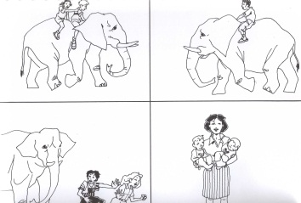LC
Double negation | LC- Ni le garçon ni le cheval ne courent.  [Neither the boy nor the horse run]  RC- Le garçon n’a ni chapeau ni chaussure.  [The boy has no hat and no shoes]  Mean % (RC [45]): 95.35 (Range: 90.72 and 99.97) | 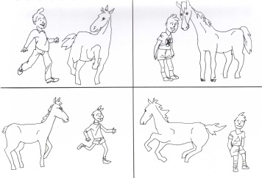LC
Spatial terms | LC- Le crayon est derrière la boîte.  [The pencil is behind the box]  RC- La boîte est derrière la tasse.  [The box is behind the cup]  Mean % (RC [45]): 78.09 (Range: 71.13 to 89.69) | 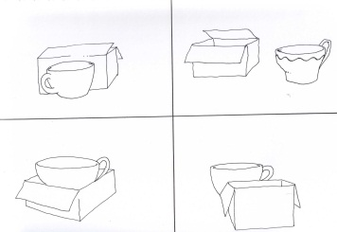RC
Relatives | LC- Le crayon qui est sur le livre est jaune.  [The pencil which is on the pencil is yellow]  RC- L’étoile qui est dans le cercle est rouge.  [The star which is in the circle is red]  Mean % (RC [45]): 73.21 (Range: 72.16 to 75.26) | 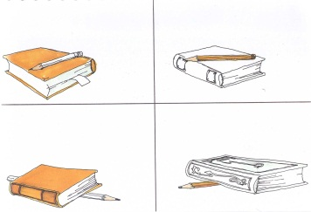LC

