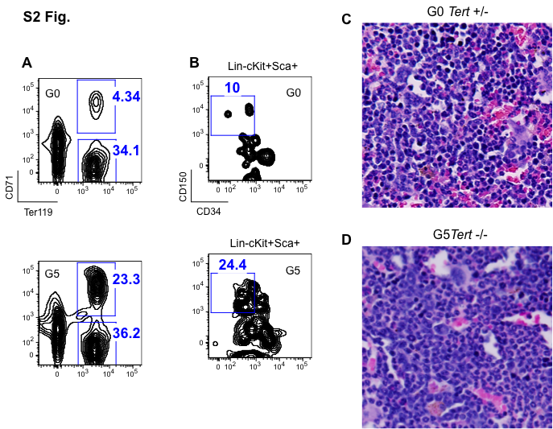

S2 Fig. Extramedullary Hematopoiesis and Histopathology of the bone marrow in G5 Tert-/- mice. (A and B) Representative FACS profiles showing frequency of (A) immature erythroblasts (CD71+Ter119+) and (B) HSC (Lin-c-Kit+Sca1+CD34-CD150+) population in the spleen from G0 Tert+/- and G5 Tert-/- mice. In total 3 mice of each genotype were studied. (C and D) A representative section of bone marrow from a G0 Tert+/- and G5 Tert-/- mouse stained with H&E showing presence of many erythroid precursors in G0 Tert+/- and predominance of myeloid cells and relative erythroid hypoplasia in G5 Tert-/-.

