A Pareto-Optimal Refinement Method for Protein Design Scaffolds
Lucas Gregorio Nivón, Rocco Moretti, David Baker

Supporting Information

Table S1
Energy term name | INPUTS (mean) | COORD (mean) | Delta
fa_dun | 404.19 | 245.01 | -159.18
fa_rep | 207.59 | 117.73 | -89.86
fa_cust_pair_dist | 27.55 | 1.21 | -26.34
omega | 35.57 | 26.20 | -9.37
ch_bond_bb_bb | -19.50 | -27.90 | -8.40
hbond_bb_sc | -77.28 | -84.50 | -7.22
hbond_sc | -25.29 | -31.98 | -6.69
hbond_lr_bb | -60.53 | -67.02 | -6.48
fa_sol | 531.28 | 527.77 | -3.50
rama | 7.05 | 6.02 | -1.04
pro_close | -14.67 | -15.51 | -0.85
p_aa_pp | -17.86 | -18.66 | -0.80
fa_pair | 0.88 | 0.39 | -0.49
dslf_ss_dst | -0.96 | -1.16 | -0.20
hack_elec | 2.48 | 2.32 | -0.16
dslf_cs_ang | 0.18 | 0.05 | -0.13
hbond_sr_bb | -21.29 | -21.41 | -0.12
fa_atr | -1051.68 | -1051.78 | -0.10
dslf_ss_dih | 0.13 | 0.08 | -0.06
ref | -19.69 | -19.69 | 0.00
dslf_ca_dih | 0.01 | 0.01 | 0.00
coordinate_constraint | 0.00 | 60.16 | 60.16
total | -91.84 | -352.66 | -260.82
total_minus_coord | -91.84 | -412.81 | -320.98

Table S2.

label | total INPUT | total COORD | fa_dun INPUT | fa_dun COORD | fa_rep INPUT | fa_rep COORD | Delta Total | Delta fa_dun | Delta fa_rep
V284 | 19.51 | 0.76 | 3.61 | 1.72 | 18.26 | 1.39 | -18.75 | -1.89 | -16.87
Y286 | 17.38 | -0.29 | 1.34 | 1.60 | 19.94 | 2.49 | -17.67 | 0.26 | -17.45
K188 | 13.95 | 0.34 | 15.61 | 1.54 | 0.43 | 0.26 | -13.61 | -14.08 | -0.17
T161 | 12.90 | 0.01 | 5.12 | 0.69 | 9.78 | 0.39 | -12.89 | -4.43 | -9.39
E157 | 7.92 | -1.20 | 1.48 | 1.59 | 10.16 | 0.85 | -9.13 | 0.11 | -9.31
V212 | 6.91 | -1.20 | 1.92 | 0.67 | 7.81 | 0.69 | -8.11 | -1.25 | -7.12
L144 | 4.54 | -2.35 | 0.17 | 0.34 | 7.87 | 0.76 | -6.89 | 0.17 | -7.11
V129 | 6.82 | 1.32 | 6.74 | 1.39 | 1.97 | 1.32 | -5.50 | -5.35 | -0.64
E156 | 5.16 | -0.20 | 8.50 | 2.28 | 0.27 | 0.43 | -5.36 | -6.22 | 0.16
S131 | 4.75 | -0.07 | 4.65 | 0.35 | 2.47 | 0.98 | -4.82 | -4.29 | -1.49

Table S3.
Protocol | fa_dun | Total
No relax (Y) | 3.0 | 0.41
Restrained relax (Y) | 1.34 | -1.17
No relax after enzdes (E) | 1.31 | -1.14
Restrained relax after enzdes (Y) | 0.48 | -1.62

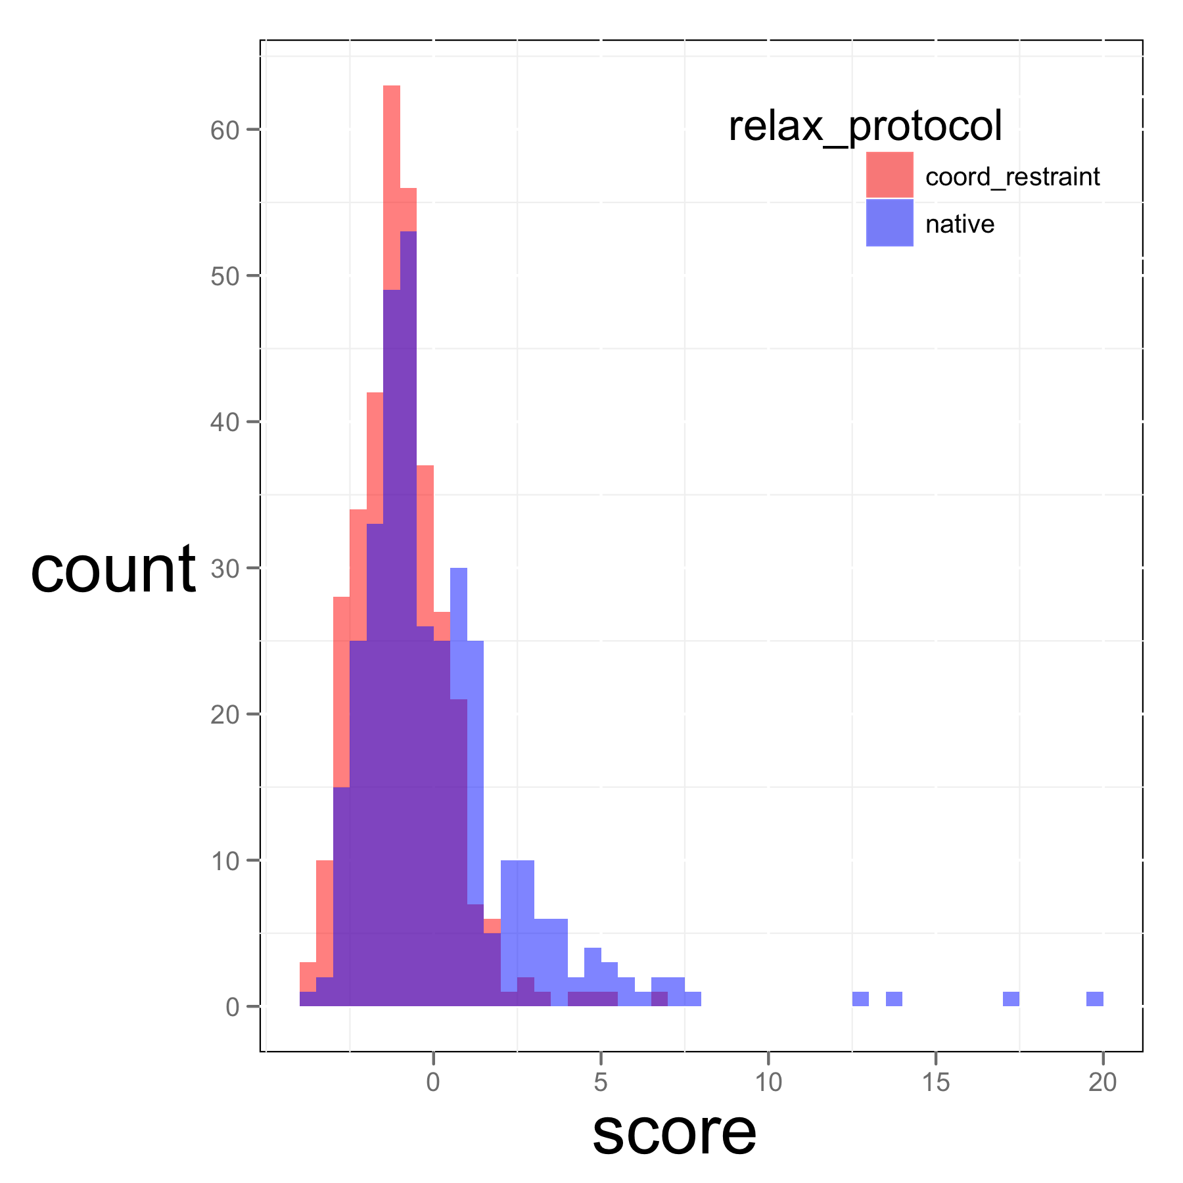
Figure S1.

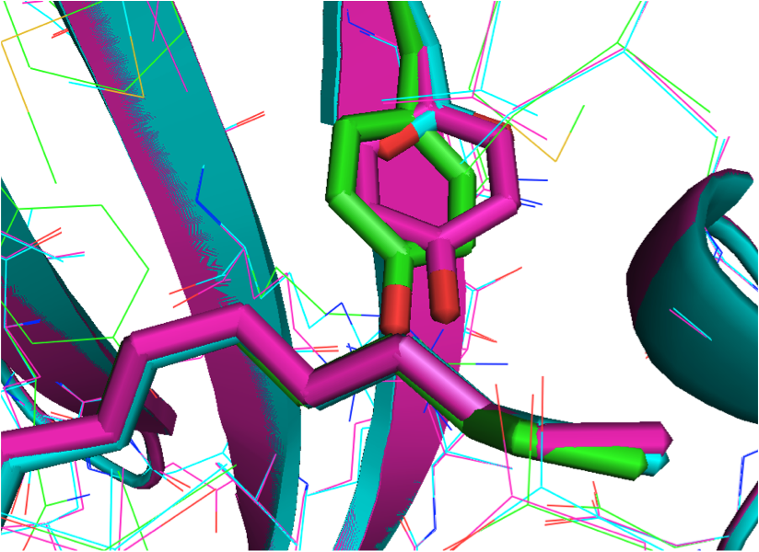
Figure S2.

Release info
Special issue requirements: We have integration test, demo and documentation:
rosetta_source/doc/apps/public/prepare_pdb_for_rosetta_with_relax.dox
rosetta/rosetta_tests/integration/tests/relax_w_allatom_cst
/work/nivon/rosetta/rosetta_demos/public/prepare_pdb_for_rosetta_with_relax

