Table S6: Compounds that were annotated.
Compound name | Concentration [µM] | Source | Broad ID | Structure
(+ -)-BACLOFEN | 5.00 | Biomol International Inc. | BRD-A84174873 | 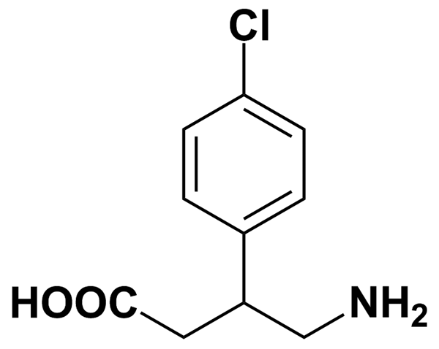
(D,L)-TETRAHYDROBERBERINE | 2.95 | Prestwick Chemical Inc. | BRD-A69950438 | 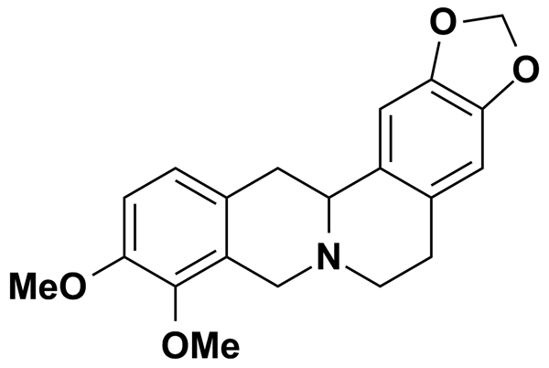
(RS)-(+ -)-SULPIRIDE | 5.00 | Biomol International Inc. | BRD-A55272860 | 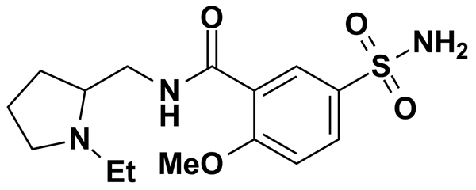
1,25-DIHYDROXYVITAMIN D3 | 0.50 | Biomol International Inc. | BRD-K27316855 | 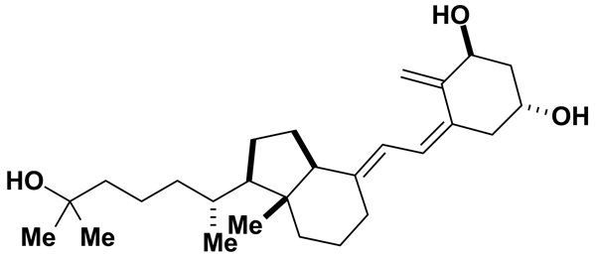
1,3-DIPROPYL-8-CYCLOPENTYLXANTHINE [DPCPX] | 5.00 | MicroSource Discovery Systems Inc. | BRD-K01824921 | 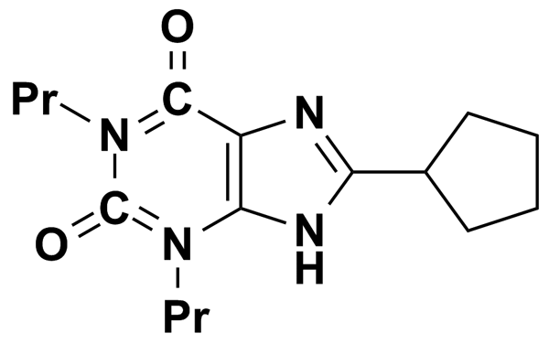
1-(3-TRIFLUOROMETHYL) PHENYLPIPERAZINE MONOHYDROCHLORIDE | 5.00 | Biomol International Inc. | BRD-K94887716 | 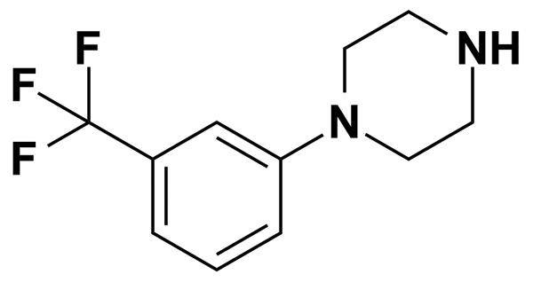
1-PHENYLBIGUANIDE HYDROCHLORIDE | 5.00 | MicroSource Discovery Systems Inc. | BRD-K31491153 | 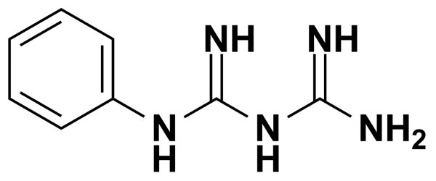
13-CIS RETINOIC ACID | 0.50 | Biomol International Inc. | BRD-K76723084 | 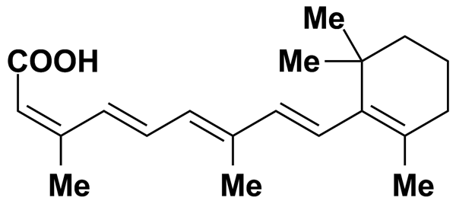
17-PHENYL-TRINOR-PGE2 | 0.50 | Biomol International Inc. | BRD-K90214371 | 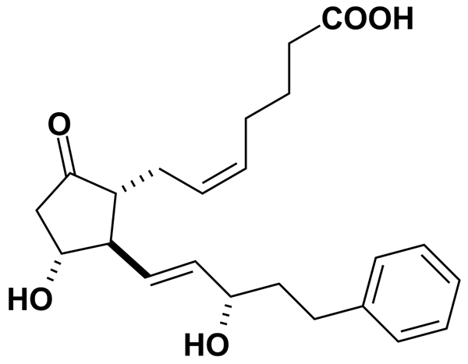
1R,9S-HYDRASTINE | 5.00 | MicroSource Discovery Systems Inc. | BRD-K77435797 | 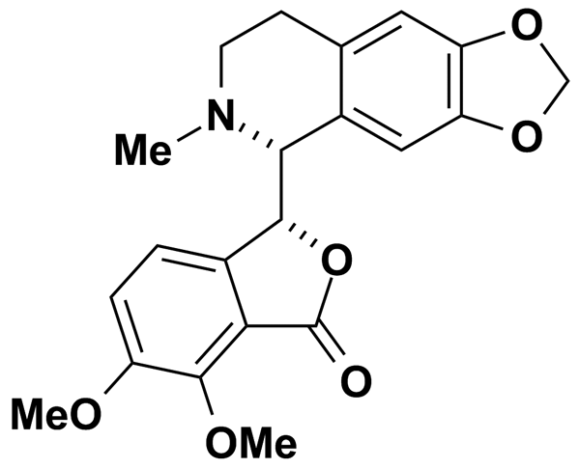
2,3-DIOXO-6-NITRO-1,2,3,4-TETRAHYDROBENZO[F]QUINOXALINE-7-SULFONAMIDE | 5.00 | Biomol International Inc. | BRD-K11796549 | 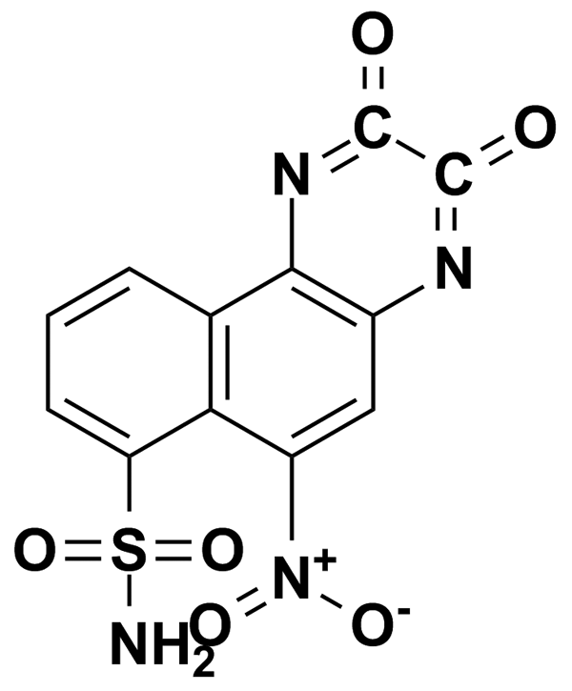
2,4,5-TRICHLOROPHENOXYACETIC ACID | 5.00 | MicroSource Discovery Systems Inc. | BRD-K92860374 | 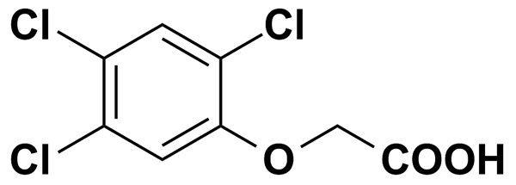
2,4-DICHLOROPHENOXYACETIC ACID | 5.00 | MicroSource Discovery Systems Inc. | BRD-K01473791 | 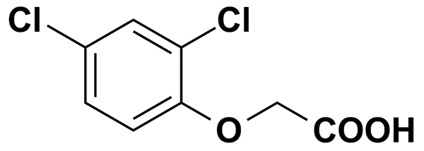
2,5-DITERTBUTYLHYDROQUINONE | 11.24 | Biomol International Inc. | BRD-K95603879 | 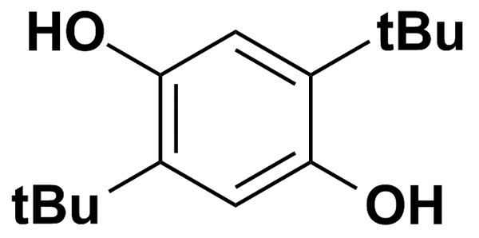
2-ARACHIDONOYLGLYCEROL | 0.50 | Biomol International Inc. | BRD-K71198913 | 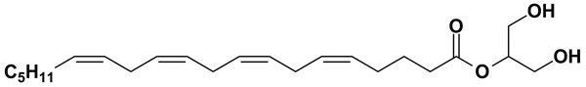
24,25-DIHYDROXYVITAMIN D3 | 0.50 | Biomol International Inc. | BRD-K02965577 | 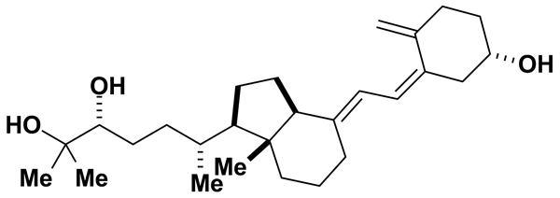
3,4-DICHLOROISOCOUMARIN | 11.63 | Biomol International Inc. | BRD-K23704908 | 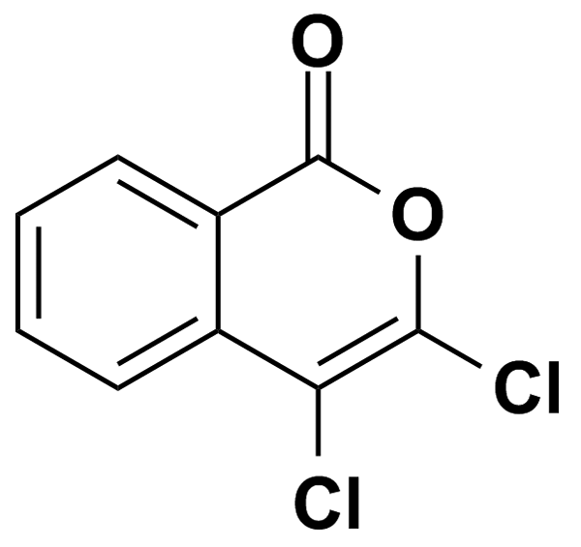
3-HYDROXYBENZYLHYDRAZINE DIHYDROCHLORIDE | 5.00 | MicroSource Discovery Systems Inc. | BRD-K66416915 | 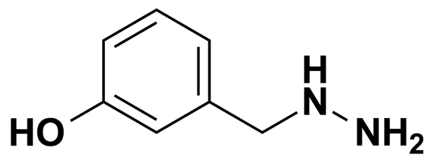
3-HYDROXYMETHYL-BETA-CARBOLINE | 5.00 | Biomol International Inc. | BRD-K69585439 | 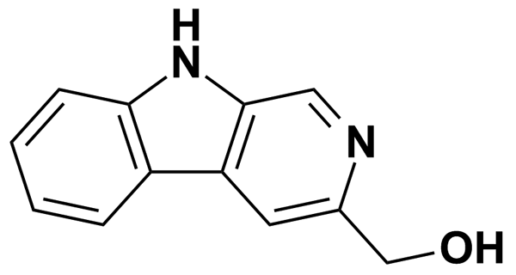
3-METHYLCHOLANTHRENE | 5.00 | MicroSource Discovery Systems Inc. | BRD-K61463582 | 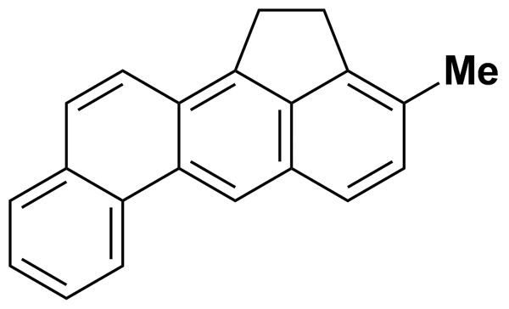
6-FORMYLINDOLO [3,2-B] CARBAZOLE | 0.50 | Biomol International Inc. | BRD-K00184207 | 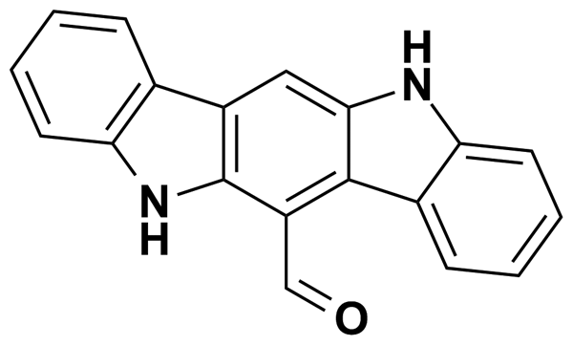
6-FURFURYLAMINOPURINE | 4.65 | Prestwick Chemical Inc. | BRD-K65667145 | 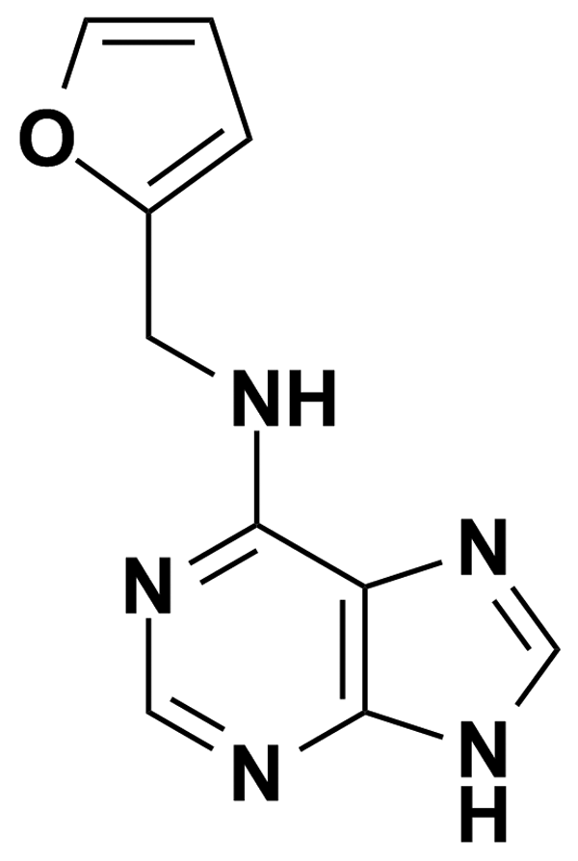
7,8-DIHYDROXYFLAVONE | 5.00 | MicroSource Discovery Systems Inc. | BRD-K49535716 | 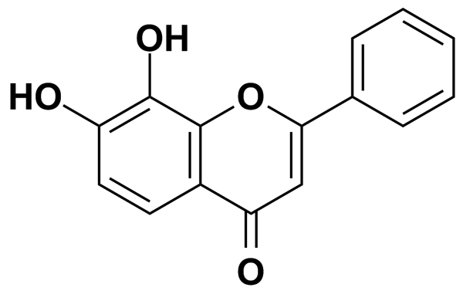
7-CHLORO-3-METHYL-3,4-DIHYDRO-2H-1,2,4-BENZOTHIADIAZINE-S,S-DIOXIDE | 5.00 | Biomol International Inc. | BRD-A14344385 | 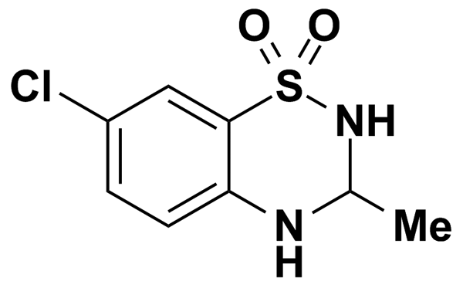
7-NITROINDAZOLE | 5.00 | MicroSource Discovery Systems Inc. | BRD-K04430056 | 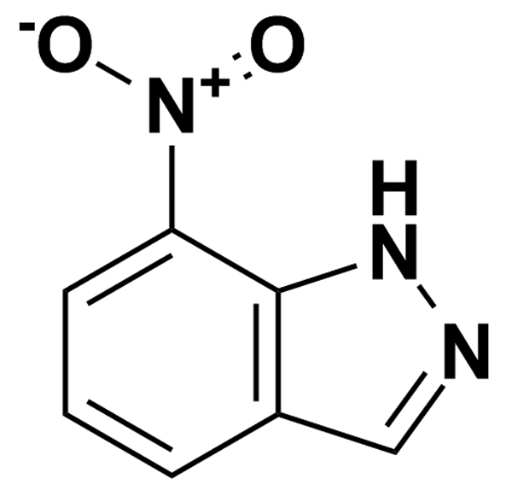
8-CYCLOPENTYLTHEOPHYLLINE | 5.00 | MicroSource Discovery Systems Inc. | BRD-K38347298 | 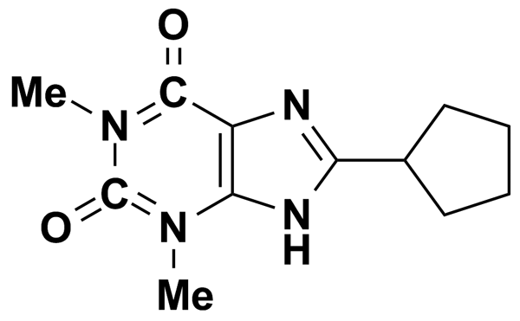
8-METHOXYMETHYL-IBMX | 9.39 | Biomol International Inc. | BRD-K56077740 | 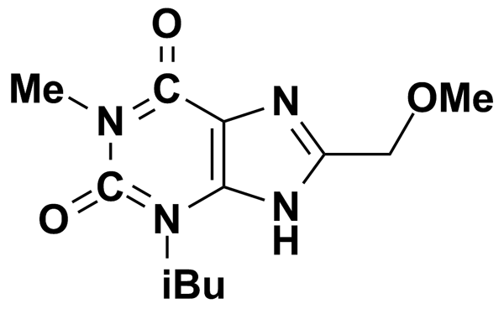
A-23187 | 4.77 | Biomol International Inc. | BRD-A19134330 | 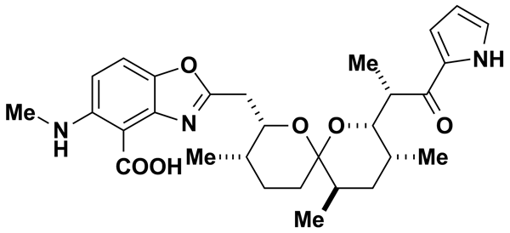
A-3 | 8.78 | Biomol International Inc. | BRD-K51215422 | 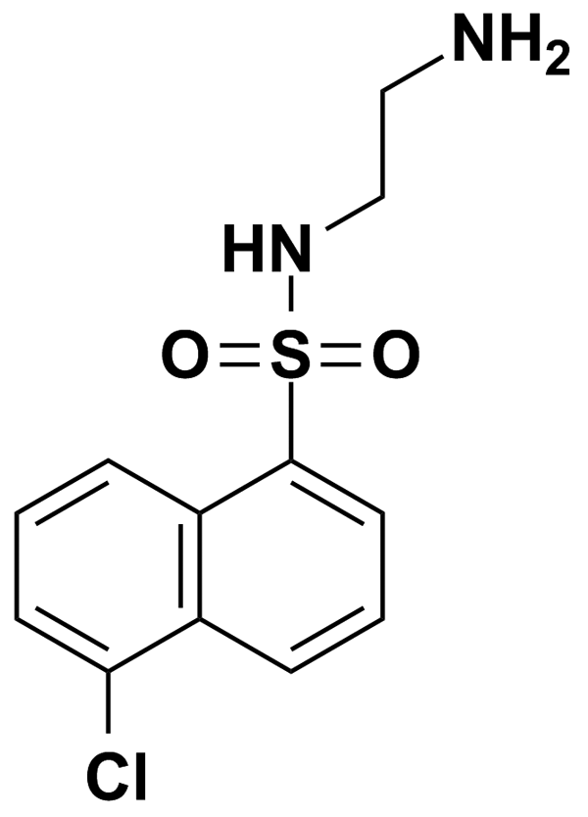
ACACETIN | 3.52 | Prestwick Chemical Inc. | BRD-K77685744 | 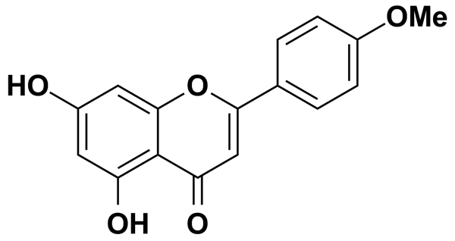
ACEBUTOLOL HYDROCHLORIDE | 2.68 | Prestwick Chemical Inc. | BRD-A29260609 | 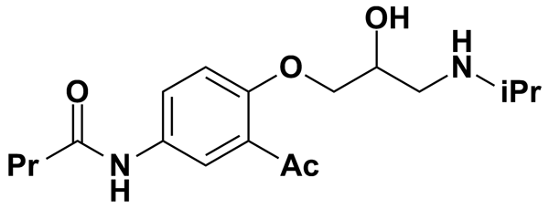
ACECLIDINE HYDROCHLORIDE | 5.00 | MicroSource Discovery Systems Inc. | BRD-A32673558 | 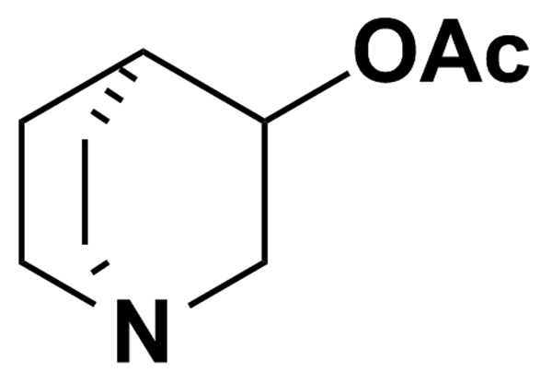
ACEMETACIN | 2.40 | Prestwick Chemical Inc. | BRD-K67563174 | 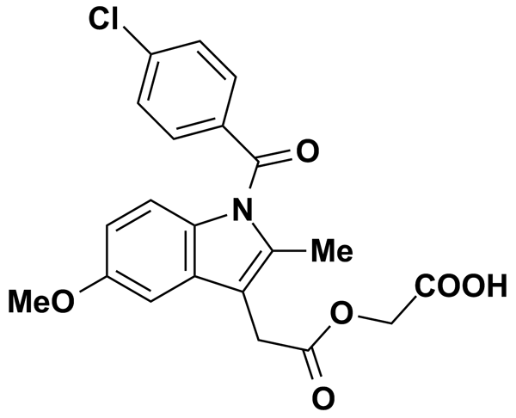
ACETOCHLOR | 5.00 | MicroSource Discovery Systems Inc. | BRD-K16652251 | 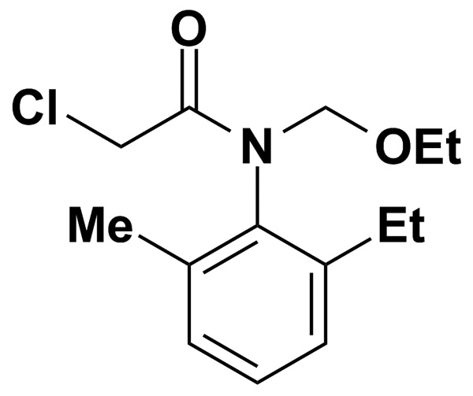
ACETYL (N)-S-FARNESYL-L-CYSTEINE | 6.80 | Biomol International Inc. | BRD-K79437791 | 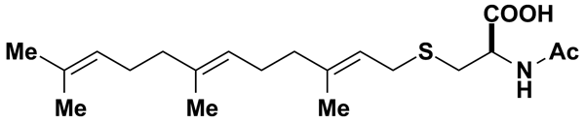
ACETYLTRYPTOPHANAMIDE | 5.00 | MicroSource Discovery Systems Inc. | BRD-K10171338 | 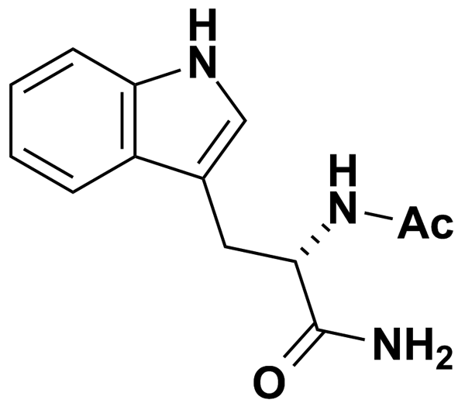
ACTINONIN | 5.00 | MicroSource Discovery Systems Inc. | BRD-K24621118 | 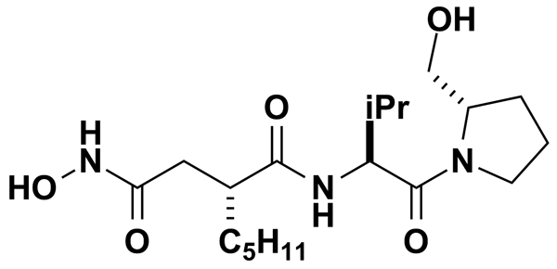
ADIPHENINE HYDROCHLORIDE | 2.87 | Prestwick Chemical Inc. | BRD-K60907894 | 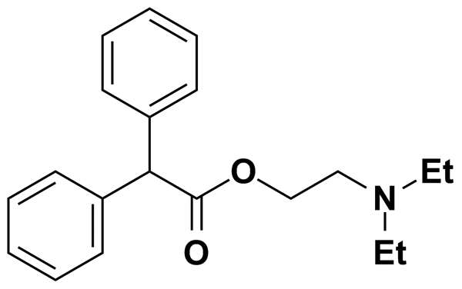
AESCULIN | 5.00 | MicroSource Discovery Systems Inc. | BRD-K51742987 | 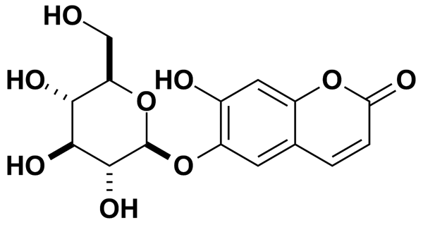
AG-1296 | 9.39 | Biomol International Inc. | BRD-K76064317 | 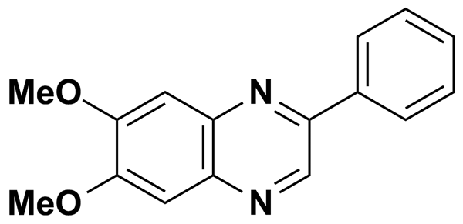
AG-370 | 9.64 | Biomol International Inc. | BRD-K33204703 | 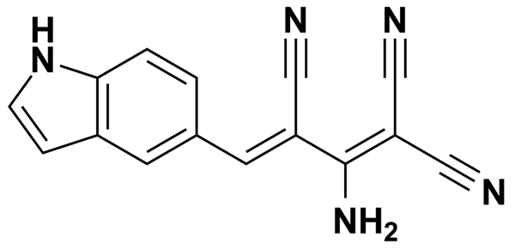
AG-490 | 8.49 | Biomol International Inc. | BRD-K47105409 | 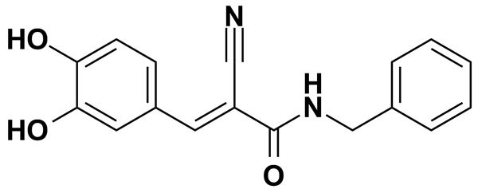
AG-879 | 7.90 | Biomol International Inc. | BRD-K59469039 | 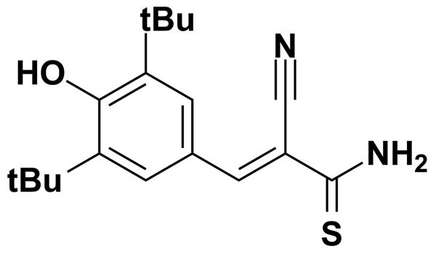
AG1478 | 7.10 | Biomol International Inc. | BRD-K68336408 | 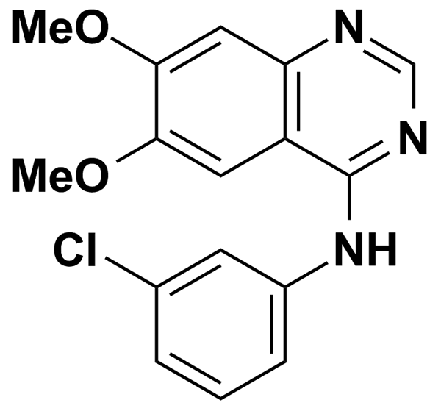
AGGC | 0.50 | Biomol International Inc. | BRD-K75181824 | 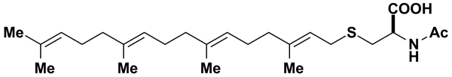
ALACHLOR | 5.00 | MicroSource Discovery Systems Inc. | BRD-K02548315 | 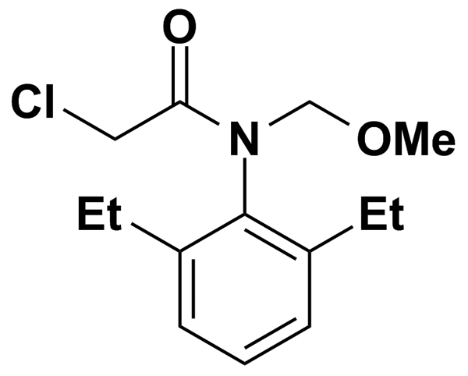
ALMOTRIPTAN | 5.00 | MicroSource Discovery Systems Inc. | BRD-K67601717 | 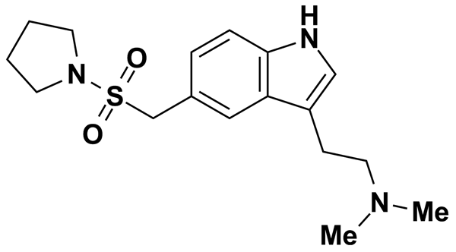
ALPHA-CYANO-4-HYDROXYCINNAMIC ACID | 5.00 | MicroSource Discovery Systems Inc. | BRD-K60302405 | 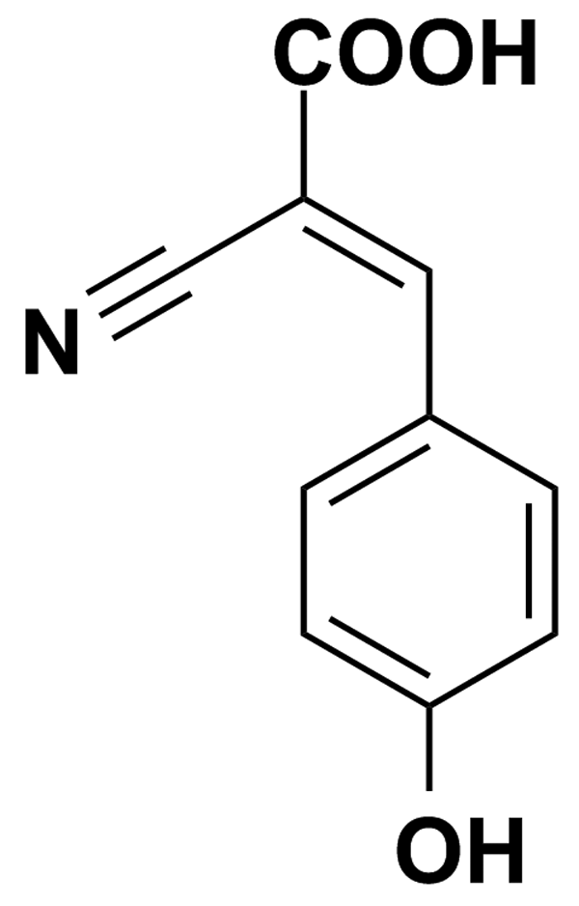
ALPRENOLOL HYDROCHLORIDE | 3.50 | Prestwick Chemical Inc. | BRD-A00993607 | 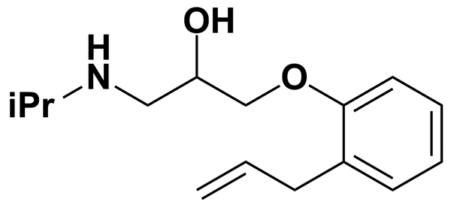
ALTHIAZIDE | 2.60 | Prestwick Chemical Inc. | BRD-A56675431 | 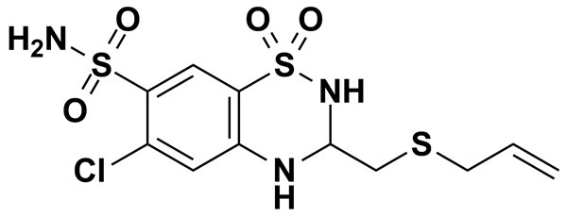
ALVERINE CITRATE SALT | 2.11 | Prestwick Chemical Inc. | BRD-K89055274 | 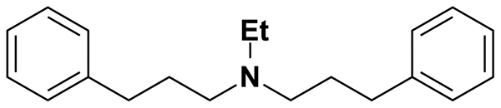
AM 92016 | 5.59 | Biomol International Inc. | BRD-A11813248 | 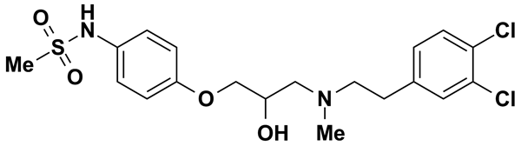
AM-251 | 0.50 | Biomol International Inc. | BRD-K92000912 | 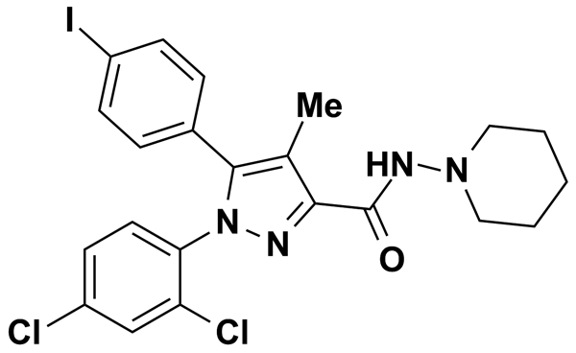
AM-580 | 0.50 | Biomol International Inc. | BRD-K06854232 | 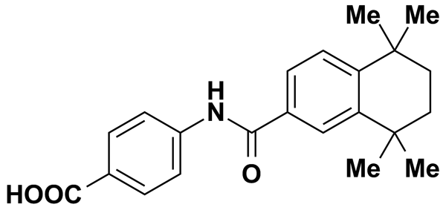
AMCINONIDE | 5.00 | MicroSource Discovery Systems Inc. | BRD-A36010170 | 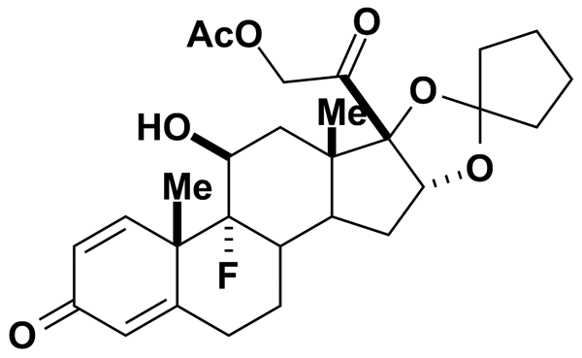
AMILORIDE HYDROCHLORIDE DIHYDRATE | 3.31 | Prestwick Chemical Inc. | BRD-K97181089 | 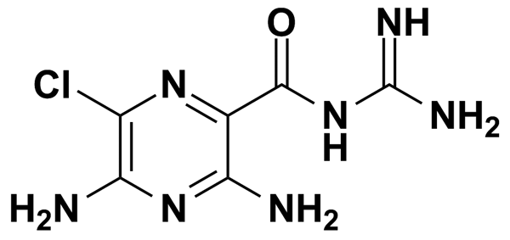
AMITRYPTILINE HYDROCHLORIDE | 3.19 | Prestwick Chemical Inc. | BRD-K53737926 | 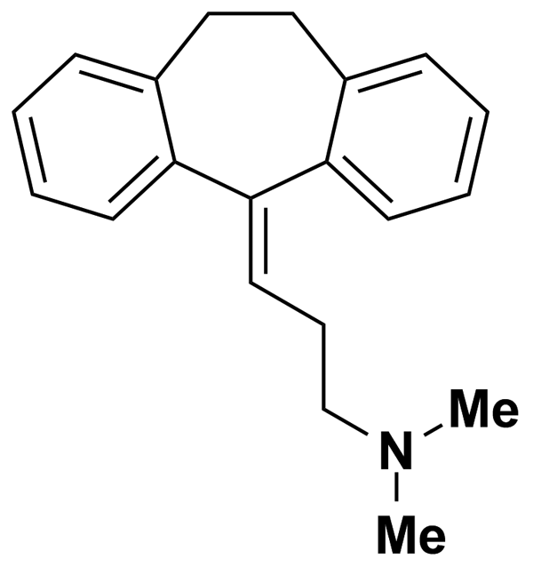
AMOXAPINE | 3.19 | Prestwick Chemical Inc. | BRD-K02265150 | 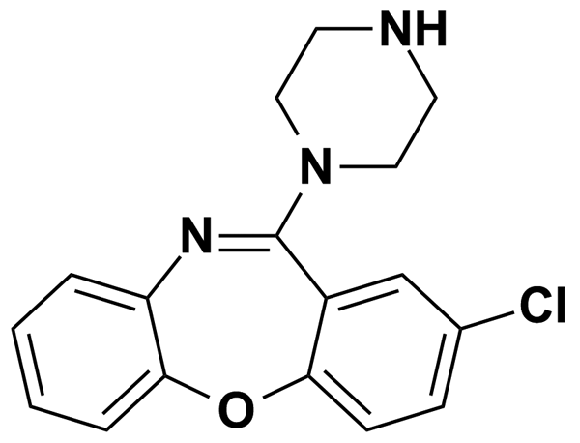
AMPEROZIDE | 5.00 | Biomol International Inc. | BRD-K52397688 | 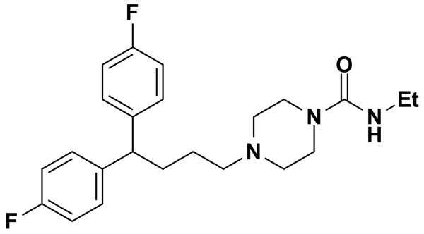
ANANDAMIDE (20:3,N-6) | 0.50 | Biomol International Inc. | BRD-K78280988 | 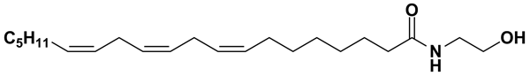
ANANDAMIDE (22:4,N-6) | 0.50 | Biomol International Inc. | BRD-K30199352 | 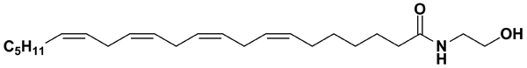
ANISOMYCIN | 9.42 | Biomol International Inc. | BRD-K91370081 | 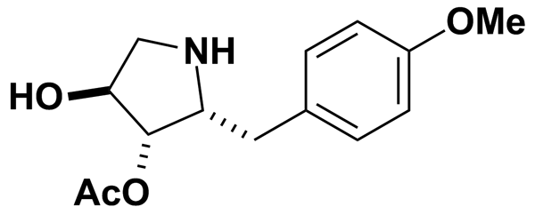
ANTAZOLINE HYDROCHLORIDE | 3.31 | Prestwick Chemical Inc. | BRD-K99300445 | 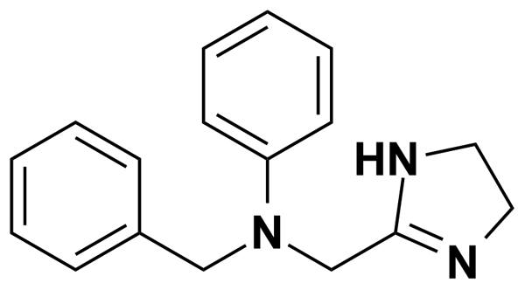
ANTIPYRINE | 5.31 | Prestwick Chemical Inc. | BRD-K46937689 | 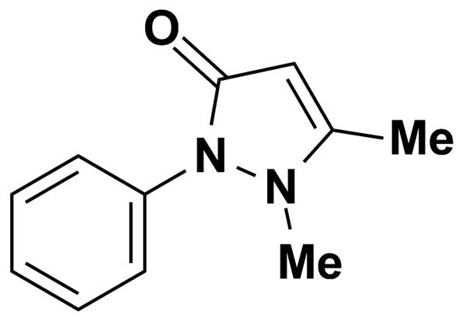
ARACHIDONAMIDE | 0.50 | Biomol International Inc. | BRD-K29555132 | 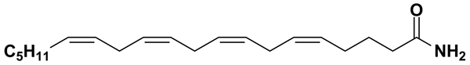
ARECOLINE HYDROBROMIDE | 4.24 | Prestwick Chemical Inc. | BRD-K88646909 | 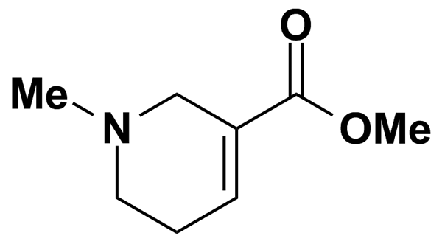
ASTEMIZOLE | 2.18 | Prestwick Chemical Inc. | BRD-K37249724 | 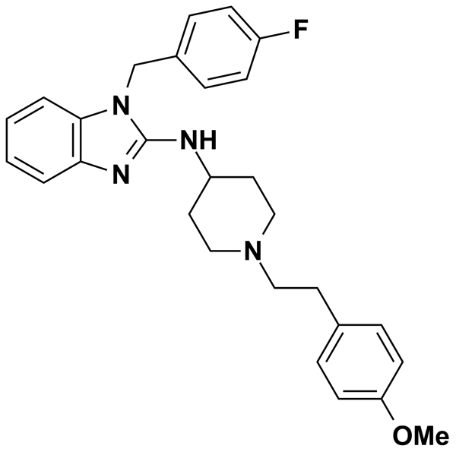
ATENOLOL | 5.00 | MicroSource Discovery Systems Inc. | BRD-A20239487 | 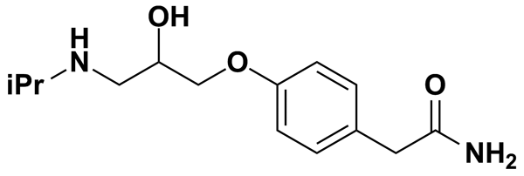
ATOVAQUONE | 5.00 | MicroSource Discovery Systems Inc. | BRD-A19795905 | 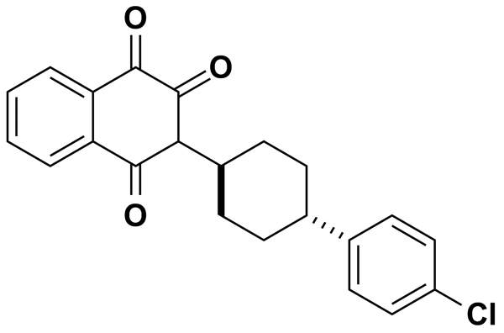
AZATHIOPRINE | 3.61 | Prestwick Chemical Inc. | BRD-K32821942 | 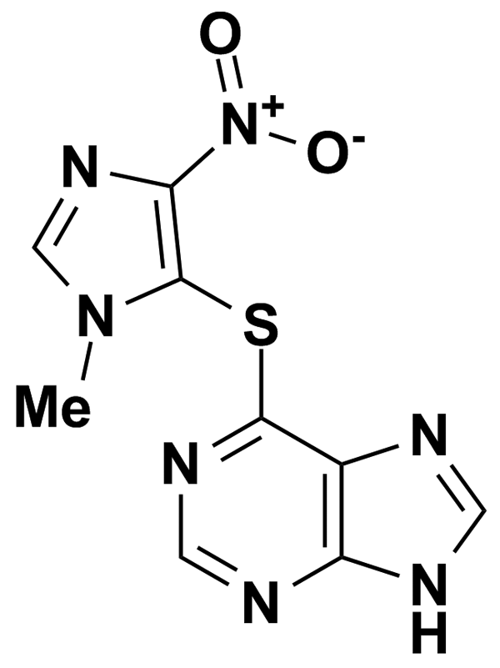
AZINPHOS METHYL | 5.00 | MicroSource Discovery Systems Inc. | BRD-K21893543 | 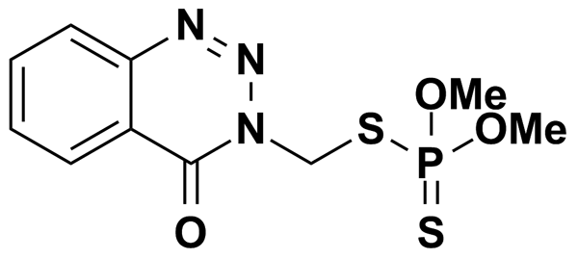
B581 | 5.31 | Biomol International Inc. | BRD-K04877770 | 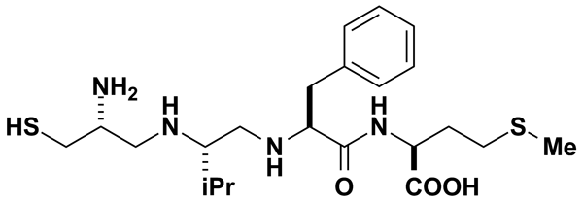
BAPTA-AM | 3.27 | Biomol International Inc. | BRD-K40919711 | 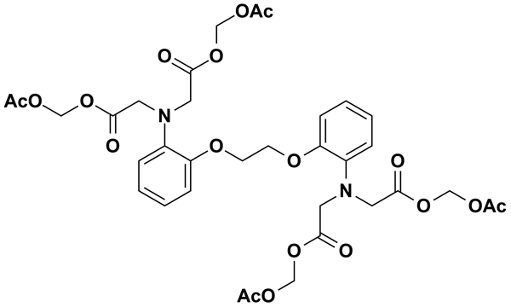
BAY 11-7082 | 12.06 | Biomol International Inc. | BRD-K15025317 | 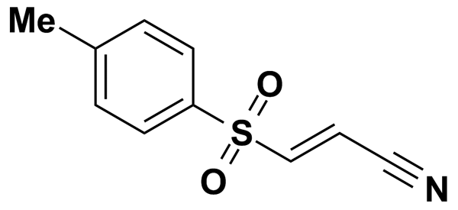
BAY K-8644 | 7.02 | Biomol International Inc. | BRD-A05457250 | 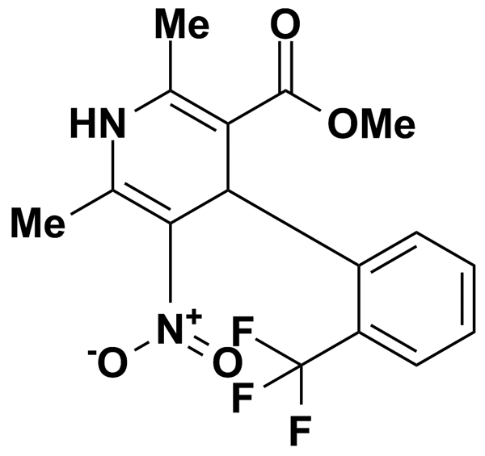
BENDROFLUMETHIAZIDE | 2.37 | Prestwick Chemical Inc. | BRD-A80017228 | 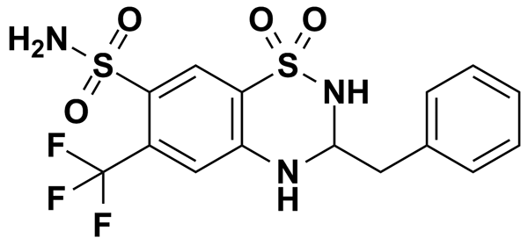
BENFLUOREX HYDROCHLORIDE | 2.58 | Prestwick Chemical Inc. | BRD-A22305049 | 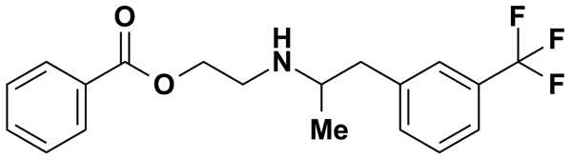
BENTAZON | 5.00 | MicroSource Discovery Systems Inc. | BRD-K33986892 | 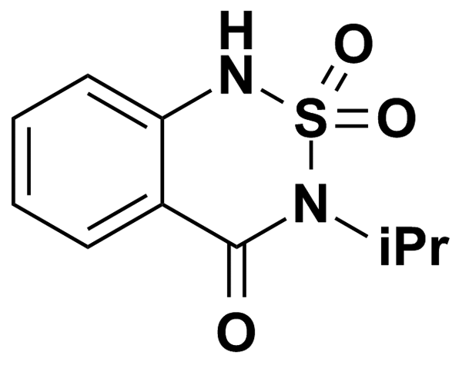
BENZOCAINE | 6.05 | Prestwick Chemical Inc. | BRD-K75466013 | 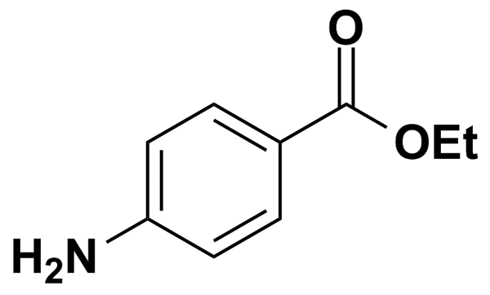
BENZYL PENICILLIN POTASSIUM | 5.00 | MicroSource Discovery Systems Inc. | BRD-K55191674 | 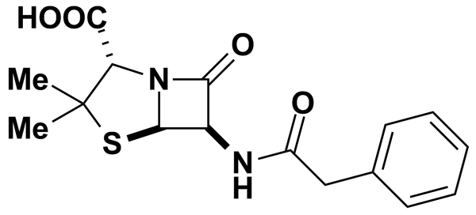
BENZYLPENICILLIN SODIUM | 2.80 | Prestwick Chemical Inc. | BRD-K55191674 | 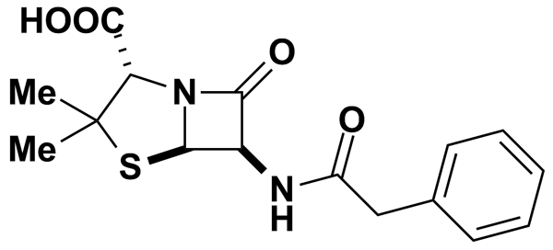
BERBERINE CHLORIDE | 2.68 | Prestwick Chemical Inc. | BRD-K14796088 | 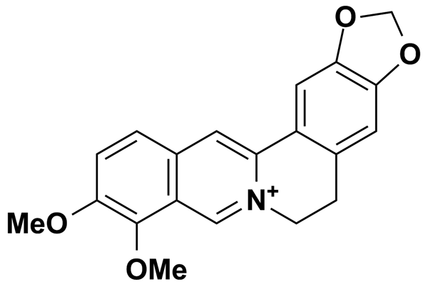
BERGAPTEN | 5.00 | MicroSource Discovery Systems Inc. | BRD-K12968785 | 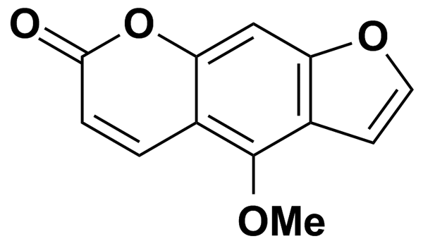
BESTATIN | 8.11 | Biomol International Inc. | BRD-K59574735 | 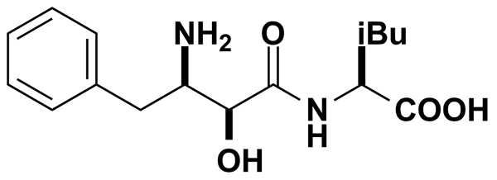
BETAHISTINE HYDROCHLORIDE | 5.00 | MicroSource Discovery Systems Inc. | BRD-K91315211 | 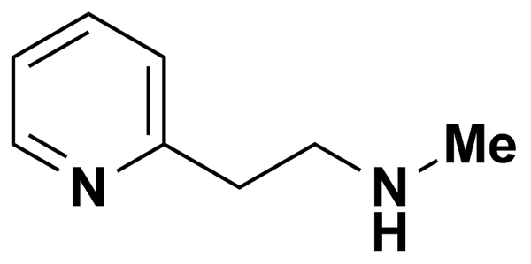
BETAHISTINE MESYLATE | 3.05 | Prestwick Chemical Inc. | BRD-K91315211 | 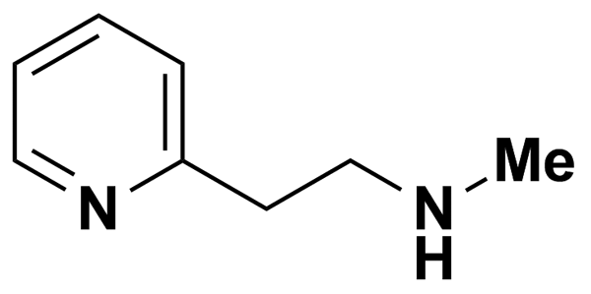
BETULINIC ACID | 5.47 | Biomol International Inc. | BRD-K45401373 | 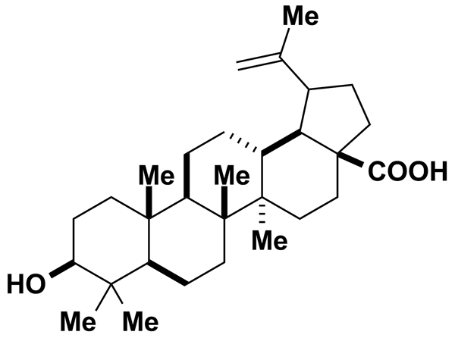
BIOCHANIN A | 5.00 | MicroSource Discovery Systems Inc. | BRD-K73303757 | 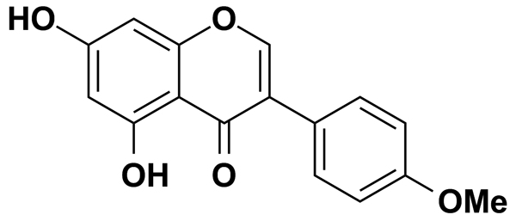
BISACODYL | 2.77 | Prestwick Chemical Inc. | BRD-K39987650 | 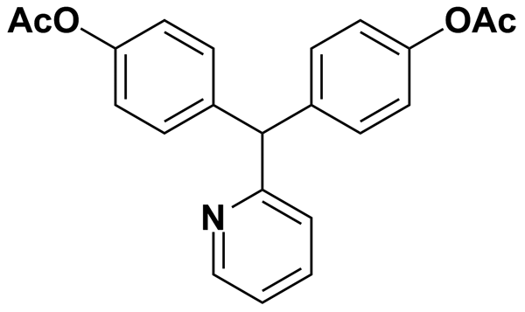
BLEBBISTATIN | 8.55 | Biomol International Inc. | BRD-A75817871 | 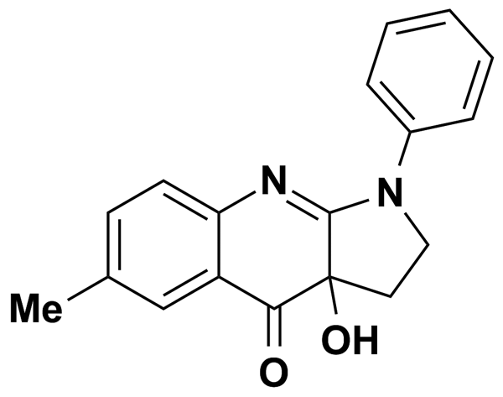
BML-190 | 0.50 | Biomol International Inc. | BRD-K94379058 | 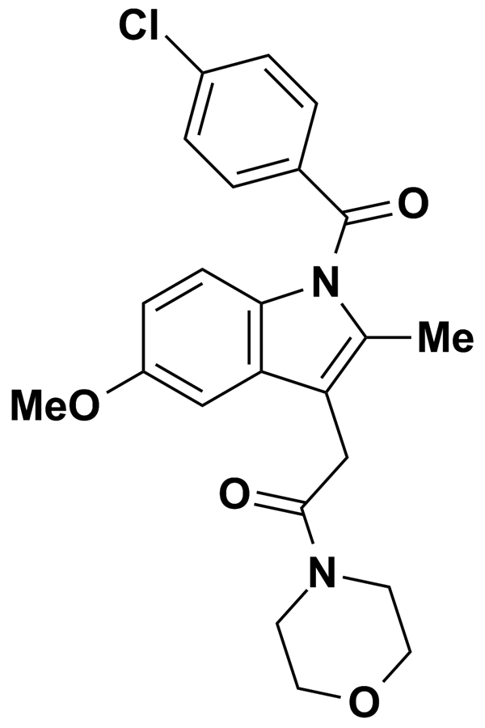
BROMHEXINE HYDROCHLORIDE | 5.00 | MicroSource Discovery Systems Inc. | BRD-K47631482 | 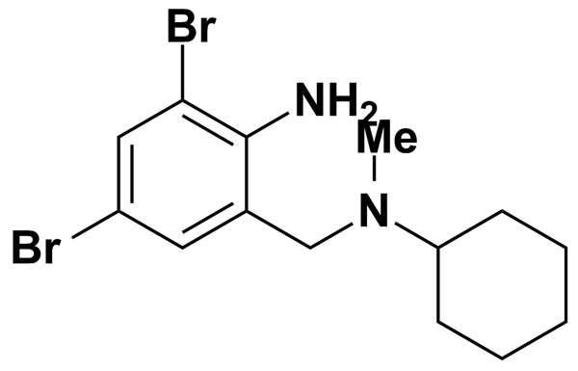
BROMO-7-NITROINDAZOLE [3-BROMO-7-NITROINDAZOLE] | 10.33 | Biomol International Inc. | BRD-K24689407 | 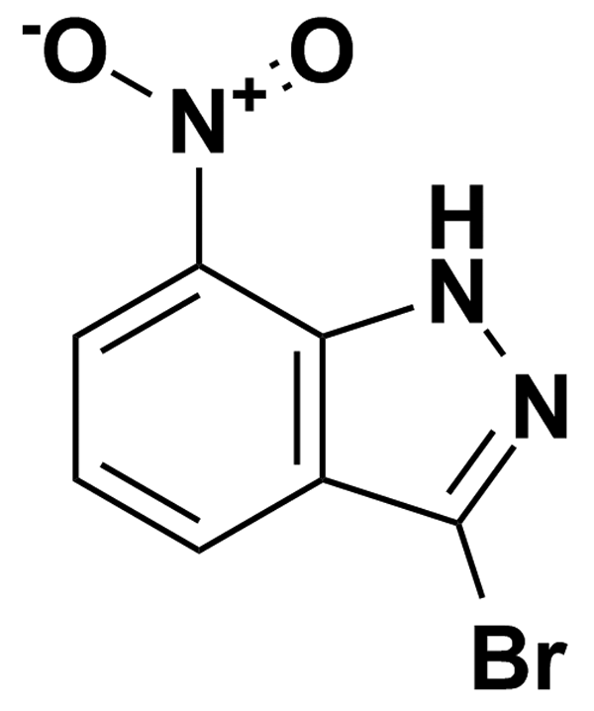
BROMOCRIPTINE MESYLATE | 5.00 | MicroSource Discovery Systems Inc. | BRD-A80151636 | 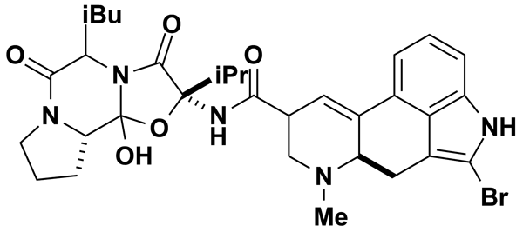
BROMOPRIDE | 2.90 | Prestwick Chemical Inc. | BRD-K73642618 | 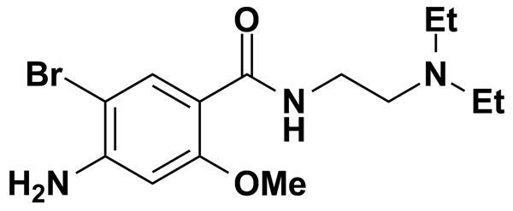
BUMETANIDE | 6.86 | Biomol International Inc. | BRD-K38197229 | 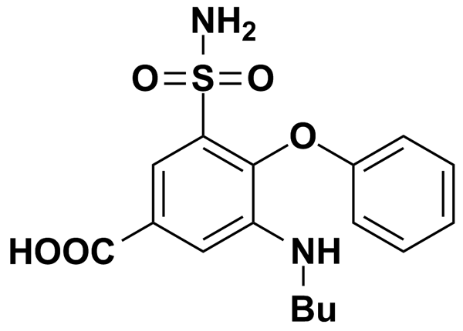
BUPIVACAINE HYDROCHLORIDE | 3.08 | Prestwick Chemical Inc. | BRD-A01636364 | 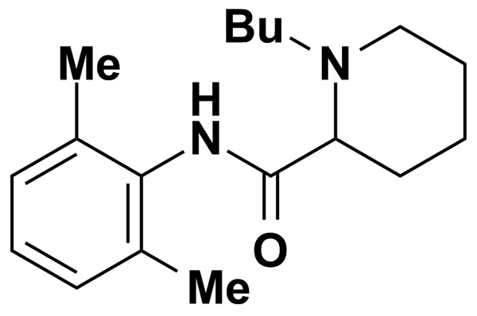
BUSPIRONE | 5.00 | Biomol International Inc. | BRD-K93461745 | 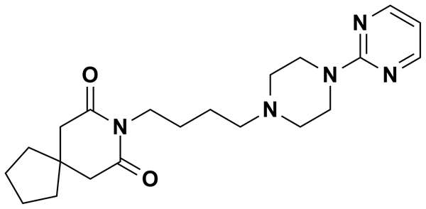
BUSPIRONE HYDROCHLORIDE | 2.37 | Prestwick Chemical Inc. | BRD-K93461745 | 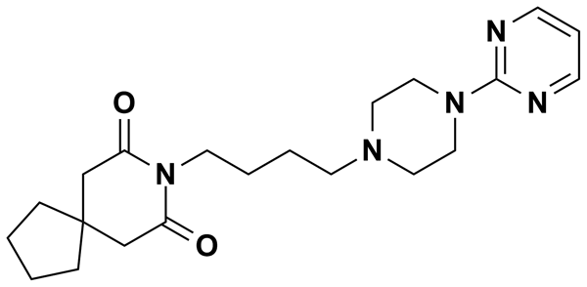
BUTAMBEN | 5.17 | Prestwick Chemical Inc. | BRD-K27217864 | 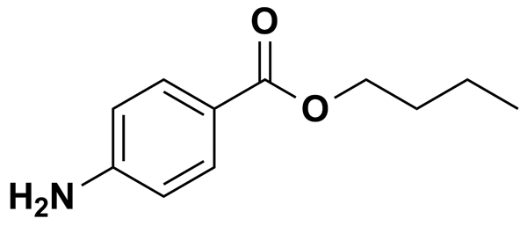
BW-B 70C | 7.90 | Biomol International Inc. | BRD-A55946879 | 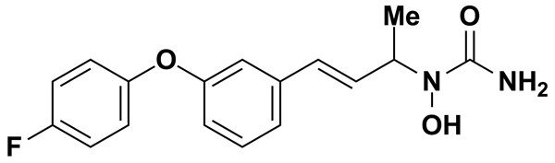
C2 CERAMIDE | 0.50 | Biomol International Inc. | BRD-K41707108 | 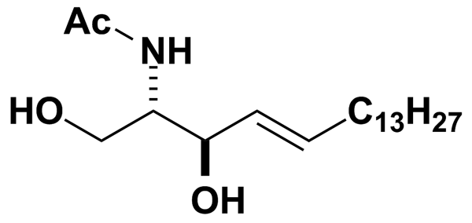
CA-074-ME | 6.29 | Biomol International Inc. | BRD-A56020723 | 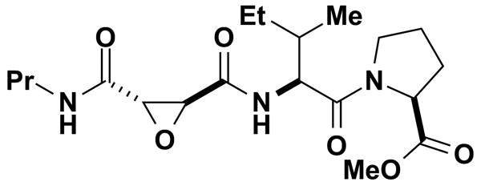
CAFFEINE | 5.00 | MicroSource Discovery Systems Inc. | BRD-K02404261 | 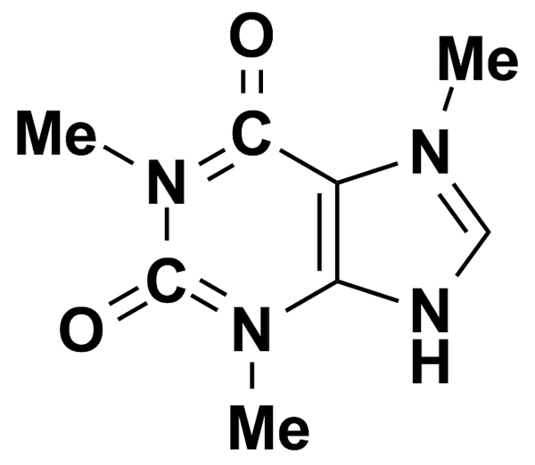
CAPSAZEPINE | 6.63 | Biomol International Inc. | BRD-K44849676 | 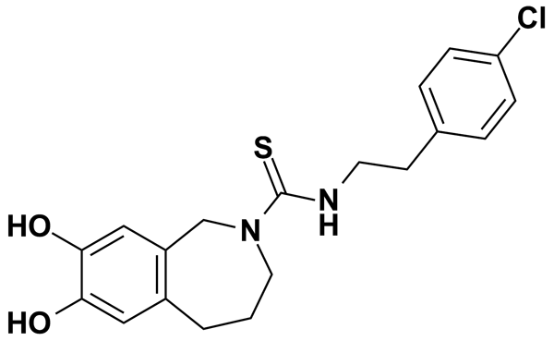
CAPTOPRIL | 4.60 | Prestwick Chemical Inc. | BRD-K54529596 | 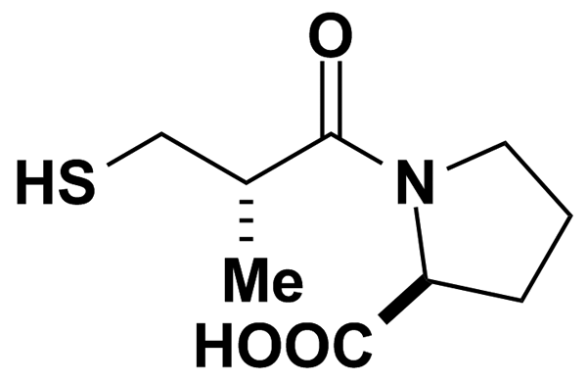
CARBAMAZEPINE | 4.23 | Prestwick Chemical Inc. | BRD-K71799949 | 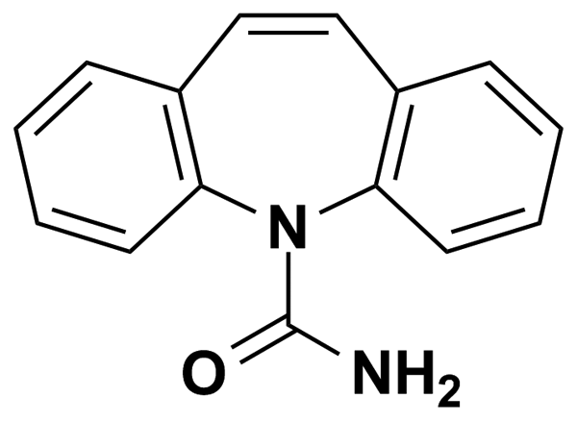
CARBETAPENTANE CITRATE | 1.90 | Prestwick Chemical Inc. | BRD-K06181161 | 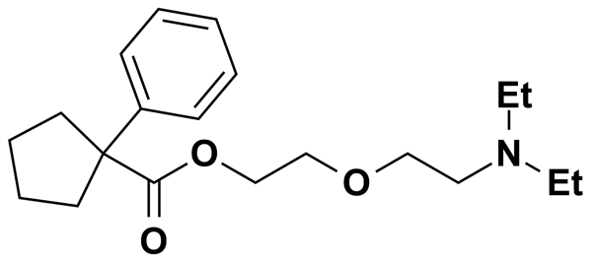
CARBINOXAMINE MALEATE SALT | 2.46 | Prestwick Chemical Inc. | BRD-A29426959 | 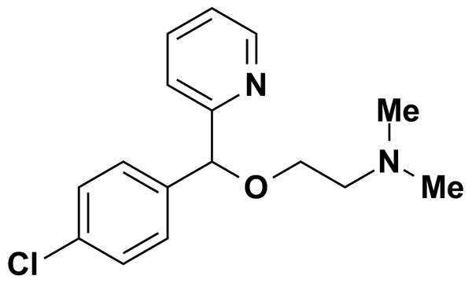
CELECOXIB | 5.00 | MicroSource Discovery Systems Inc. | BRD-K02637541 | 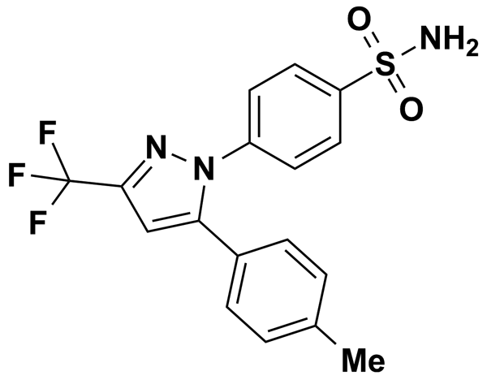
CEPHALOTHIN SODIUM SALT | 2.38 | Prestwick Chemical Inc. | BRD-K28210218 | 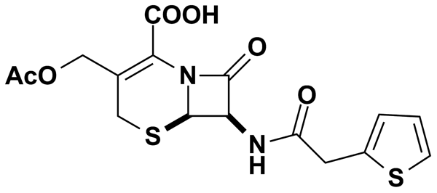
CERULENIN | 11.20 | Biomol International Inc. | BRD-K52075040 | 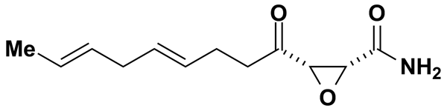
CGP-37157 | 7.71 | Biomol International Inc. | BRD-A35623999 | 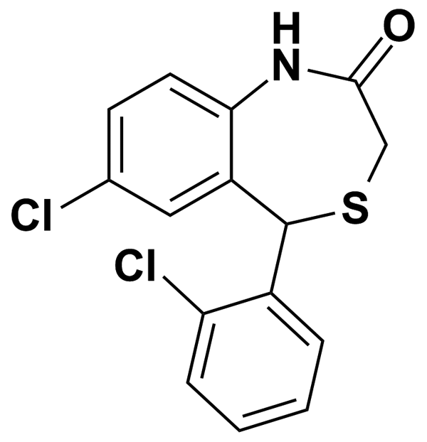
CHLORAMBUCIL | 3.29 | Prestwick Chemical Inc. | BRD-K29458283 | 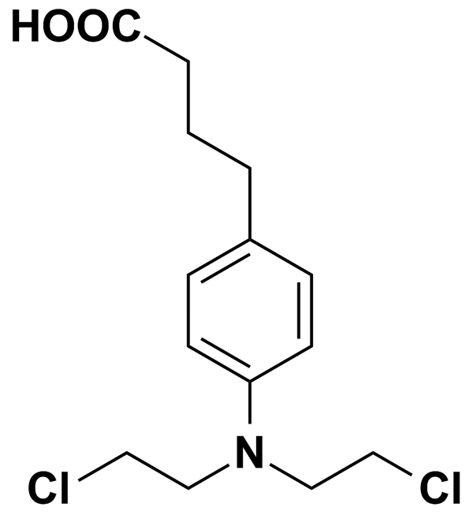
CHLORAMPHENICOL | 3.09 | Prestwick Chemical Inc. | BRD-K08111712 | 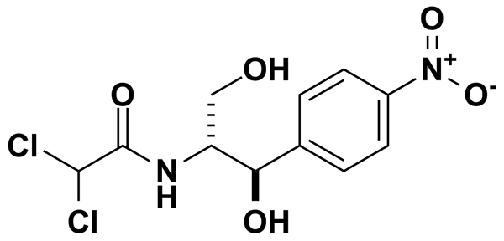
CHLORMEZANONE | 5.00 | Biomol International Inc. | BRD-A20348246 | 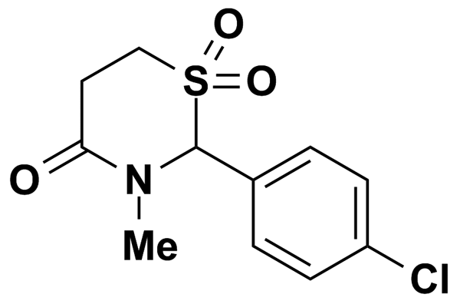
CHLOROXYLENOL | 5.00 | MicroSource Discovery Systems Inc. | BRD-K17223896 | 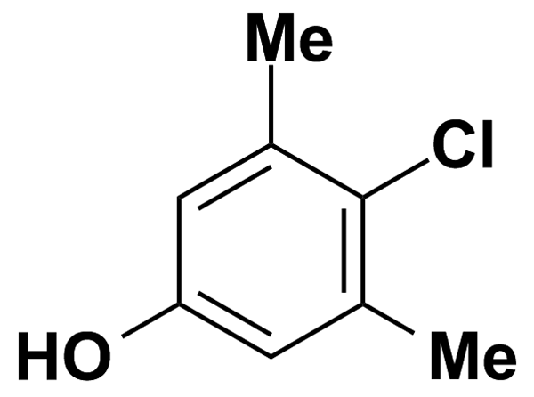
CHLORPHENIRAMINE MALEATE | 2.56 | Prestwick Chemical Inc. | BRD-A04553218 | 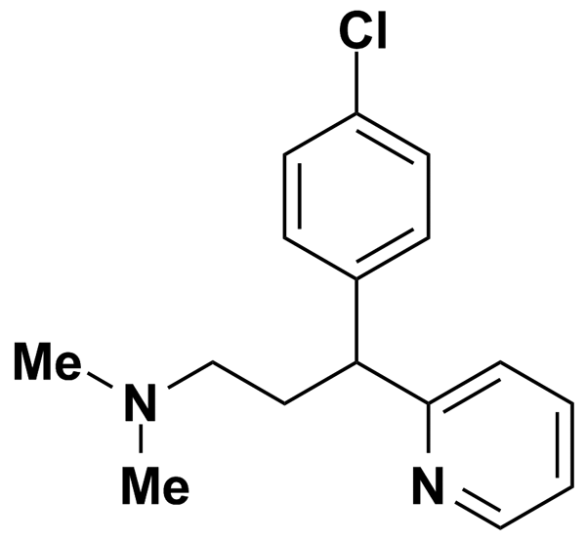
CHLORPROPAMIDE | 3.61 | Prestwick Chemical Inc. | BRD-K97746869 | 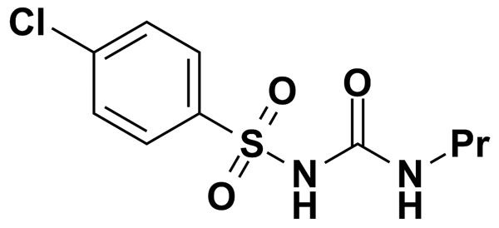
CHLORPROPHAM | 5.00 | MicroSource Discovery Systems Inc. | BRD-K59590127 | 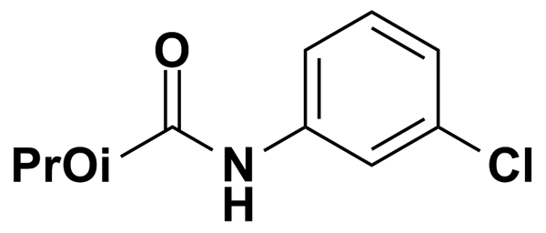
CHLORPROTHIXENE HYDROCHLORIDE | 2.84 | Prestwick Chemical Inc. | BRD-K59058766 | 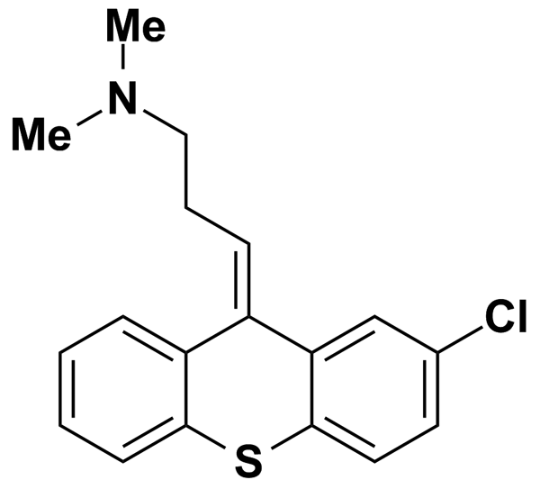
CHLORPYRIFOS | 5.00 | MicroSource Discovery Systems Inc. | BRD-K08303368 | 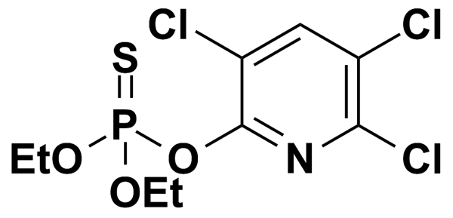
CHLORTHALIDONE | 2.95 | Prestwick Chemical Inc. | BRD-A26384407 | 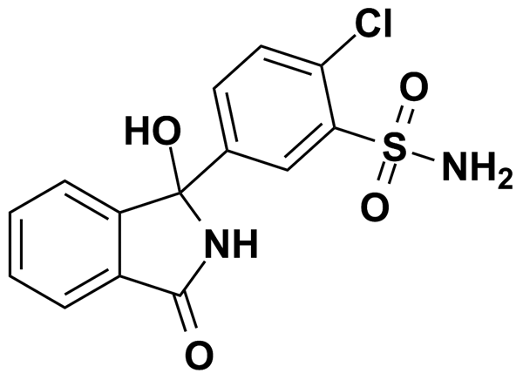
CHLORZOXAZONE | 5.90 | Prestwick Chemical Inc. | BRD-K98174813 | 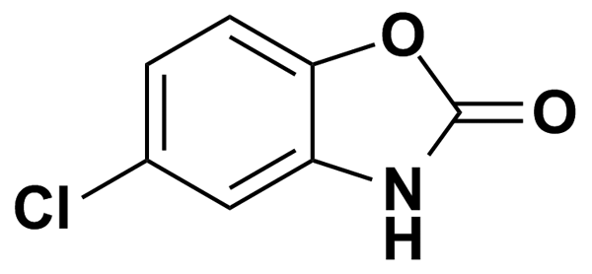
CHROMOCARB | 5.00 | MicroSource Discovery Systems Inc. | BRD-K94720315 | 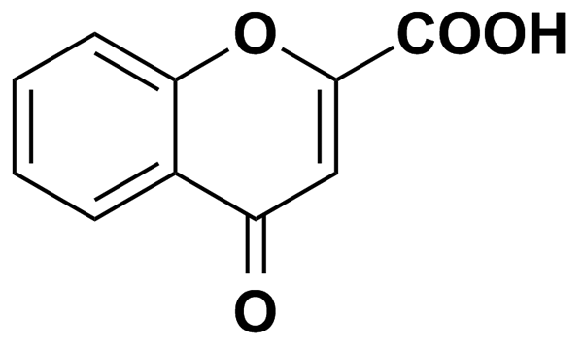
CIGLITAZONE | 0.50 | Biomol International Inc. | BRD-A93000692 | 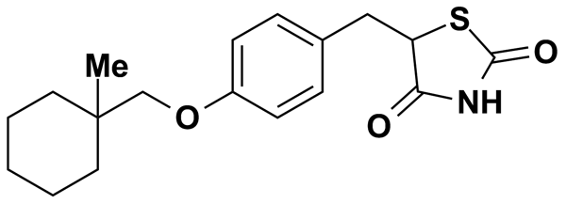
CIMATEROL | 11.40 | Biomol International Inc. | BRD-A65440446 | 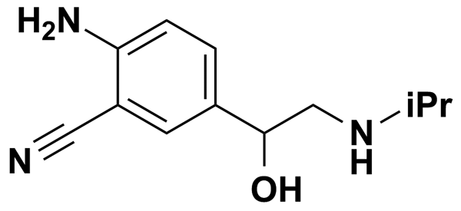
CINNARAZINE | 5.00 | MicroSource Discovery Systems Inc. | BRD-K32256916 | 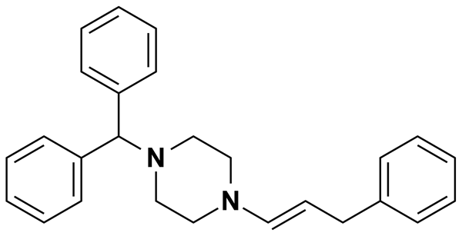
CINNARIZINE | 2.71 | Prestwick Chemical Inc. | BRD-K07220430 | 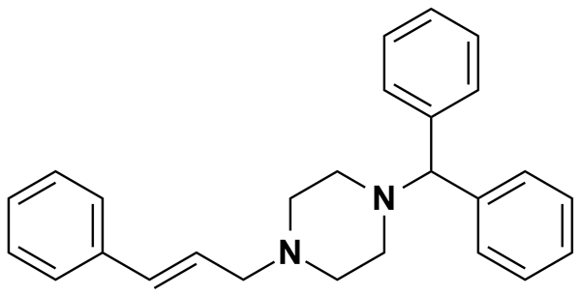
CINOXACIN | 3.81 | Prestwick Chemical Inc. | BRD-K14704277 | 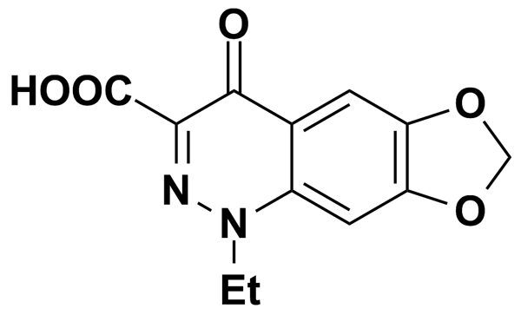
CIPROFIBRATE | 3.46 | Prestwick Chemical Inc. | BRD-A49358627 | 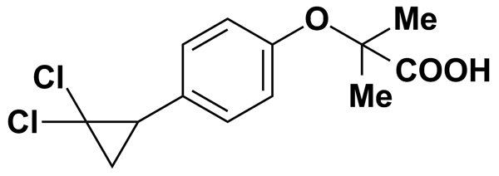
CIPROFLOXACIN HYDROCHLORIDE | 2.59 | Prestwick Chemical Inc. | BRD-K04804440 | 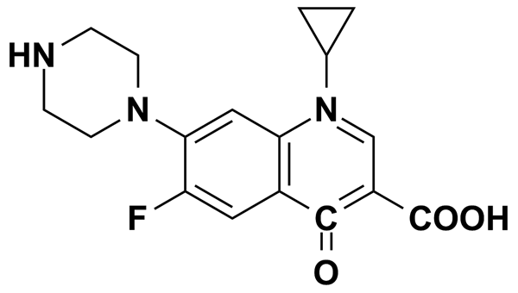
CIRAZOLINE | 11.56 | Biomol International Inc. | BRD-K54142781 | 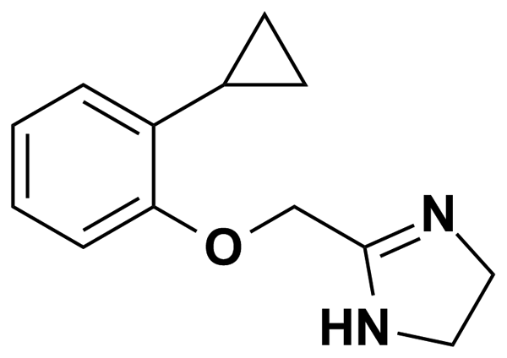
CLEMASTINE FUMARATE | 2.17 | Prestwick Chemical Inc. | BRD-K30240666 | 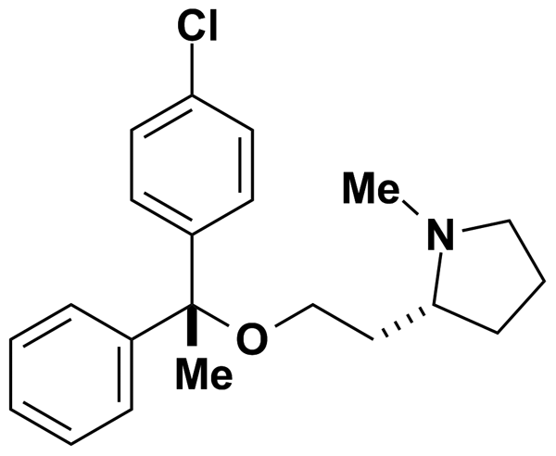
CLENBUTEROL HYDROCHLORIDE | 3.19 | Prestwick Chemical Inc. | BRD-A75726477 | 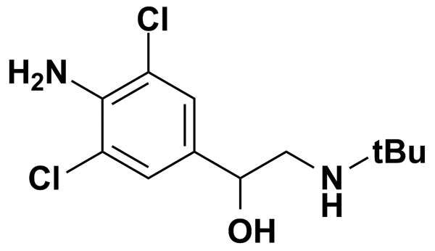
CLOBETASOL PROPIONATE | 5.00 | MicroSource Discovery Systems Inc. | BRD-A26095496 | 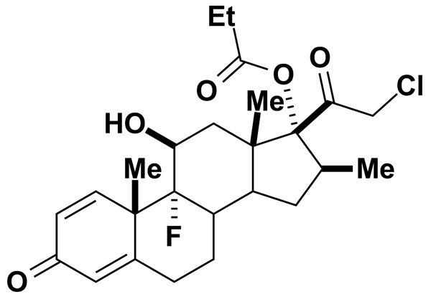
CLOFIBRIC ACID | 4.66 | Prestwick Chemical Inc. | BRD-K19111024 | 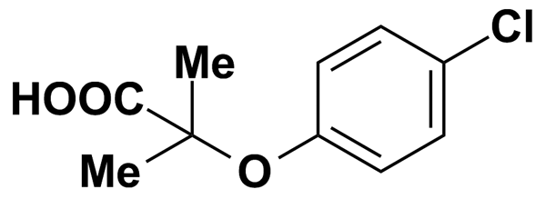
CLOMIPHENE CITRATE | 5.00 | MicroSource Discovery Systems Inc. | BRD-K29950728 | 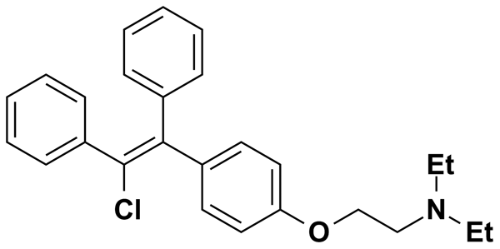
CLOMIPRAMINE | 5.00 | Biomol International Inc. | BRD-K52989797 | 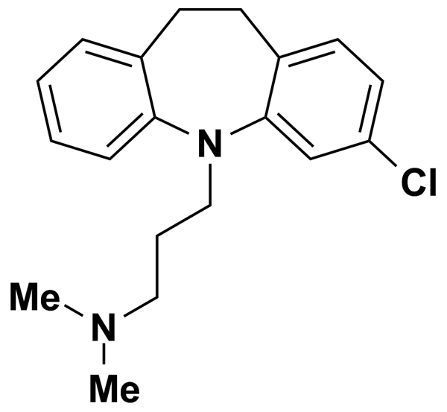
CLOMIPRAMINE HYDROCHLORIDE | 2.85 | Prestwick Chemical Inc. | BRD-K52989797 | 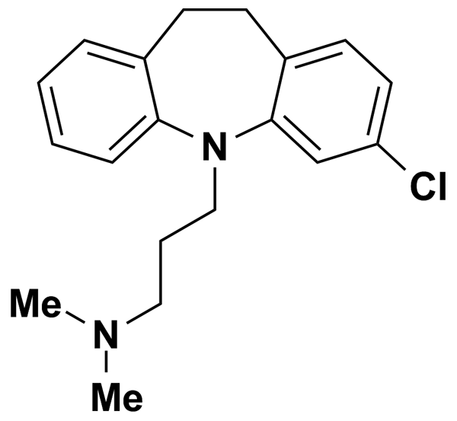
CLONIDINE | 10.87 | Biomol International Inc. | BRD-K98530306 | 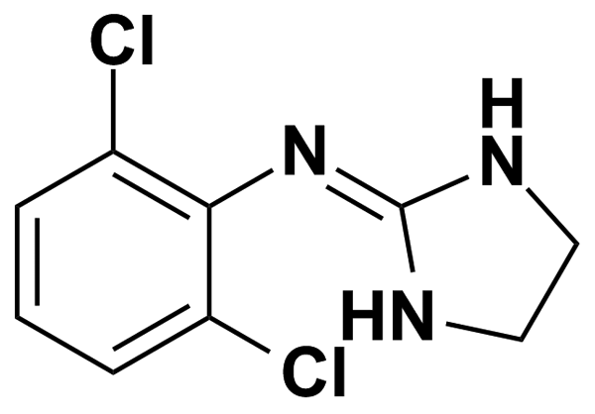
CLONIDINE HYDROCHLORIDE | 3.75 | Prestwick Chemical Inc. | BRD-K98530306 | 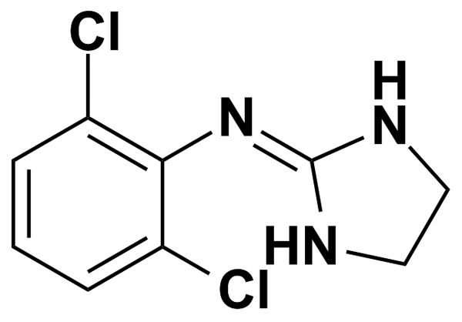
CLOPAMIDE | 5.00 | MicroSource Discovery Systems Inc. | BRD-A85651701 | 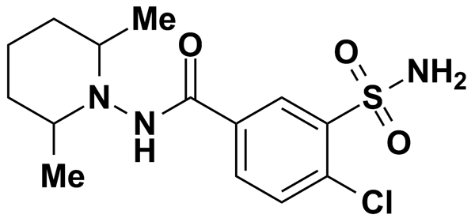
CLOPERASTINE HYDROCHLORIDE | 2.73 | Prestwick Chemical Inc. | BRD-A80908310 | 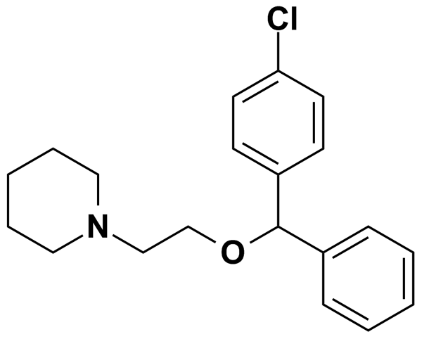
CLOPIDOGREL SULFATE | 5.00 | MicroSource Discovery Systems Inc. | BRD-K27721098 | 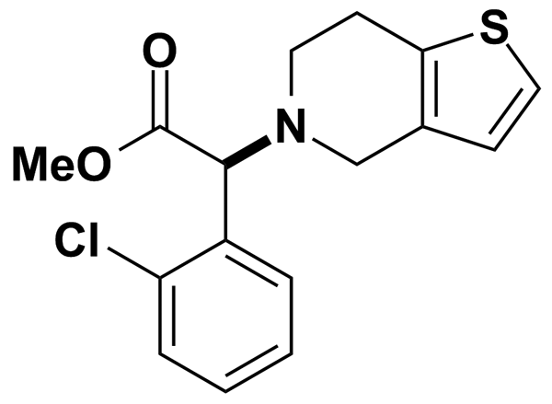
CLOPROSTENOL | 0.50 | Biomol International Inc. | BRD-K17850764 | 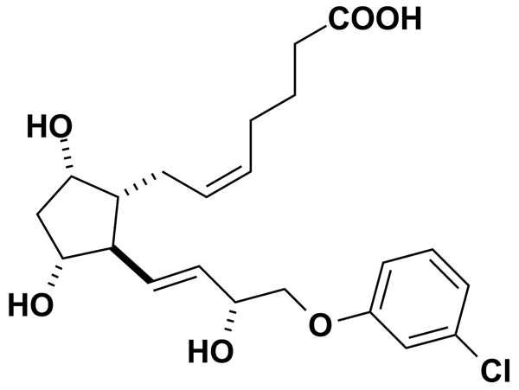
CLOXACILLIN SODIUM SALT | 2.18 | Prestwick Chemical Inc. | BRD-K01244426 | 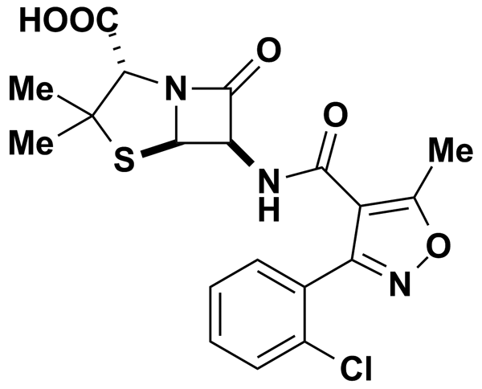
CLOXYQUIN | 5.00 | MicroSource Discovery Systems Inc. | BRD-K46982791 | 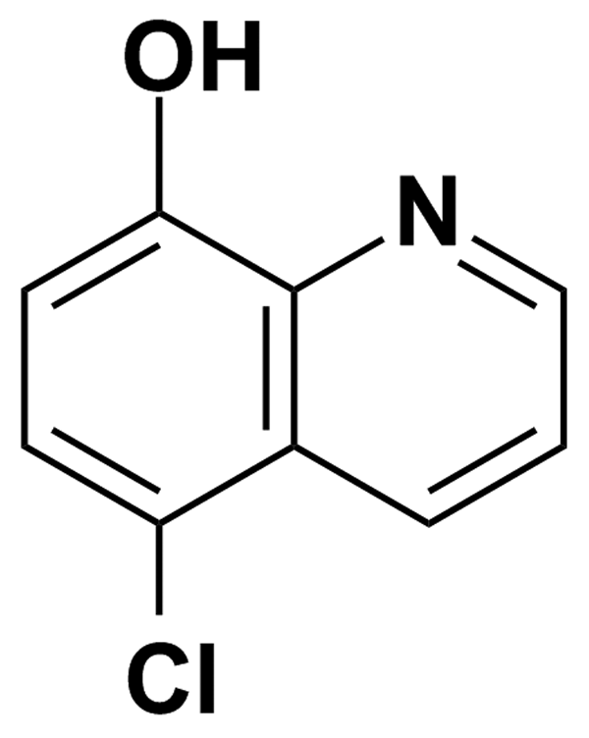
CLOZAPINE | 5.00 | Biomol International Inc. | BRD-K37289225 | 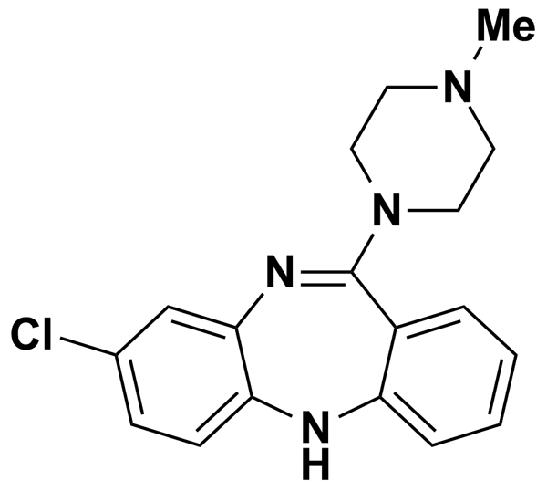
COLCHICINE | 2.50 | Prestwick Chemical Inc. | BRD-K00259736 | 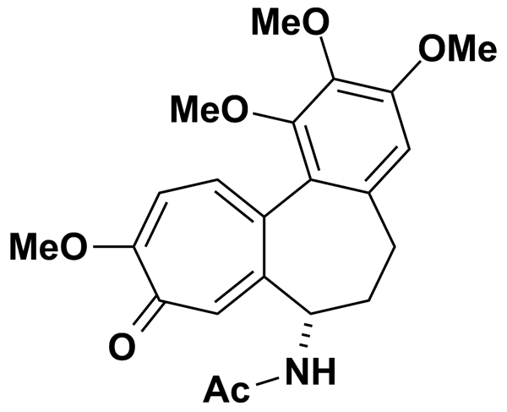
CORTICOSTERONE | 2.89 | Prestwick Chemical Inc. | BRD-K73589401 | 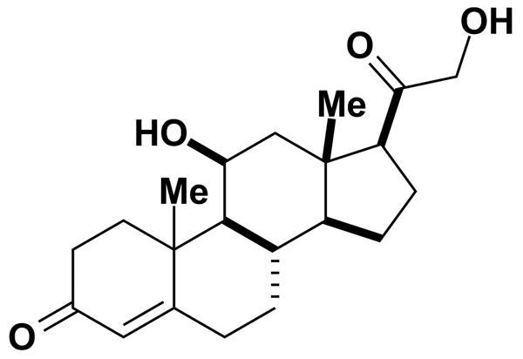
CORYNANTHINE HYDROCHLORIDE | 2.56 | Prestwick Chemical Inc. | BRD-K06467078 | 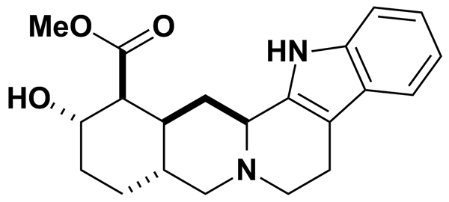
COTININE (-) | 5.67 | Prestwick Chemical Inc. | BRD-K94144010 | 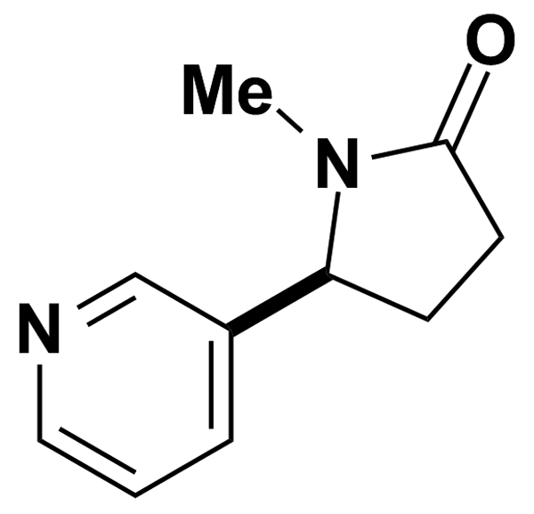
COUMOPHOS | 5.00 | MicroSource Discovery Systems Inc. | BRD-K41567533 | 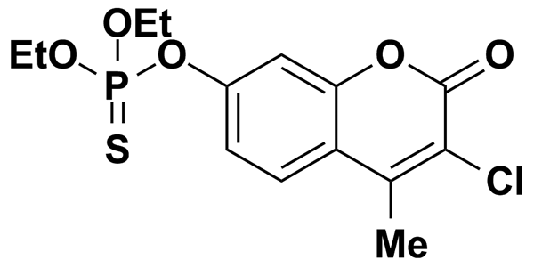
CURCUMIN | 5.00 | MicroSource Discovery Systems Inc. | BRD-K07572174 | 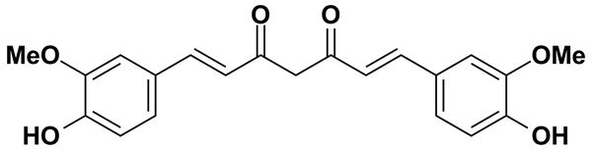
CYCLIZINE | 5.00 | MicroSource Discovery Systems Inc. | BRD-K79501723 | 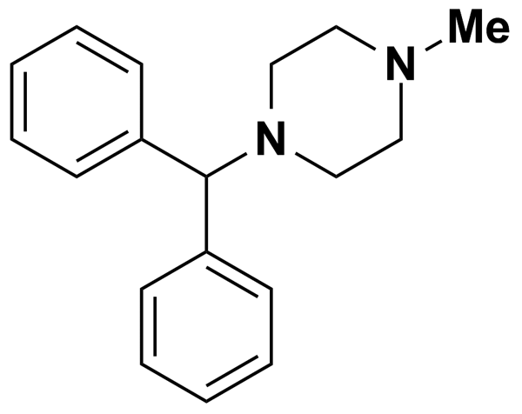
CYCLIZINE HYDROCHLORIDE | 3.30 | Prestwick Chemical Inc. | BRD-K79501723 | 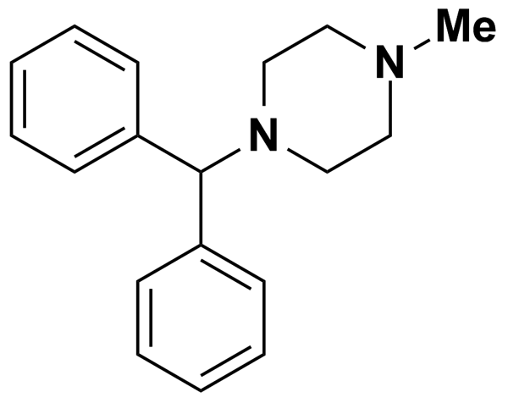
CYCLOBENZAPRINE HYDROCHLORIDE | 3.21 | Prestwick Chemical Inc. | BRD-K42348709 | 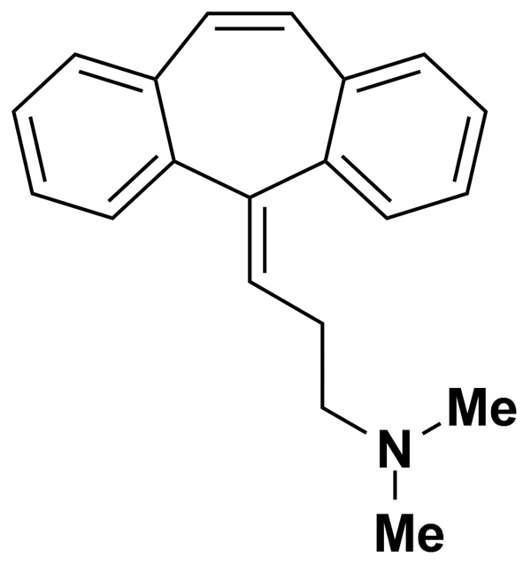
CYCLOPENTOLATE HYDROCHLORIDE | 3.05 | Prestwick Chemical Inc. | BRD-A77291778 | 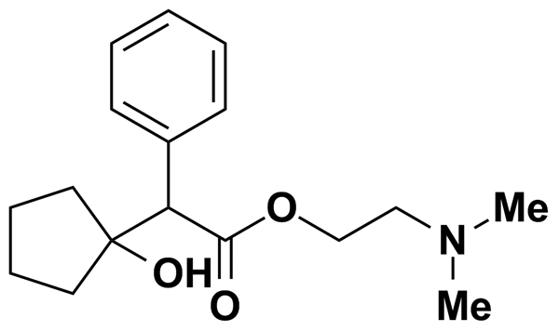
CYCLOPIAZONIC ACID | 5.00 | MicroSource Discovery Systems Inc. | BRD-A26787626 | 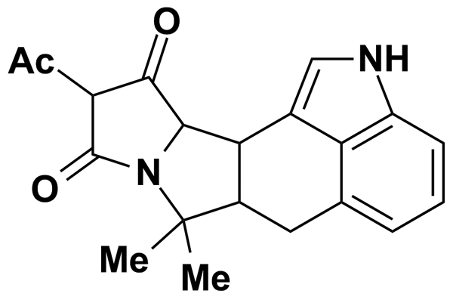
CYCLOTHIAZIDE | 5.00 | Biomol International Inc. | BRD-A38675539 | 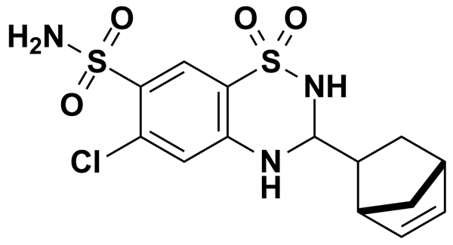
CYPROTERONE ACETATE | 5.00 | MicroSource Discovery Systems Inc. | BRD-A95207036 | 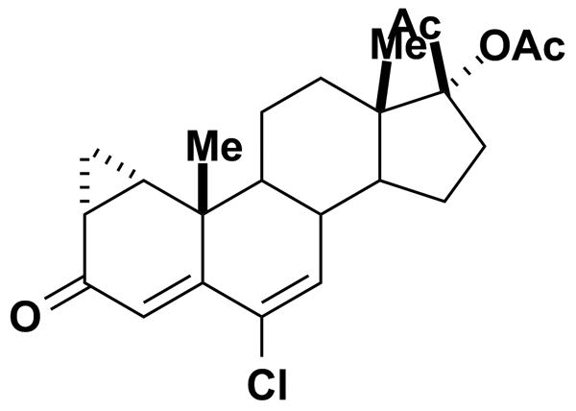
DAIDZEIN | 5.00 | Biomol International Inc. | BRD-K42095107 | 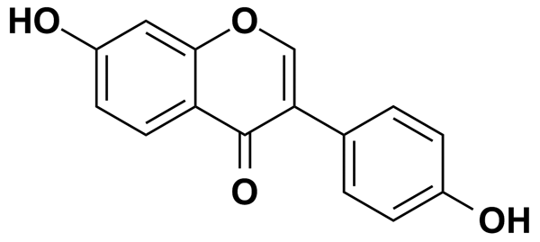
DANAZOL | 5.00 | MicroSource Discovery Systems Inc. | BRD-A92537424 | 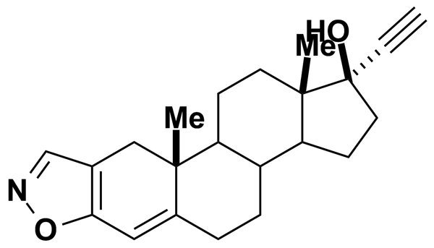
DANTRON | 5.00 | MicroSource Discovery Systems Inc. | BRD-K10065684 | 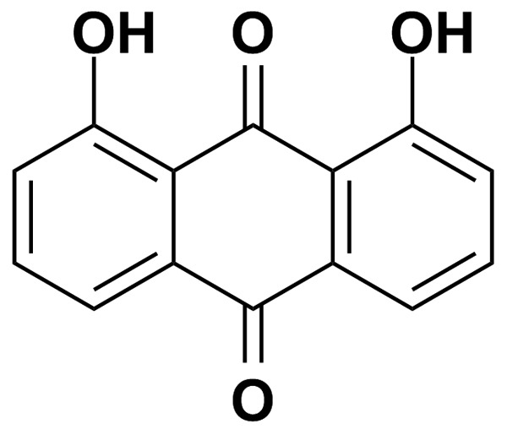
DAPHNETIN | 5.00 | MicroSource Discovery Systems Inc. | BRD-K61269089 | 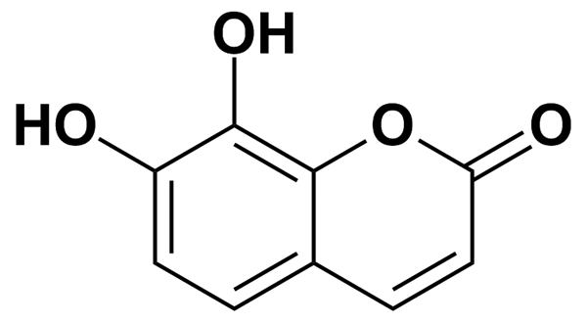
DAPSONE | 4.03 | Prestwick Chemical Inc. | BRD-K62363391 | 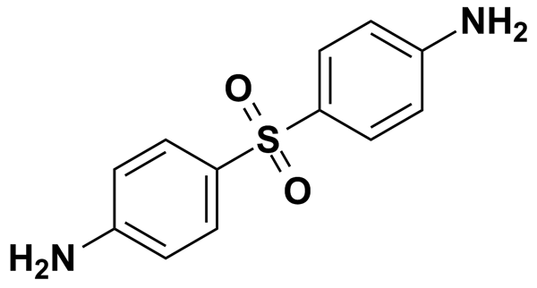
DAUNORUBICIN HYDROCHLORIDE | 1.77 | Prestwick Chemical Inc. | BRD-K43389675 | 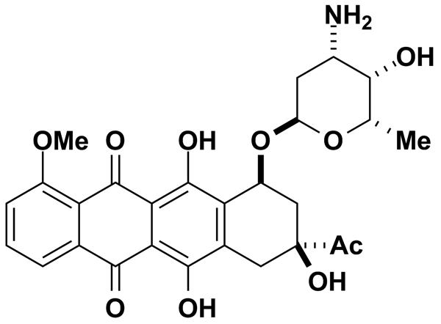
DEMECLOCYCLINE HYDROCHLORIDE | 1.99 | Prestwick Chemical Inc. | BRD-A34145622 | 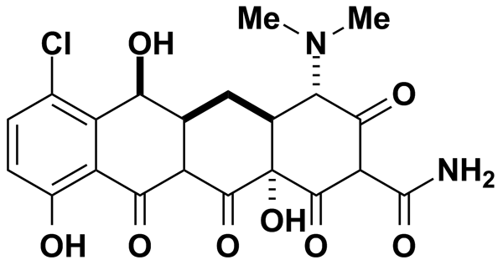
DEPRENYL | 13.35 | Biomol International Inc. | BRD-K86434416 | 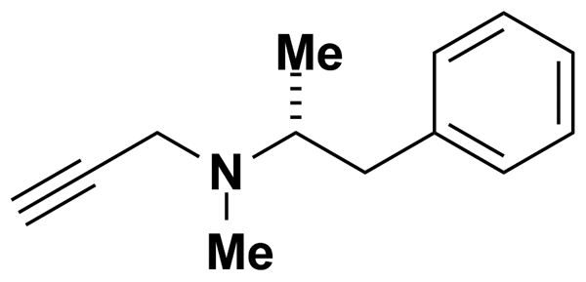
DEXTROMETHORPHAN HYDROBROMIDE | 5.00 | MicroSource Discovery Systems Inc. | BRD-K24053527 | 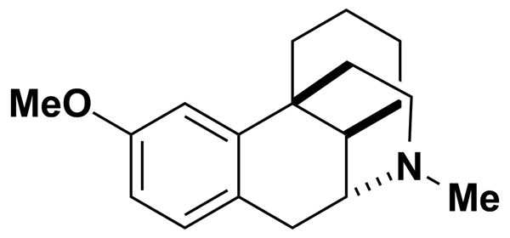
DIAZEPAM | 5.00 | MicroSource Discovery Systems Inc. | BRD-K16508793 | 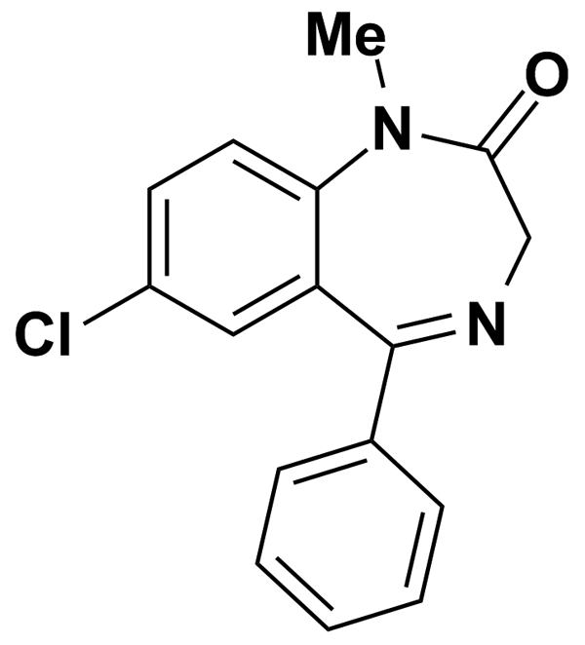
DIAZOXIDE | 10.84 | Biomol International Inc. | BRD-K73109821 | 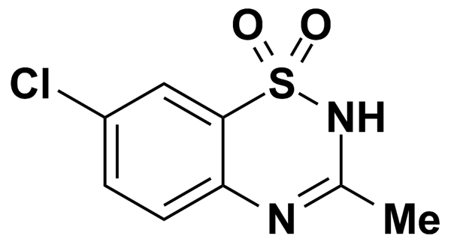
DIBUCAINE | 2.91 | Prestwick Chemical Inc. | BRD-K99121711 | 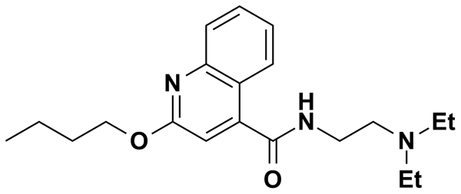
DIBUCAINE HYDROCHLORIDE | 5.00 | MicroSource Discovery Systems Inc. | BRD-K99121711 | 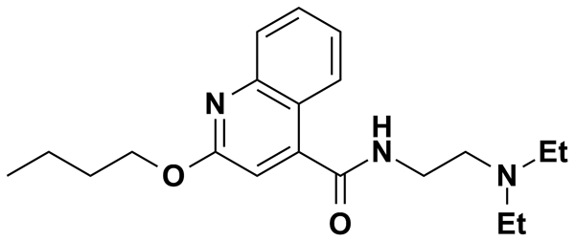
DIBUTYRYLCYCLIC AMP | 5.08 | Biomol International Inc. | BRD-A94624445 | 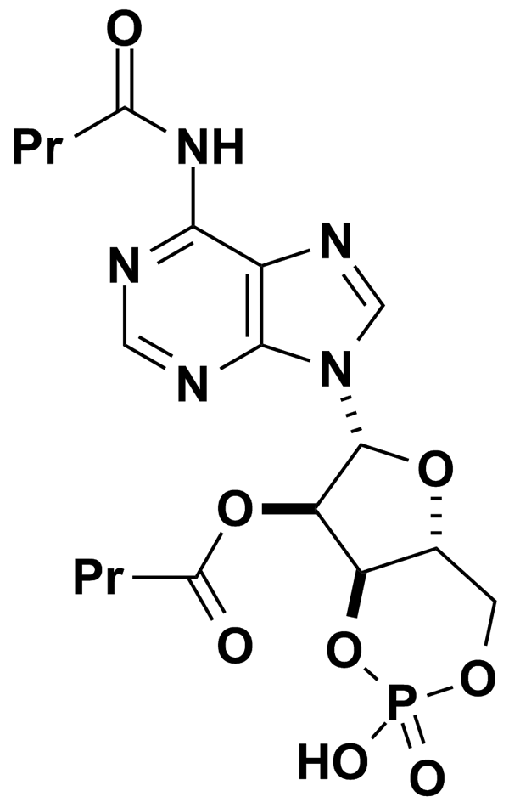
DICHLORODIPHENYLTRICHLOROETHANE | 5.00 | MicroSource Discovery Systems Inc. | BRD-K51799616 | 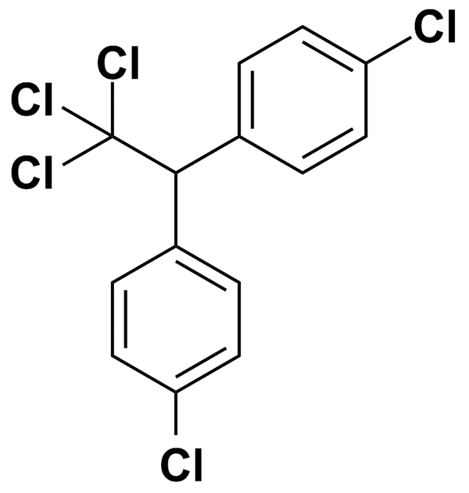
DICLOFENAC SODIUM | 3.13 | Prestwick Chemical Inc. | BRD-K08252256 | 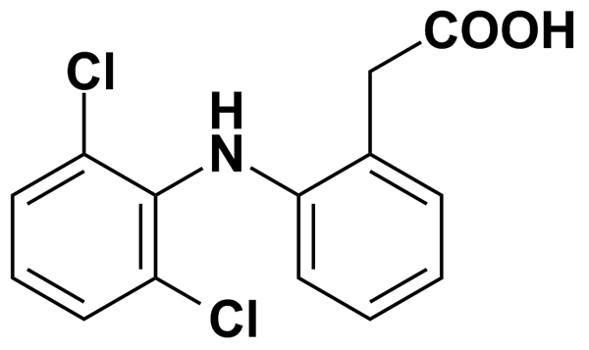
DICLOXACILLIN SODIUM SALT | 1.96 | Prestwick Chemical Inc. | BRD-K05673000 | 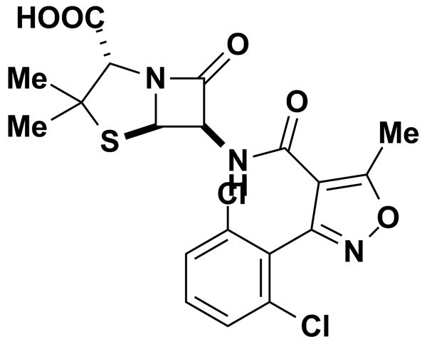
DICUMAROL | 2.97 | Prestwick Chemical Inc. | BRD-K82236179 | 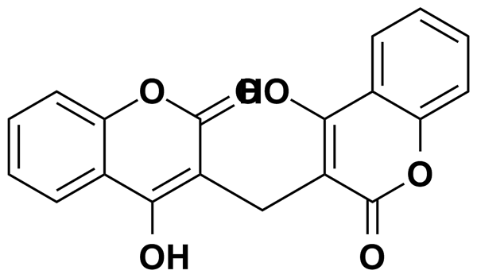
DIENESTROL | 3.75 | Prestwick Chemical Inc. | BRD-K95309561 | 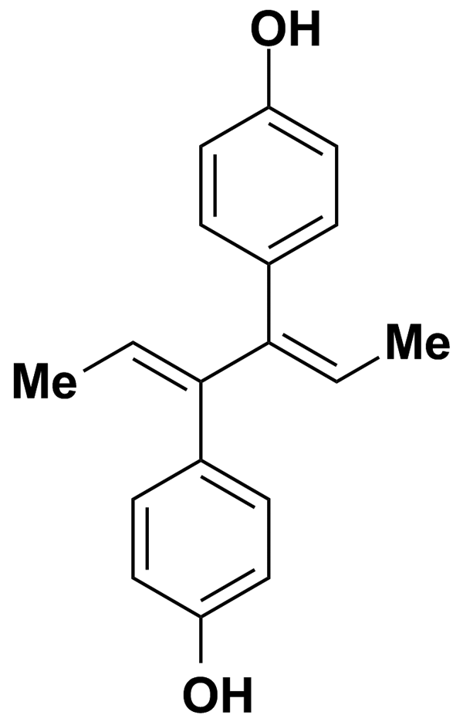
DIETHYLCARBAMAZINE CITRATE | 2.55 | Prestwick Chemical Inc. | BRD-K45542189 | 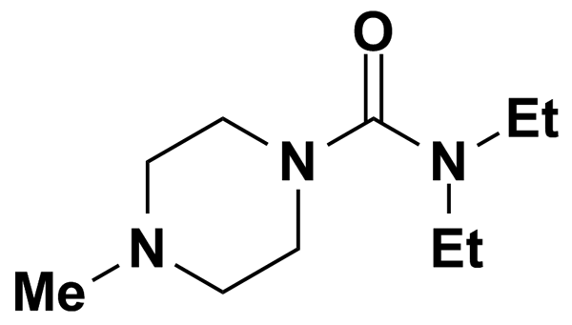
DIFLUNISAL | 4.00 | Prestwick Chemical Inc. | BRD-K22031190 | 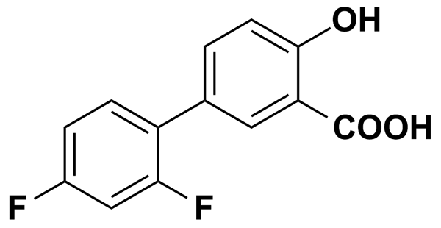
DIGITOXIN | 5.00 | MicroSource Discovery Systems Inc. | BRD-A93236127 | 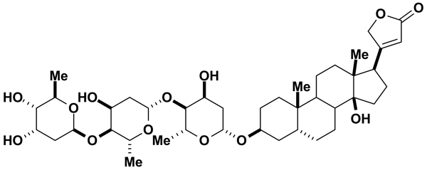
DIGOXIN | 5.00 | MicroSource Discovery Systems Inc. | BRD-A94756469 | 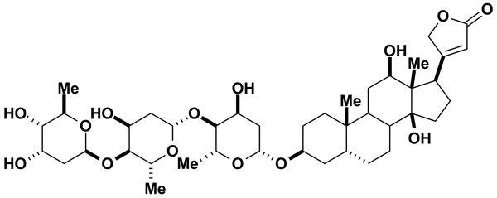
DIHYDROERGOTAMINE MESYLATE | 5.00 | MicroSource Discovery Systems Inc. | BRD-K72166146 | 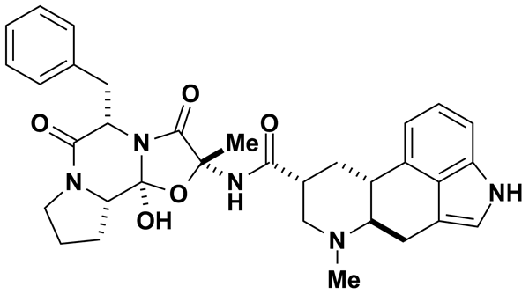
DIINDOLYLMETHANE | 0.50 | Biomol International Inc. | BRD-K37846922 | 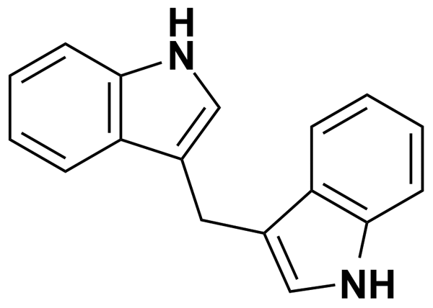
DILTIAZEM | 6.03 | Biomol International Inc. | BRD-K24023109 | 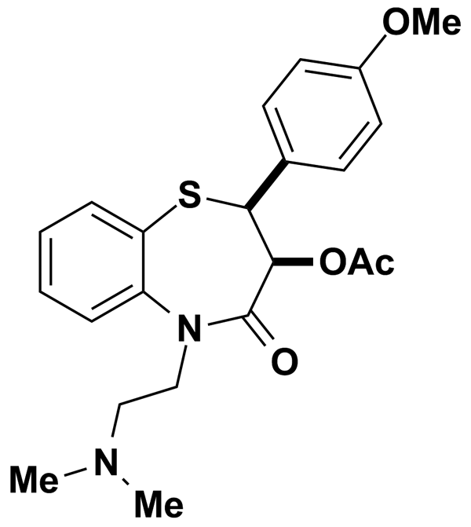
DILTIAZEM HYDROCHLORIDE | 2.22 | Prestwick Chemical Inc. | BRD-K24023109 | 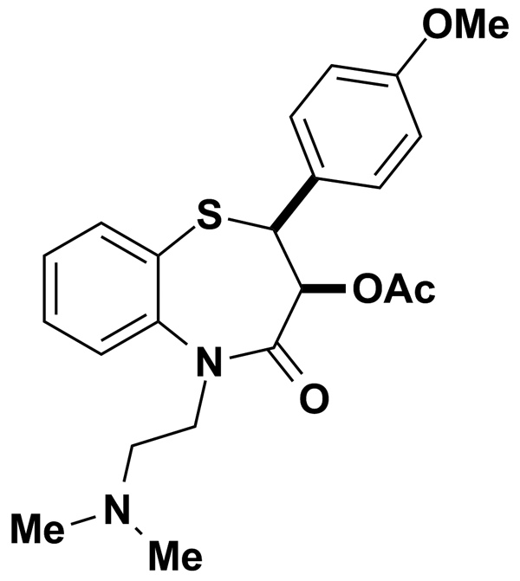
DIMETHOATE | 5.00 | MicroSource Discovery Systems Inc. | BRD-K94763113 | 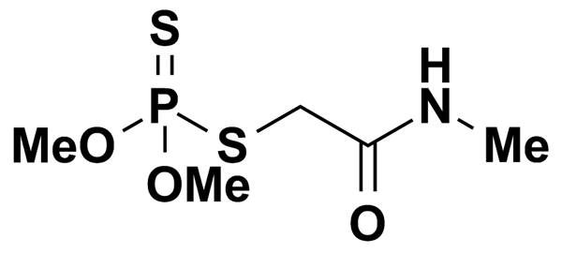
DIMETHYL 4,4-O-PHENYLENE-BIS (3-THIOPHANATE) | 5.00 | MicroSource Discovery Systems Inc. | BRD-K90168339 | 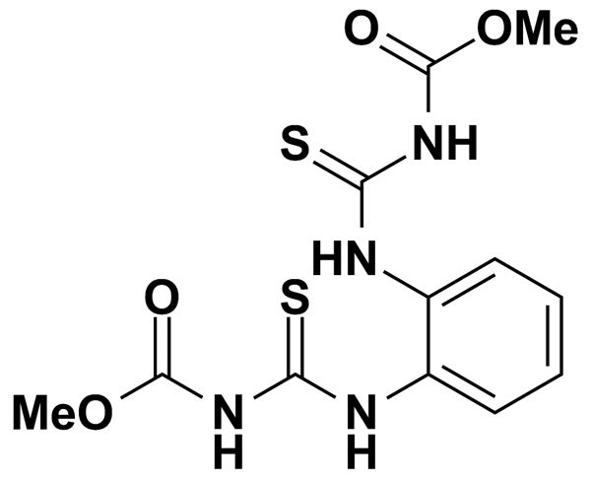
DIPHENHYDRAMINE HYDROCHLORIDE | 3.43 | Prestwick Chemical Inc. | BRD-K47278471 | 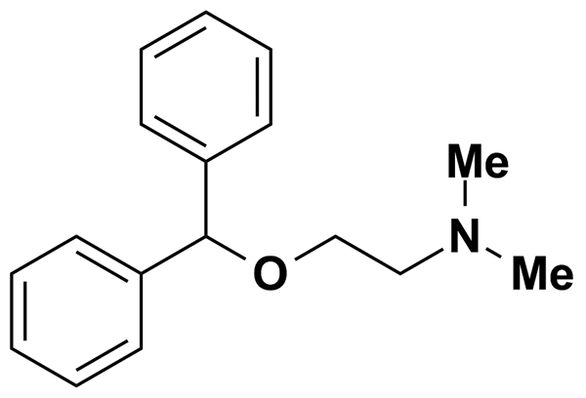
DIPHENYLPYRALINE HYDROCHLORIDE | 3.15 | Prestwick Chemical Inc. | BRD-K22936972 | 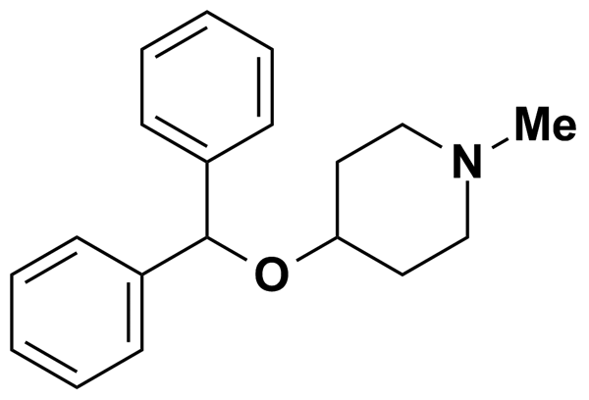
DIPROPHYLLINE | 3.93 | Prestwick Chemical Inc. | BRD-A00827783 | 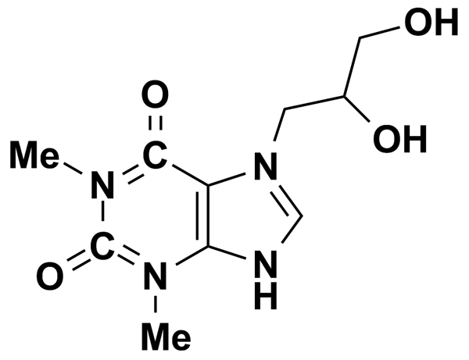
DIPYRONE | 2.99 | Prestwick Chemical Inc. | BRD-K76812510 | 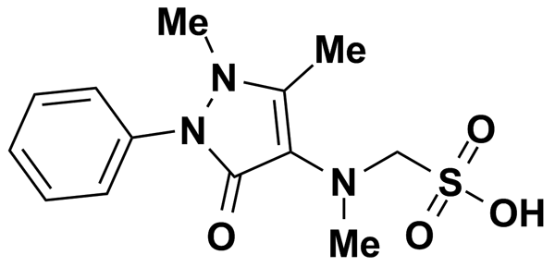
DISOPYRAMIDE | 2.95 | Prestwick Chemical Inc. | BRD-A29734509 | 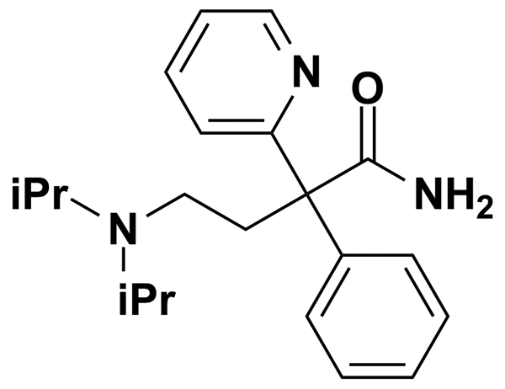
DISOPYRAMIDE PHOSPHATE | 5.00 | MicroSource Discovery Systems Inc. | BRD-A29734509 | 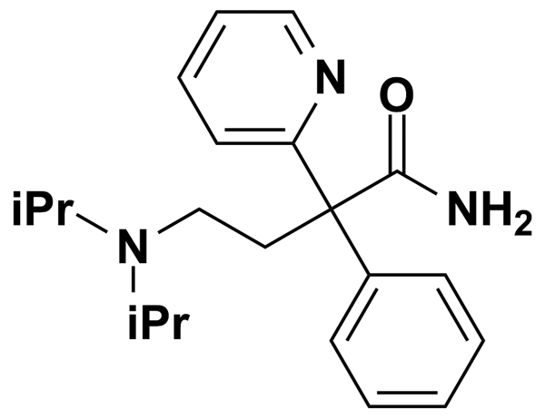
DISULFIRAM | 3.37 | Prestwick Chemical Inc. | BRD-K32744045 | 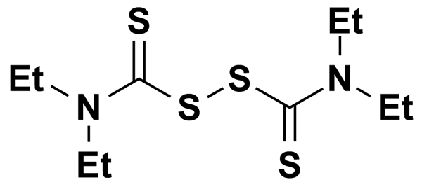
DL-PDMP | 0.50 | Biomol International Inc. | BRD-K05653692 | 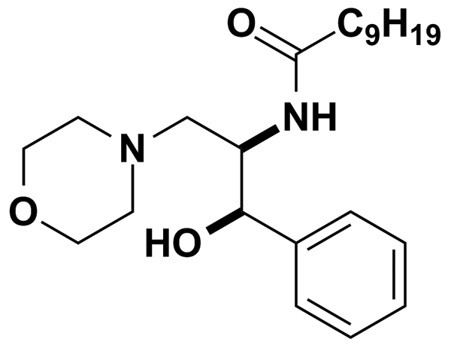
DOMPERIDONE | 5.00 | Biomol International Inc. | BRD-K38305202 | 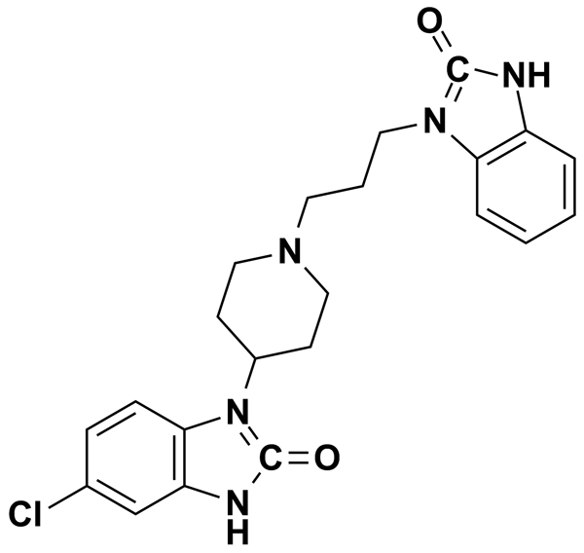
DOXEPIN HYDROCHLORIDE | 5.00 | MicroSource Discovery Systems Inc. | BRD-K37694030 | 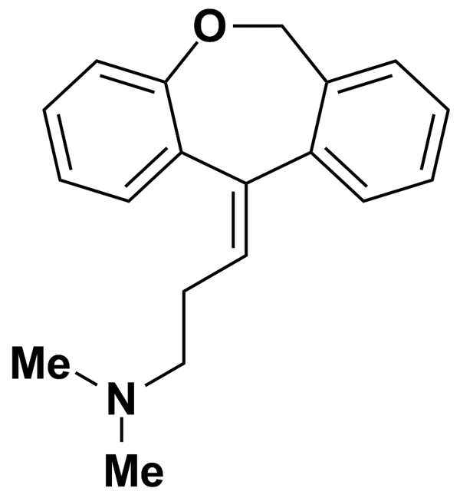
DOXYLAMINE SUCCINATE | 2.57 | Prestwick Chemical Inc. | BRD-A44008656 | 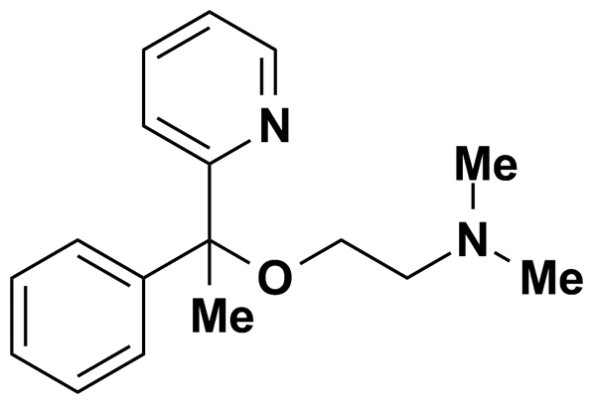
DROFENINE HYDROCHLORIDE | 2.83 | Prestwick Chemical Inc. | BRD-A22267103 | 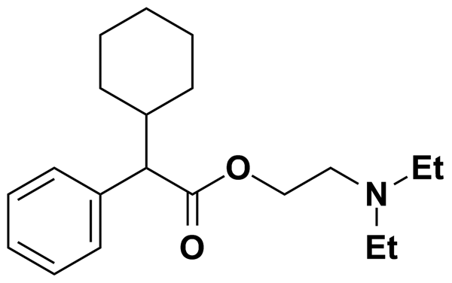
DROPERIDOL | 2.64 | Prestwick Chemical Inc. | BRD-K97158071 | 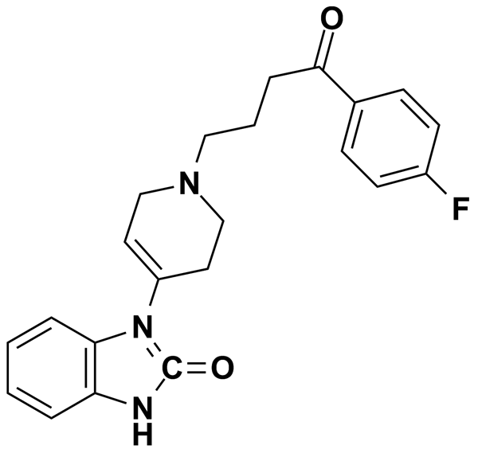
DROPROPIZINE (R,S) | 4.23 | Prestwick Chemical Inc. | BRD-A29349577 | 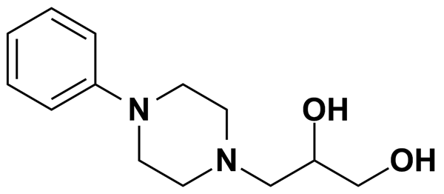
DYCLONINE HYDROCHLORIDE | 3.07 | Prestwick Chemical Inc. | BRD-K72259270 | 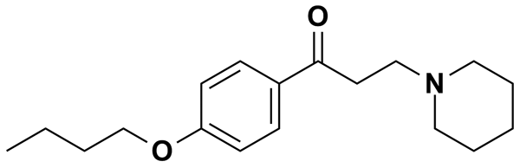
E-4031 | 6.23 | Biomol International Inc. | BRD-K41713976 | 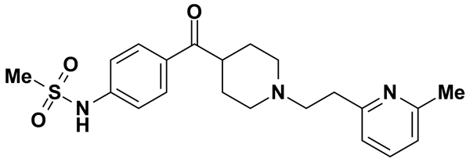
EBSELEN | 9.12 | Biomol International Inc. | BRD-K29359156 | 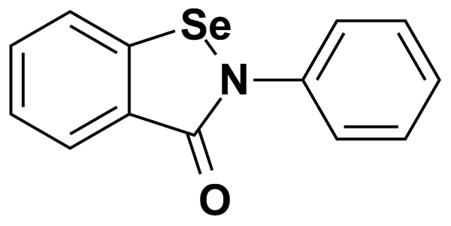
EBURNAMONINE (-) | 3.40 | Prestwick Chemical Inc. | BRD-K40227168 | 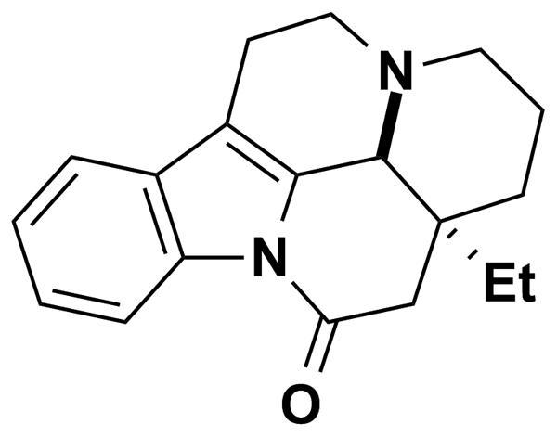
ECONAZOLE NITRATE | 2.25 | Prestwick Chemical Inc. | BRD-A51820102 | 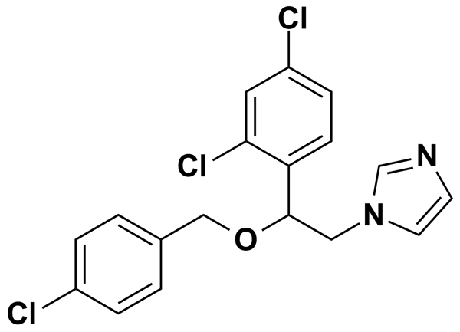
EHNA | 9.01 | Biomol International Inc. | BRD-K27450477 | 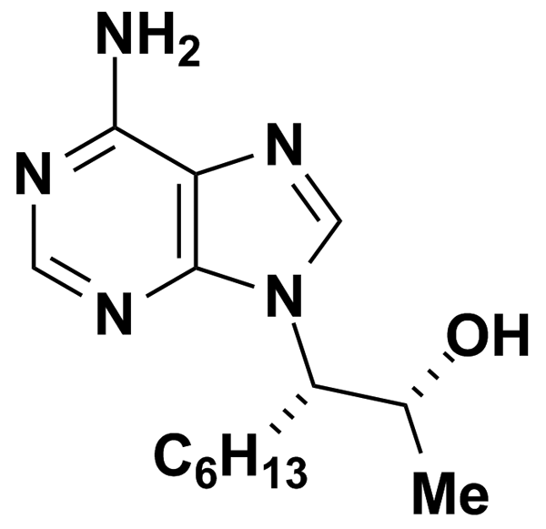
EICOSAPENTAENOIC ACID (20:5 N-3) | 0.50 | Biomol International Inc. | BRD-K47192521
ELLIPTICINE | 4.06 | Prestwick Chemical Inc. | BRD-K85985071 | 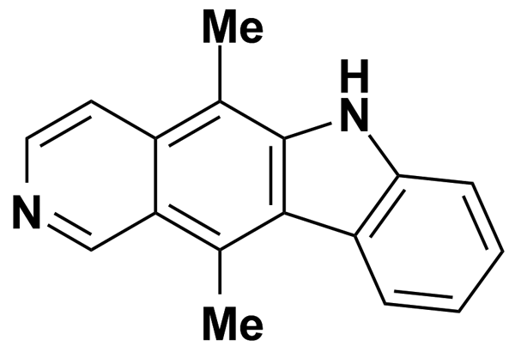
ENOXACIN | 3.12 | Prestwick Chemical Inc. | BRD-K78113049 | 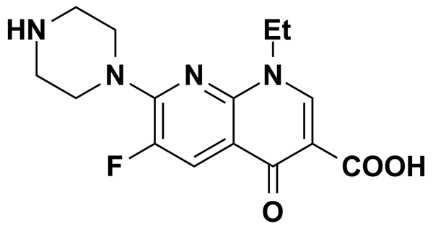
ENOXOLONE | 5.00 | MicroSource Discovery Systems Inc. | BRD-A20200672 | 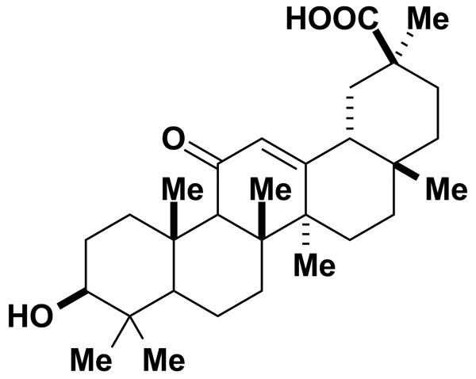
EPICATECHIN-(-) | 3.45 | Prestwick Chemical Inc. | BRD-K58736316 | 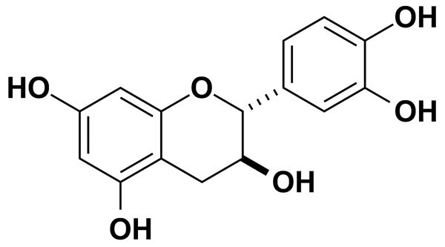
EPIVINCAMINE | 2.82 | Prestwick Chemical Inc. | BRD-K89704198 | 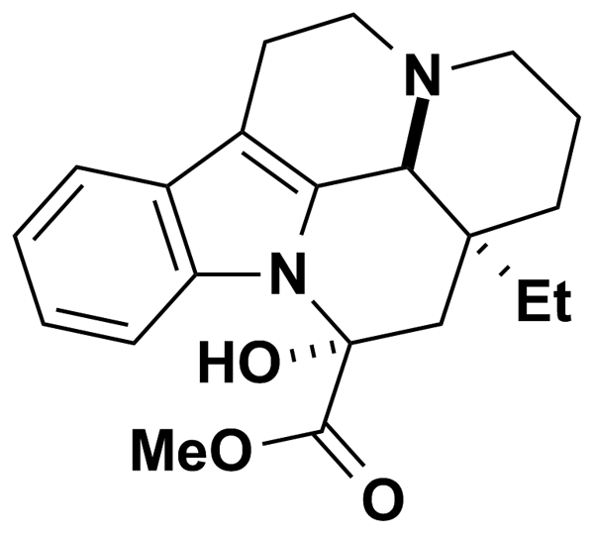
ESTRADIOL | 9.18 | Biomol International Inc. | BRD-K18910433 | 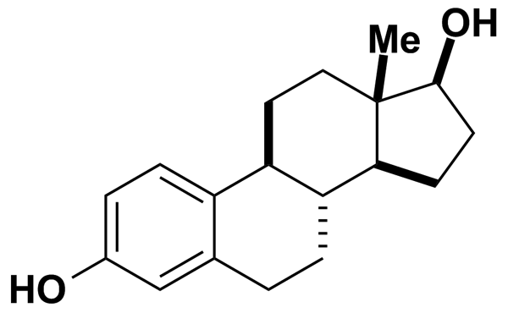
ESTRADIOL CYPIONATE | 5.00 | MicroSource Discovery Systems Inc. | BRD-A91452556 | 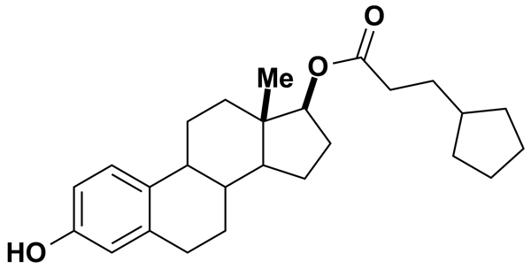
ESTRADIOL DIACETATE | 5.00 | MicroSource Discovery Systems Inc. | BRD-A33614871 | 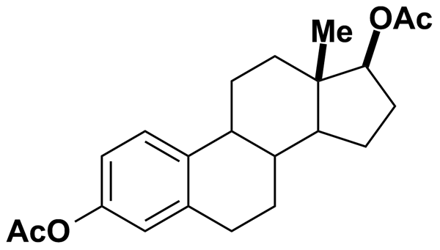
ESTRADIOL VALERATE | 5.00 | MicroSource Discovery Systems Inc. | BRD-A39747742 | 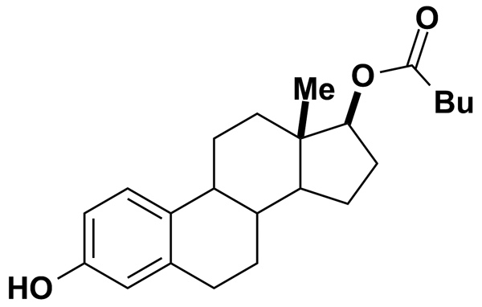
ESTRADIOL-3-SULFATE, SODIUM SALT | 5.00 | MicroSource Discovery Systems Inc. | BRD-A91702150 | 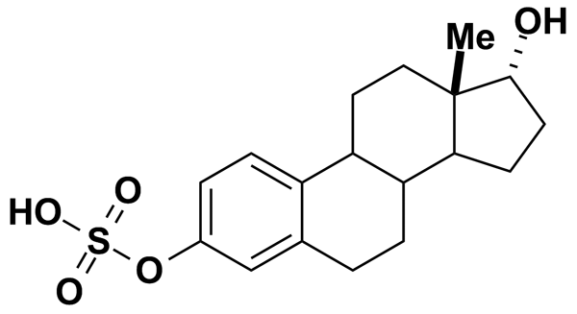
ESTRIOL | 5.00 | MicroSource Discovery Systems Inc. | BRD-A18620900 | 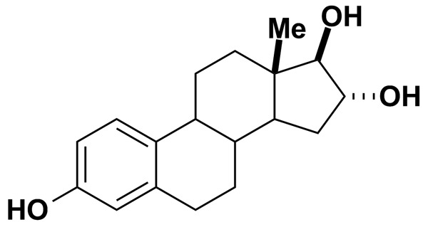
ETHACRYNIC ACID | 3.30 | Prestwick Chemical Inc. | BRD-K63630713 | 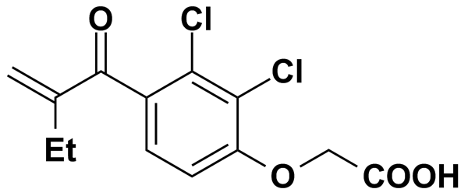
ETHINYL ESTRADIOL | 5.00 | MicroSource Discovery Systems Inc. | BRD-A02367930 | 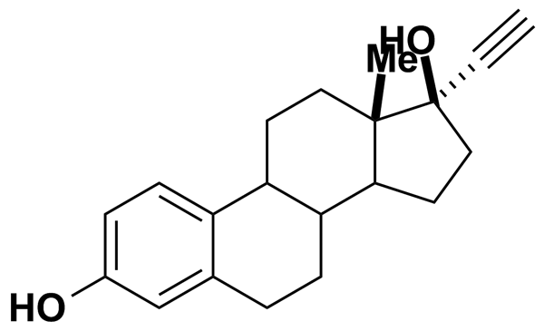
ETHION | 5.00 | MicroSource Discovery Systems Inc. | BRD-K84268861 | 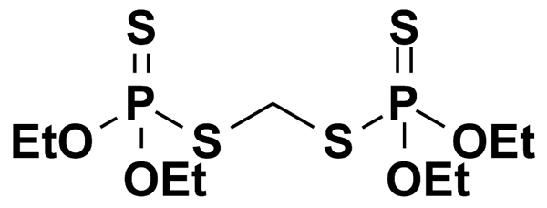
ETHIONAMIDE | 6.02 | Prestwick Chemical Inc. | BRD-K33710385 | 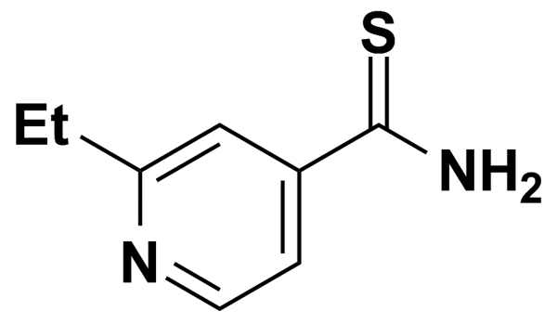
ETHOPROP | 5.00 | MicroSource Discovery Systems Inc. | BRD-K08556791 | 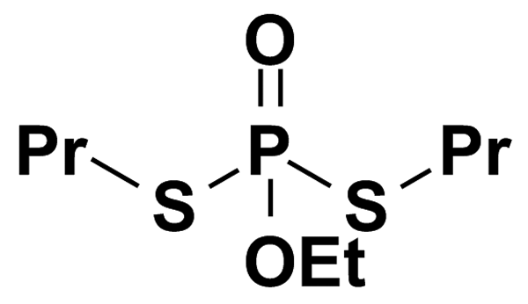
ETHOSUXIMIDE | 7.08 | Prestwick Chemical Inc. | BRD-A99633051 | 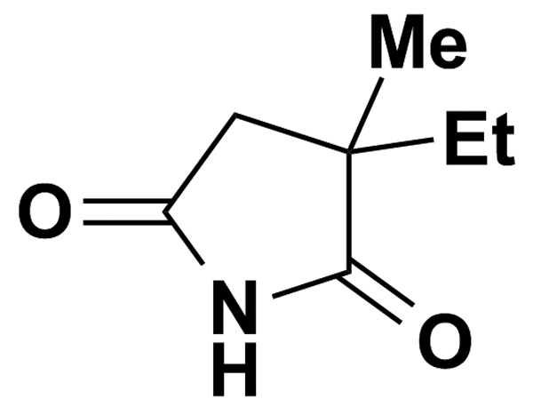
ETHOXYQUIN | 4.60 | Prestwick Chemical Inc. | BRD-K56792340 | 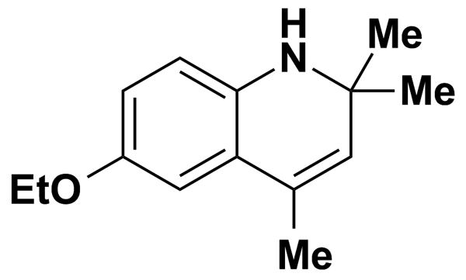
ETODOLAC | 3.48 | Prestwick Chemical Inc. | BRD-A74667430 | 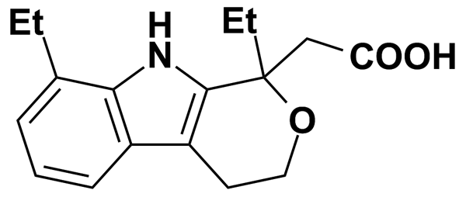
ETOFYLLINE | 4.46 | Prestwick Chemical Inc. | BRD-K83064458 | 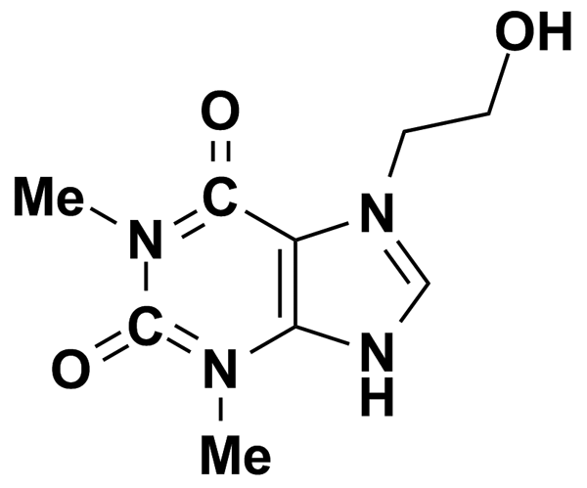
ETOPOSIDE | 1.70 | Prestwick Chemical Inc. | BRD-K37798499 | 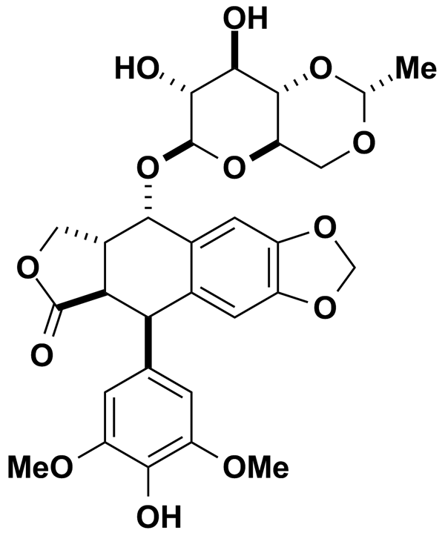
EUCATROPINE HYDROCHLORIDE | 5.00 | MicroSource Discovery Systems Inc. | BRD-A69786436 | 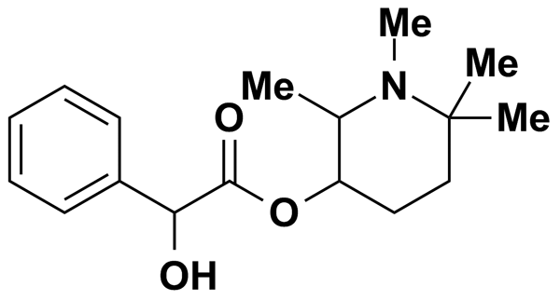
FAMCICLOVIR | 5.00 | MicroSource Discovery Systems Inc. | BRD-K45033733 | 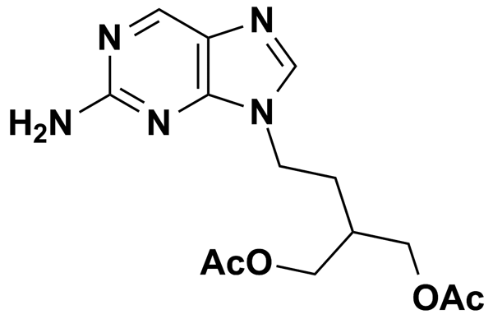
FCCP | 9.84 | Biomol International Inc. | BRD-K14821540 | 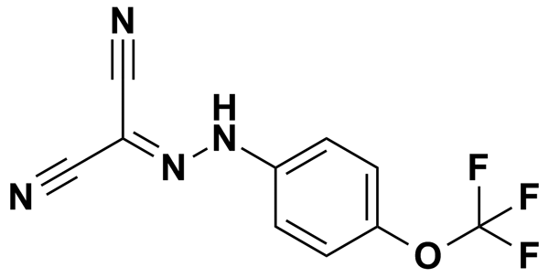
FELBAMATE | 5.00 | Biomol International Inc. | BRD-K99107520 | 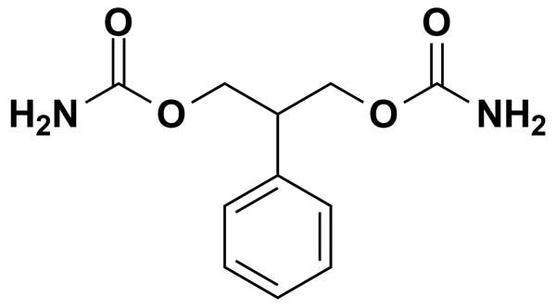
FENBENDAZOLE | 3.34 | Prestwick Chemical Inc. | BRD-K51318897 | 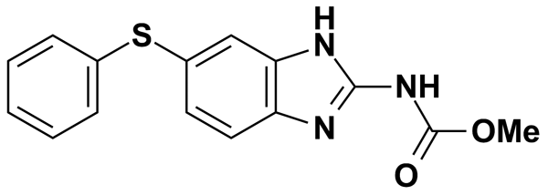
FENBUFEN | 3.93 | Prestwick Chemical Inc. | BRD-K12513978 | 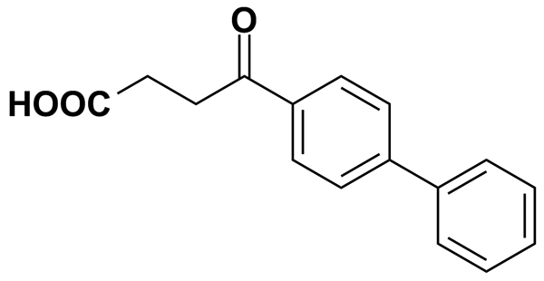
FENDILINE HYDROCHLORIDE | 2.84 | Prestwick Chemical Inc. | BRD-A71033472 | 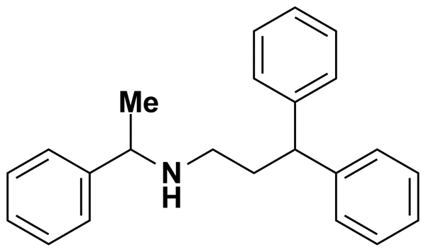
FENOFIBRATE | 2.77 | Prestwick Chemical Inc. | BRD-K50388907 | 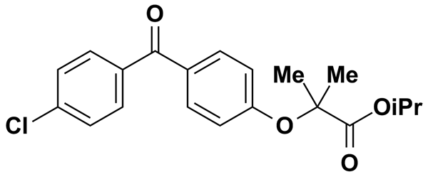
FENOLDOPAM | 5.00 | Biomol International Inc. | BRD-A50684349 | 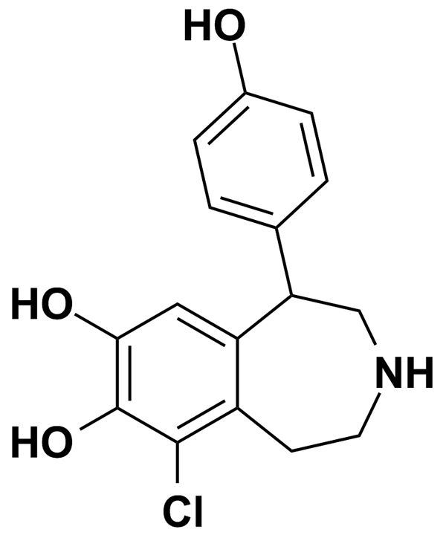
FENOTEROL HYDROBROMIDE | 2.60 | Prestwick Chemical Inc. | BRD-A97104540 | 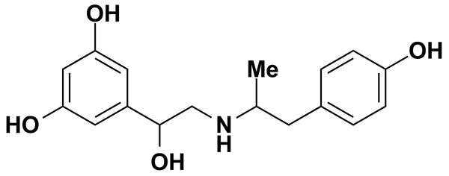
FENSPIRIDE HYDROCHLORIDE | 3.37 | Prestwick Chemical Inc. | BRD-K26739552 | 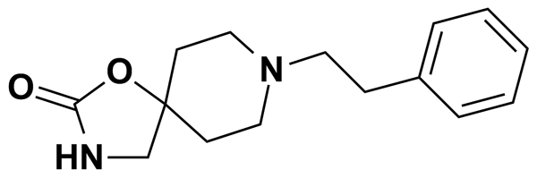
FENTHION | 5.00 | MicroSource Discovery Systems Inc. | BRD-K67217586 | 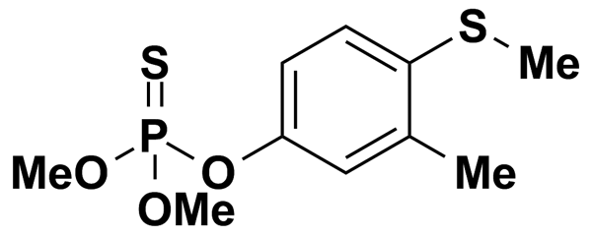
FGIN-1-27 | 5.00 | Biomol International Inc. | BRD-K09778810 | 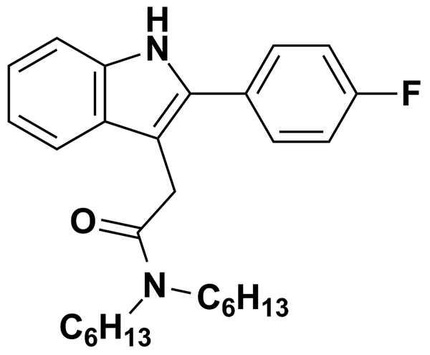
FIPEXIDE HYDROCHLORIDE | 2.35 | Prestwick Chemical Inc. | BRD-K37688416 | 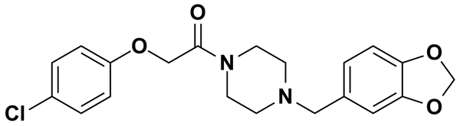
FIPRONIL | 5.72 | Biomol International Inc. | BRD-A50675702 | 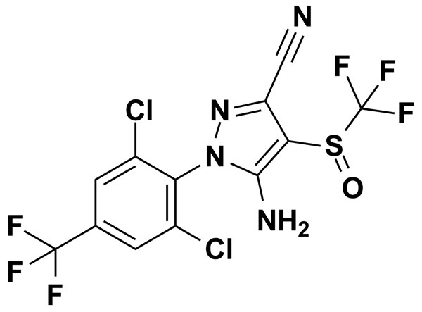
FLECAINIDE | 6.03 | Biomol International Inc. | BRD-A09472452 | 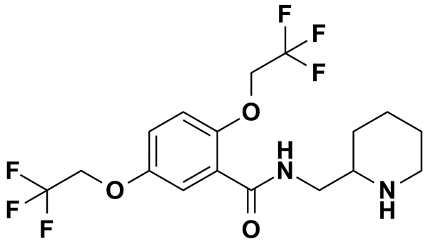
FLECAINIDE ACETATE | 2.11 | Prestwick Chemical Inc. | BRD-A09472452 | 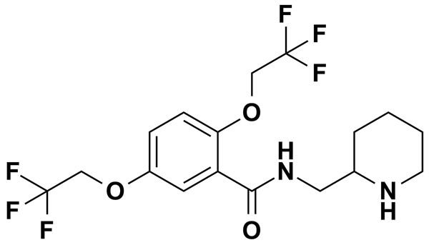
FLOPROPIONE | 5.00 | MicroSource Discovery Systems Inc. | BRD-K43383936 | 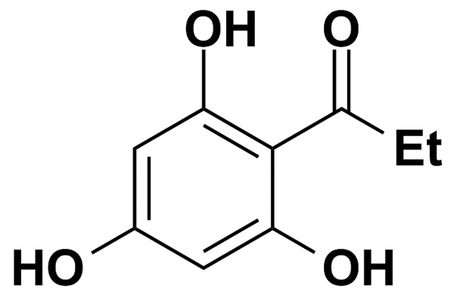
FLUCONAZOLE | 5.00 | MicroSource Discovery Systems Inc. | BRD-K05977355 | 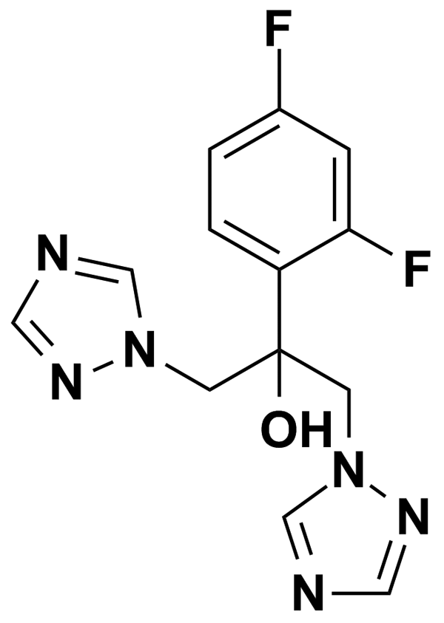
FLUFENAMIC ACID | 8.89 | Biomol International Inc. | BRD-K44067360 | 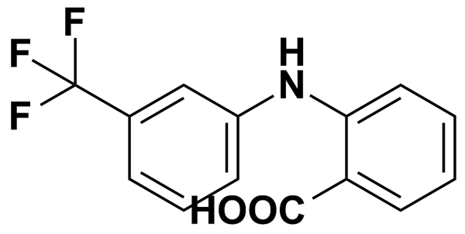
FLUMEQUINE | 3.83 | Prestwick Chemical Inc. | BRD-A69777949 | 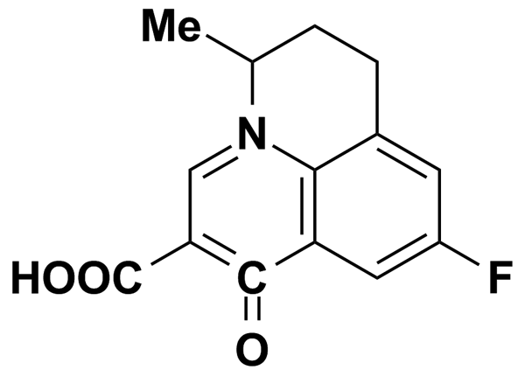
FLUNARIZINE | 6.18 | Biomol International Inc. | BRD-K29582677 | 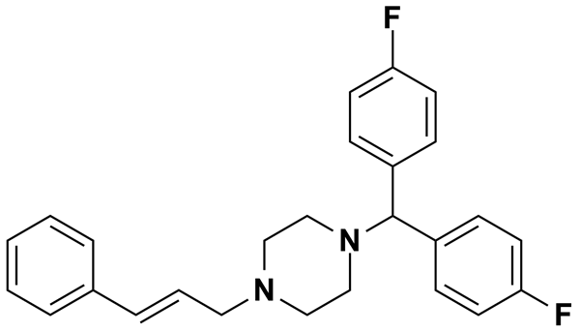
FLUNARIZINE DIHYDROCHLORIDE | 2.09 | Prestwick Chemical Inc. | BRD-K29582677 | 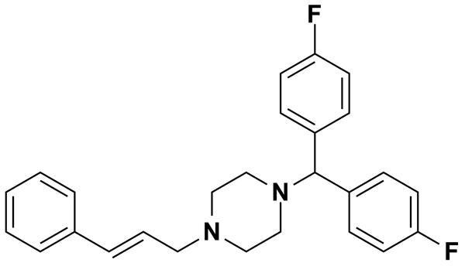
FLUNISOLIDE | 5.00 | MicroSource Discovery Systems Inc. | BRD-A65449987 | 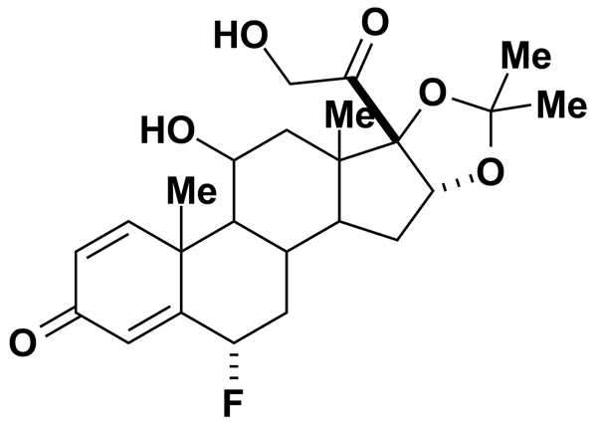
FLUOROMETHOLONE | 5.00 | MicroSource Discovery Systems Inc. | BRD-A13133631 | 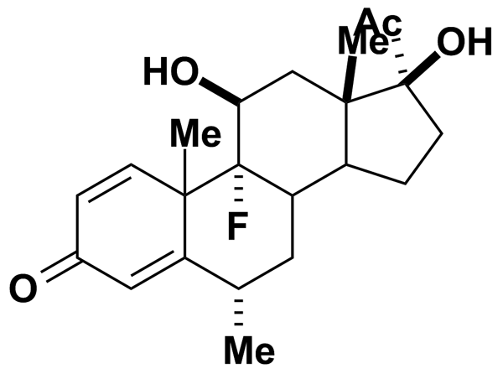
FLUPHENAZINE | 5.00 | Biomol International Inc. | BRD-K55127134 | 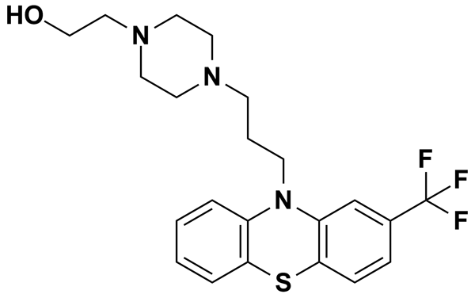
FLUPHENAZINE DIHYDROCHLORIDE | 1.96 | Prestwick Chemical Inc. | BRD-K55127134 | 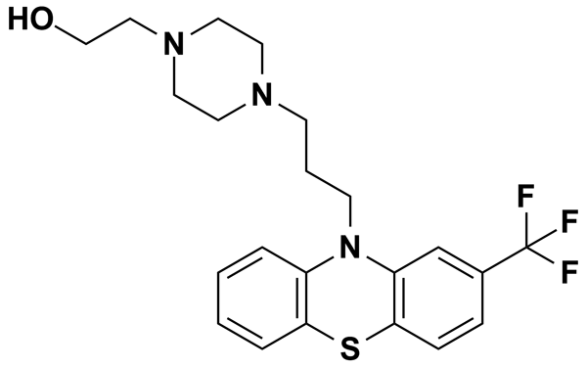
FLUPROSTENOL | 0.50 | Biomol International Inc. | BRD-K31611373 | 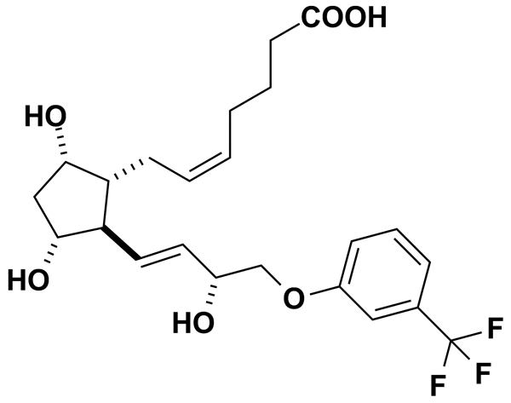
FLURANDRENOLIDE | 5.00 | MicroSource Discovery Systems Inc. | BRD-A49765801 | 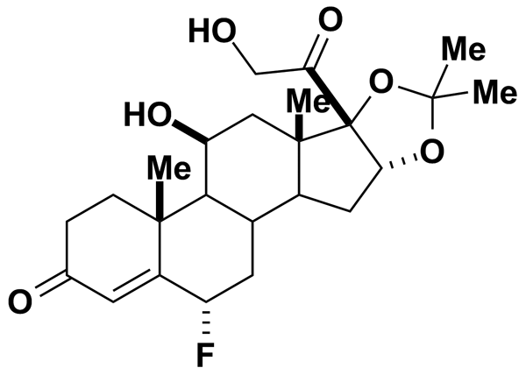
FLUTAMIDE | 3.62 | Prestwick Chemical Inc. | BRD-K28307902 | 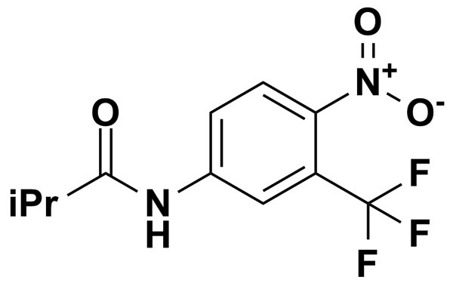
FORMONONETIN | 5.00 | MicroSource Discovery Systems Inc. | BRD-K55567017 | 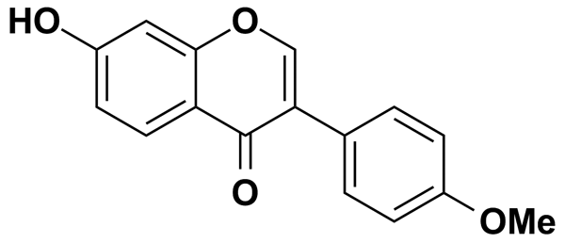
FUREGRELATE SODIUM | 5.00 | MicroSource Discovery Systems Inc. | BRD-K55529781 | 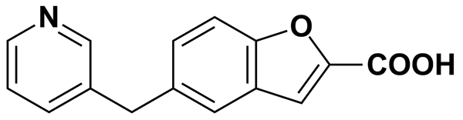
FUROSEMIDE | 3.02 | Prestwick Chemical Inc. | BRD-K78010432 | 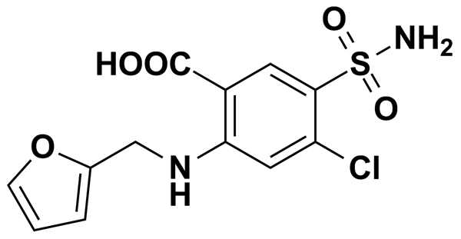
FUSIDIC ACID | 5.00 | MicroSource Discovery Systems Inc. | BRD-A06935312 | 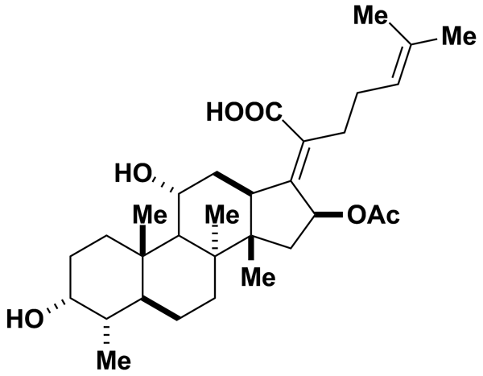
GALANTHAMINE HYDROBROMIDE | 2.72 | Prestwick Chemical Inc. | BRD-K49481516 | 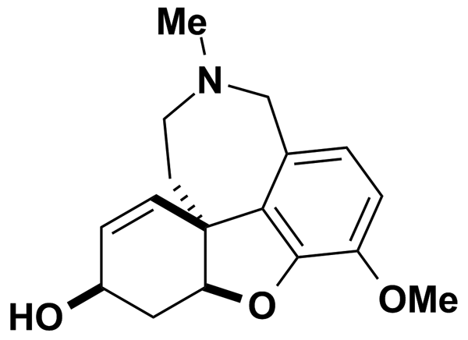
GAMMA-LINOLENIC ACID (18:3 N-6) | 0.50 | Biomol International Inc. | BRD-K18059238
GBR 12935 | 5.00 | Biomol International Inc. | BRD-K50135270 | 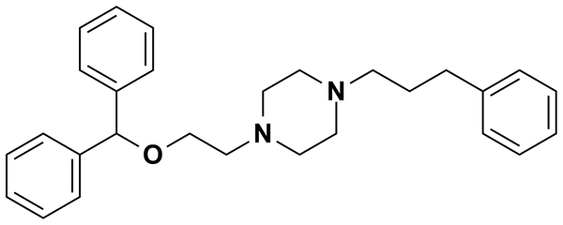
GEDUNIN | 5.00 | MicroSource Discovery Systems Inc. | BRD-A48397526 | 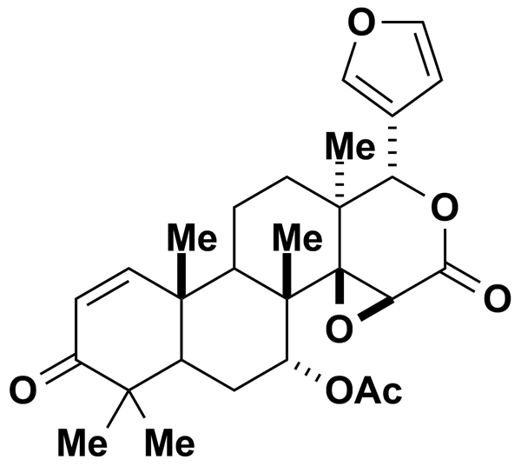
GEMFIBROZIL | 3.99 | Prestwick Chemical Inc. | BRD-K11129031 | 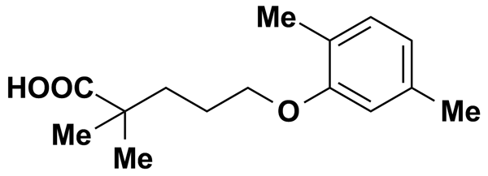
GENISTEIN | 5.00 | MicroSource Discovery Systems Inc. | BRD-K43797669 | 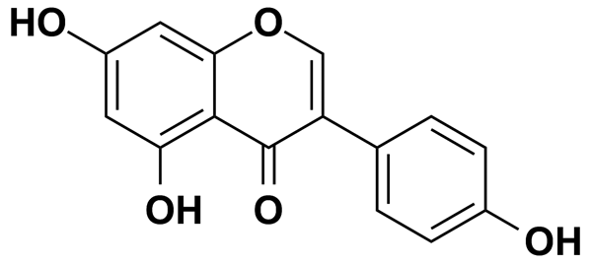
GENTIAN VIOLET | 5.00 | MicroSource Discovery Systems Inc. | BRD-K60025295 | 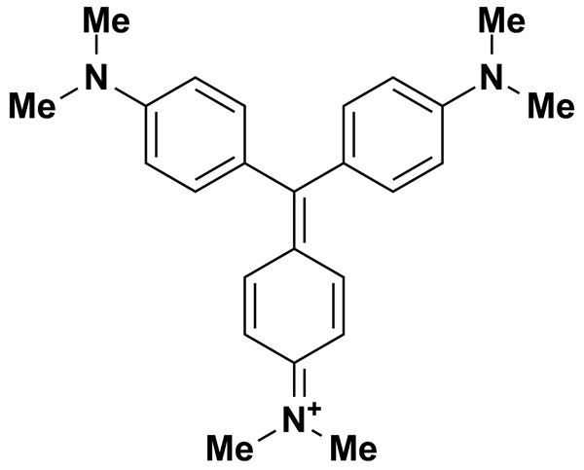
GF-109203X | 6.06 | Biomol International Inc. | BRD-K31342827 | 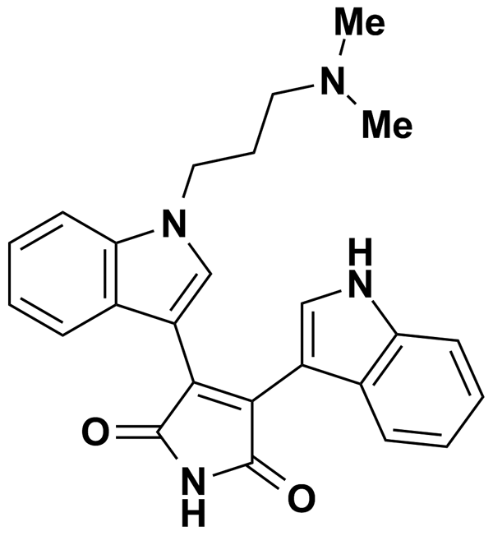
GINGEROL | 8.49 | Biomol International Inc. | BRD-K26117720 | 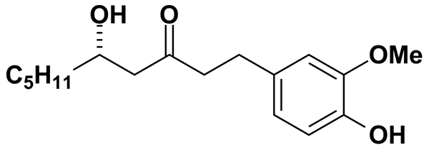
GLAFENINE HYDROCHLORIDE | 2.44 | Prestwick Chemical Inc. | BRD-A38076815 | 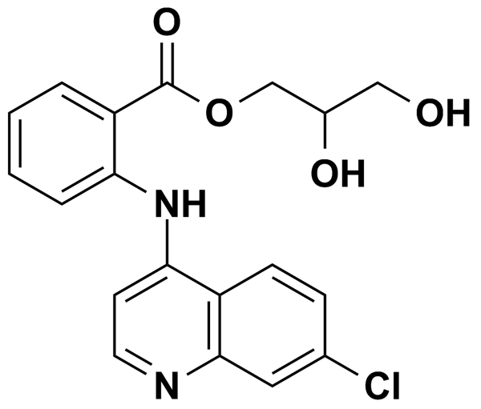
GLIMEPIRIDE | 2.04 | Prestwick Chemical Inc. | BRD-K34776109 | 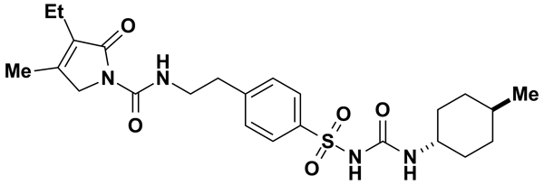
GLIPIZIDE | 5.61 | Biomol International Inc. | BRD-K12219985 | 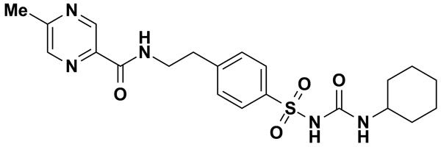
GLUTETHIMIDE, PARA-AMINO | 4.31 | Prestwick Chemical Inc. | BRD-A25234499 | 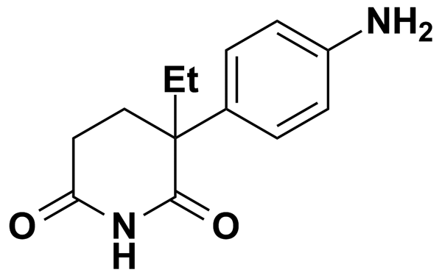
GLYBURIDE | 5.06 | Biomol International Inc. | BRD-K36927236 | 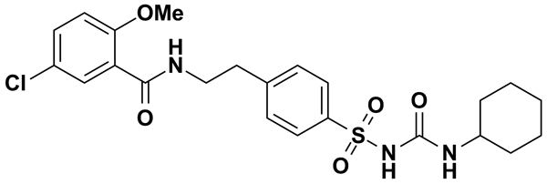
GO6976 | 6.61 | Biomol International Inc. | BRD-K59304176 | 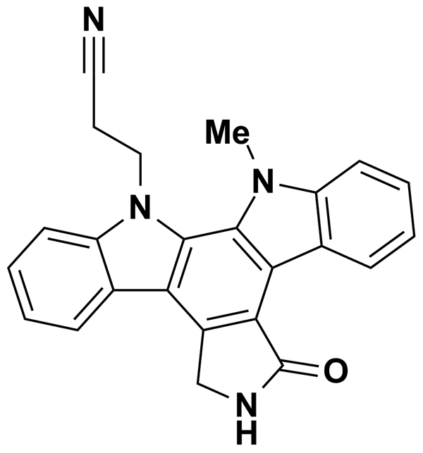
GOSSYPOL | 1.93 | Prestwick Chemical Inc. | BRD-K19295594 | 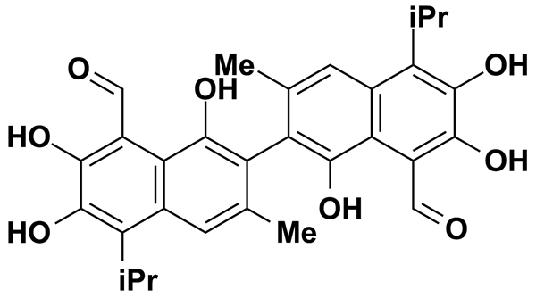
GOSSYPOL-ACETIC ACID COMPLEX | 5.00 | MicroSource Discovery Systems Inc. | BRD-K19295594 | 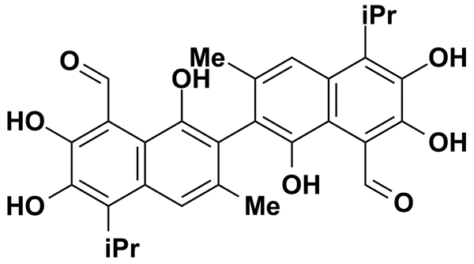
GRISEOFULVIN | 2.83 | Prestwick Chemical Inc. | BRD-K08273968 | 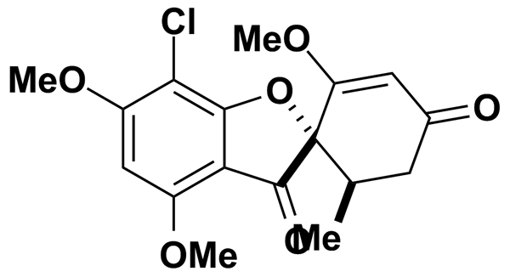
GUAIFENESIN | 5.05 | Prestwick Chemical Inc. | BRD-A90515964 | 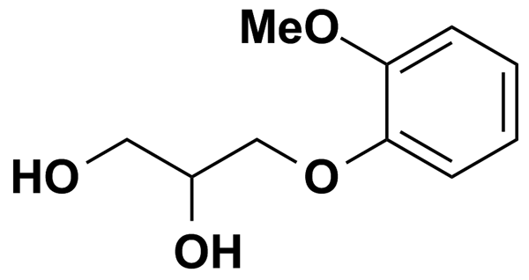
H-89 | 5.60 | Biomol International Inc. | BRD-K27737647 | 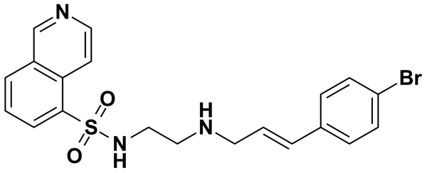
H7 | 8.58 | Biomol International Inc. | BRD-A55756846 | 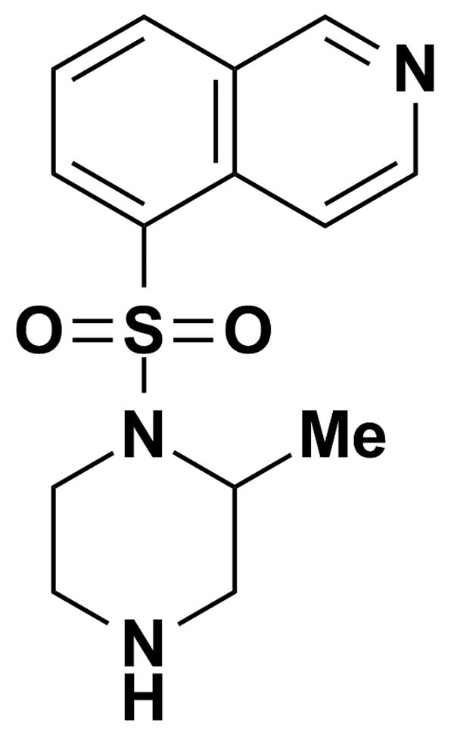
HA-1004 | 8.52 | Biomol International Inc. | BRD-K05434375 | 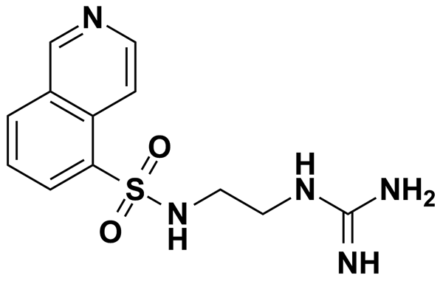
HALOPERIDOL | 5.00 | Biomol International Inc. | BRD-K67783091 | 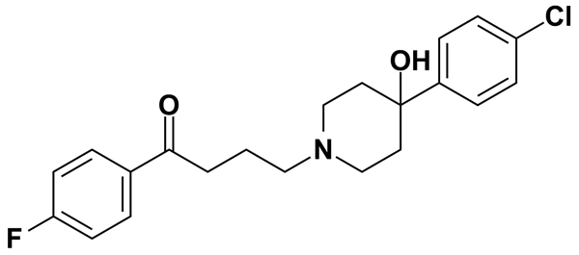
HARMALINE | 5.00 | MicroSource Discovery Systems Inc. | BRD-K91317041 | 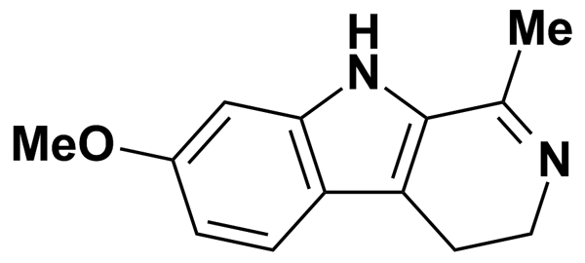
HARMALINE HYDROCHLORIDE DIHYDRATE | 3.49 | Prestwick Chemical Inc. | BRD-K91317041 | 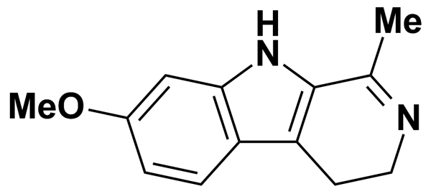
HARMALOL HYDROCHLORIDE | 5.00 | MicroSource Discovery Systems Inc. | BRD-K14756138 | 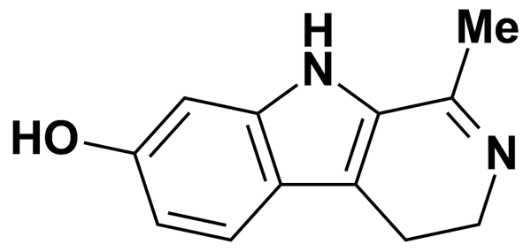
HARMALOL HYDROCHLORIDE DIHYDRATE | 3.67 | Prestwick Chemical Inc. | BRD-K14756138 | 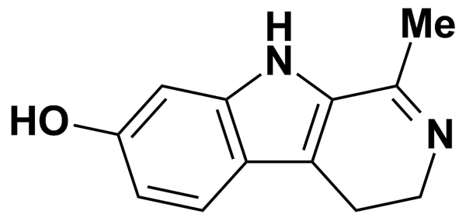
HESPERETIN | 3.31 | Prestwick Chemical Inc. | BRD-K30553453 | 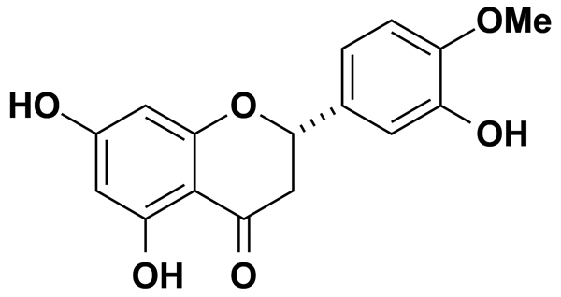
HEXACHLOROPHENE | 5.00 | MicroSource Discovery Systems Inc. | BRD-K99792991 | 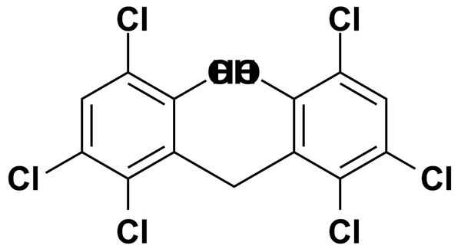
HEXESTROL | 3.70 | Prestwick Chemical Inc. | BRD-A01078468 | 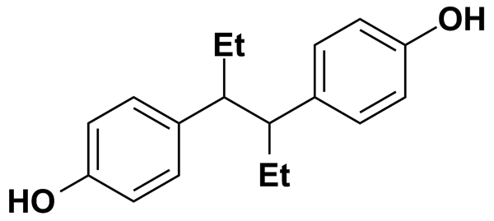
HEXYLRESORCINOL | 5.00 | MicroSource Discovery Systems Inc. | BRD-K99946902 | 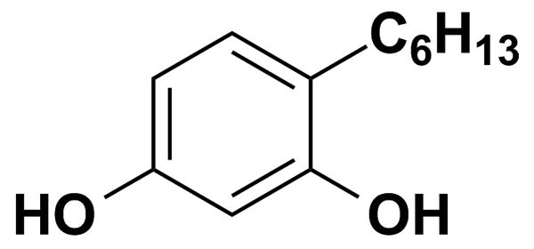
HOMATROPINE METHYLBROMIDE | 5.00 | MicroSource Discovery Systems Inc. | BRD-A43999749 | 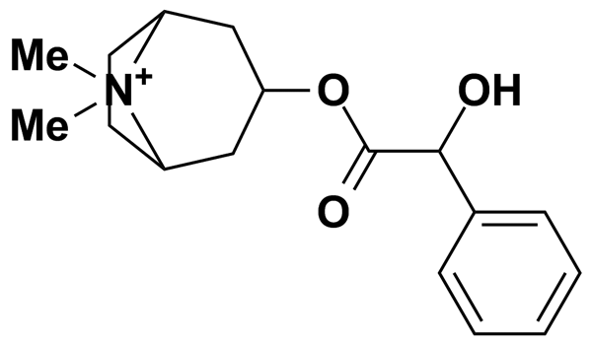
HYCANTHONE | 2.81 | Prestwick Chemical Inc. | BRD-K50406511 | 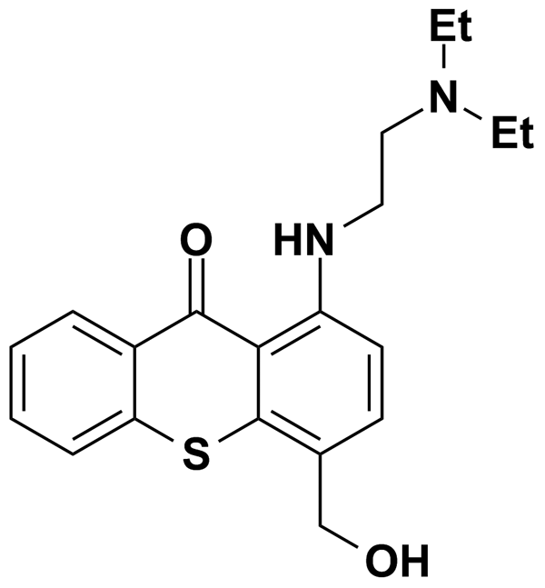
HYDRALAZINE HYDROCHLORIDE | 5.00 | MicroSource Discovery Systems Inc. | BRD-K82103381 | 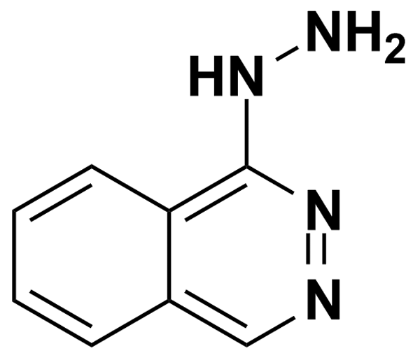
HYDROCHLOROTHIAZIDE | 3.36 | Prestwick Chemical Inc. | BRD-K13078532 | 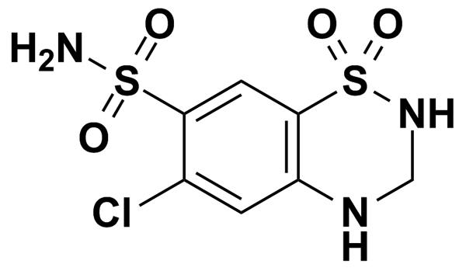
HYDROCORTISONE | 5.00 | MicroSource Discovery Systems Inc. | BRD-A75172220 | 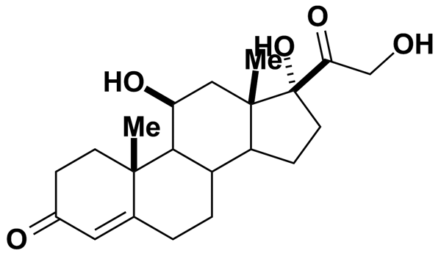
HYDROCORTISONE ACETATE | 5.00 | MicroSource Discovery Systems Inc. | BRD-A65767837 | 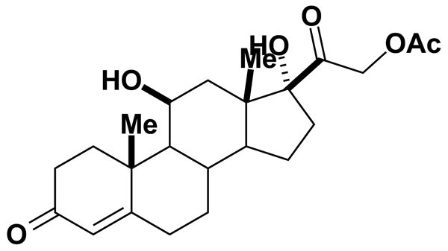
HYDROCORTISONE HEMISUCCINATE | 5.00 | MicroSource Discovery Systems Inc. | BRD-A07000685 | 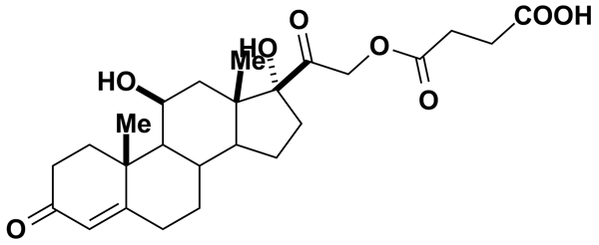
HYDROFLUMETHIAZIDE | 3.02 | Prestwick Chemical Inc. | BRD-K36862742 | 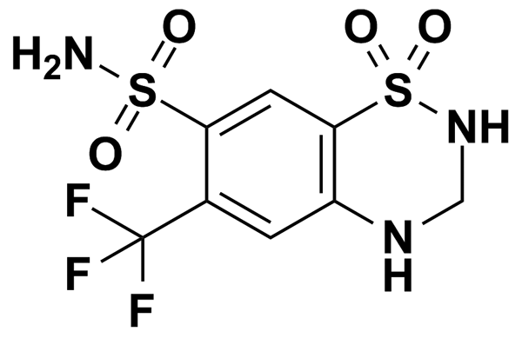
HYDROXYPROGESTERONE CAPROATE | 5.00 | MicroSource Discovery Systems Inc. | BRD-A29731977 | 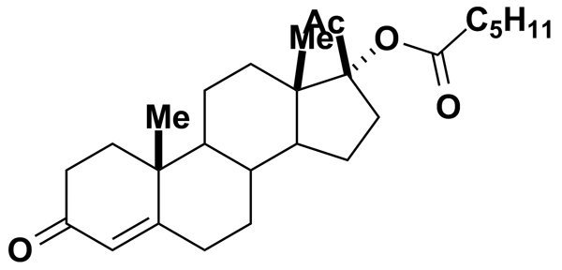
HYDROXYTACRINE MALEATE (R,S) | 3.03 | Prestwick Chemical Inc. | BRD-A98299281 | 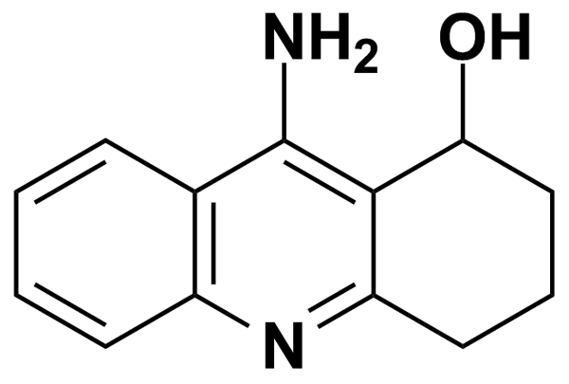
HYOSCYAMINE | 5.00 | MicroSource Discovery Systems Inc. | BRD-A78303415 | 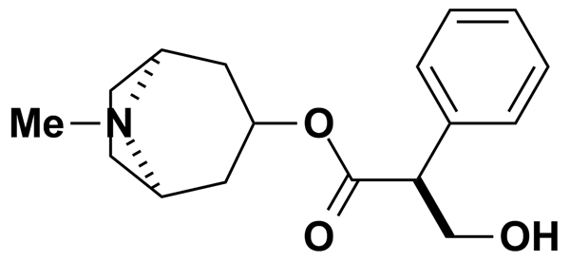
IAA-94 | 7.00 | Biomol International Inc. | BRD-K85383046 | 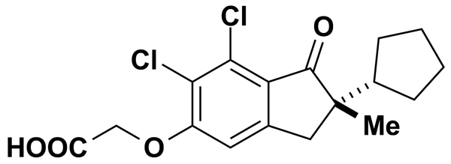
IB-MECA | 4.90 | Biomol International Inc. | BRD-A48809242 | 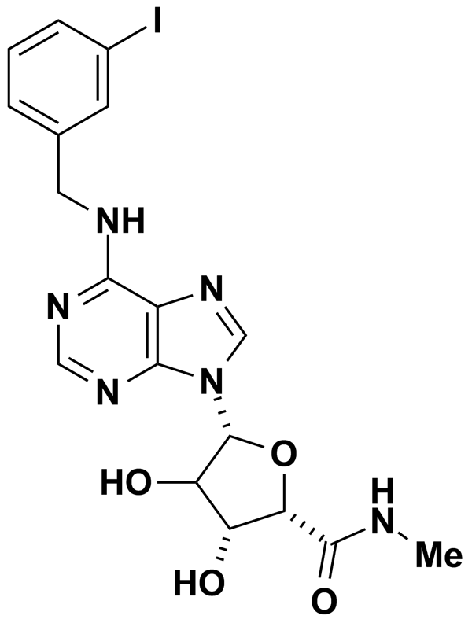
IBMX | 11.25 | Biomol International Inc. | BRD-K94979336 | 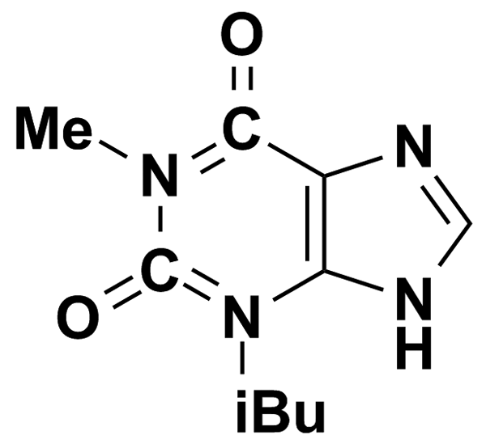
IMIPRAMINE HYDROCHLORIDE | 3.16 | Prestwick Chemical Inc. | BRD-K38436528 | 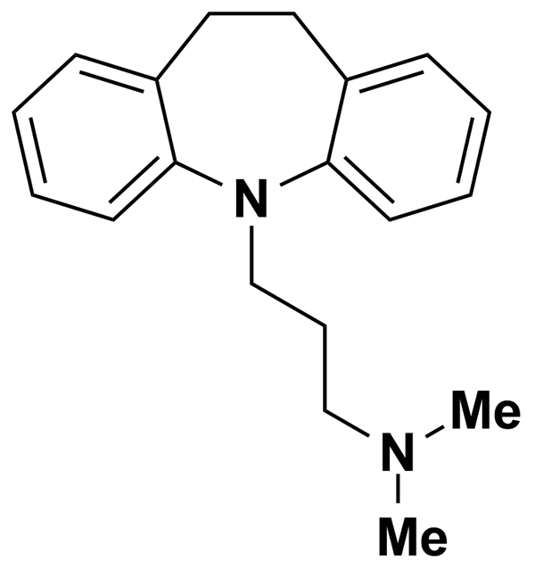
INDAPAMIDE | 2.73 | Prestwick Chemical Inc. | BRD-A95869247 | 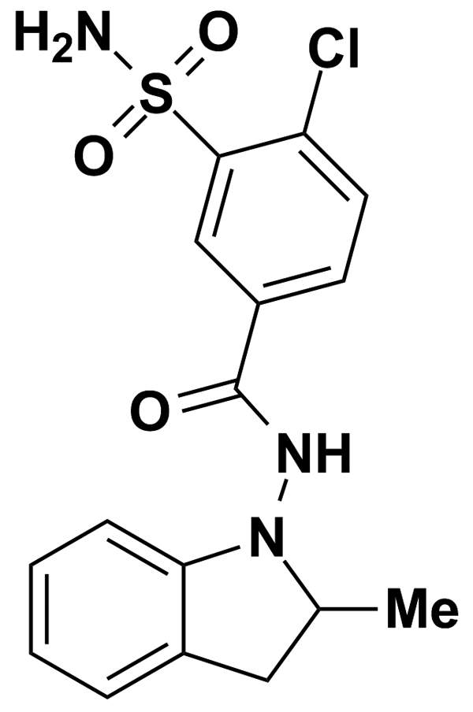
INDOLE-3-CARBINOL | 5.00 | MicroSource Discovery Systems Inc. | BRD-K01815685 | 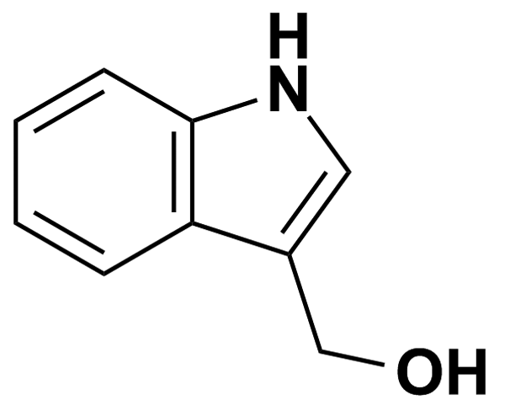
IPRONIAZIDE PHOSPHATE | 3.61 | Prestwick Chemical Inc. | BRD-K88568253 | 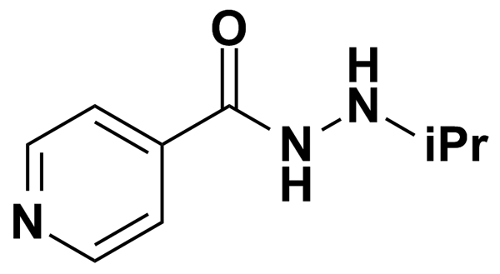
IRBESARTAN | 5.00 | MicroSource Discovery Systems Inc. | BRD-K60038276 | 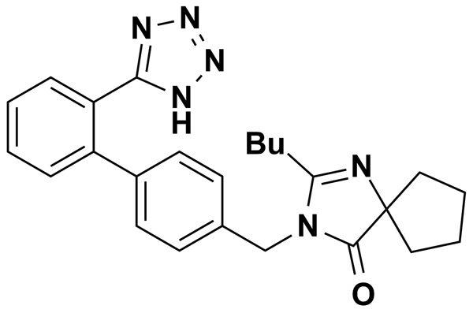
ISOCARBOXAZID | 4.32 | Prestwick Chemical Inc. | BRD-K93332168 | 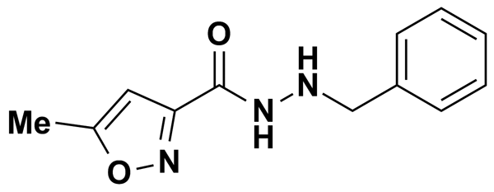
ISOXICAM | 2.98 | Prestwick Chemical Inc. | BRD-A75552914 | 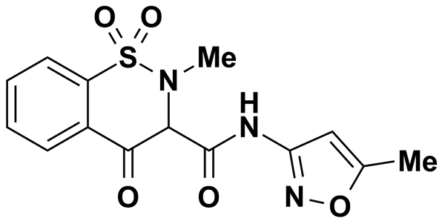
KAEMPFEROL | 3.49 | Prestwick Chemical Inc. | BRD-K12807006 | 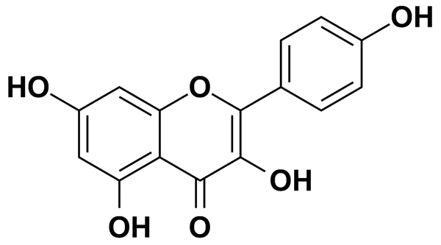
KETANSERIN | 5.00 | Biomol International Inc. | BRD-K49671696 | 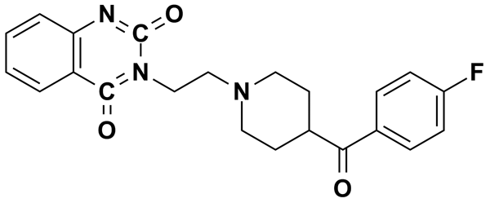
KETANSERIN TARTRATE HYDRATE | 1.77 | Prestwick Chemical Inc. | BRD-K49671696 | 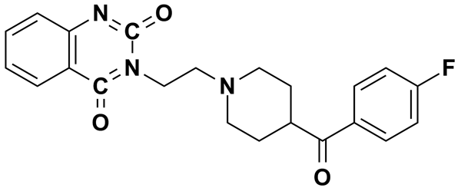
KETOCONAZOLE | 5.00 | MicroSource Discovery Systems Inc. | BRD-A38350138 | 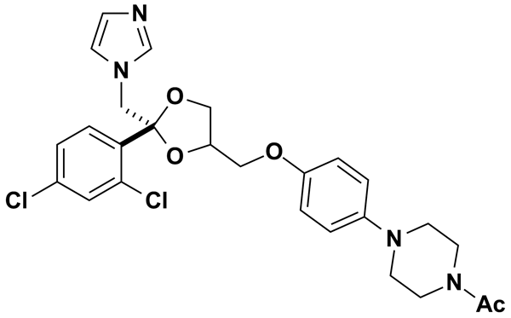
KETOPROFEN | 3.93 | Prestwick Chemical Inc. | BRD-A97739905 | 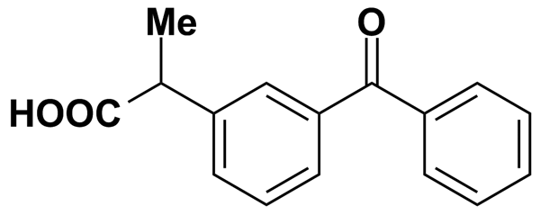
KETOTIFEN FUMARATE | 2.35 | Prestwick Chemical Inc. | BRD-K28936863 | 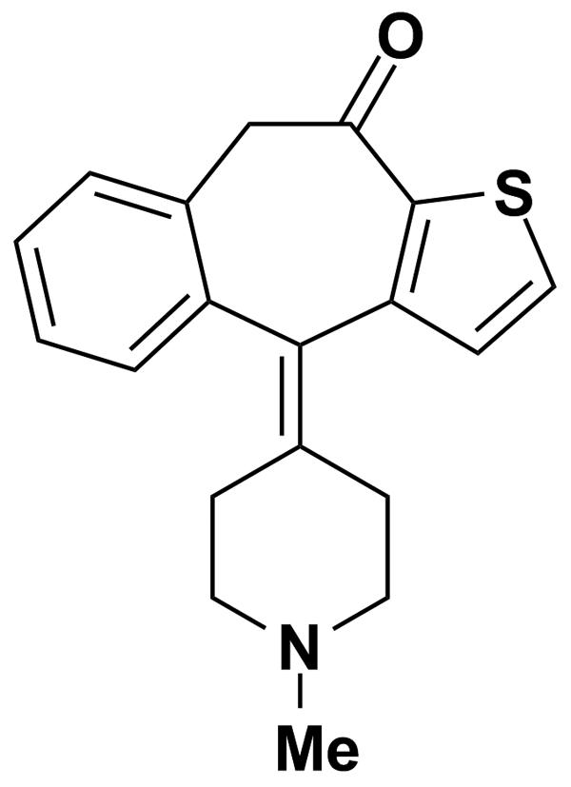
KHELLIN | 3.84 | Prestwick Chemical Inc. | BRD-K80353807 | 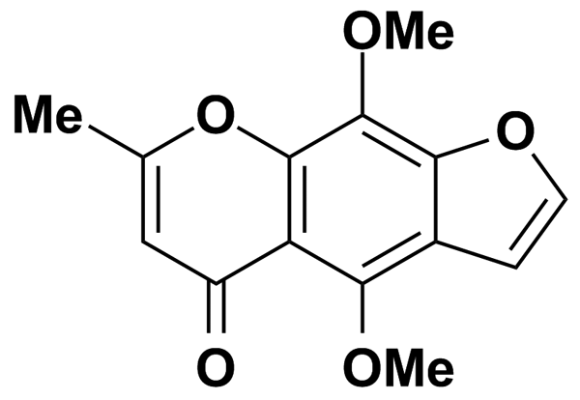
KINETIN RIBOSIDE | 5.00 | MicroSource Discovery Systems Inc. | BRD-K94325918 | 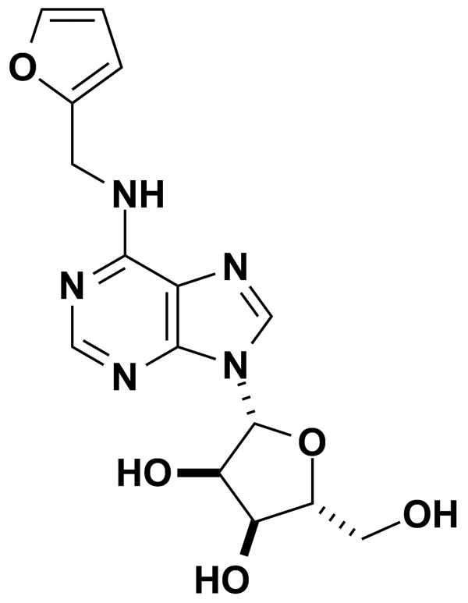
L-745,870 | 5.00 | Biomol International Inc. | BRD-K05528470 | 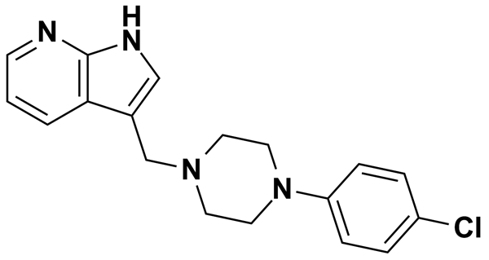
LABETALOL HYDROCHLORIDE | 2.74 | Prestwick Chemical Inc. | BRD-A07440155 | 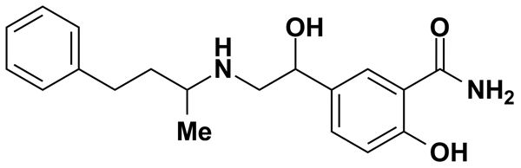
LANATOSIDE C | 5.00 | MicroSource Discovery Systems Inc. | BRD-A64242993 | 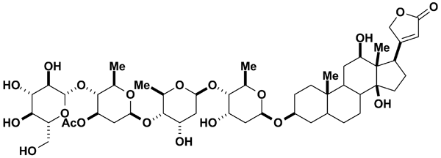
LANSOPRAZOLE | 2.71 | Prestwick Chemical Inc. | BRD-A49172652 | 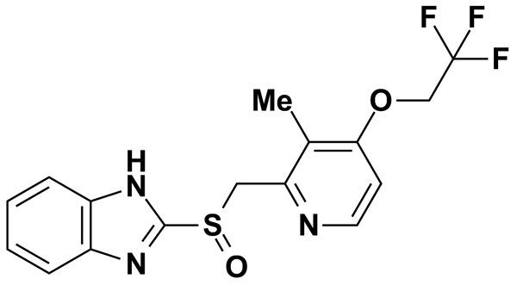
LAPACHOL | 5.00 | MicroSource Discovery Systems Inc. | BRD-A06912736 | 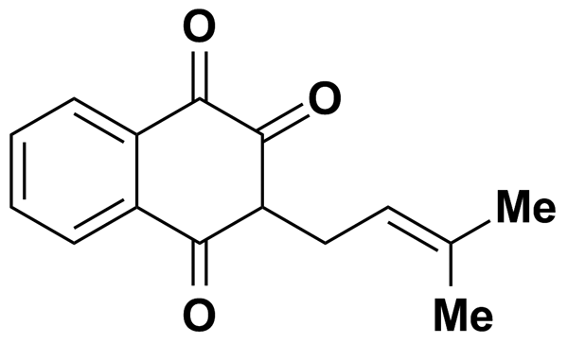
LAUDANOSINE (R,S) | 2.80 | Prestwick Chemical Inc. | BRD-A24817035 | 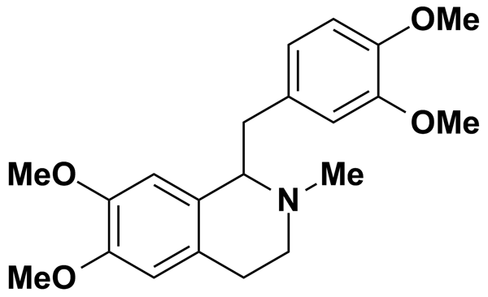
LAVENDUSTIN A | 6.56 | Biomol International Inc. | BRD-K23583188 | 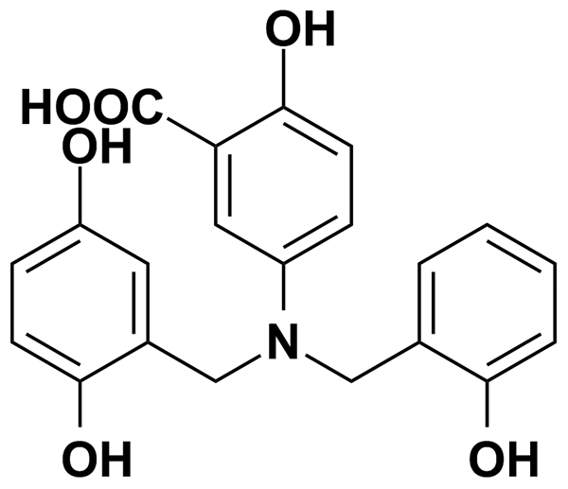
LEFLUNOMIDE | 3.70 | Prestwick Chemical Inc. | BRD-K78692225 | 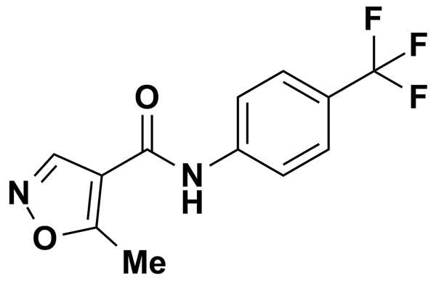
LETROZOLE | 3.51 | Prestwick Chemical Inc. | BRD-K88789588 | 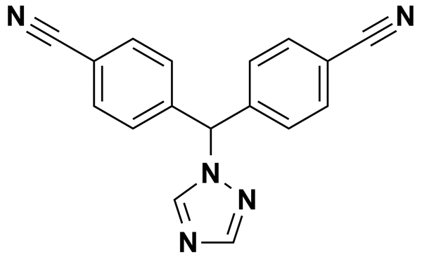
LEVAMISOLE HYDROCHLORIDE | 4.15 | Prestwick Chemical Inc. | BRD-A46393198 | 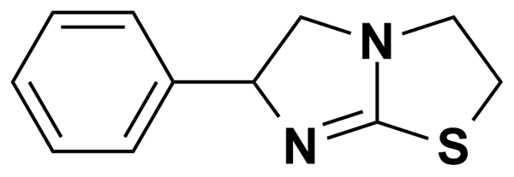
LEVAMISOLE HYDROCHLORIDE | 5.00 | MicroSource Discovery Systems Inc. | BRD-K73107279 | 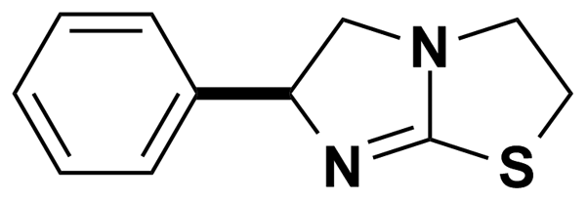
LIDOCAINE | 10.67 | Biomol International Inc. | BRD-K52662033 | 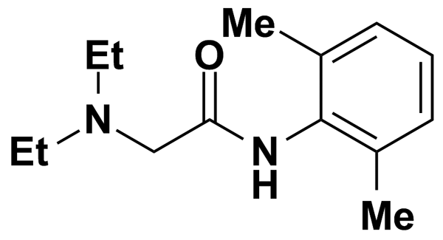
LIDOCAINE HYDROCHLORIDE | 3.69 | Prestwick Chemical Inc. | BRD-K52662033 | 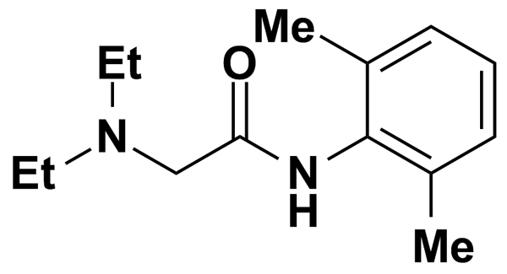
LINCOMYCIN HYDROCHLORIDE | 5.00 | MicroSource Discovery Systems Inc. | BRD-K08033334 | 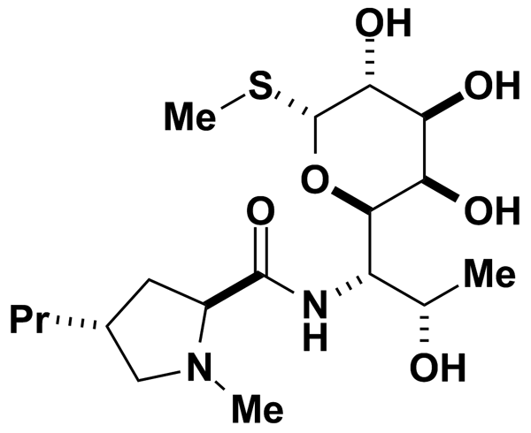
LIOTHYRONINE | 5.00 | MicroSource Discovery Systems Inc. | BRD-A74642112 | 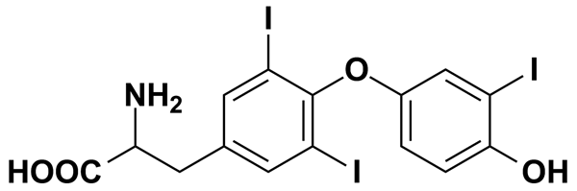
LISINOPRIL | 2.26 | Prestwick Chemical Inc. | BRD-K67966701 | 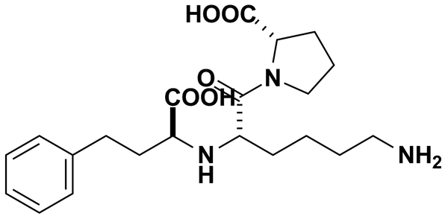
LOMEFLOXACIN HYDROCHLORIDE | 2.58 | Prestwick Chemical Inc. | BRD-A75850590 | 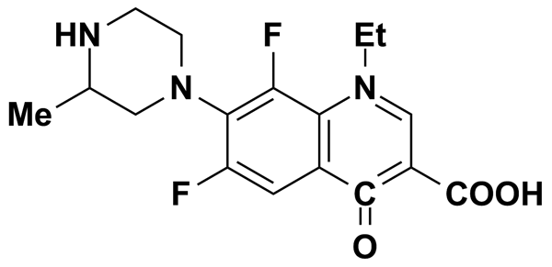
LONIDAMINE | 5.00 | MicroSource Discovery Systems Inc. | BRD-K96670504 | 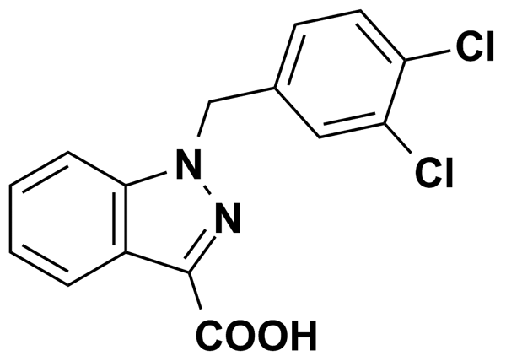
LOPERAMIDE | 5.24 | Biomol International Inc. | BRD-K61250553 | 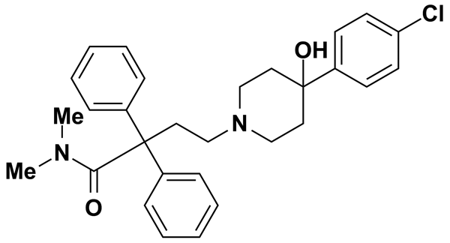
LOPERAMIDE HYDROCHLORIDE | 1.95 | Prestwick Chemical Inc. | BRD-K61250553 | 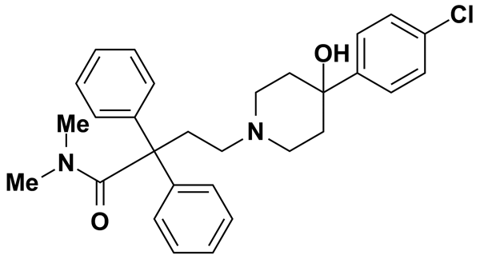
LORATADINE | 5.00 | MicroSource Discovery Systems Inc. | BRD-K82795137 | 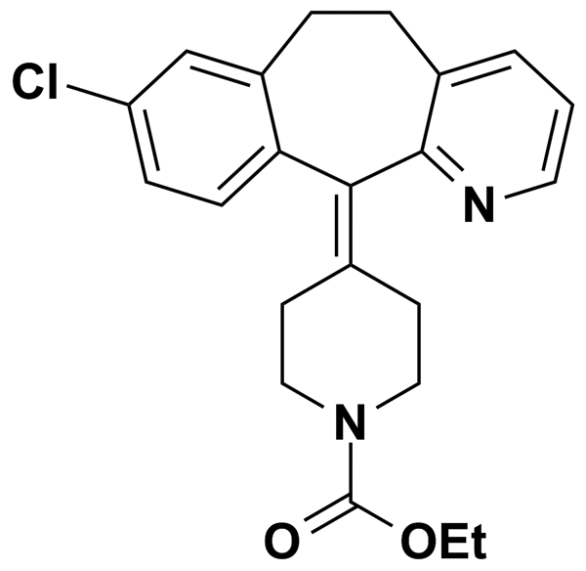
LOSARTAN | 5.00 | MicroSource Discovery Systems Inc. | BRD-K76205745 | 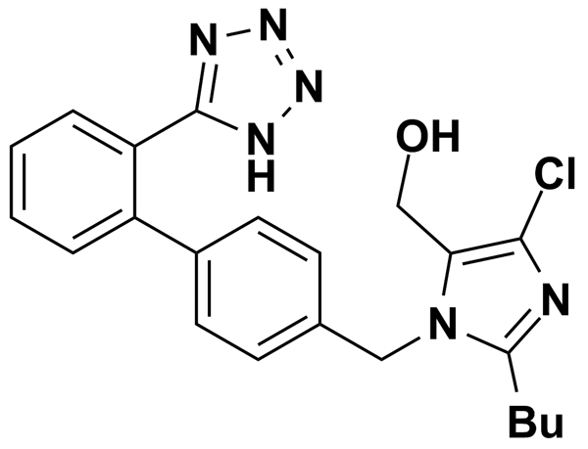
LUTEOLIN | 3.49 | Prestwick Chemical Inc. | BRD-K05236810 | 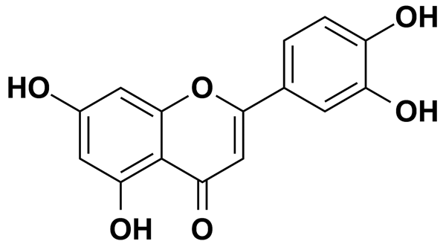
LY-294002 | 8.13 | Biomol International Inc. | BRD-K27305650 | 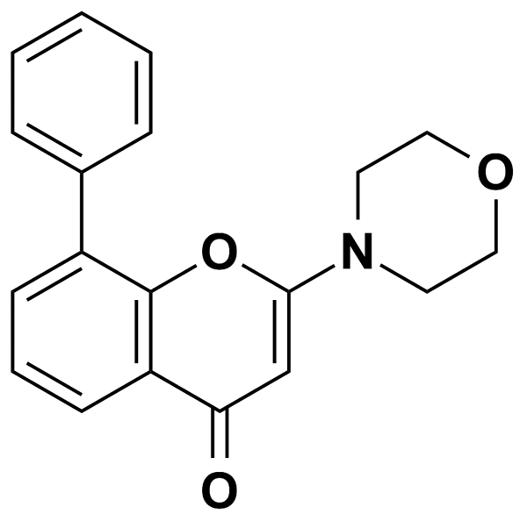
LY-83583 | 9.99 | Biomol International Inc. | BRD-K62792802 | 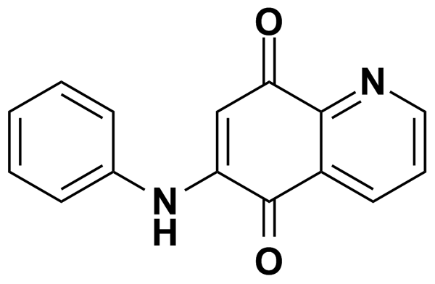
LYCORINE | 5.00 | MicroSource Discovery Systems Inc. | BRD-A10335634 | 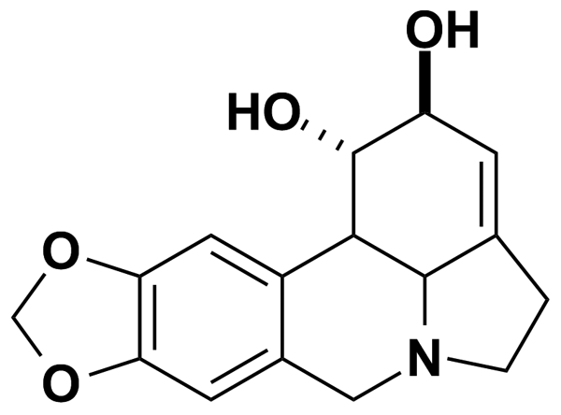
MAPP, D-ERYTHRO | 0.50 | Biomol International Inc. | BRD-K76274772 | 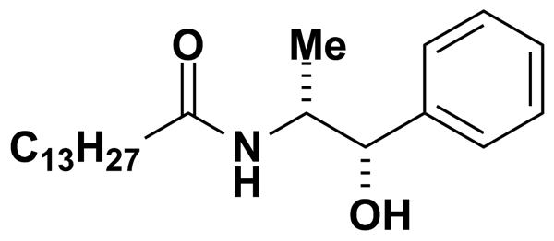
MCI-186 | 14.35 | Biomol International Inc. | BRD-K35458079 | 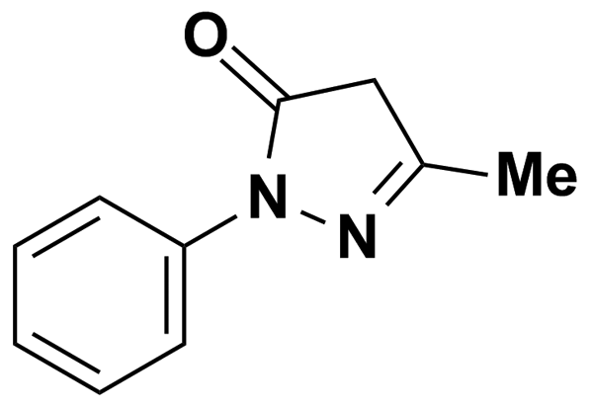
MEAD ACID (20:3 N-9) | 0.50 | Biomol International Inc. | BRD-K96144918
MEBEVERINE HYDROCHLORIDE | 2.15 | Prestwick Chemical Inc. | BRD-A09467419 | 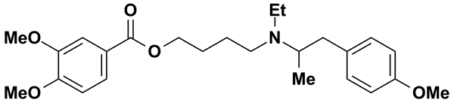
MECLOFENAMATE SODIUM | 5.00 | MicroSource Discovery Systems Inc. | BRD-K50398167 | 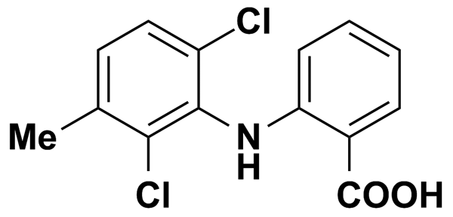
MECLOFENAMIC ACID SODIUM SALT MONOHYDRATE | 2.97 | Prestwick Chemical Inc. | BRD-K50398167 | 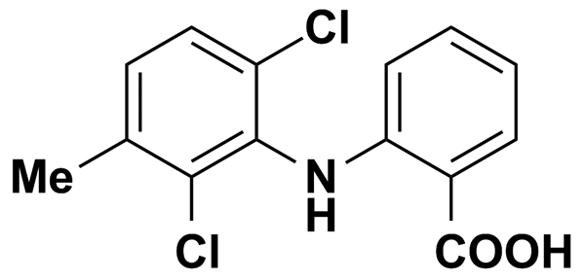
MECLOFENOXATE HYDROCHLORIDE | 3.40 | Prestwick Chemical Inc. | BRD-K10314788 | 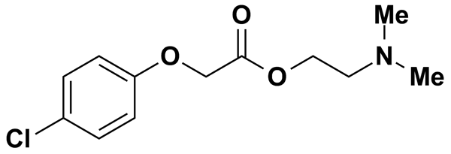
MECLOZINE DIHYDROCHLORIDE | 2.16 | Prestwick Chemical Inc. | BRD-A50311610 | 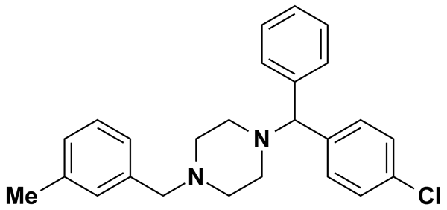
MEDROXYPROGESTERONE ACETATE | 5.00 | MicroSource Discovery Systems Inc. | BRD-A61221616 | 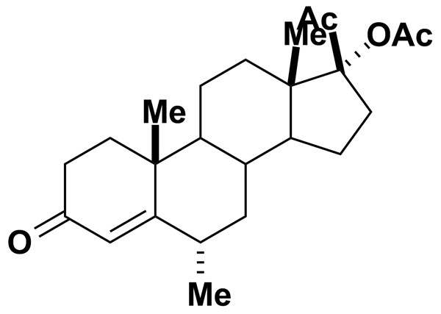
MEDRYSONE | 5.00 | MicroSource Discovery Systems Inc. | BRD-A20126139 | 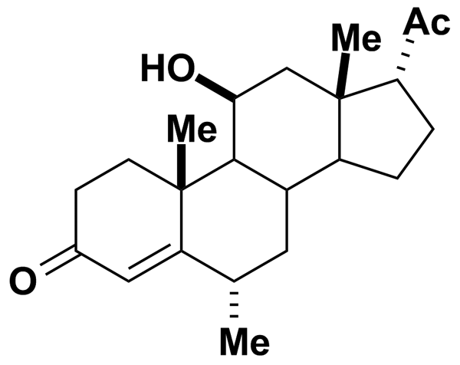
MEFENAMIC ACID | 4.14 | Prestwick Chemical Inc. | BRD-K92778217 | 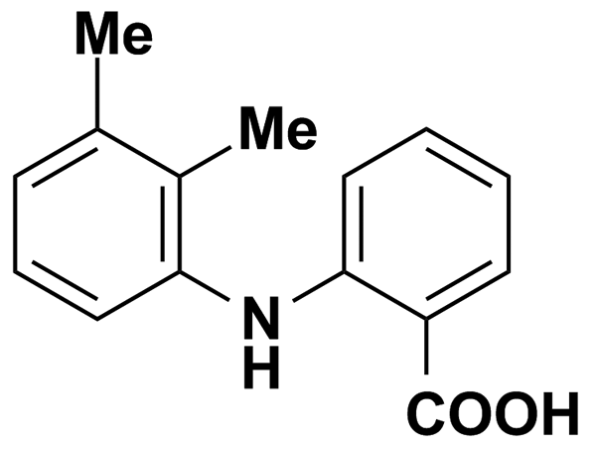
MEFEXAMIDE HYDROCHLORIDE | 3.16 | Prestwick Chemical Inc. | BRD-K20655524 | 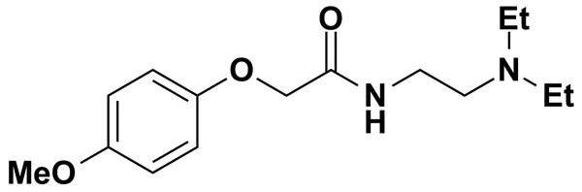
MEFLOQUINE HYDROCHLORIDE | 2.41 | Prestwick Chemical Inc. | BRD-A89585551 | 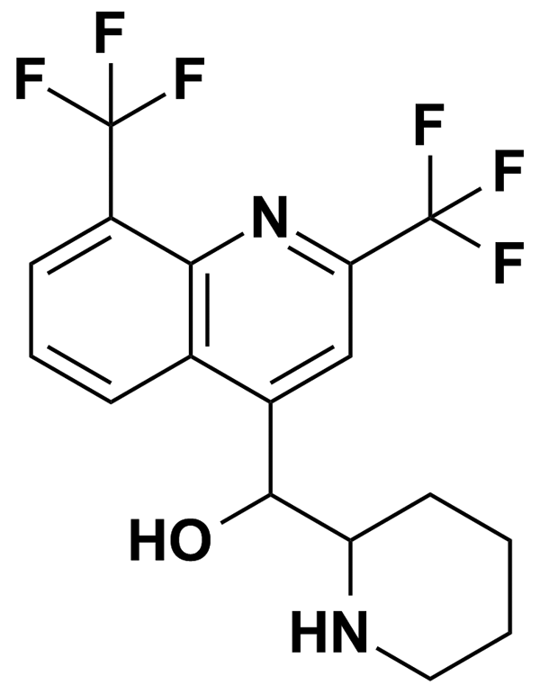
MELATONIN | 4.31 | Prestwick Chemical Inc. | BRD-K97530723 | 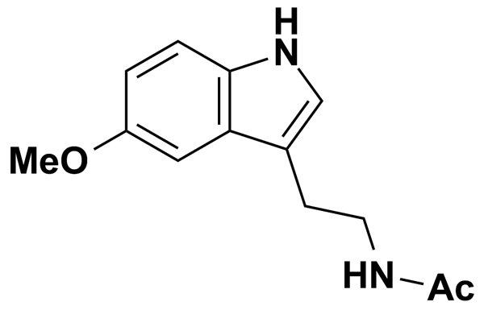
MELOXICAM | 5.00 | MicroSource Discovery Systems Inc. | BRD-A84174393 | 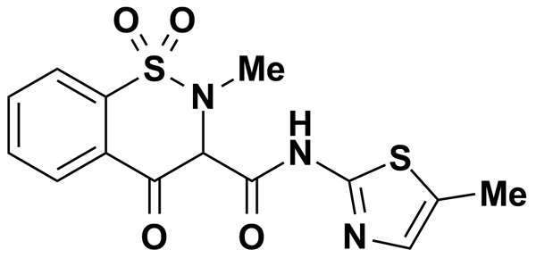
MELPHALAN | 5.00 | MicroSource Discovery Systems Inc. | BRD-K87827419 | 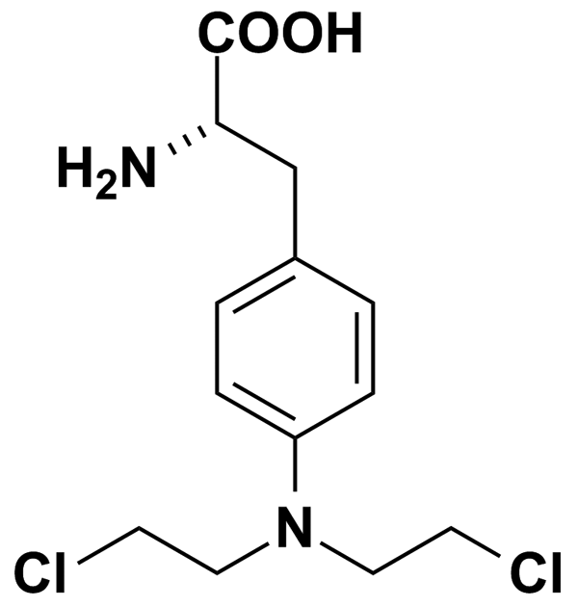
MEPENZOLATE BROMIDE | 2.37 | Prestwick Chemical Inc. | BRD-A62421304 | 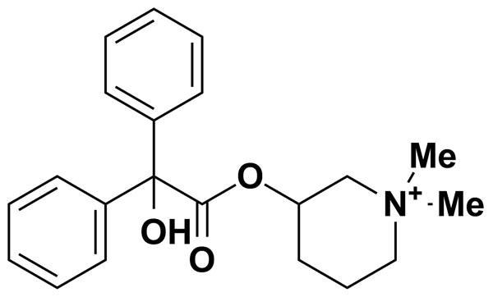
MEPHENYTOIN | 4.58 | Prestwick Chemical Inc. | BRD-A83937277 | 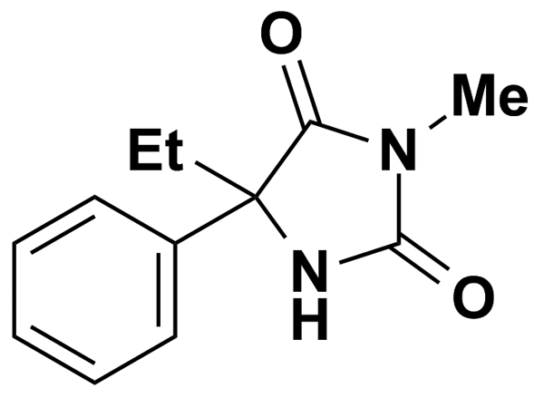
METHACYCLINE HYDROCHLORIDE | 2.09 | Prestwick Chemical Inc. | BRD-A49035384 | 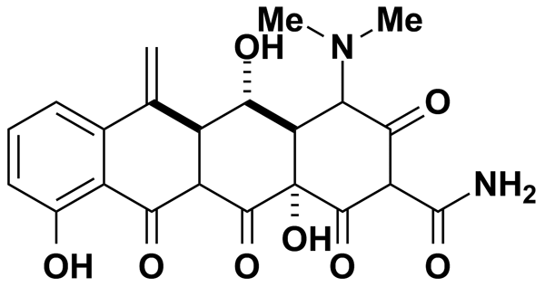
METHAPYRILENE HYDROCHLORIDE | 3.36 | Prestwick Chemical Inc. | BRD-K47323024 | 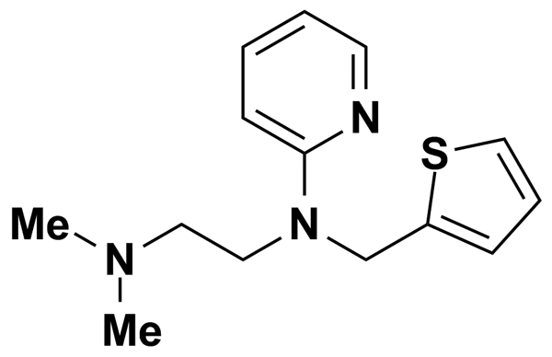
METHICILLIN SODIUM | 5.00 | MicroSource Discovery Systems Inc. | BRD-K34388247 | 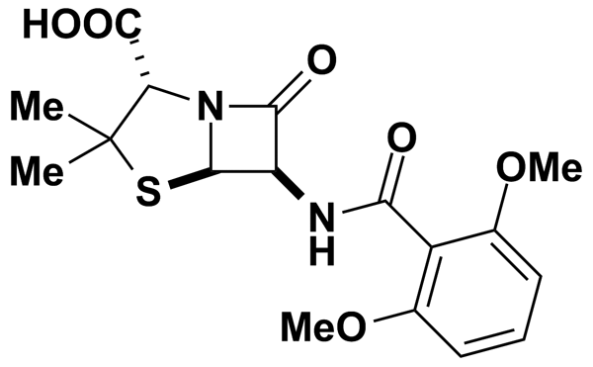
METHIOTHEPIN | 5.00 | Biomol International Inc. | BRD-A07932845 | 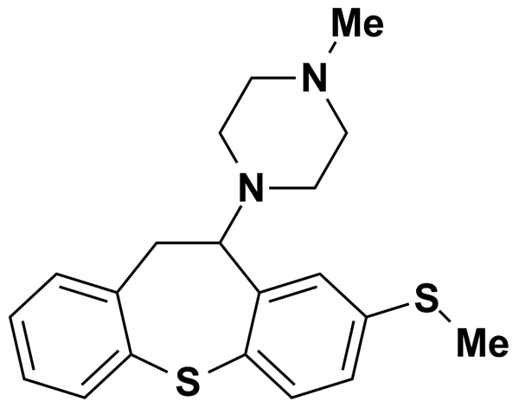
METHIOTHEPIN MALEATE | 2.12 | Prestwick Chemical Inc. | BRD-A07932845 | 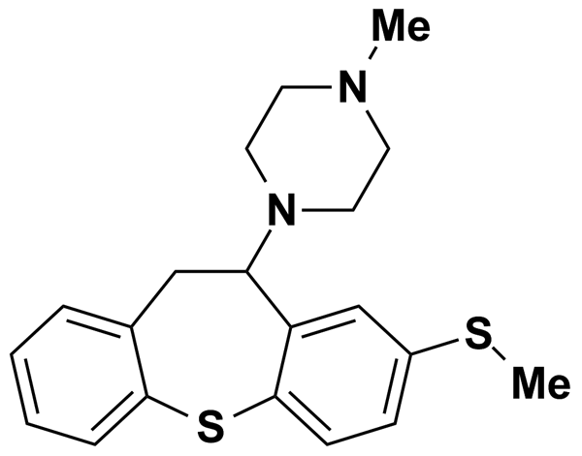
METHOCARBAMOL | 4.15 | Prestwick Chemical Inc. | BRD-A31521121 | 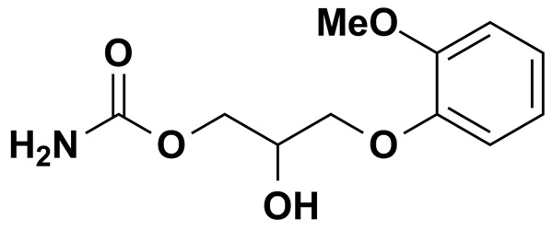
METHOPRENE ACID | 0.50 | Biomol International Inc. | BRD-A41145729 | 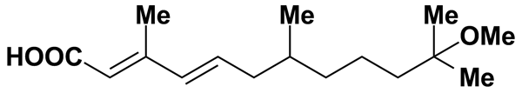
METHOXY VERAPAMIL | 5.16 | Biomol International Inc. | BRD-A52922642 | 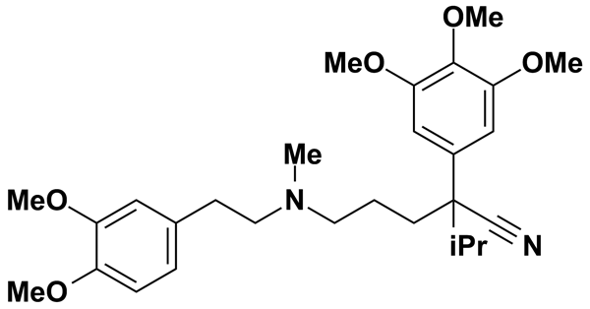
METHOXY-8-PSORALEN | 4.63 | Prestwick Chemical Inc. | BRD-K63430059 | 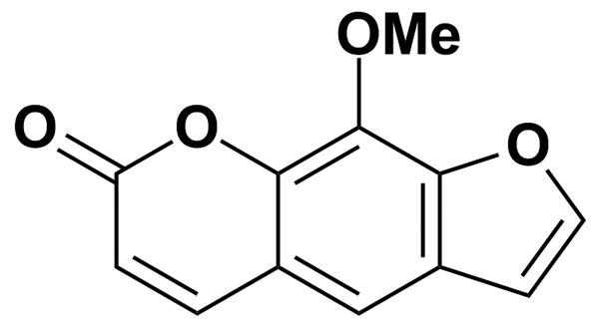
METHSCOPOLAMINE BROMIDE | 5.00 | MicroSource Discovery Systems Inc. | BRD-A03932035 | 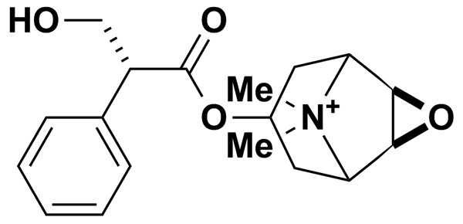
METHYLPREDNISOLONE | 5.00 | MicroSource Discovery Systems Inc. | BRD-A53176877 | 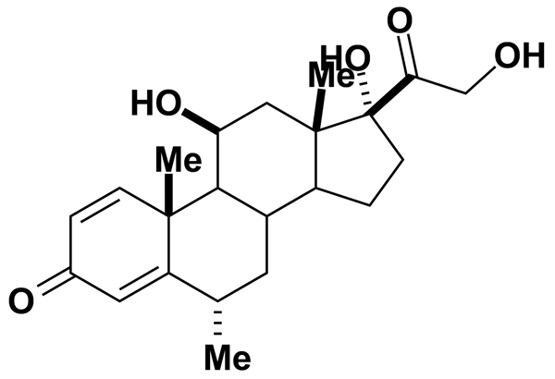
METHYSERGIDE | 5.00 | Biomol International Inc. | BRD-K35941380 | 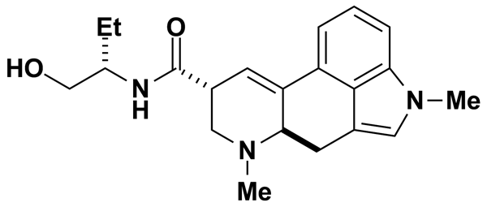
METOCLOPRAMIDE | 5.00 | Biomol International Inc. | BRD-K75641298 | 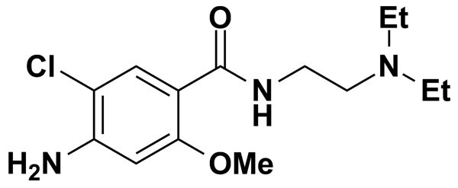
METOCLOPRAMIDE MONOHYDROCHLORIDE | 2.97 | Prestwick Chemical Inc. | BRD-K75641298 | 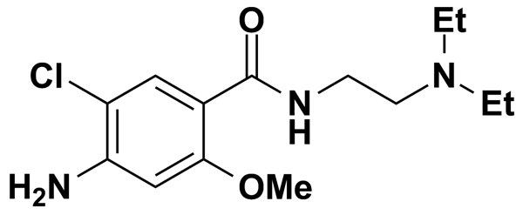
METOLAZONE | 2.73 | Prestwick Chemical Inc. | BRD-A61793559 | 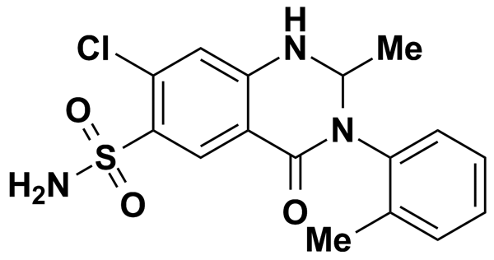
MEVINOLIN (LOVASTATIN) | 6.18 | Biomol International Inc. | BRD-K09416995 | 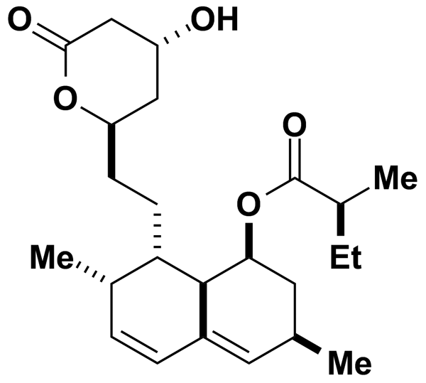
MEXILETINE HYDROCHLORIDE | 4.64 | Prestwick Chemical Inc. | BRD-A64092382 | 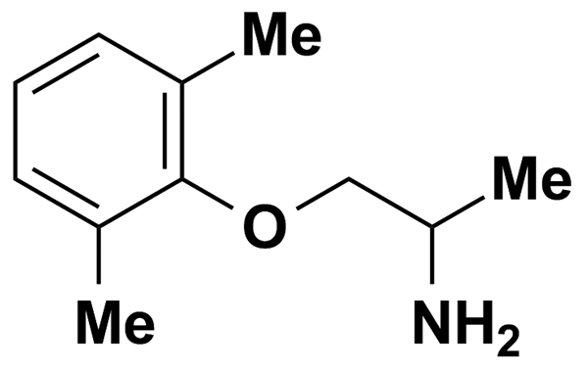
MIANSERINE HYDROCHLORIDE | 3.32 | Prestwick Chemical Inc. | BRD-A19661776 | 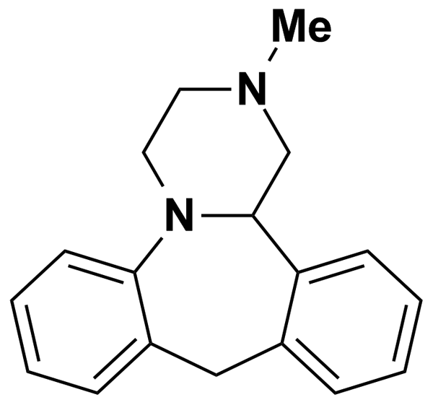
MICONAZOLE | 2.40 | Prestwick Chemical Inc. | BRD-A82396632 | 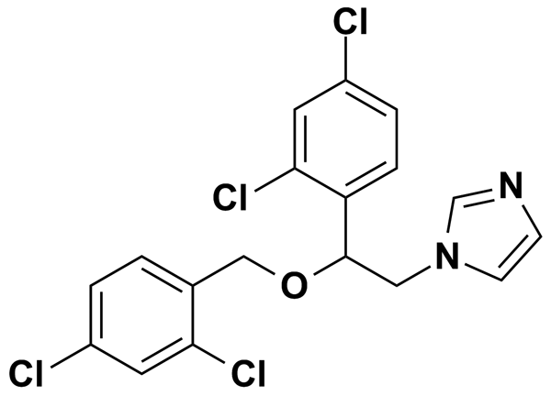
MICONAZOLE NITRATE | 5.00 | MicroSource Discovery Systems Inc. | BRD-A82396632 | 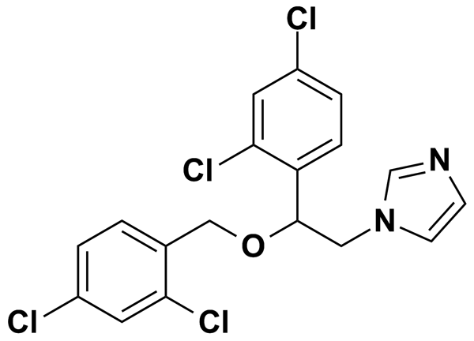
MIDODRINE HYDROCHLORIDE | 3.44 | Prestwick Chemical Inc. | BRD-A79981887 | 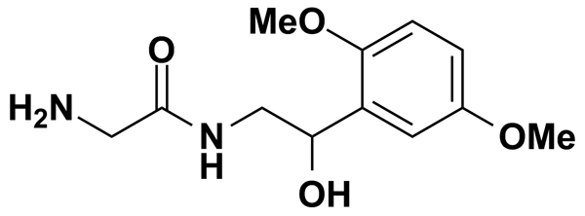
MIFEPRISTONE | 2.33 | Prestwick Chemical Inc. | BRD-K37270826 | 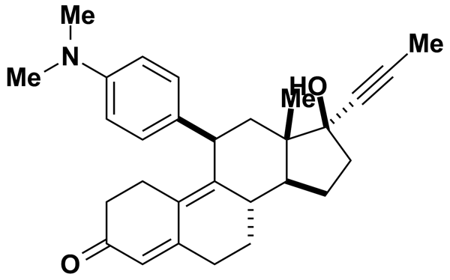
MINAPRINE DIHYDROCHLORIDE | 2.69 | Prestwick Chemical Inc. | BRD-K02867583 | 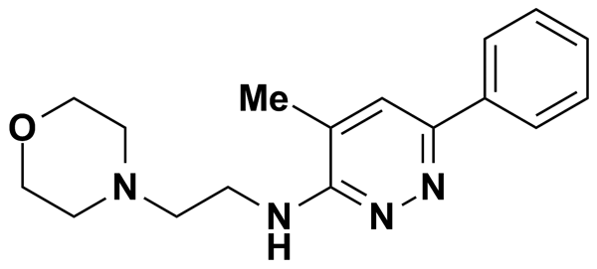
MINOXIDIL | 11.95 | Biomol International Inc. | BRD-K06902185 | 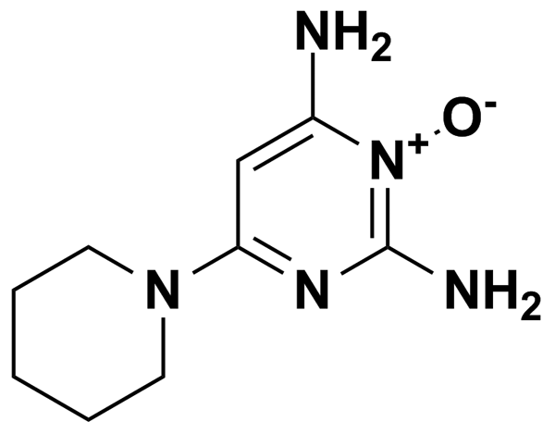
MITOXANTRONE DIHYDROCHLORIDE | 1.93 | Prestwick Chemical Inc. | BRD-K21680192 | 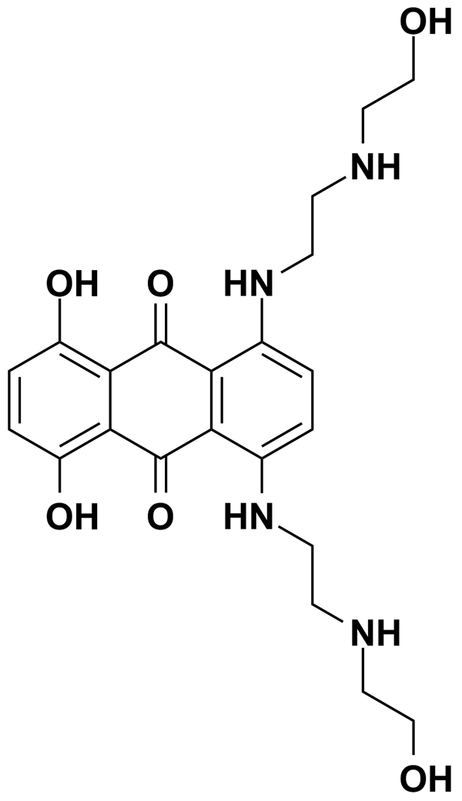
ML7 | 6.01 | Biomol International Inc. | BRD-K93201660 | 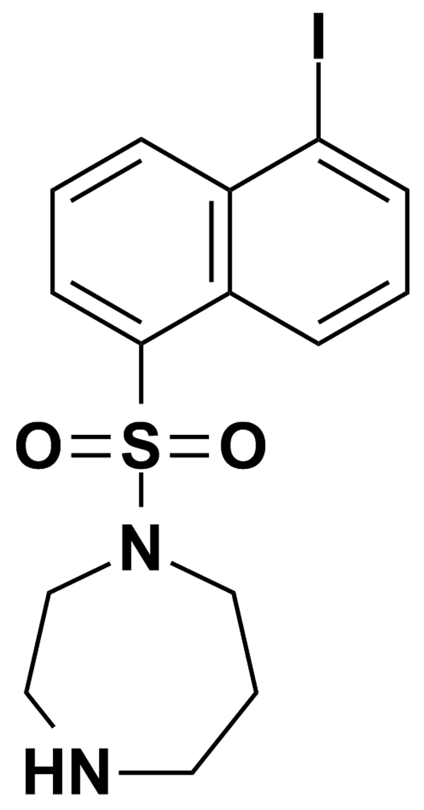
ML9 | 7.70 | Biomol International Inc. | BRD-K68402494 | 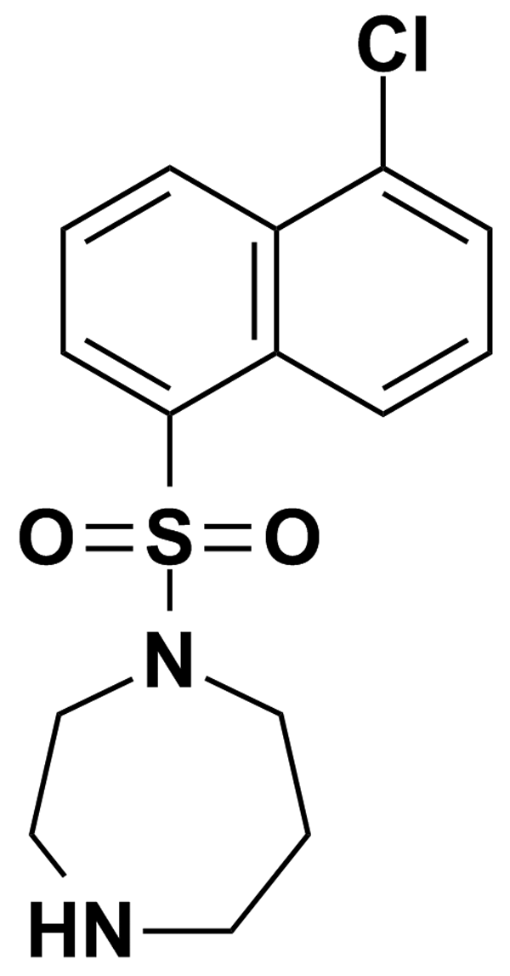
MODAFINIL | 5.00 | MicroSource Discovery Systems Inc. | BRD-A16332958 | 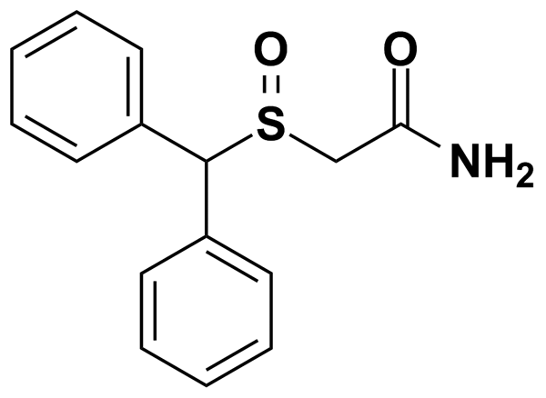
MOLSIDOMINE | 5.00 | MicroSource Discovery Systems Inc. | BRD-K63861289 | 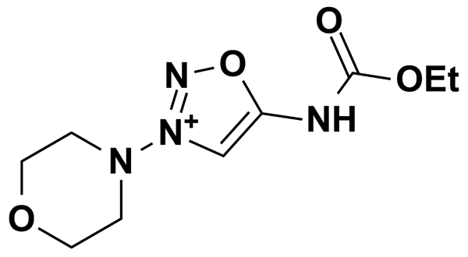
MONOCROTALINE | 3.07 | Prestwick Chemical Inc. | BRD-K65508953 | 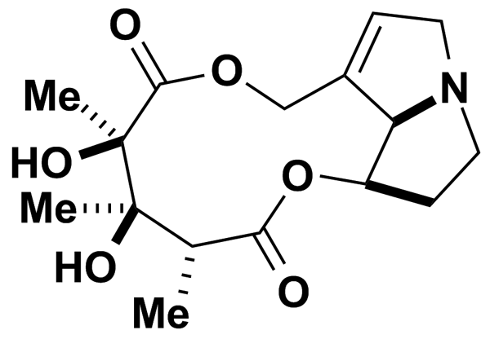
MY-5445 | 7.53 | Biomol International Inc. | BRD-K90524085 | 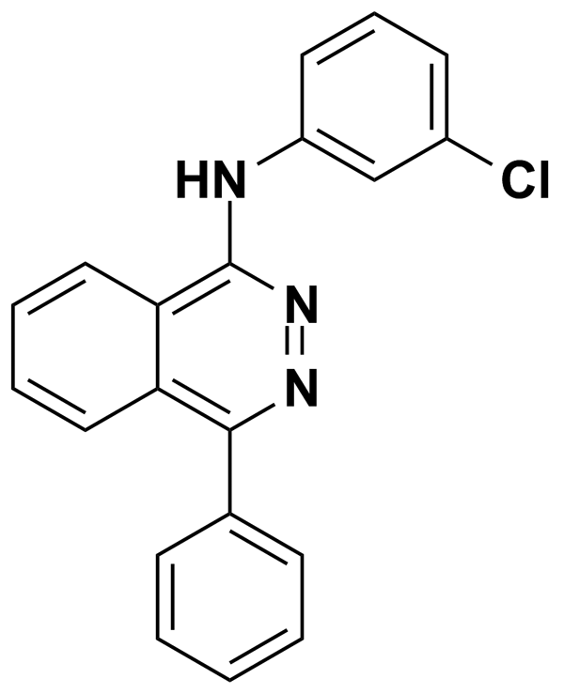
MYCOPHENOLIC ACID | 3.12 | Prestwick Chemical Inc. | BRD-K63750851 | 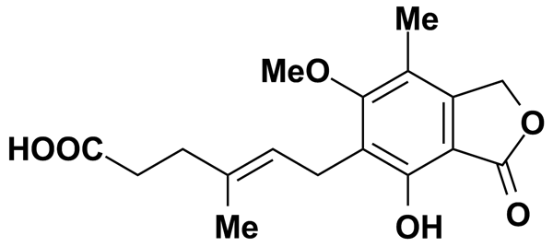
MYRICETIN | 3.14 | Prestwick Chemical Inc. | BRD-K43149758 | 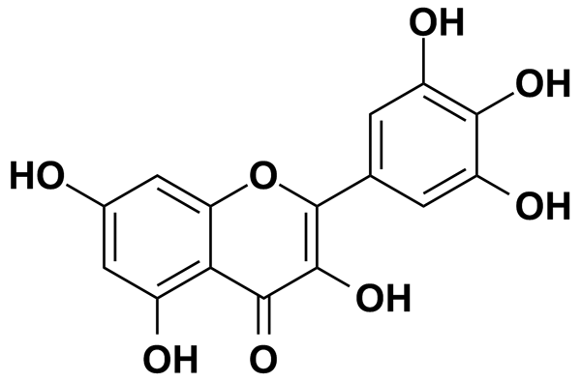
N- (3-TRIFLUOROMETHYLPHENYL)PIPERAZINE HYDROCHLORIDE (TFMPP) | 5.00 | MicroSource Discovery Systems Inc. | BRD-K94887716 | 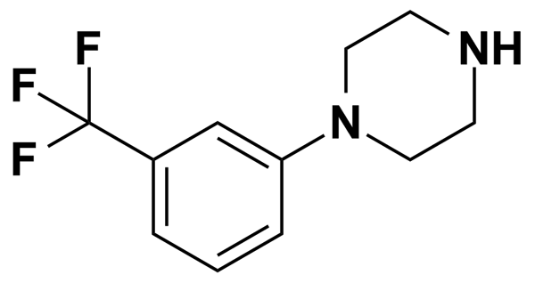
N- (9-FLUORENYLMETHOXYCARBONYL)-L-LEUCINE | 5.00 | MicroSource Discovery Systems Inc. | BRD-K65275554 | 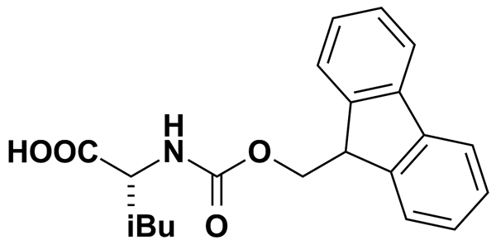
N-LINOLEOYLGLYCINE | 0.50 | Biomol International Inc. | BRD-K76293260 | 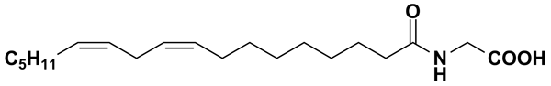
N-METHYL (-)EPHEDRINE | 5.00 | MicroSource Discovery Systems Inc. | BRD-K82236108 | 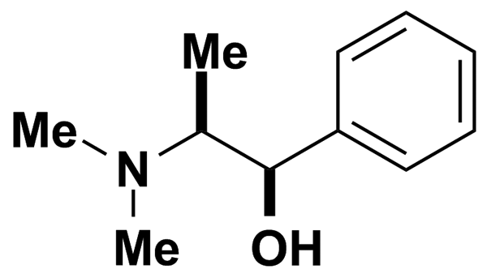
N-PHENYLANTHRANILIC | 11.72 | Biomol International Inc. | BRD-K80863915 | 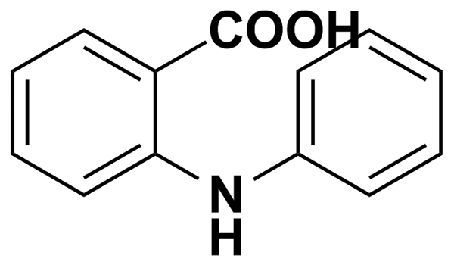
N9-ISOPROPYLOLOMOUCINE | 7.66 | Biomol International Inc. | BRD-K71726959 | 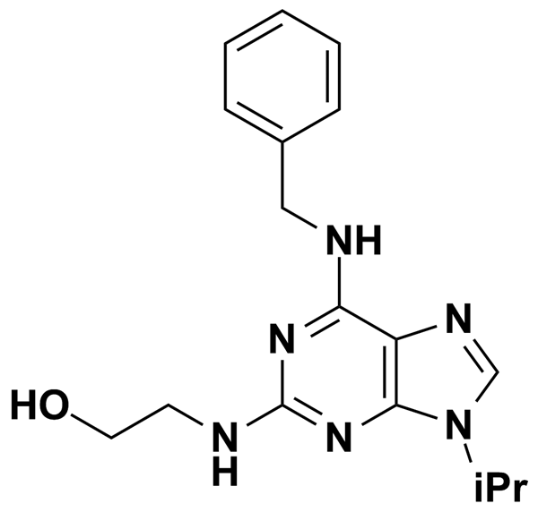
NAFCILLIN SODIUM | 5.00 | MicroSource Discovery Systems Inc. | BRD-A99402294 | 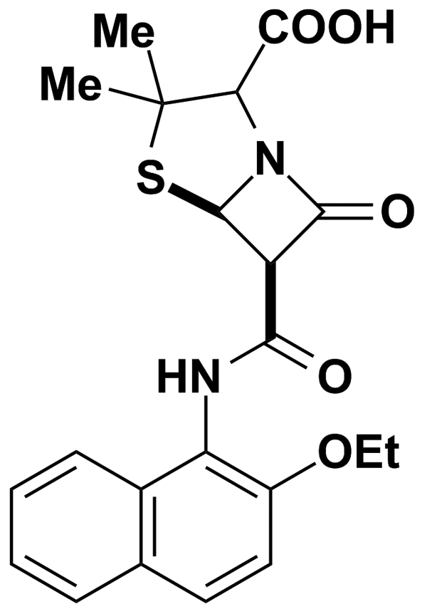
NAFRONYL OXALATE | 2.11 | Prestwick Chemical Inc. | BRD-A67862938 | 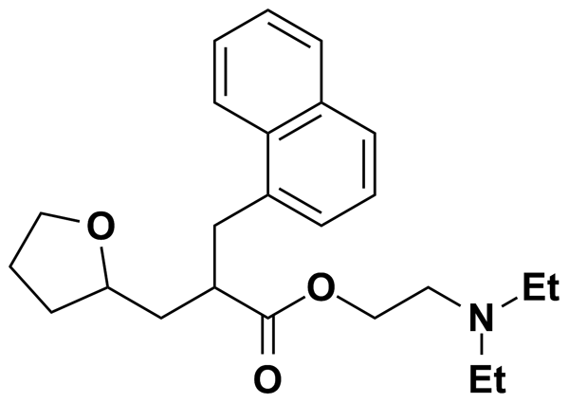
NALBUPHINE HYDROCHLORIDE | 2.54 | Prestwick Chemical Inc. | BRD-K66404838 | 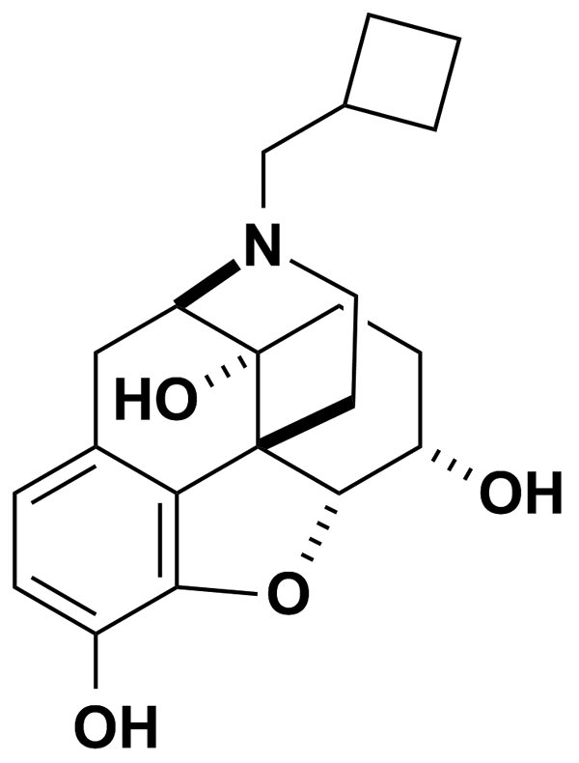
NALIDIXIC ACID SODIUM SALT HYDRATE | 3.66 | Prestwick Chemical Inc. | BRD-K47886988 | 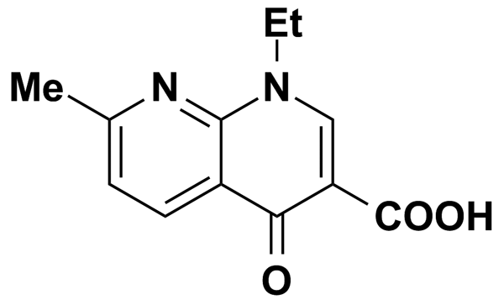
NALOXONE HYDROCHLORIDE | 2.75 | Prestwick Chemical Inc. | BRD-K67511046 | 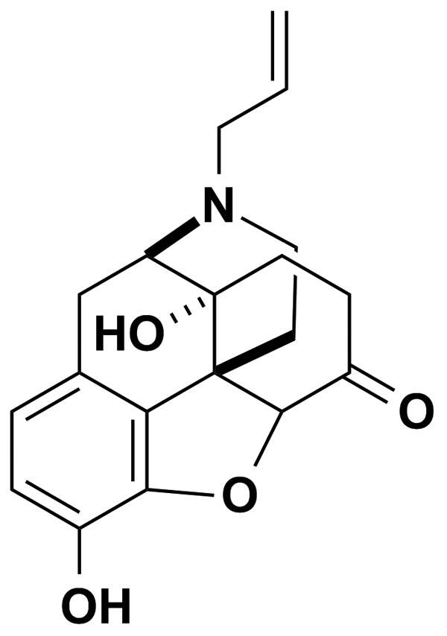
NAN-190 | 5.00 | Biomol International Inc. | BRD-K69195780 | 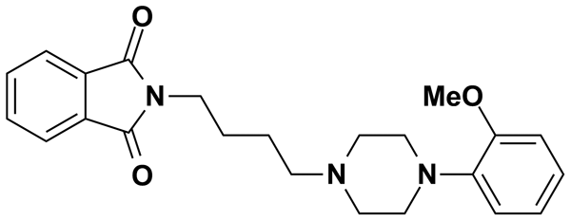
NAPHAZOLINE HYDROCHLORIDE | 4.05 | Prestwick Chemical Inc. | BRD-K77641333 | 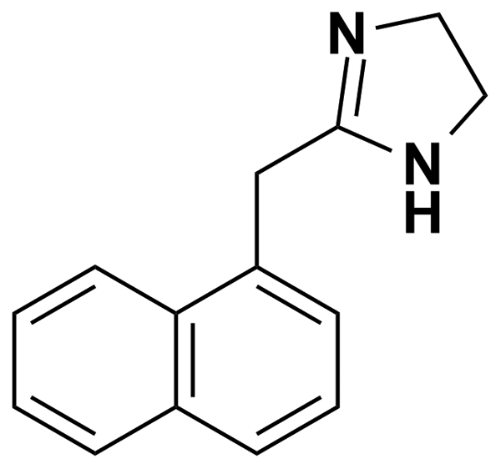
NAPROXEN(+) | 5.00 | MicroSource Discovery Systems Inc. | BRD-K59197931 | 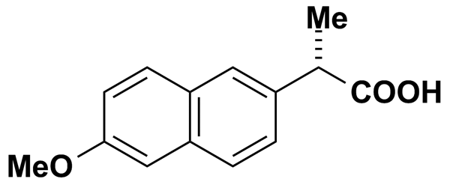
NARINGENIN | 5.00 | MicroSource Discovery Systems Inc. | BRD-K08832567 | 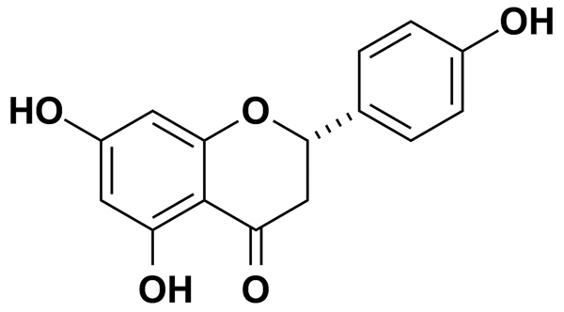
NARINGIN HYDRATE | 1.67 | Prestwick Chemical Inc. | BRD-K02953697 | 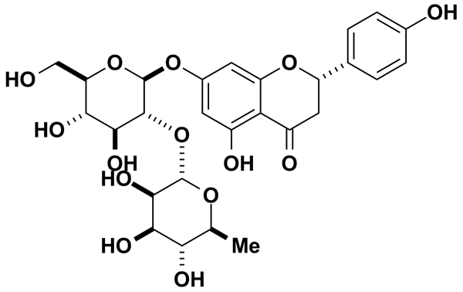
NEFOPAM HYDROCHLORIDE | 3.45 | Prestwick Chemical Inc. | BRD-A78877355 | 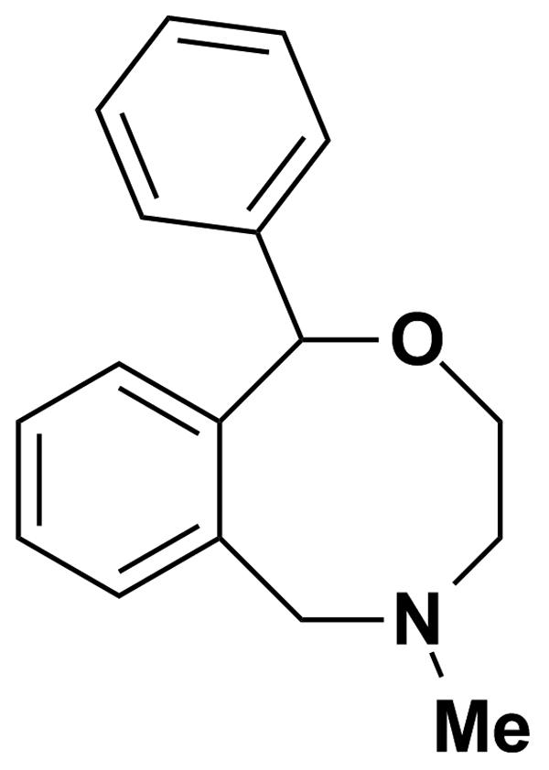
NEOSTIGMINE BROMIDE | 3.29 | Prestwick Chemical Inc. | BRD-K18922609 | 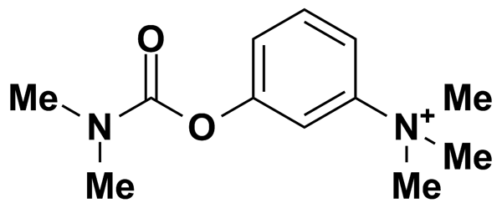
NERIIFOLIN | 5.00 | MicroSource Discovery Systems Inc. | BRD-A31385885 | 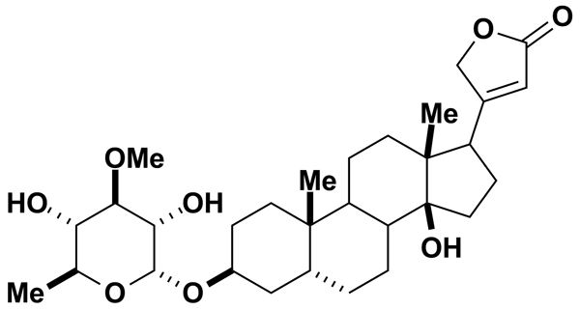
NICARDIPINE | 5.21 | Biomol International Inc. | BRD-A26711594 | 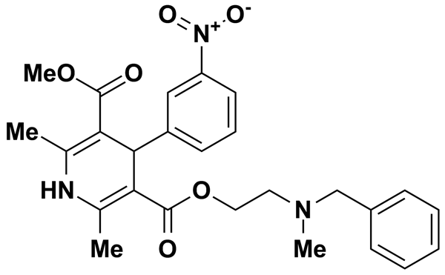
NICARDIPINE HYDROCHLORIDE | 1.94 | Prestwick Chemical Inc. | BRD-A26711594 | 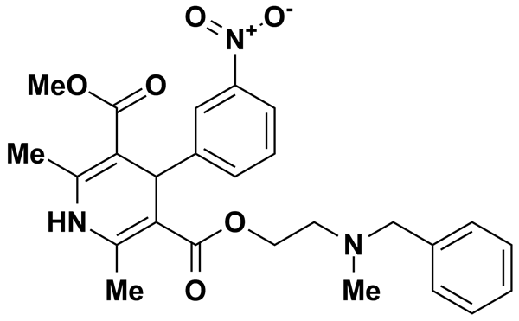
NICERGOLINE | 2.06 | Prestwick Chemical Inc. | BRD-K76810206 | 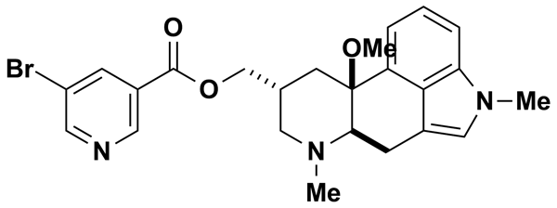
NICLOSAMIDE | 3.06 | Prestwick Chemical Inc. | BRD-K35960502 | 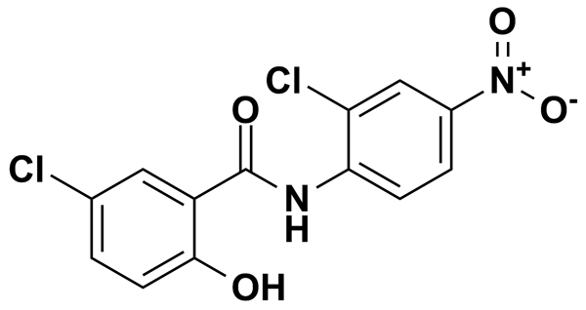
NICOTINE DITARTRATE | 5.00 | MicroSource Discovery Systems Inc. | BRD-K05395900 | 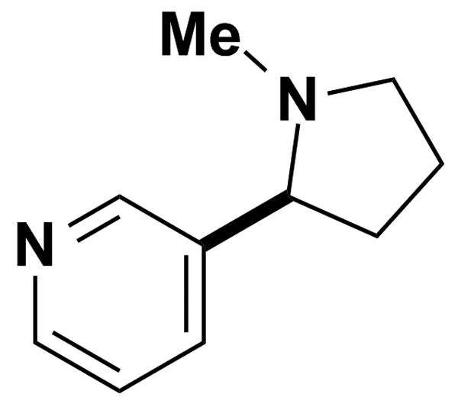
NIFENAZONE | 3.24 | Prestwick Chemical Inc. | BRD-K47407372 | 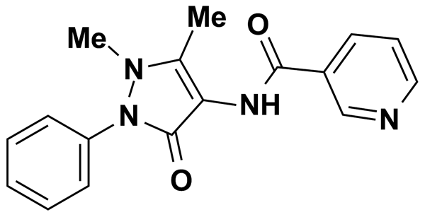
NIFLUMIC ACID | 8.86 | Biomol International Inc. | BRD-K98763141 | 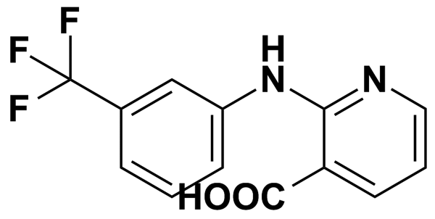
NIMODIPINE | 5.97 | Biomol International Inc. | BRD-A58048407 | 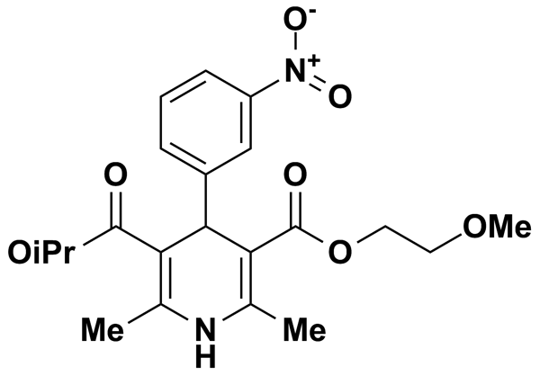
NITRENDIPINE | 6.94 | Biomol International Inc. | BRD-A02006392 | 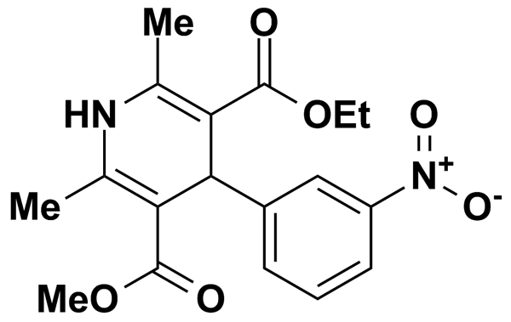
NOMIFENSINE MALEATE | 2.82 | Prestwick Chemical Inc. | BRD-A29644307 | 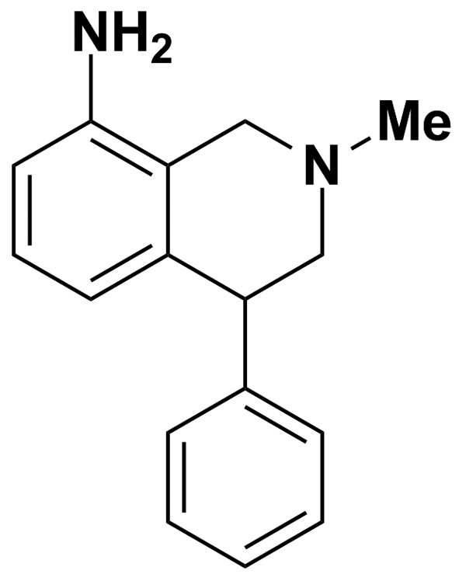
NORETHINDRONE | 5.00 | MicroSource Discovery Systems Inc. | BRD-A39415247 | 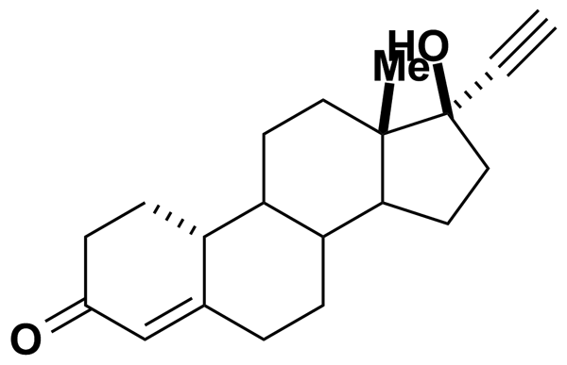
NORFLOXACIN | 3.13 | Prestwick Chemical Inc. | BRD-K11196887 | 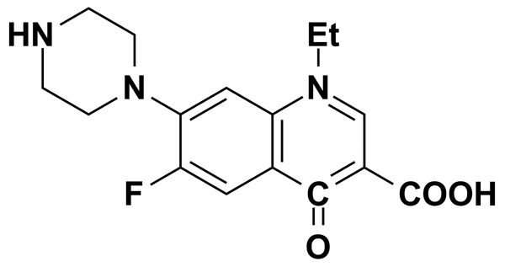
NORTRIPTYLINE HYDROCHLORIDE | 3.34 | Prestwick Chemical Inc. | BRD-K91263825 | 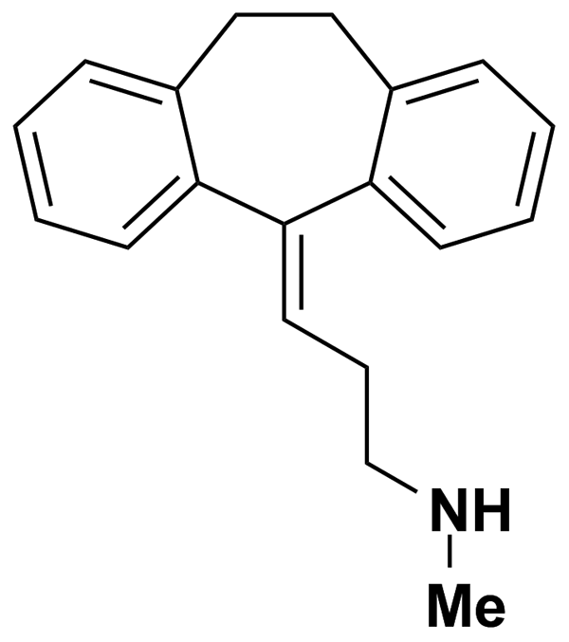
NOVOBIOCIN SODIUM | 5.00 | MicroSource Discovery Systems Inc. | BRD-K85307935 | 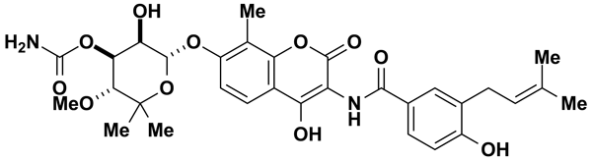
NPPB | 8.32 | Biomol International Inc. | BRD-K89272762 | 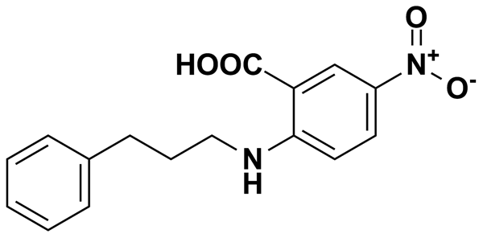
NS-1619 | 6.90 | Biomol International Inc. | BRD-K54210043 | 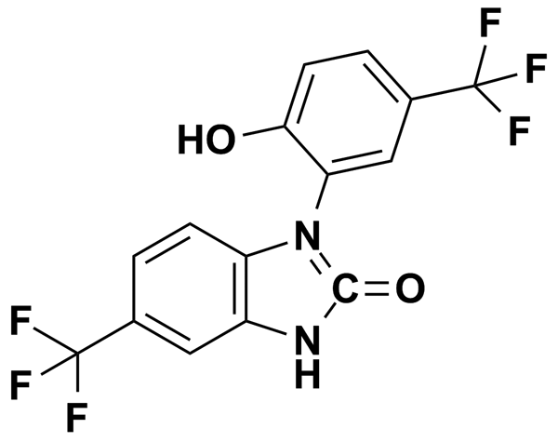
NSC-95397 | 8.05 | Biomol International Inc. | BRD-K68143200 | 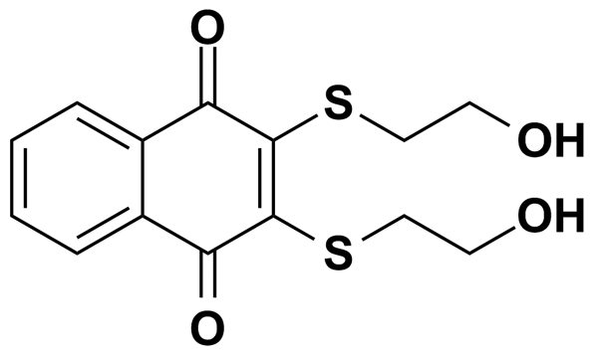
OFLOXACIN | 2.77 | Prestwick Chemical Inc. | BRD-A24228527 | 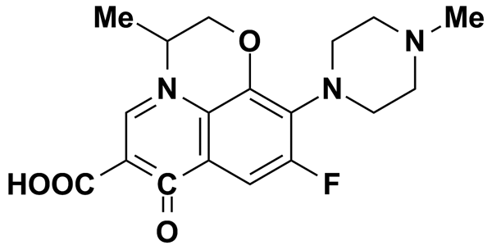
OXAPROZIN | 3.41 | Prestwick Chemical Inc. | BRD-K25394294 | 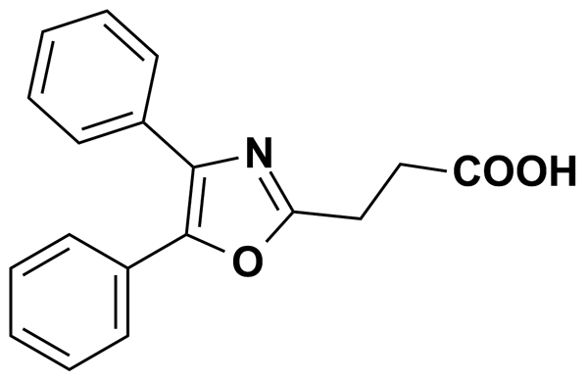
OXETHAZAINE | 2.14 | Prestwick Chemical Inc. | BRD-K56940463 | 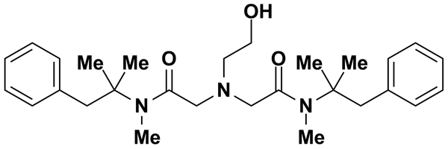
OXIBENDAZOLE | 5.00 | MicroSource Discovery Systems Inc. | BRD-K52075715 | 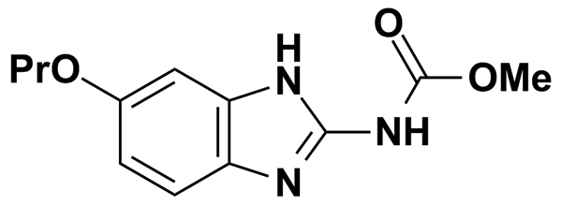
OXYMETAZOLINE | 5.00 | Biomol International Inc. | BRD-K16195444 | 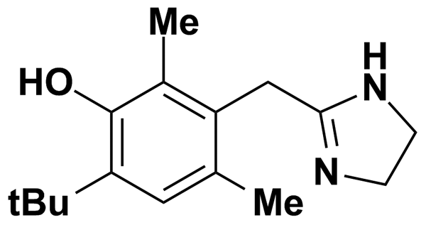
OXYPHENBUTAZONE | 3.08 | Prestwick Chemical Inc. | BRD-A33749298 | 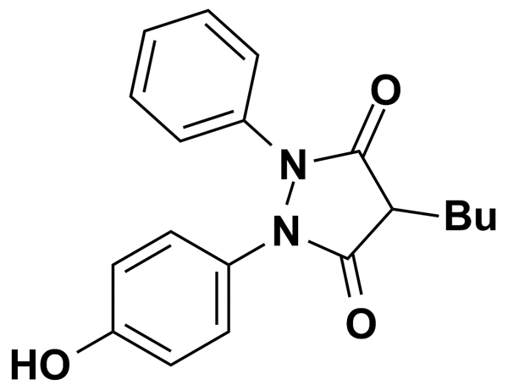
OXYQUINOLINE HEMISULFATE | 5.00 | MicroSource Discovery Systems Inc. | BRD-K66808046 | 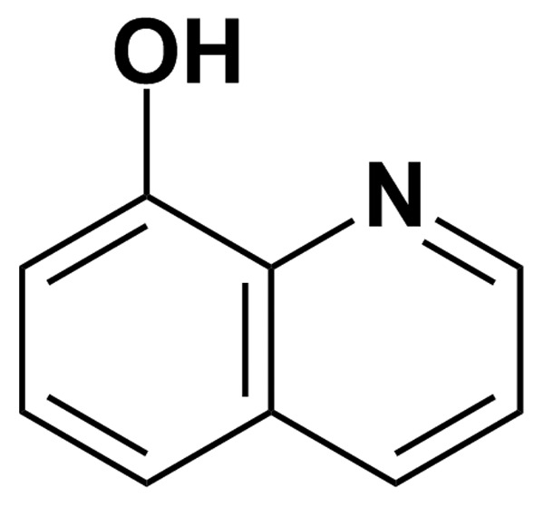
PACLITAXEL | 1.17 | Prestwick Chemical Inc. | BRD-K62008436 | 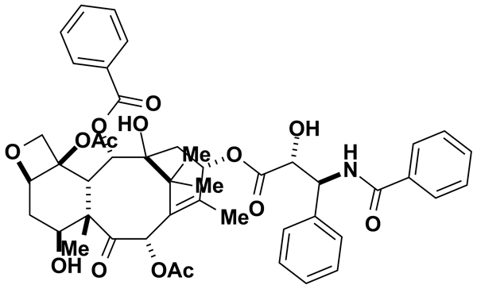
PANTOPRAZOLE | 5.00 | MicroSource Discovery Systems Inc. | BRD-A22380646 | 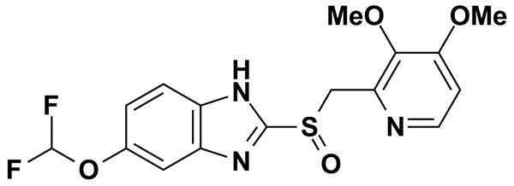
PAPAVERINE HYDROCHLORIDE | 2.66 | Prestwick Chemical Inc. | BRD-K15567136 | 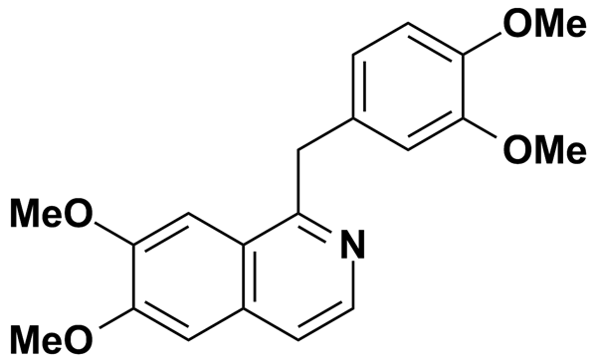
PARAXANTHINE | 5.00 | MicroSource Discovery Systems Inc. | BRD-K24084088 | 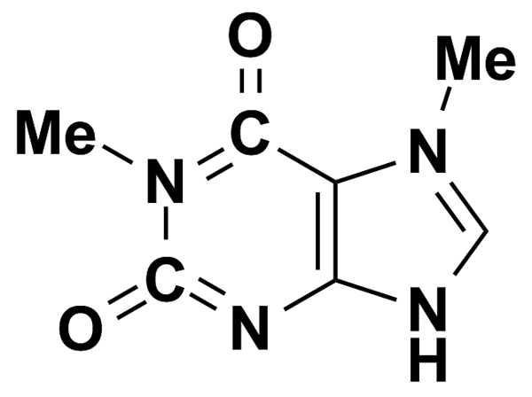
PARGYLINE HYDROCHLORIDE | 5.11 | Prestwick Chemical Inc. | BRD-K83597974 | 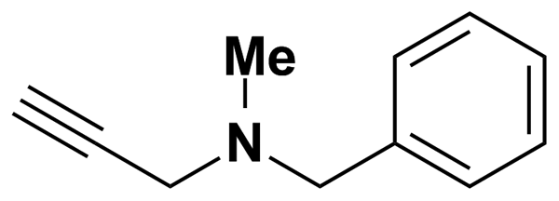
PAXILLINE | 5.74 | Biomol International Inc. | BRD-K38251852 | 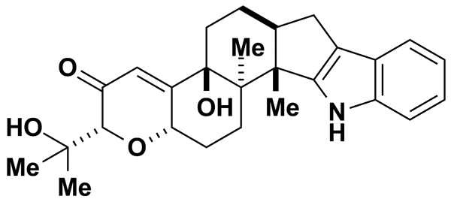
PCA 4248 | 6.92 | Biomol International Inc. | BRD-A29289453 | 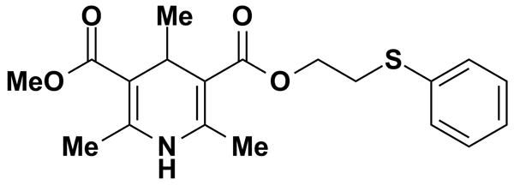
PCO-400 | 8.35 | Biomol International Inc. | BRD-K52721684 | 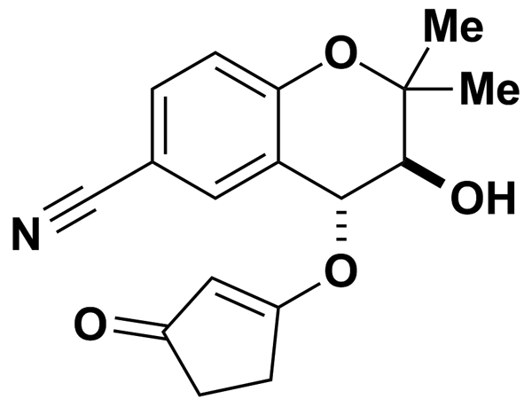
PENICILLIN V POTASSIUM | 5.00 | MicroSource Discovery Systems Inc. | BRD-K43966364 | 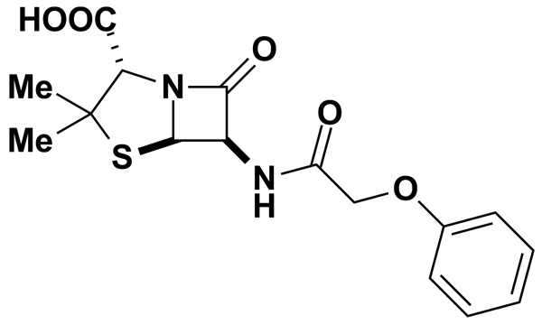
PENITREM A | 3.94 | Biomol International Inc. | BRD-K03842655 | 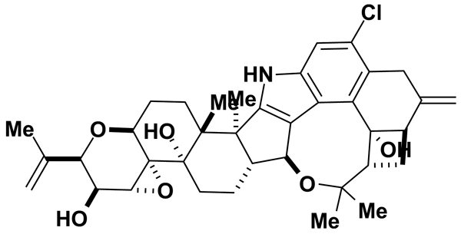
PENTACHLOROPHENOL | 5.00 | MicroSource Discovery Systems Inc. | BRD-K50711164 | 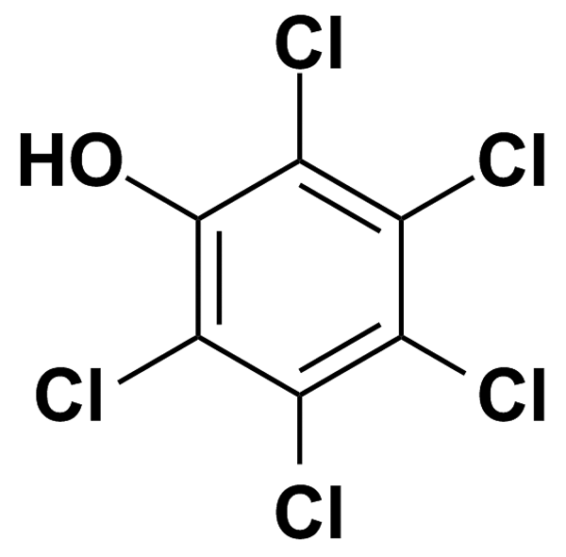
PENTOXIFYLLINE | 3.59 | Prestwick Chemical Inc. | BRD-K57569181 | 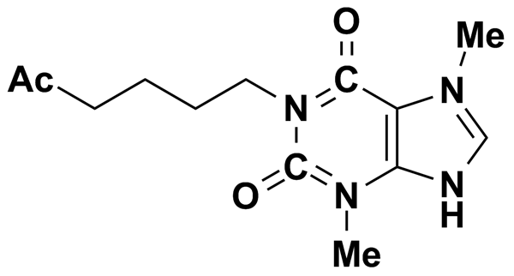
PERGOLIDE MESYLATE | 2.44 | Prestwick Chemical Inc. | BRD-K60770992 | 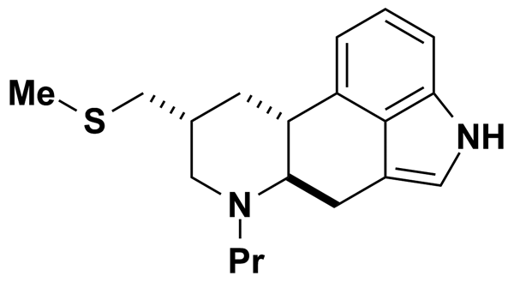
PERGOLIDE METHANESULFONATE | 5.00 | Biomol International Inc. | BRD-K60770992 | 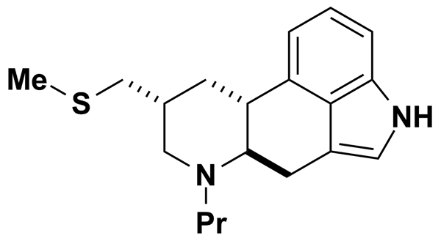
PERICIAZINE | 5.00 | MicroSource Discovery Systems Inc. | BRD-K89669299 | 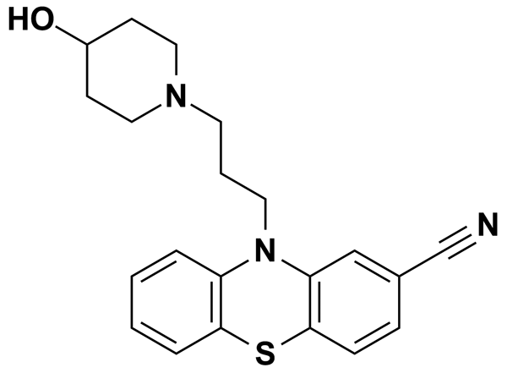
PERPHENAZINE | 2.48 | Prestwick Chemical Inc. | BRD-K10995081 | 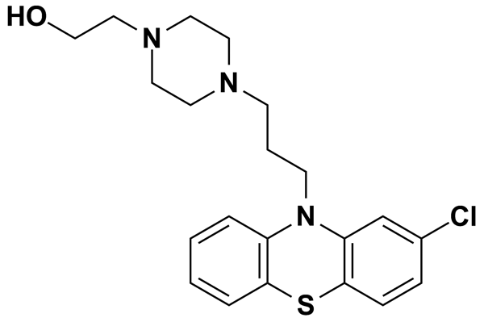
PERUVOSIDE | 5.00 | MicroSource Discovery Systems Inc. | BRD-A57089740 | 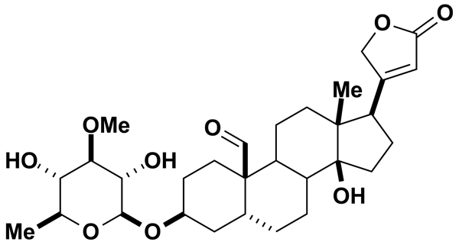
PHENACEMIDE | 5.00 | MicroSource Discovery Systems Inc. | BRD-K40905133 | 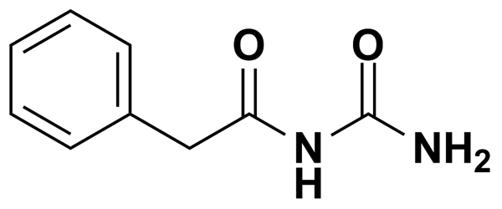
PHENACETIN | 5.58 | Prestwick Chemical Inc. | BRD-K38323065 | 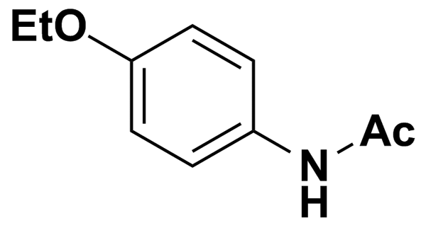
PHENAMIL | 8.18 | Biomol International Inc. | BRD-K21350491 | 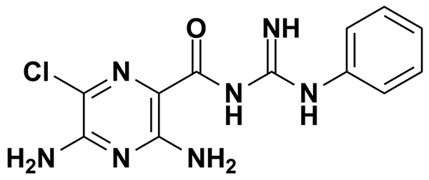
PHENELZINE SULFATE | 4.27 | Prestwick Chemical Inc. | BRD-K87024524 | 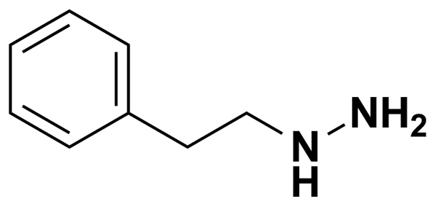
PHENETHICILLIN POTASSIUM SALT | 2.48 | Prestwick Chemical Inc. | BRD-A66025870 | 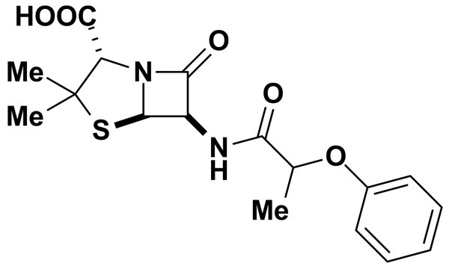
PHENIRAMINE MALEATE | 2.81 | Prestwick Chemical Inc. | BRD-A23072235 | 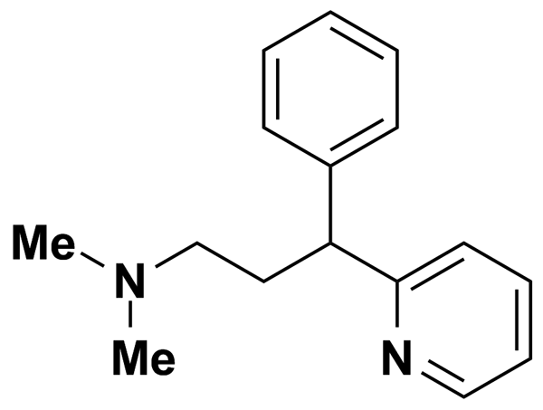
PHENOLPHTHALEIN | 5.00 | MicroSource Discovery Systems Inc. | BRD-K19227686 | 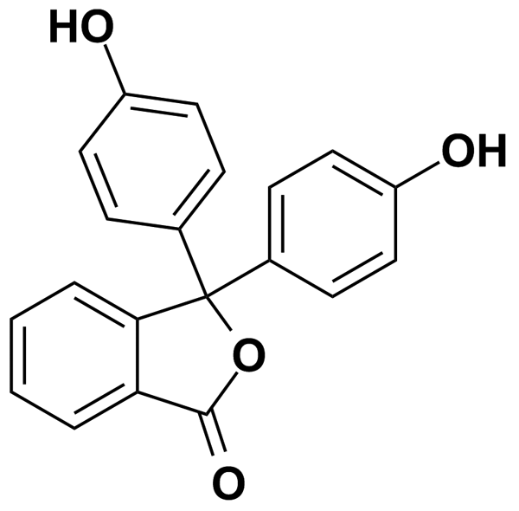
PHENOTHRIN | 5.00 | MicroSource Discovery Systems Inc. | BRD-A22106989 | 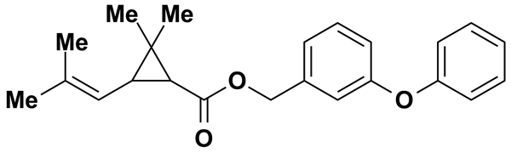
PHENYLBUTYRIC ACID | 5.00 | MicroSource Discovery Systems Inc. | BRD-K67102207 | 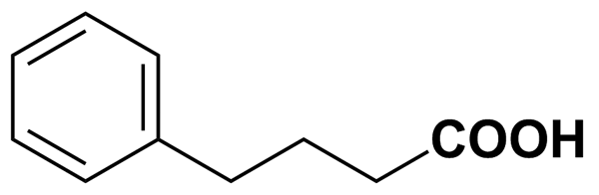
PHENYTOIN | 9.91 | Biomol International Inc. | BRD-K55930204 | 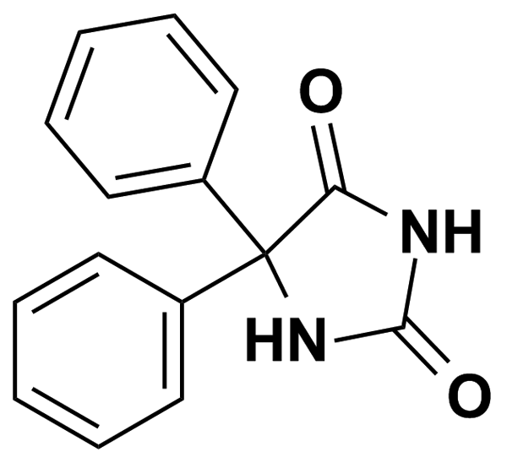
PHLORETIN | 5.00 | MicroSource Discovery Systems Inc. | BRD-K15563106 | 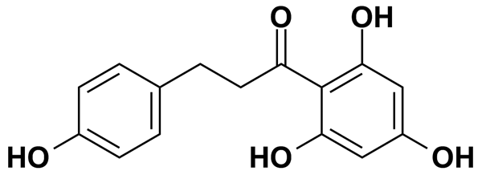
PHOSALONE | 5.00 | MicroSource Discovery Systems Inc. | BRD-K71671197 | 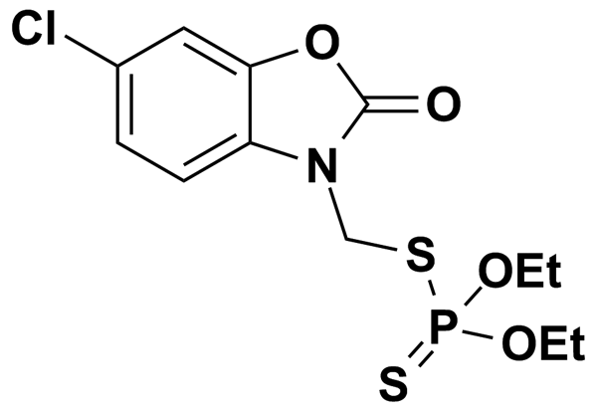
PHYSOSTIGMINE SALICYLATE | 5.00 | MicroSource Discovery Systems Inc. | BRD-K25650355 | 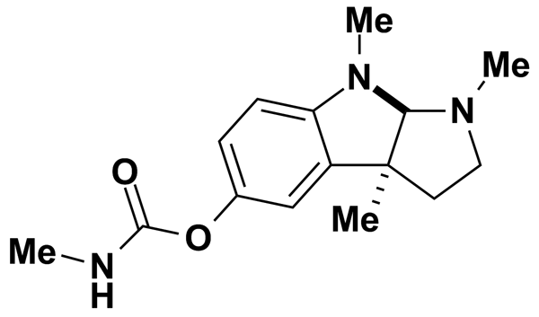
PICOTAMIDE MONOHYDRATE | 2.54 | Prestwick Chemical Inc. | BRD-K67277431 | 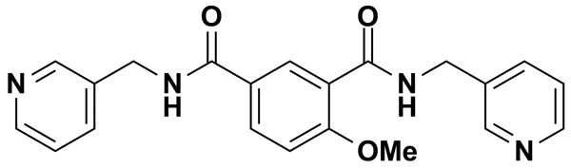
PIFITHRIN | 8.73 | Biomol International Inc. | BRD-K66874953 | 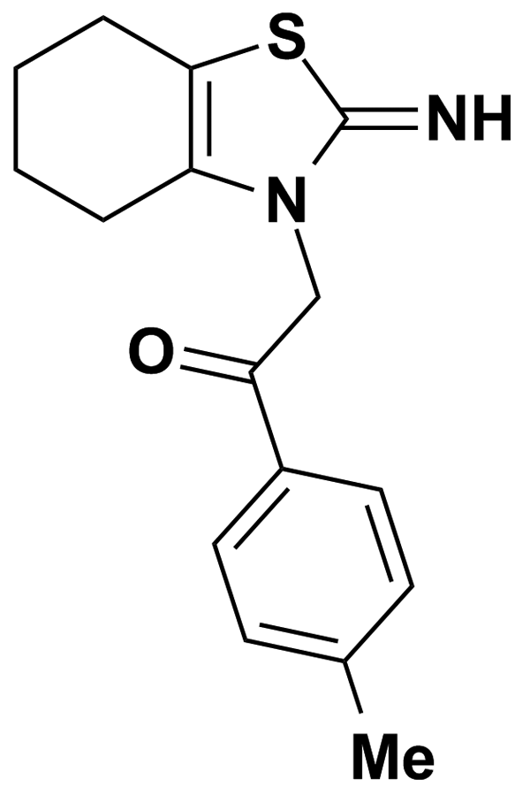
PILOCARPINE NITRATE | 3.69 | Prestwick Chemical Inc. | BRD-K85090592 | 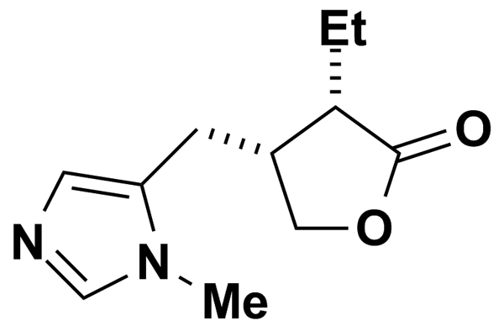
PIMETHIXENE MALEATE | 2.44 | Prestwick Chemical Inc. | BRD-K88090157 | 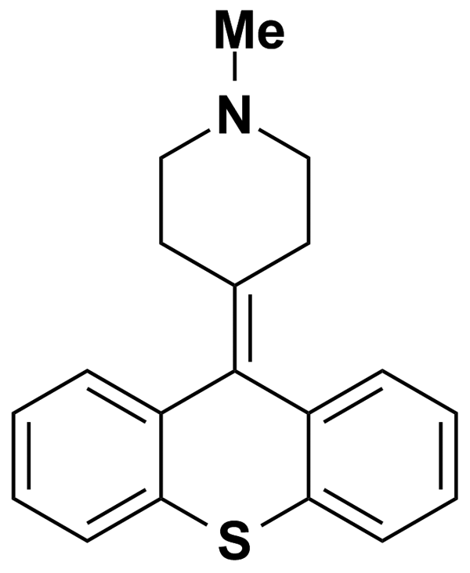
PIMPINELLIN | 5.00 | MicroSource Discovery Systems Inc. | BRD-K93197368 | 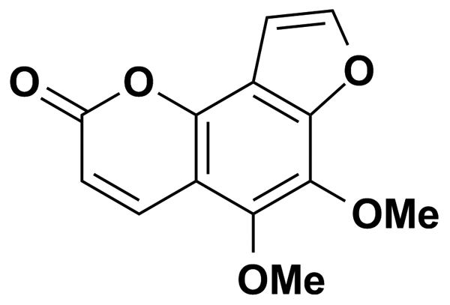
PINDOLOL | 4.03 | Prestwick Chemical Inc. | BRD-A97701745 | 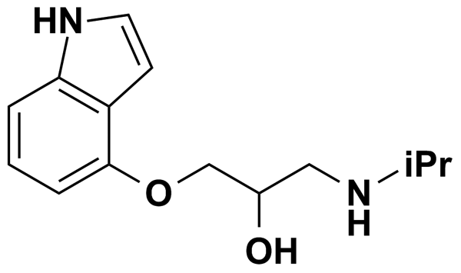
PIPERACILLIN SODIUM SALT | 1.85 | Prestwick Chemical Inc. | BRD-K86873305 | 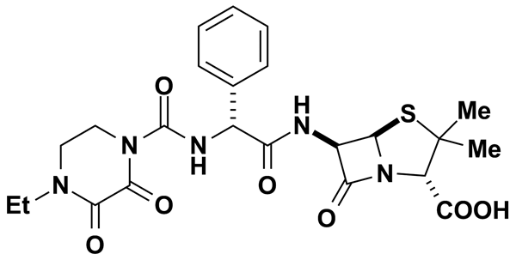
PIPERIDOLATE HYDROCHLORIDE | 2.78 | Prestwick Chemical Inc. | BRD-A97479839 | 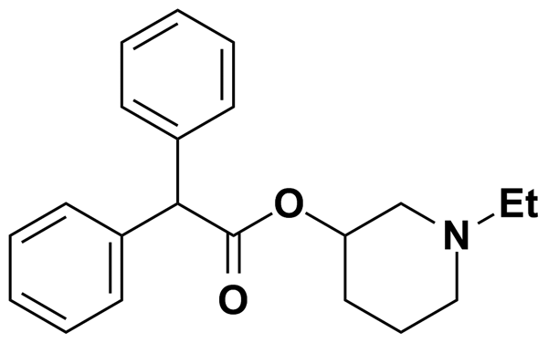
PIPERLONGUMINE | 3.15 | Prestwick Chemical Inc. | BRD-K24132293 | 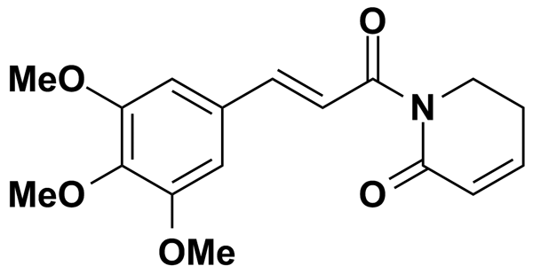
PIRENZEPINE DIHYDROCHLORIDE | 2.36 | Prestwick Chemical Inc. | BRD-K89375097 | 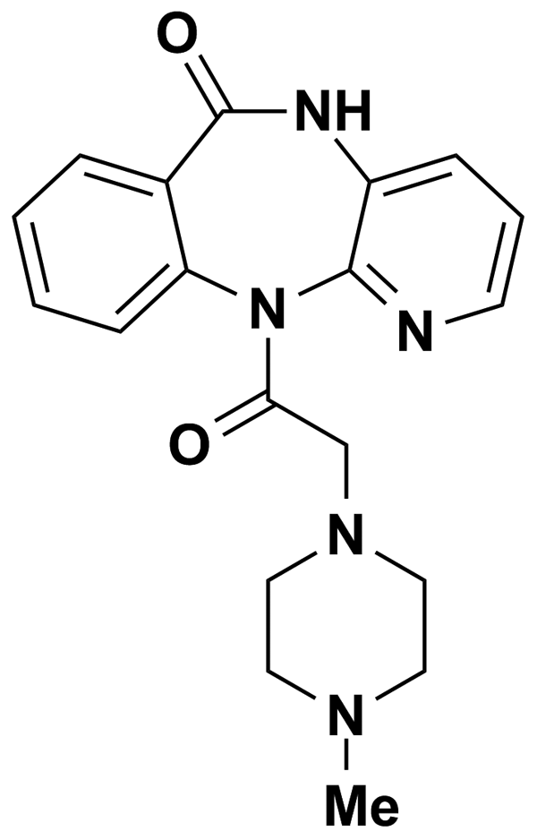
PIRETANIDE | 2.76 | Prestwick Chemical Inc. | BRD-K87990216 | 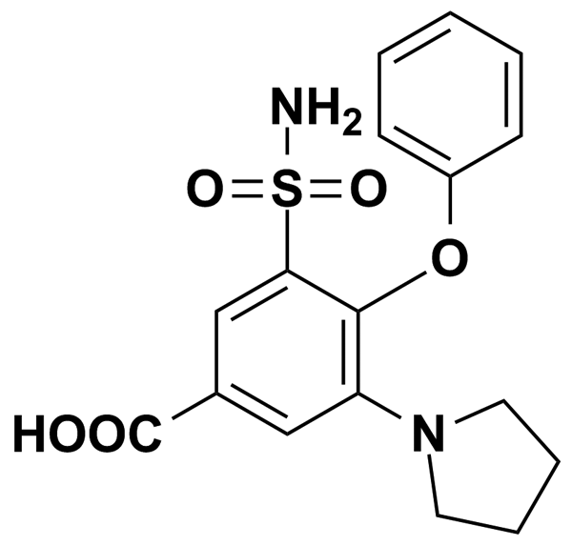
PIRIBEDIL | 5.00 | Biomol International Inc. | BRD-K47936004 | 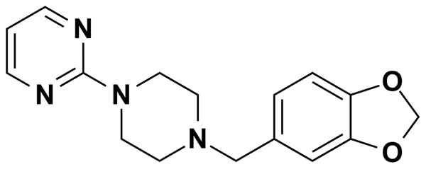
PIRIBEDIL HYDROCHLORIDE | 2.99 | Prestwick Chemical Inc. | BRD-K47936004 | 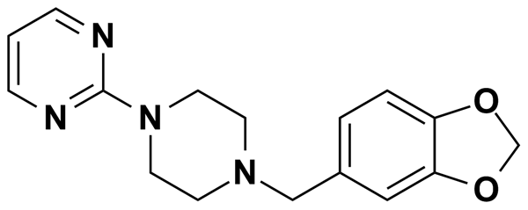
PIROMIDIC ACID | 3.47 | Prestwick Chemical Inc. | BRD-K37682401 | 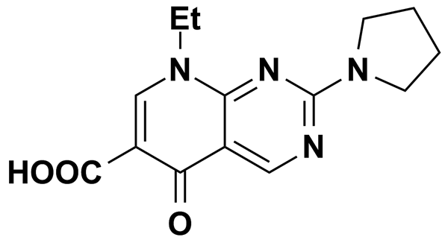
PONALRESTAT | 5.00 | MicroSource Discovery Systems Inc. | BRD-K68332390 | 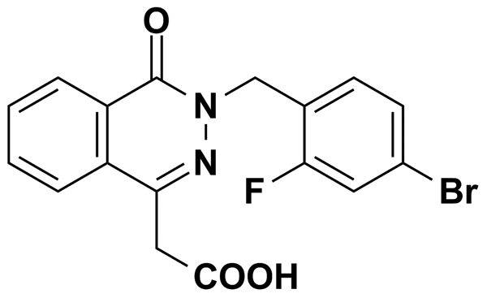
PP1 | 8.89 | Biomol International Inc. | BRD-K47598052 | 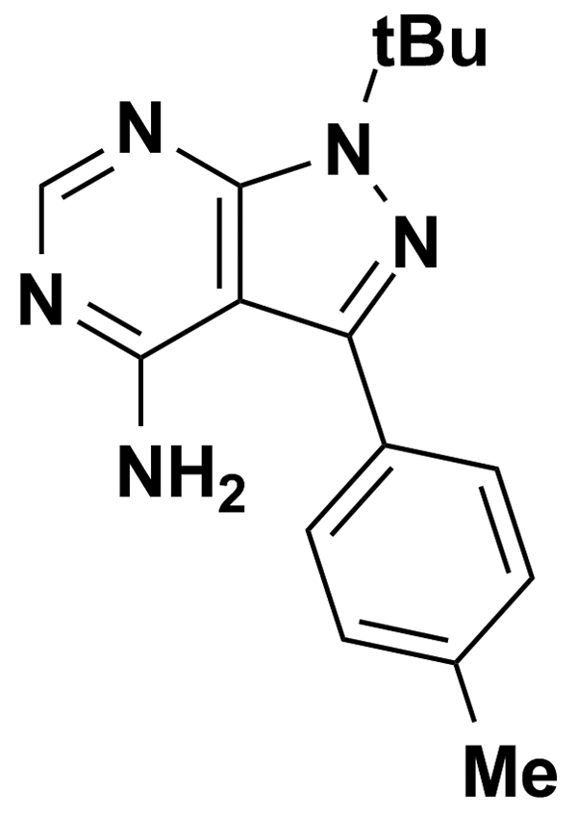
PRACTOLOL | 3.75 | Prestwick Chemical Inc. | BRD-A41304429 | 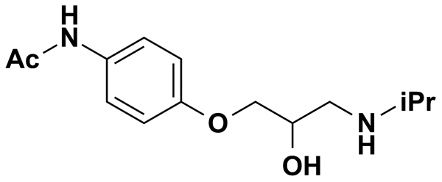
PRAMOXINE HYDROCHLORIDE | 3.03 | Prestwick Chemical Inc. | BRD-K46523383 | 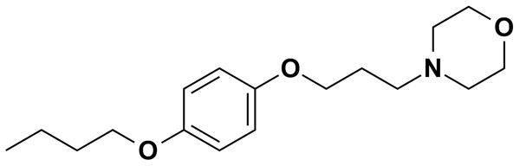
PREDNISOLONE | 5.00 | MicroSource Discovery Systems Inc. | BRD-A27887842 | 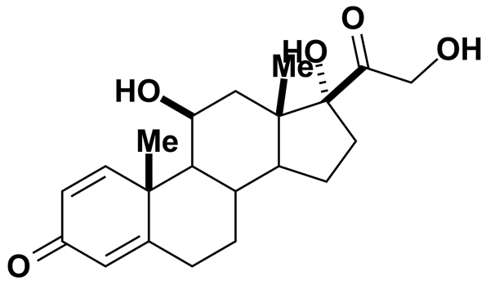
PREDNISOLONE ACETATE | 5.00 | MicroSource Discovery Systems Inc. | BRD-A01643550 | 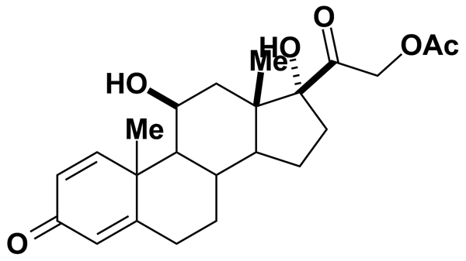
PREDNISONE | 5.00 | MicroSource Discovery Systems Inc. | BRD-A62525898 | 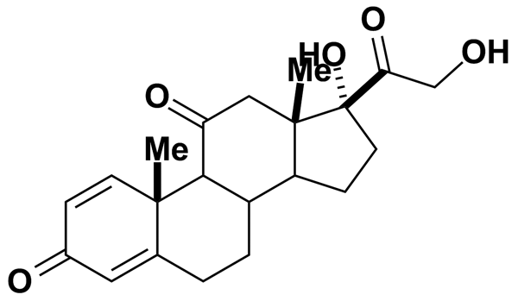
PRIDINOL METHANESULFONATE SALT | 2.55 | Prestwick Chemical Inc. | BRD-K17565903 | 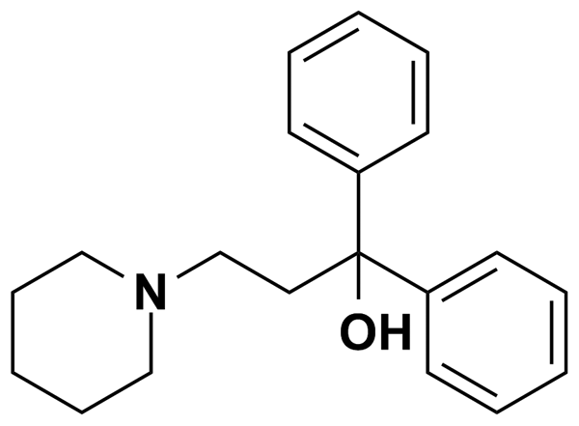
PRILOCAINE HYDROCHLORIDE | 3.89 | Prestwick Chemical Inc. | BRD-A53952395 | 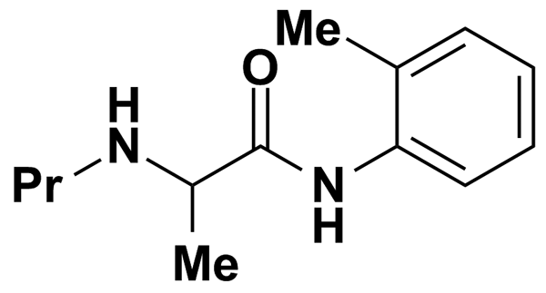
PRIMIDONE | 5.00 | Biomol International Inc. | BRD-K32247306 | 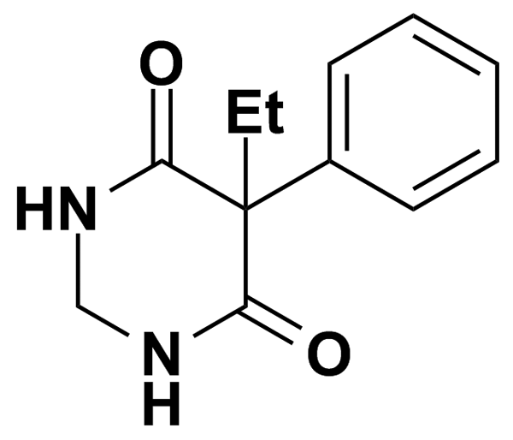
PROADIFEN HYDROCHLORIDE | 2.56 | Prestwick Chemical Inc. | BRD-K46317332 | 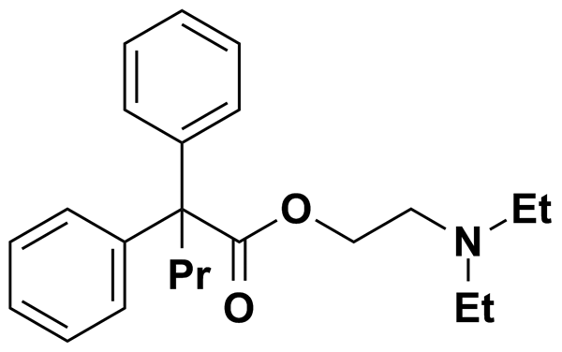
PROBENECID | 3.50 | Prestwick Chemical Inc. | BRD-K95237249 | 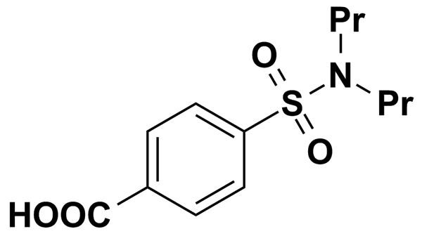
PROCAINAMIDE | 10.62 | Biomol International Inc. | BRD-K75089421 | 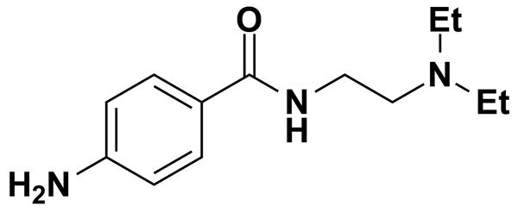
PROCAINAMIDE HYDROCHLORIDE | 3.68 | Prestwick Chemical Inc. | BRD-K75089421 | 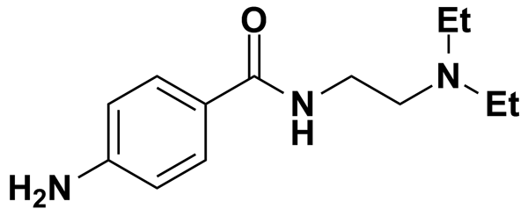
PROCAINE HYDROCHLORIDE | 3.67 | Prestwick Chemical Inc. | BRD-K24616672 | 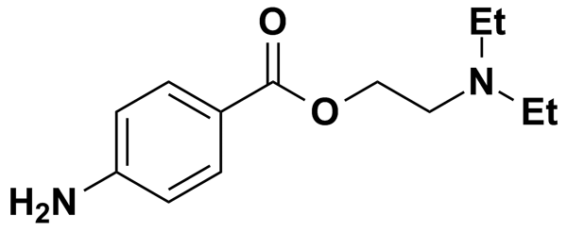
PROCHLORPERAZINE DIMALEATE | 1.65 | Prestwick Chemical Inc. | BRD-K19352500 | 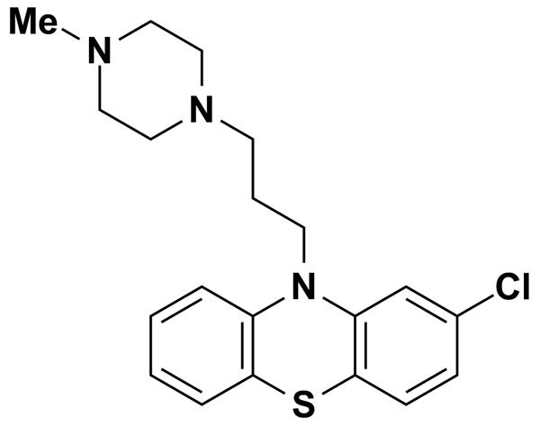
PROCHLORPERAZINE EDISYLATE | 5.00 | MicroSource Discovery Systems Inc. | BRD-K19352500 | 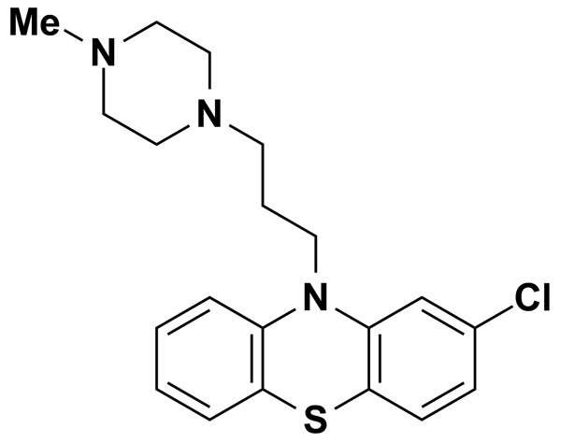
PROGESTERONE | 3.18 | Prestwick Chemical Inc. | BRD-K64994968 | 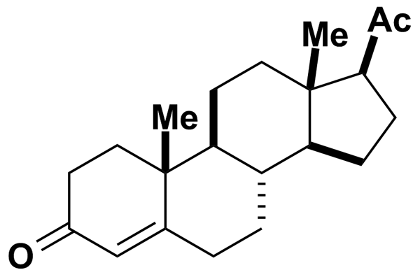
PROGLUMIDE | 2.99 | Prestwick Chemical Inc. | BRD-A44863528 | 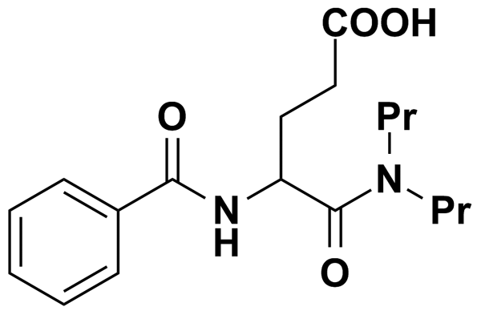
PRONETHALOL HYDROCHLORIDE | 3.76 | Prestwick Chemical Inc. | BRD-A87715314 | 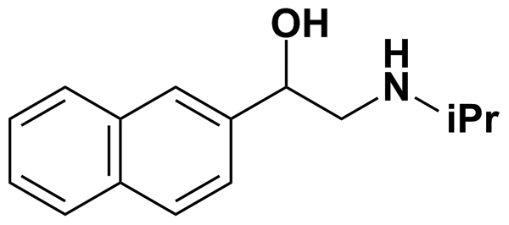
PROPACHLOR | 5.00 | MicroSource Discovery Systems Inc. | BRD-K50343025 | 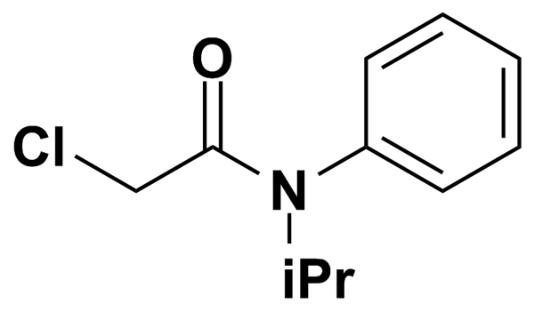
PROPAFENONE | 7.32 | Biomol International Inc. | BRD-A26334849 | 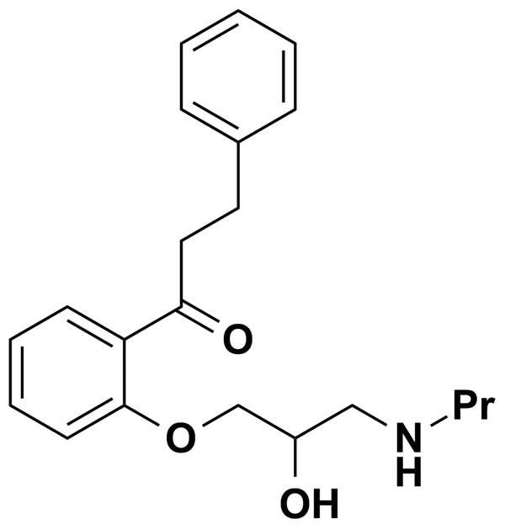
PROPAFENONE HYDROCHLORIDE | 2.65 | Prestwick Chemical Inc. | BRD-A26334849 | 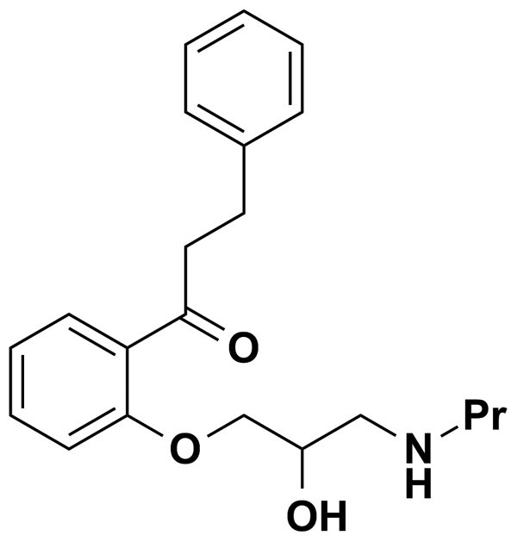
PROPIOMAZINE MALEATE | 5.00 | MicroSource Discovery Systems Inc. | BRD-A10471441 | 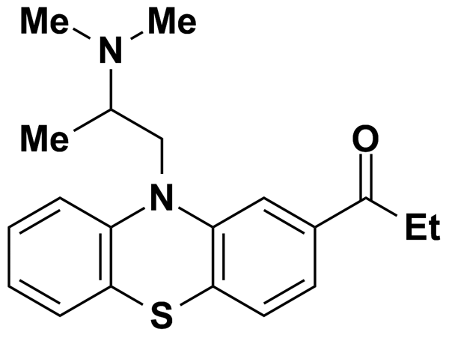
PROPOFOL | 5.00 | Biomol International Inc. | BRD-K82255054 | 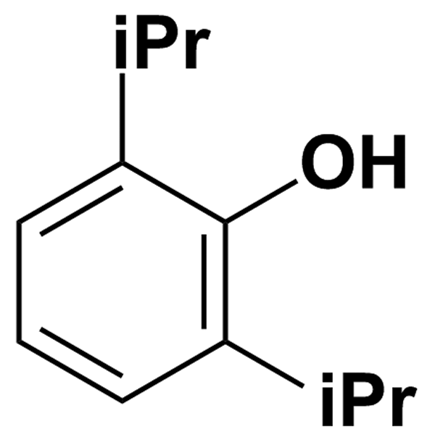
PROPYLTHIOURACIL | 5.87 | Prestwick Chemical Inc. | BRD-K48168960 | 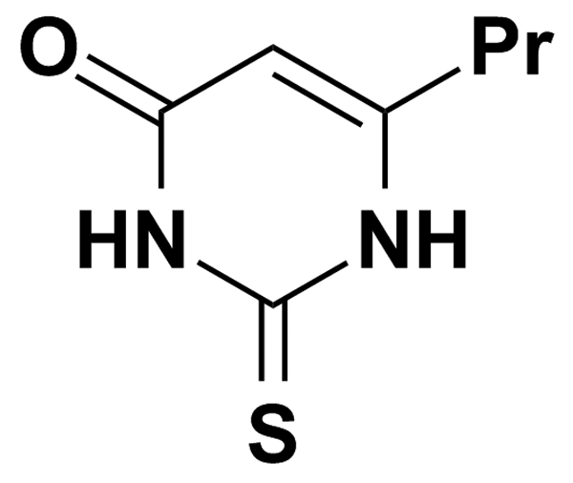
PROSTAGLANDIN A1 | 0.50 | Biomol International Inc. | BRD-K04010869 | 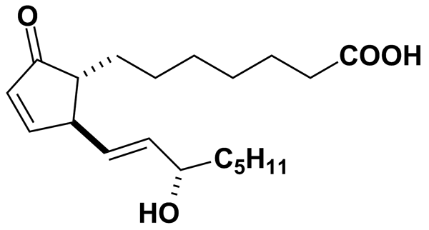
PROSTAGLANDIN A2 | 0.50 | Biomol International Inc. | BRD-K34782918 | 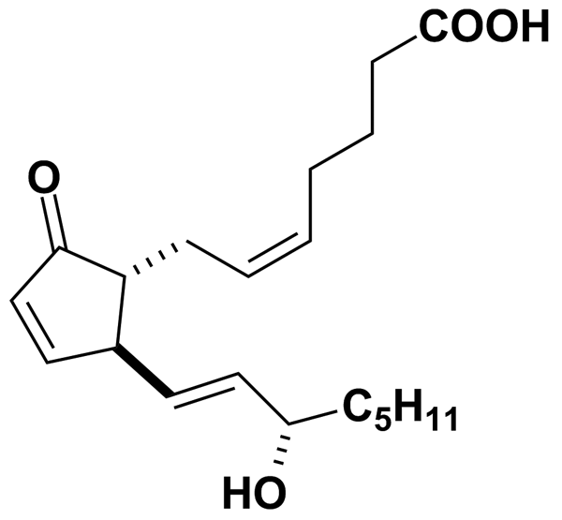
PSEUDOEPHEDRINE HYDROCHLORIDE | 5.00 | MicroSource Discovery Systems Inc. | BRD-K84175871 | 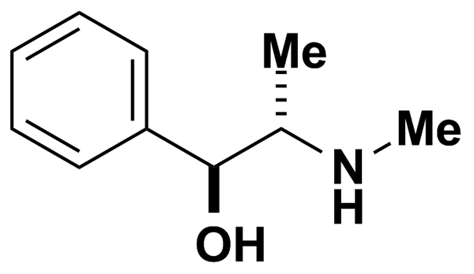
PURPUROGALLIN | 5.00 | MicroSource Discovery Systems Inc. | BRD-K31023358 | 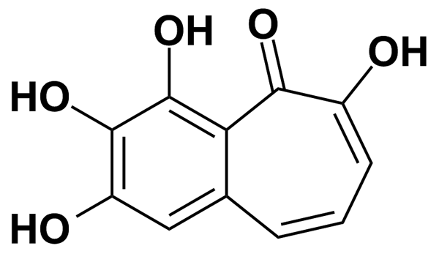
PYRILAMINE MALEATE | 2.49 | Prestwick Chemical Inc. | BRD-K97564742 | 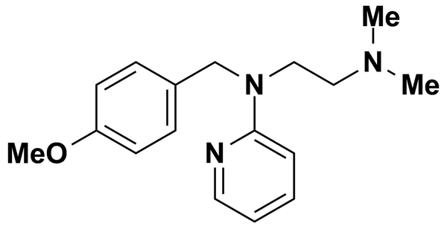
PYRIMETHAMINE | 4.02 | Prestwick Chemical Inc. | BRD-K88429204 | 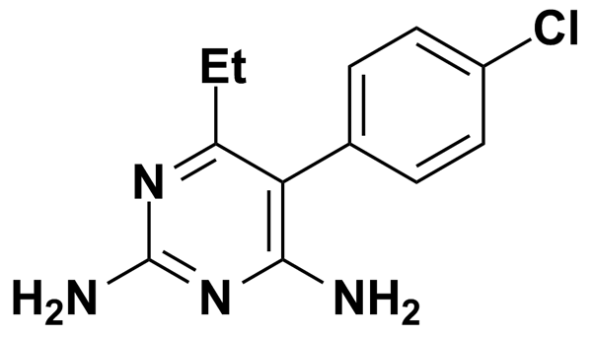
PYRITHYLDIONE | 5.98 | Prestwick Chemical Inc. | BRD-K36116267 | 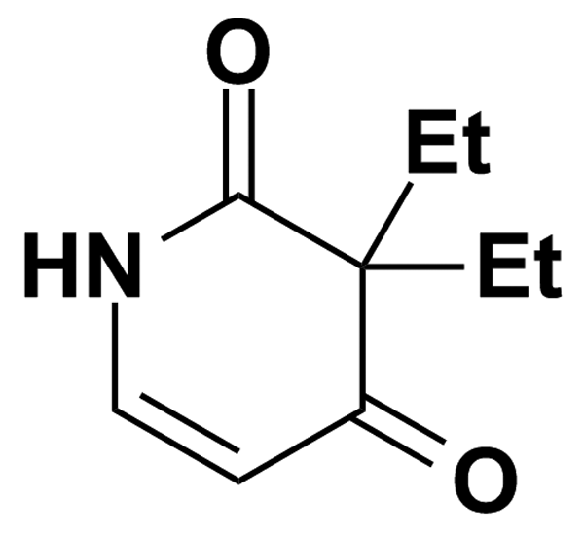
QUERCETINE DIHYDRATE | 2.96 | Prestwick Chemical Inc. | BRD-K97399794 | 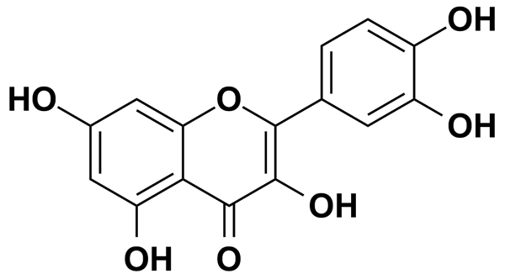
QUINACRINE DIHYDROCHLORIDE DIHYDRATE | 1.96 | Prestwick Chemical Inc. | BRD-A45889380 | 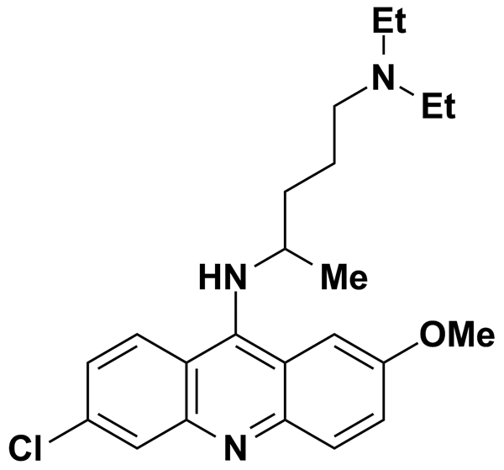
QUIPAZINE | 5.00 | Biomol International Inc. | BRD-K77925998 | 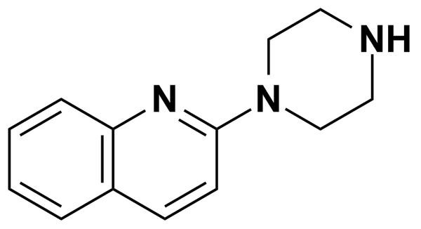
QUIPAZINE DIMALEATE SALT | 2.25 | Prestwick Chemical Inc. | BRD-K77925998 | 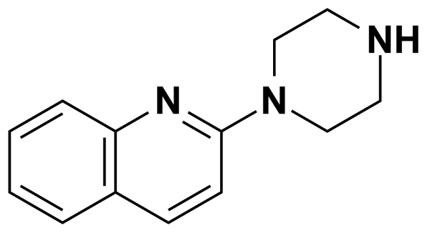
QUIPAZINE MALEATE | 5.00 | MicroSource Discovery Systems Inc. | BRD-K77925998 | 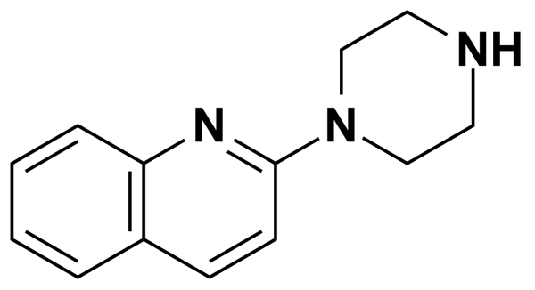
R(-)-APOMORPHINE | 5.00 | Biomol International Inc. | BRD-K76022557 | 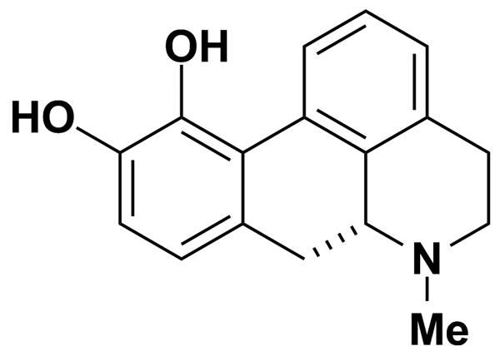
RACEPHEDRINE HYDROCHLORIDE | 5.00 | MicroSource Discovery Systems Inc. | BRD-A54236247 | 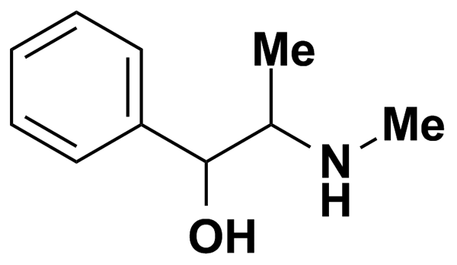
RAUWOLSCINE HYDROCHLORIDE | 2.56 | Prestwick Chemical Inc. | BRD-K77474816 | 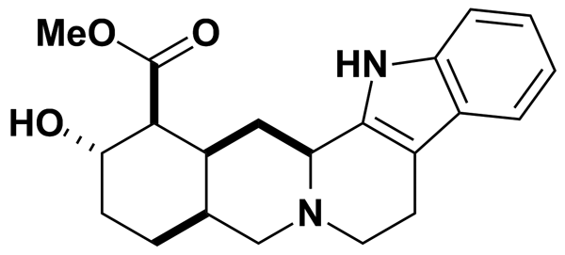
RESVERATROL | 10.95 | Biomol International Inc. | BRD-K80738081 | 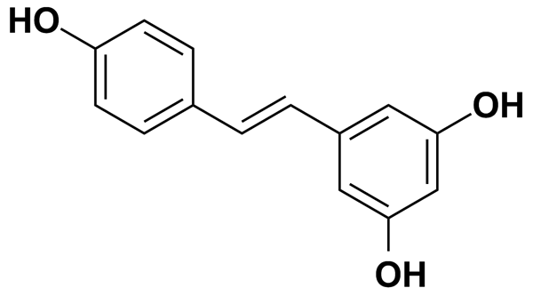
REV-5901 | 0.50 | Biomol International Inc. | BRD-A68281735 | 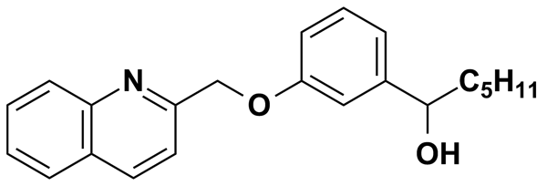
RILUZOLE | 5.00 | Biomol International Inc. | BRD-K21283037 | 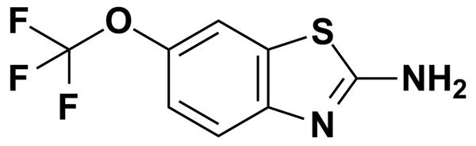
RILUZOLE HYDROCHLORIDE | 3.69 | Prestwick Chemical Inc. | BRD-K21283037 | 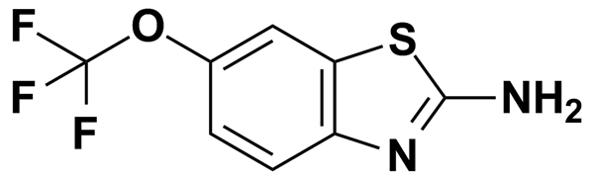
RISPERIDONE | 5.00 | Biomol International Inc. | BRD-K53857191 | 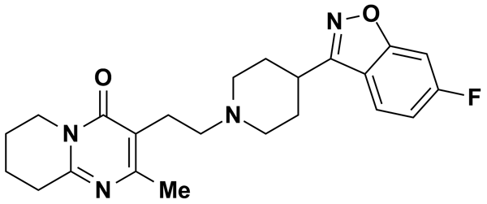
RITANSERIN | 5.00 | MicroSource Discovery Systems Inc. | BRD-K40887525 | 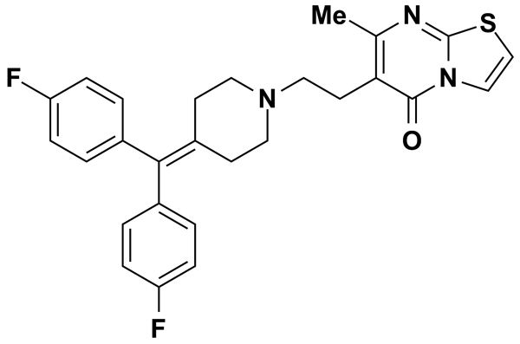
RO 20-1724 | 8.98 | Biomol International Inc. | BRD-A07207424 | 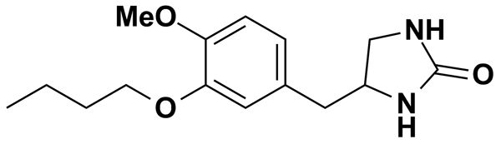
RO 31-8220 | 5.46 | Biomol International Inc. | BRD-K06543683 | 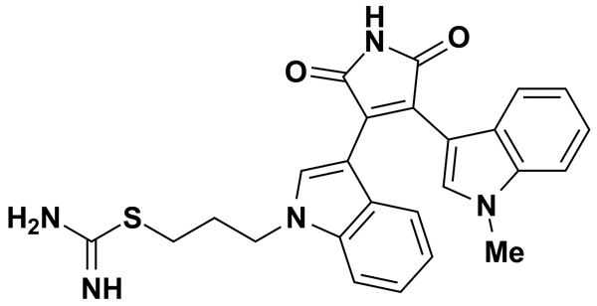
ROFECOXIB | 5.00 | MicroSource Discovery Systems Inc. | BRD-K21733600 | 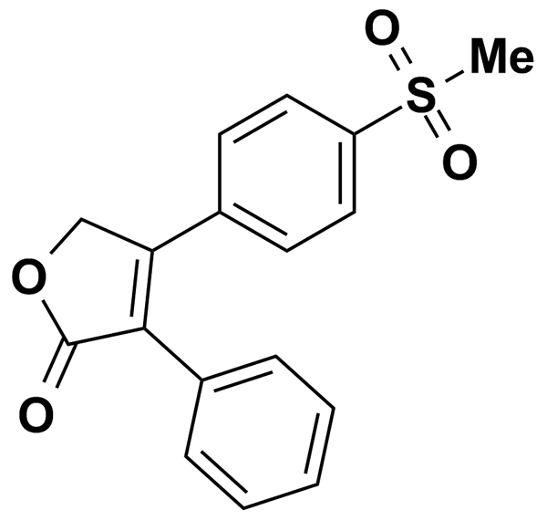
ROPINIROLE HCL | 5.00 | Biomol International Inc. | BRD-K15933101 | 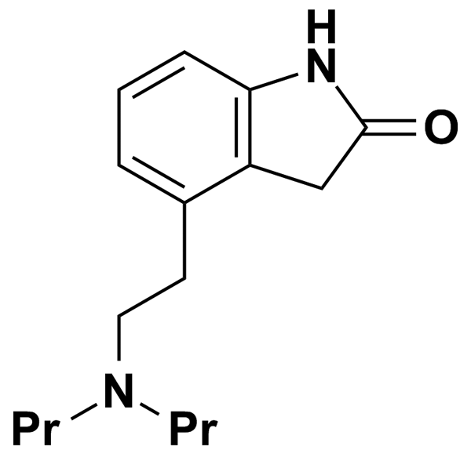
ROSIGLITAZONE | 5.00 | MicroSource Discovery Systems Inc. | BRD-A97437073 | 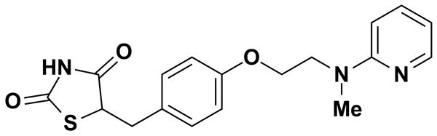
S,S,S,-TRIBUTYLPHOSPHOROTRITHIOATE | 5.00 | MicroSource Discovery Systems Inc. | BRD-K02837237 | 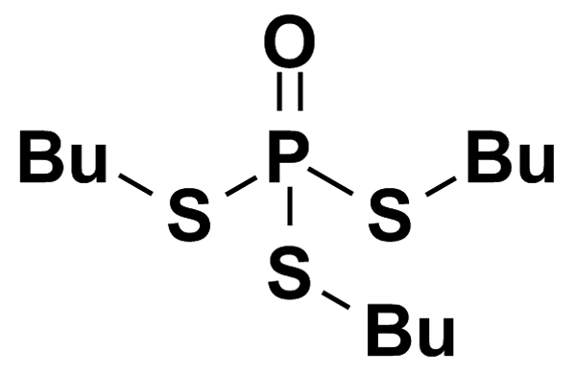
SALBUTAMOL | 4.18 | Prestwick Chemical Inc. | BRD-A88254928 | 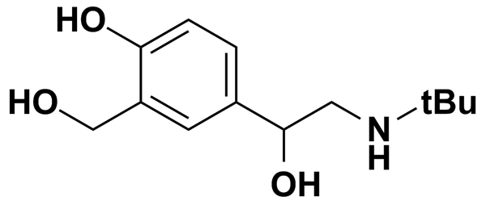
SALICYL ALCOHOL | 5.00 | MicroSource Discovery Systems Inc. | BRD-K08493205 | 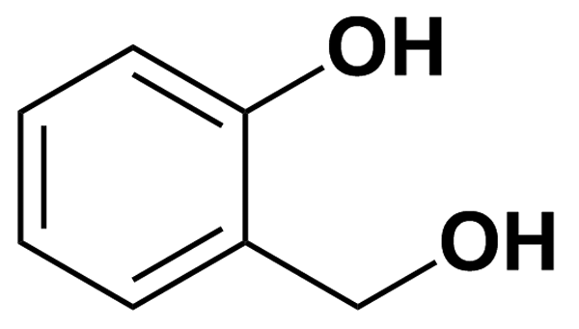
SALICYLAMIDE | 5.00 | MicroSource Discovery Systems Inc. | BRD-K81130846 | 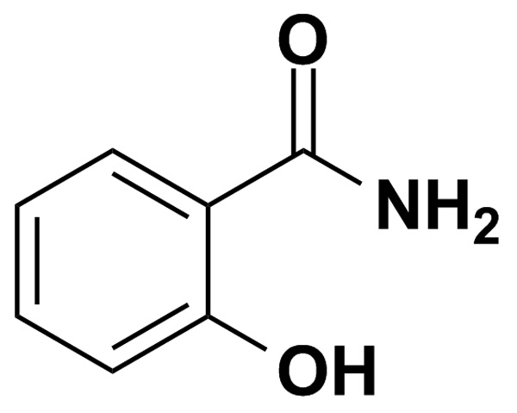
SB 202190 | 7.55 | Biomol International Inc. | BRD-K54330070 | 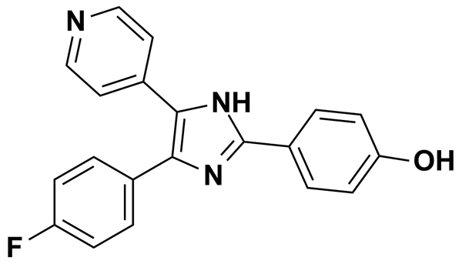
SB-415286 | 6.95 | Biomol International Inc. | BRD-K76805682 | 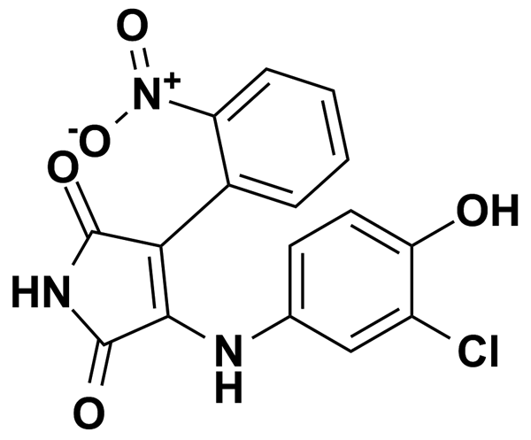
SCOPOLETIN | 5.20 | Prestwick Chemical Inc. | BRD-K96163925 | 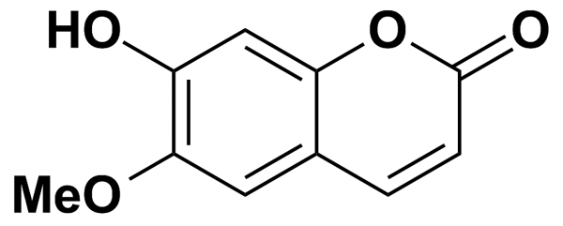
SDZ-201106 | 5.36 | Biomol International Inc. | BRD-A64553394 | 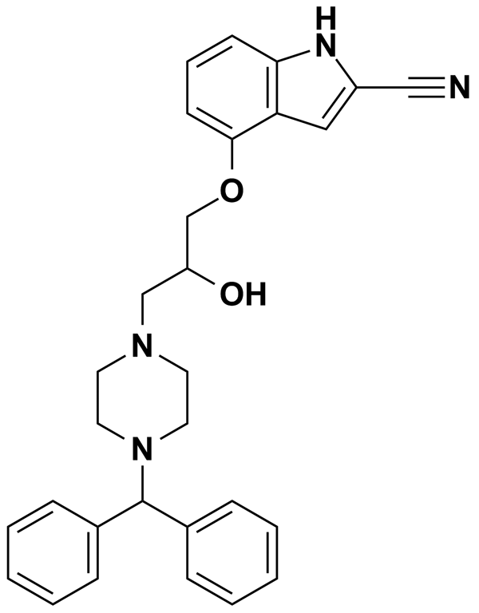
SELEGILINE HYDROCHLORIDE | 4.47 | Prestwick Chemical Inc. | BRD-K86434416 | 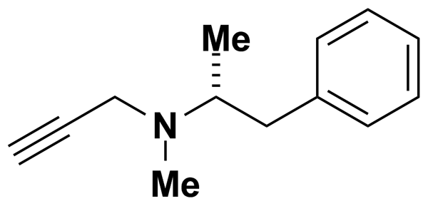
SILDENAFIL | 5.00 | MicroSource Discovery Systems Inc. | BRD-K79759585 | 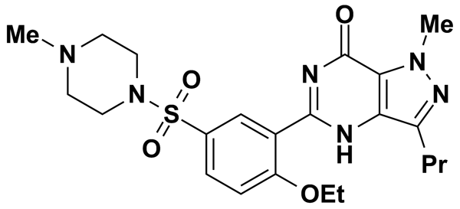
SKF-96365 | 6.82 | Biomol International Inc. | BRD-A72703248 | 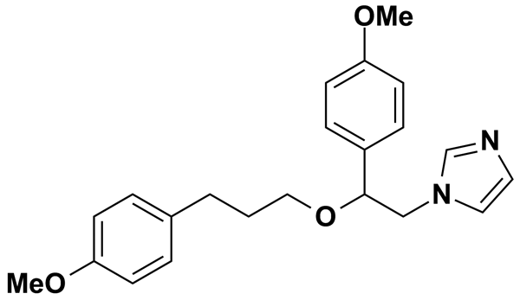
SPIPERONE | 2.53 | Prestwick Chemical Inc. | BRD-K55468218 | 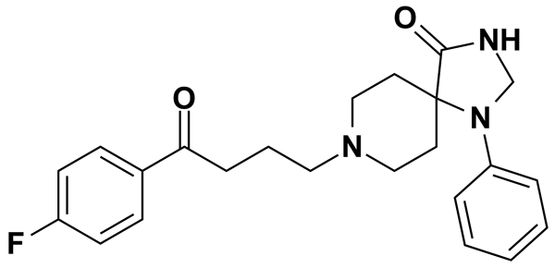
STAUROSPORINE | 5.36 | Biomol International Inc. | BRD-K17953061 | 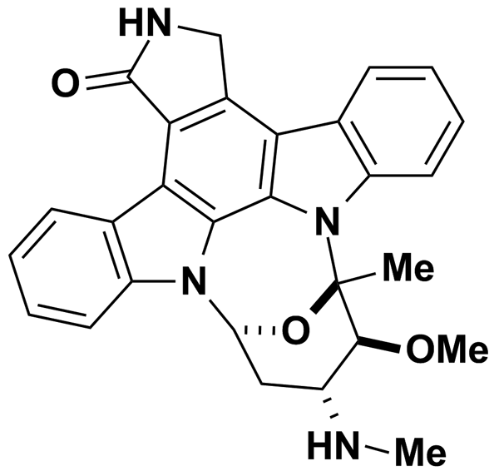
SUCCINYLSULFATHIAZOLE | 2.81 | Prestwick Chemical Inc. | BRD-K01950558 | 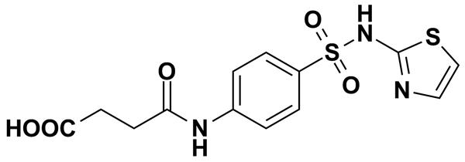
SULFABENZAMIDE | 3.62 | Prestwick Chemical Inc. | BRD-K59983611 | 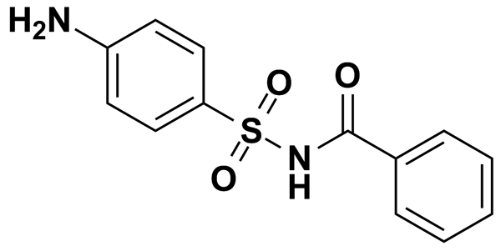
SULFADIAZINE | 4.00 | Prestwick Chemical Inc. | BRD-K32273377 | 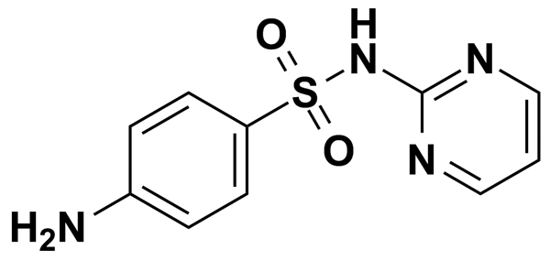
SULFADIMETHOXINE | 3.22 | Prestwick Chemical Inc. | BRD-K71125014 | 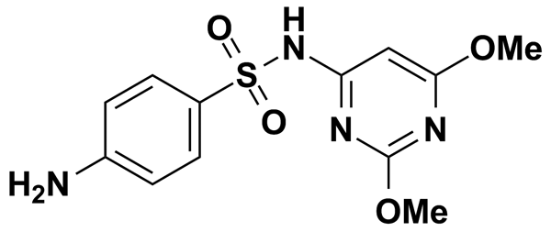
SULFAMERAZINE | 3.78 | Prestwick Chemical Inc. | BRD-K93524252 | 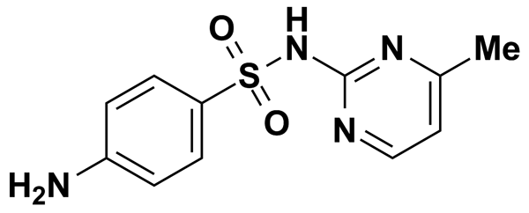
SULFAMETER | 3.57 | Prestwick Chemical Inc. | BRD-K87492696 | 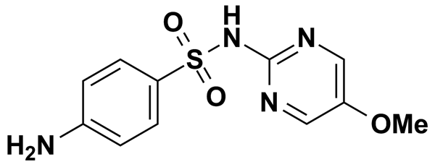
SULFAMETHAZINE | 5.00 | MicroSource Discovery Systems Inc. | BRD-K11640013 | 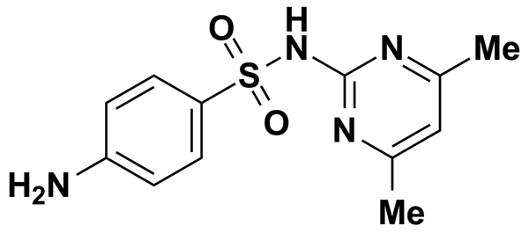
SULFAMETHAZINE SODIUM SALT | 3.32 | Prestwick Chemical Inc. | BRD-K11640013 | 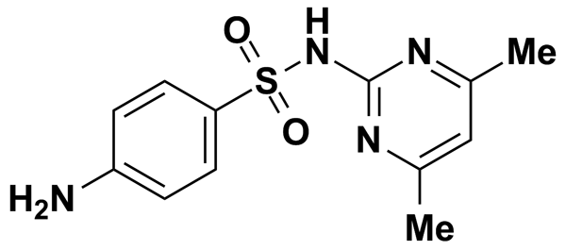
SULFAMETHIZOLE | 3.70 | Prestwick Chemical Inc. | BRD-K31682896 | 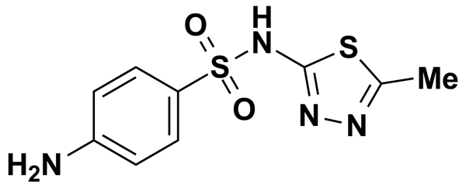
SULFAMETHOXAZOLE | 3.95 | Prestwick Chemical Inc. | BRD-K28494619 | 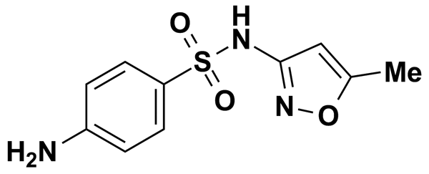
SULFAMETHOXYPYRIDAZINE | 3.57 | Prestwick Chemical Inc. | BRD-K00938507 | 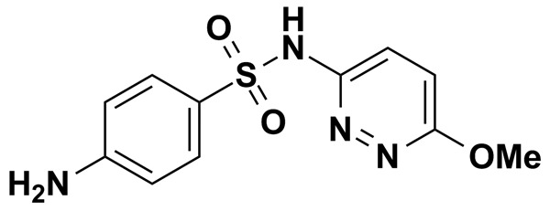
SULFANITRAN | 5.00 | MicroSource Discovery Systems Inc. | BRD-K76845197 | 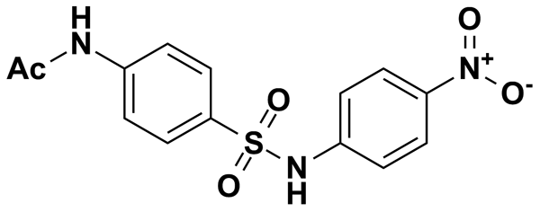
SULFAPHENAZOLE | 3.18 | Prestwick Chemical Inc. | BRD-K10671814 | 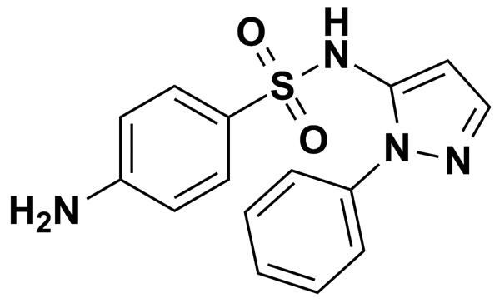
SULFAPYRIDINE | 4.01 | Prestwick Chemical Inc. | BRD-K41406082 | 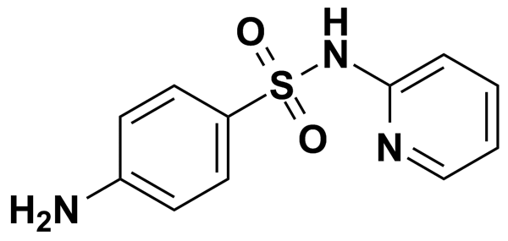
SULFAQUINOXALINE SODIUM SALT | 3.09 | Prestwick Chemical Inc. | BRD-K71133585 | 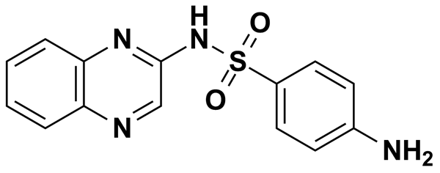
SULFATHIAZOLE | 3.92 | Prestwick Chemical Inc. | BRD-K14705039 | 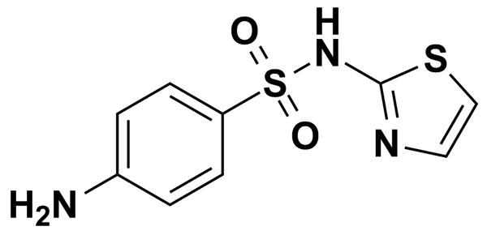
SULFINPYRAZONE | 2.47 | Prestwick Chemical Inc. | BRD-A36217750 | 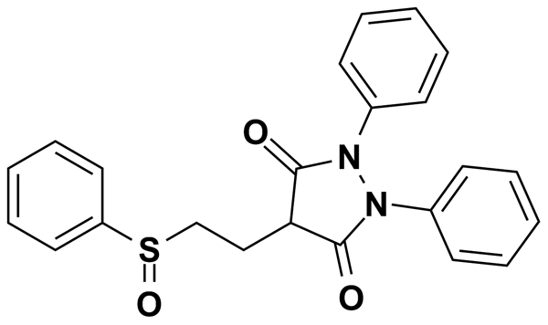
SULFISOXAZOLE | 3.74 | Prestwick Chemical Inc. | BRD-K50859149 | 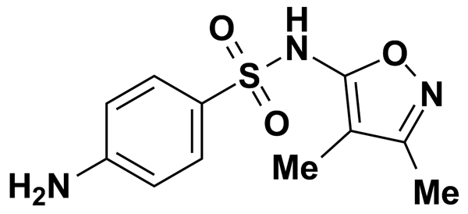
SULINDAC | 2.81 | Prestwick Chemical Inc. | BRD-A13946108 | 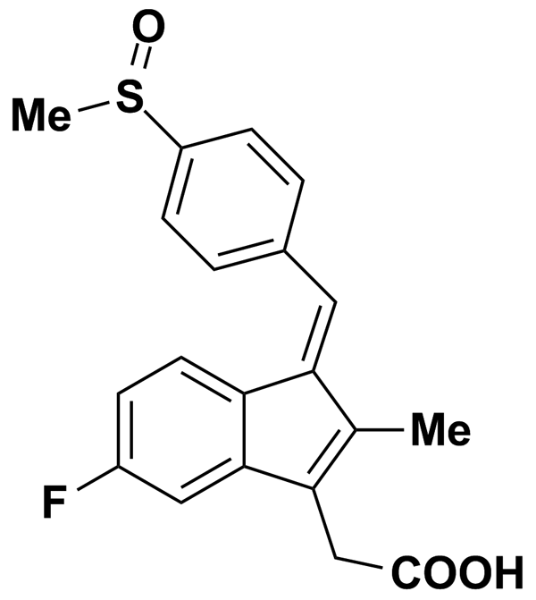
SUMATRIPTAN | 5.00 | MicroSource Discovery Systems Inc. | BRD-K50938287 | 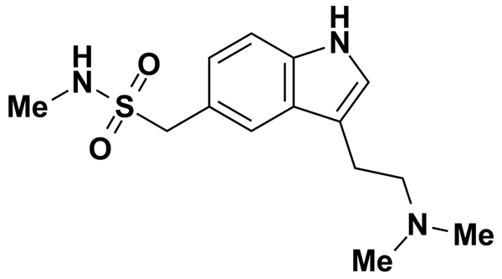
SUXIBUZONE | 2.28 | Prestwick Chemical Inc. | BRD-K78815826 | 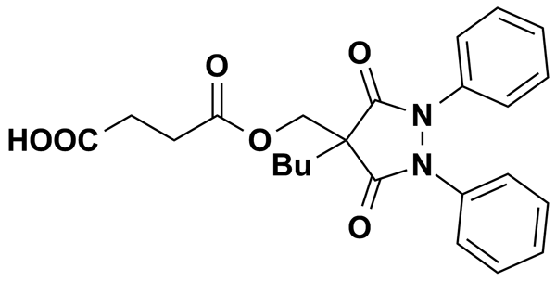
TACRINE HYDROCHLORIDE HYDRATE | 4.26 | Prestwick Chemical Inc. | BRD-K81473089 | 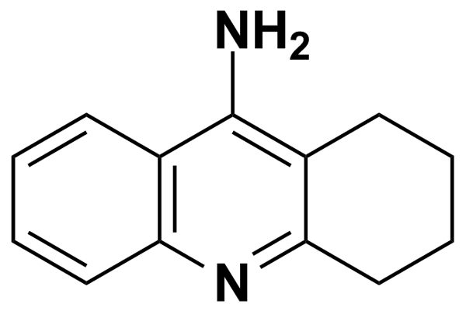
TAMOXIFEN CITRATE | 1.77 | Prestwick Chemical Inc. | BRD-K93754473 | 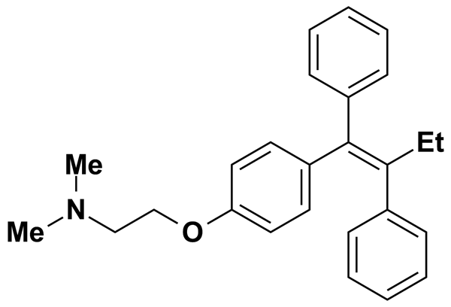
TEGASEROD | 5.00 | MicroSource Discovery Systems Inc. | BRD-K88743730 | 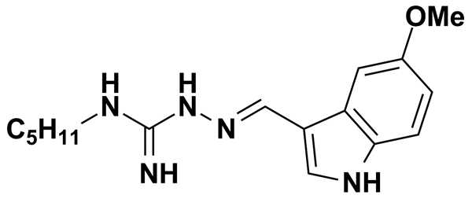
TENIPOSIDE | 5.00 | MicroSource Discovery Systems Inc. | BRD-A35588707 | 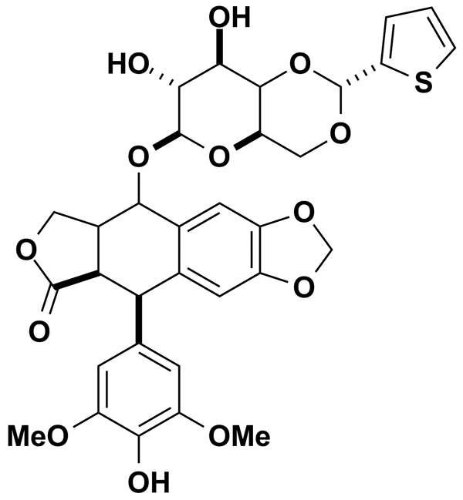
TENOXICAM | 2.96 | Prestwick Chemical Inc. | BRD-A22844106 | 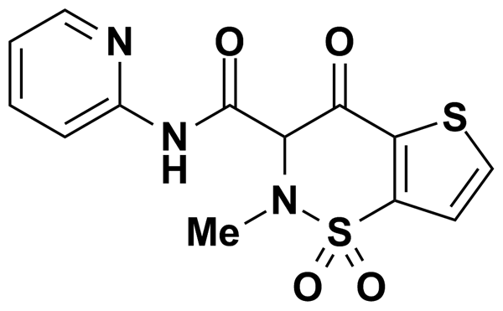
TERBUTALINE HEMISULFATE | 5.00 | MicroSource Discovery Systems Inc. | BRD-A50157456 | 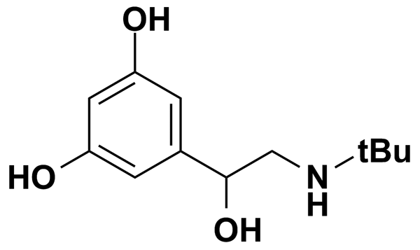
TERFENADINE | 2.12 | Prestwick Chemical Inc. | BRD-A06352418 | 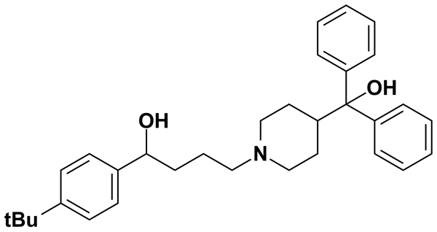
TETRACAINE HYDROCHLORIDE | 3.32 | Prestwick Chemical Inc. | BRD-K45071273 | 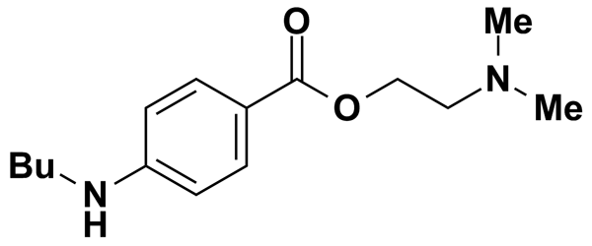
TETRAHYDROPALMATINE | 5.00 | MicroSource Discovery Systems Inc. | BRD-A43940795 | 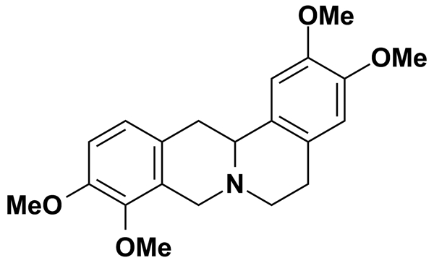
TETRAHYDROZOLINE HYDROCHLORIDE | 4.22 | Prestwick Chemical Inc. | BRD-A28856712 | 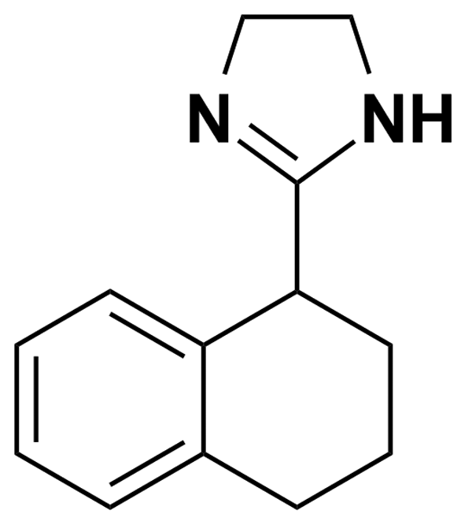
TETRANDRINE | 4.01 | Biomol International Inc. | BRD-K08078237 | 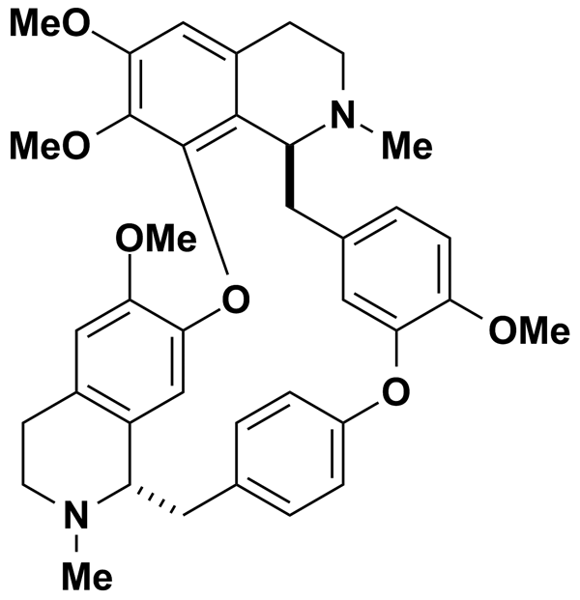
THEOPHYLLINE | 5.00 | MicroSource Discovery Systems Inc. | BRD-K97799481 | 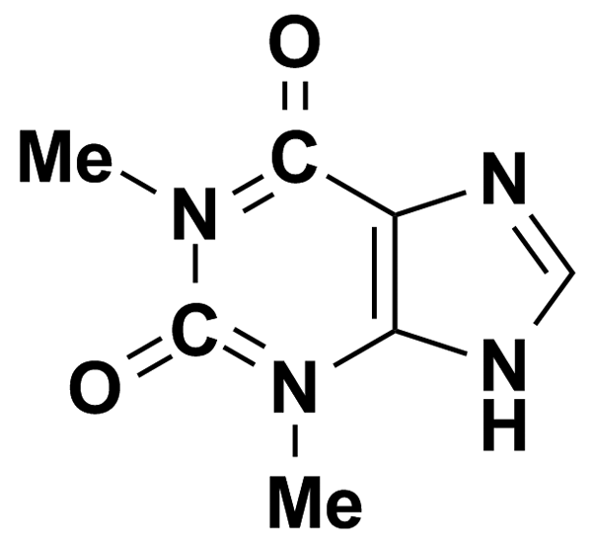
THIAMPHENICOL | 2.81 | Prestwick Chemical Inc. | BRD-K79711234 | 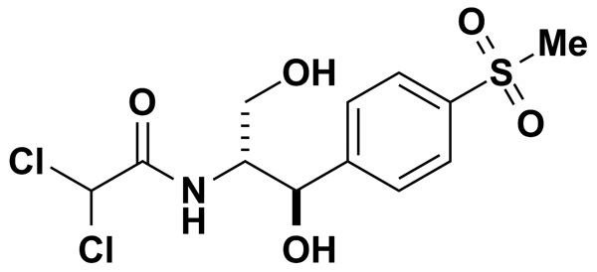
THIAMYLAL SODIUM | 5.00 | MicroSource Discovery Systems Inc. | BRD-A23970436 | 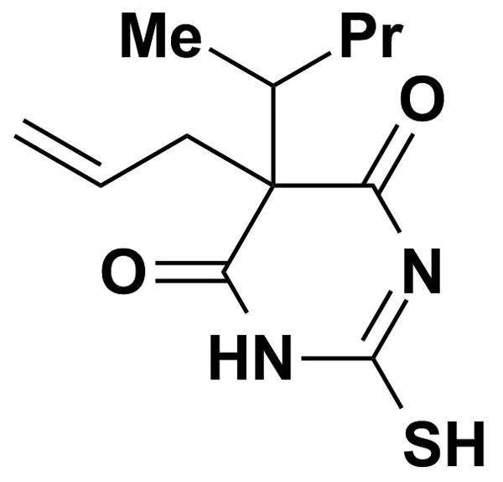
THIMEROSAL | 5.00 | MicroSource Discovery Systems Inc. | BRD-K61443650 | 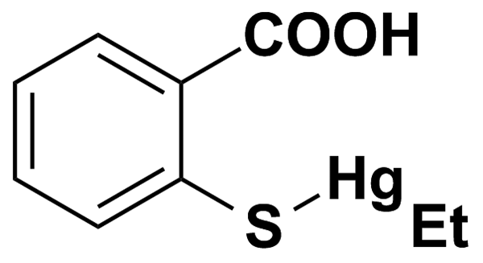
THIOTHIXENE | 5.00 | MicroSource Discovery Systems Inc. | BRD-K97309399 | 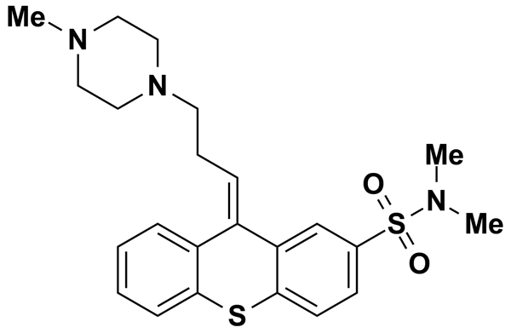
THONZYLAMINE HYDROCHLORIDE | 5.00 | MicroSource Discovery Systems Inc. | BRD-K88405679 | 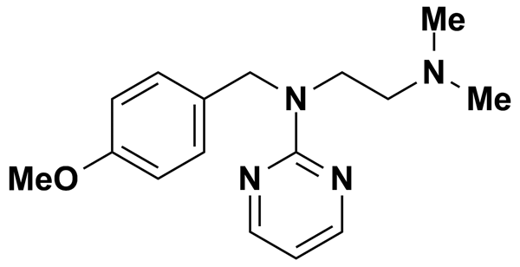
TIABENDAZOLE | 4.97 | Prestwick Chemical Inc. | BRD-K77695569 | 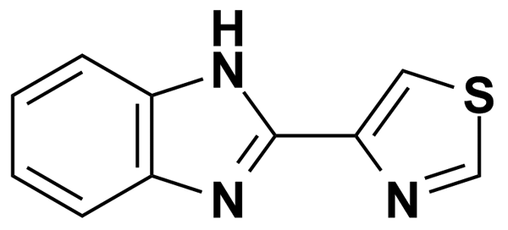
TIAPRIDE HYDROCHLORIDE | 2.74 | Prestwick Chemical Inc. | BRD-K57432881 | 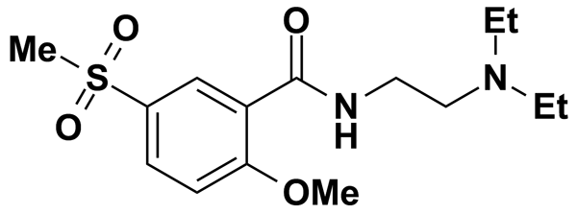
TICLOPIDINE HYDROCHLORIDE | 3.33 | Prestwick Chemical Inc. | BRD-K00603606 | 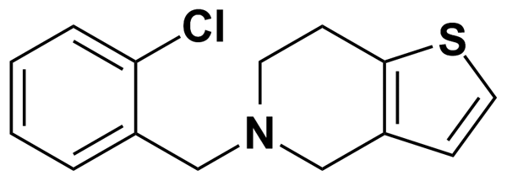
TIMOLOL MALEATE | 5.00 | MicroSource Discovery Systems Inc. | BRD-K30421593 | 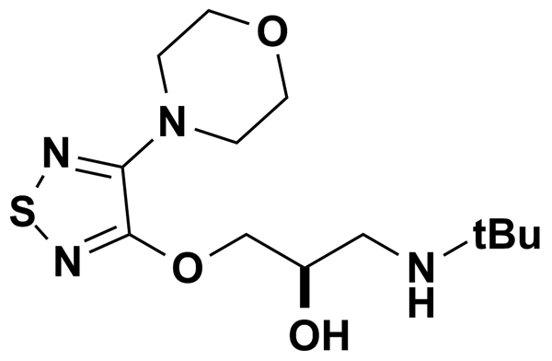
TINIDAZOLE | 4.04 | Prestwick Chemical Inc. | BRD-K89125793 | 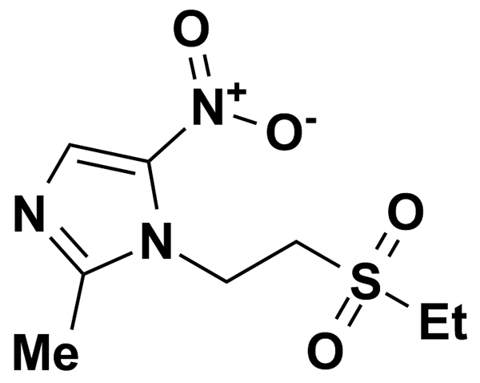
TODRALAZINE HYDROCHLORIDE | 3.72 | Prestwick Chemical Inc. | BRD-K68553471 | 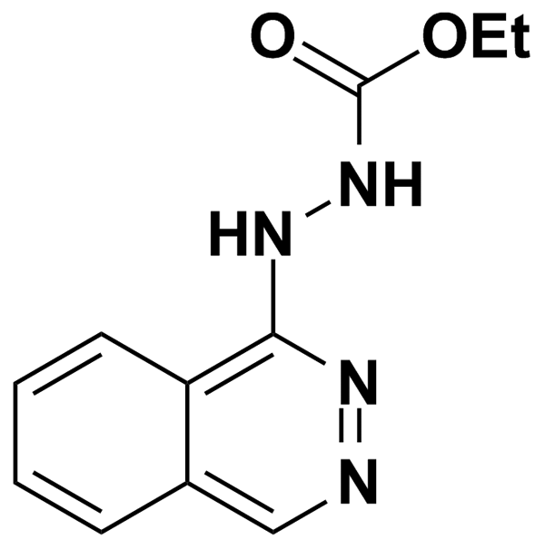
TOLAZAMIDE | 8.03 | Biomol International Inc. | BRD-K32164935 | 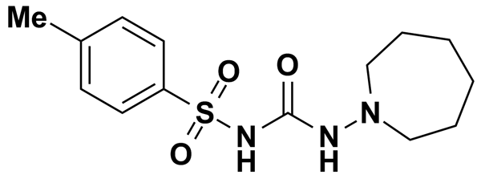
TOLAZOLINE HYDROCHLORIDE | 5.08 | Prestwick Chemical Inc. | BRD-K46211610 | 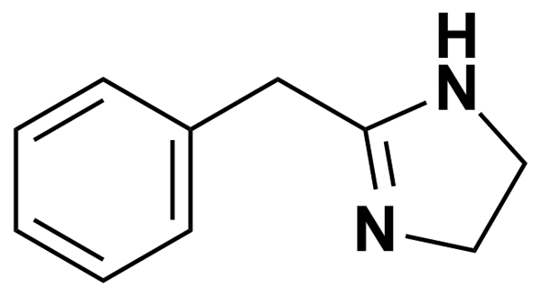
TOLBUTAMIDE | 9.25 | Biomol International Inc. | BRD-K85119730 | 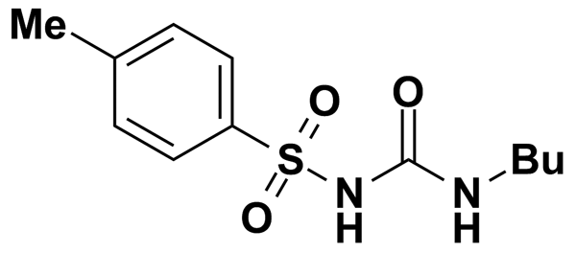
TOLMETIN SODIUM | 5.00 | MicroSource Discovery Systems Inc. | BRD-K82562631 | 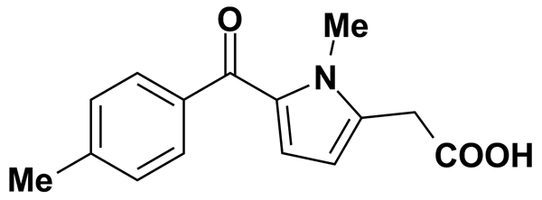
TOLNAFTATE | 3.25 | Prestwick Chemical Inc. | BRD-K44273375 | 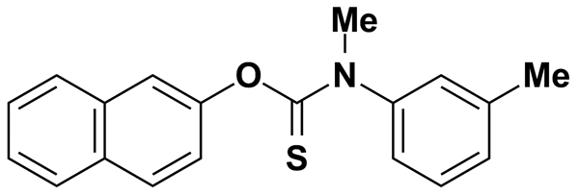
TOLPERISONE HYDROCHLORIDE | 5.00 | MicroSource Discovery Systems Inc. | BRD-A27732521 | 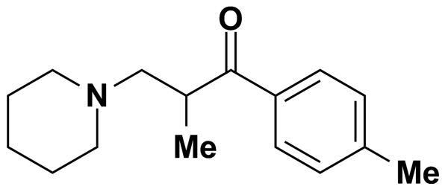
TRANYLCYPROMINE SULFATE | 5.00 | MicroSource Discovery Systems Inc. | BRD-A43974575 | 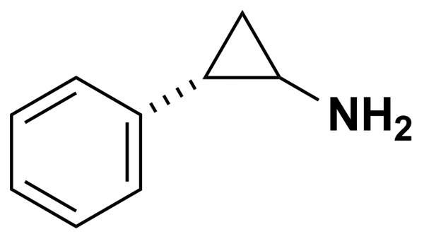
TRAZODONE HYDROCHLORIDE | 2.45 | Prestwick Chemical Inc. | BRD-K70778732 | 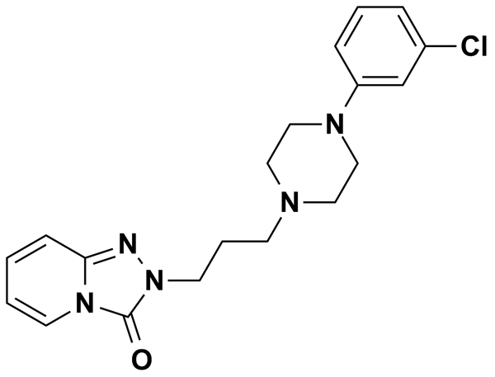
TRIALLATE | 5.00 | MicroSource Discovery Systems Inc. | BRD-K64698045 | 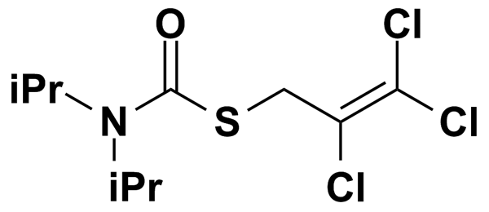
TRIAMCINOLONE ACETONIDE | 5.00 | MicroSource Discovery Systems Inc. | BRD-A92439610 | 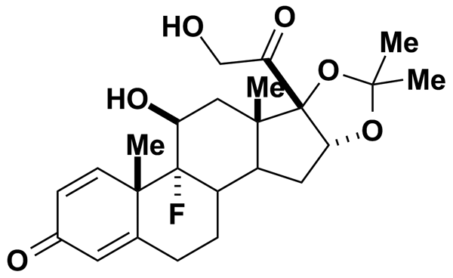
TRIAMTERENE | 3.95 | Prestwick Chemical Inc. | BRD-K92049597 | 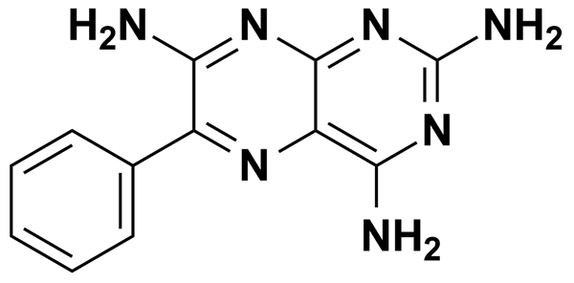
TRIFLUOPERAZINE | 5.00 | Biomol International Inc. | BRD-K89732114 | 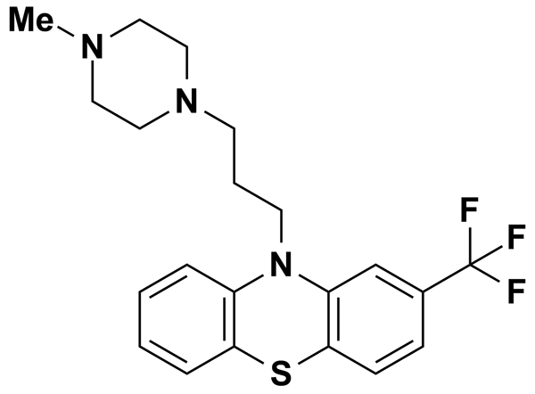
TRIFLUOPERAZINE DIHYDROCHLORIDE | 2.08 | Prestwick Chemical Inc. | BRD-K89732114 | 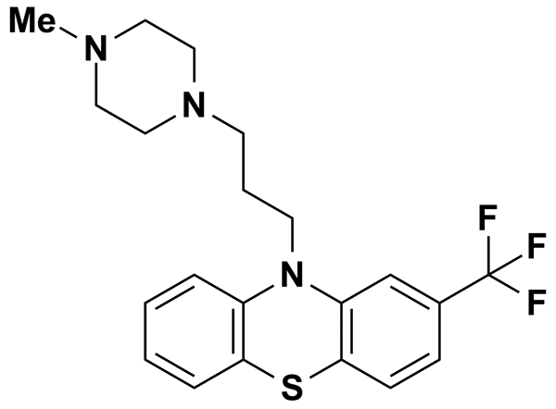
TRIHEXYPHENIDYL-D,L HYDROCHLORIDE | 2.96 | Prestwick Chemical Inc. | BRD-A48180038 | 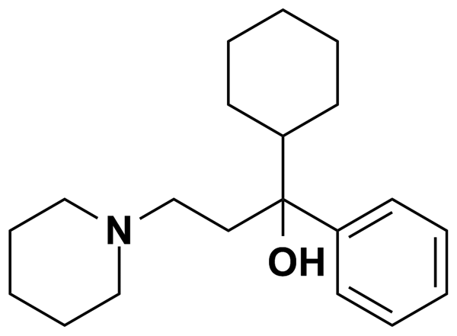
TRIM | 11.78 | Biomol International Inc. | BRD-K36851334 | 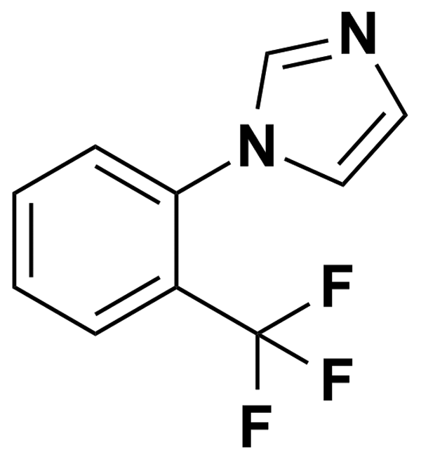
TRIMETHOBENZAMIDE HYDROCHLORIDE | 2.35 | Prestwick Chemical Inc. | BRD-K34415467 | 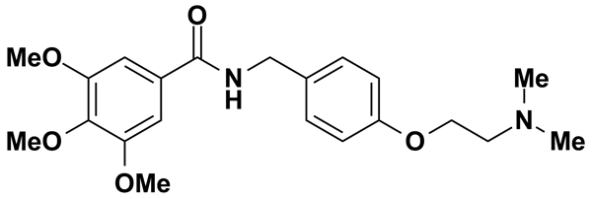
TRIMETHOPRIM | 3.44 | Prestwick Chemical Inc. | BRD-K07208025 | 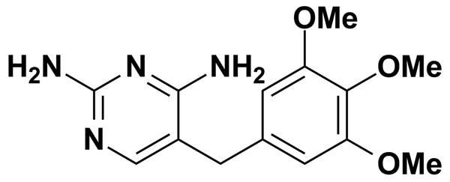
TRIMIPRAMINE MALEATE SALT | 2.44 | Prestwick Chemical Inc. | BRD-A19195498 | 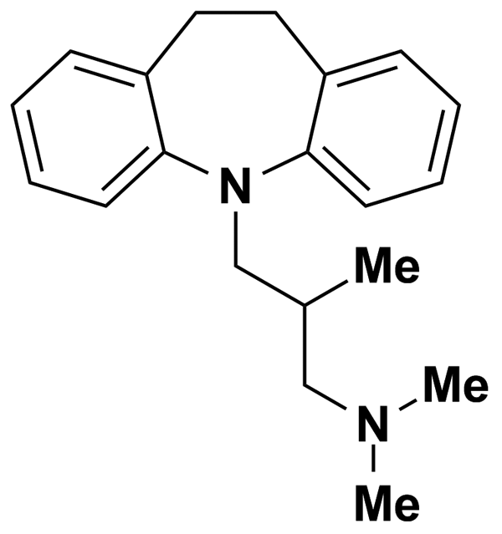
TRIPELENNAMINE CITRATE | 5.00 | MicroSource Discovery Systems Inc. | BRD-K57033106 | 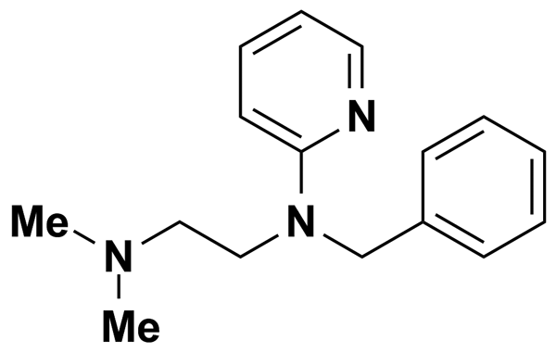
TRIPROLIDINE HYDROCHLORIDE | 3.18 | Prestwick Chemical Inc. | BRD-K11742128 | 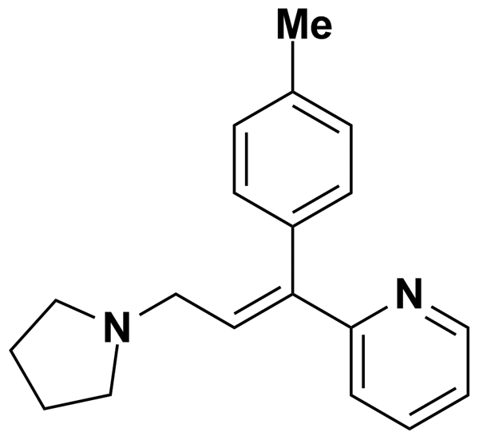
TRIPTOLIDE | 6.94 | Biomol International Inc. | BRD-K39484304 | 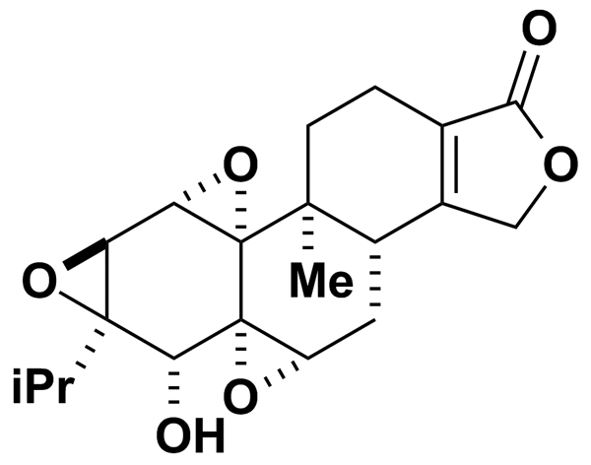
TROPICAMIDE | 3.52 | Prestwick Chemical Inc. | BRD-A79672927 | 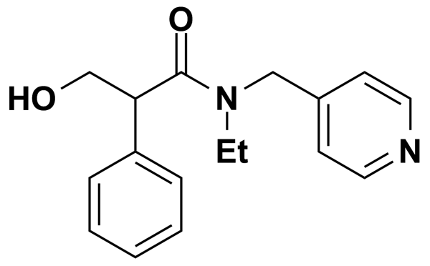
TROPISETRON | 5.00 | Biomol International Inc. | BRD-A83859836 | 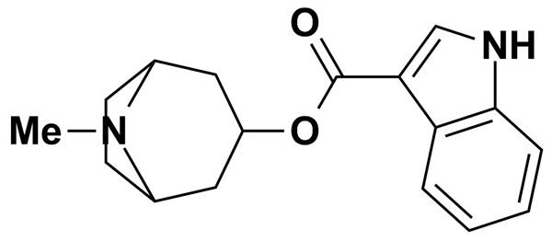
TTNPB | 0.50 | Biomol International Inc. | BRD-K49685476 | 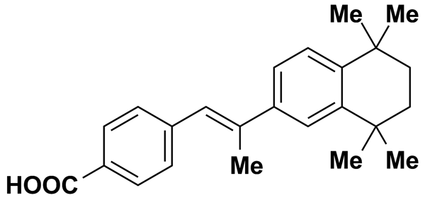
TULOBUTEROL | 5.00 | MicroSource Discovery Systems Inc. | BRD-A37441042 | 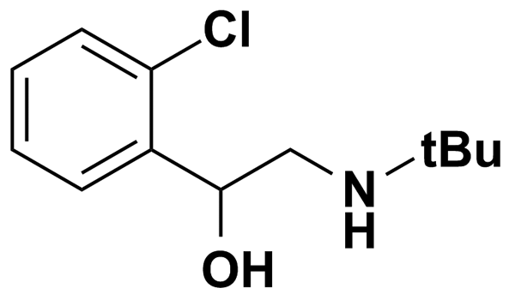
TYRPHOSTIN 1 | 13.57 | Biomol International Inc. | BRD-K41996876 | 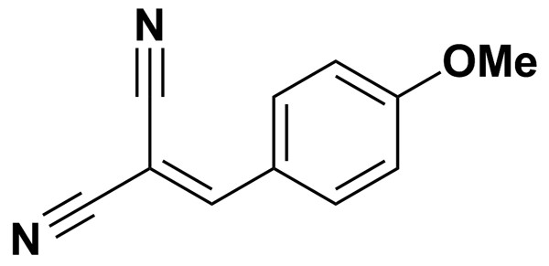
TYRPHOSTIN 46 | 5.00 | Biomol International Inc. | BRD-K60184833 | 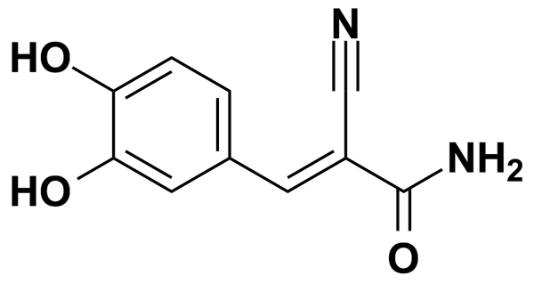
U-0126 | 5.00 | Biomol International Inc. | BRD-K18787491 | 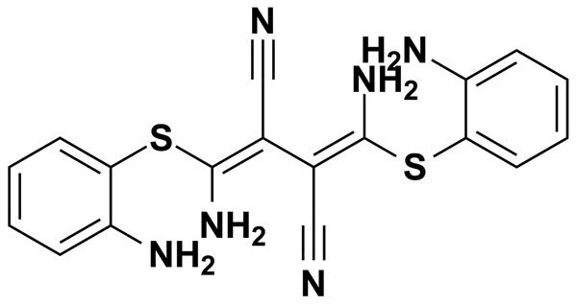
U-74389G | 4.09 | Biomol International Inc. | BRD-A96897502 | 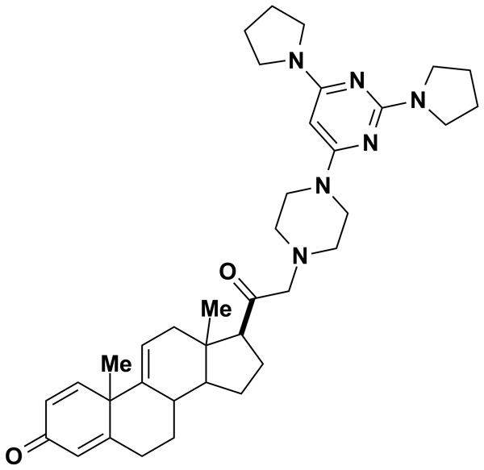
U-99194A | 5.00 | Biomol International Inc. | BRD-K70281171 | 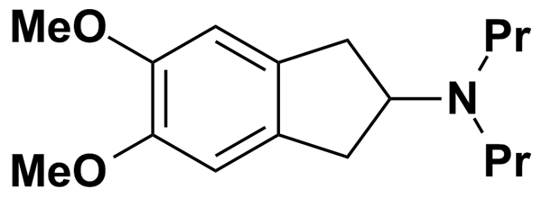
UMBELLIFERONE | 5.00 | MicroSource Discovery Systems Inc. | BRD-K87991767 | 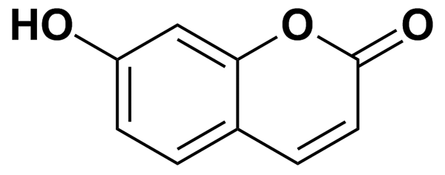
VALACYCLOVIR HYDROCHLORIDE | 5.00 | MicroSource Discovery Systems Inc. | BRD-K46435977 | 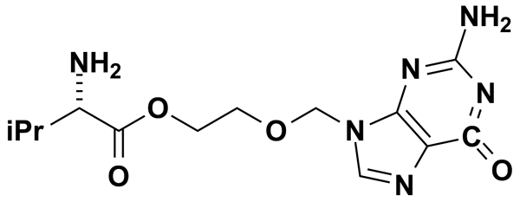
VALDECOXIB | 5.00 | MicroSource Discovery Systems Inc. | BRD-K12994359 | 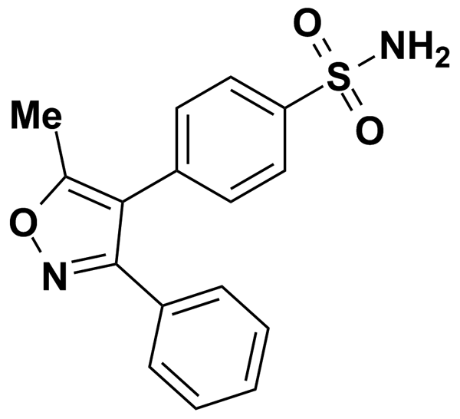
VERAPAMIL | 5.50 | Biomol International Inc. | BRD-A09533288 | 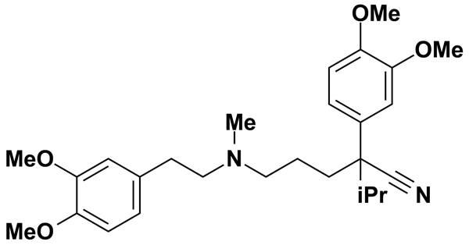
VERAPAMYL HYDROCHLORIDE | 2.04 | Prestwick Chemical Inc. | BRD-A09533288 | 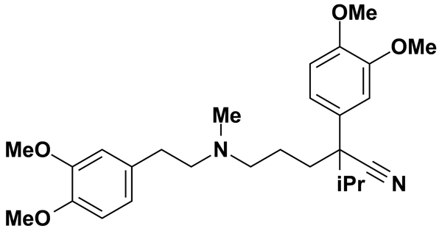
VESAMICOL HYDROCHLORIDE | 5.00 | MicroSource Discovery Systems Inc. | BRD-A76904477 | 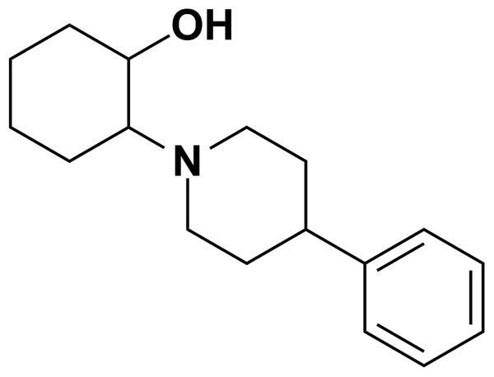
VINPOCETINE | 2.85 | Prestwick Chemical Inc. | BRD-K53318339 | 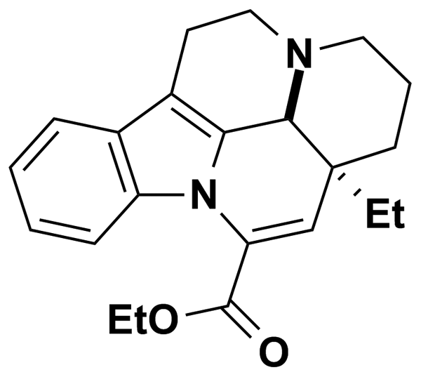
VULPINIC ACID | 5.00 | MicroSource Discovery Systems Inc. | BRD-A89237309 | 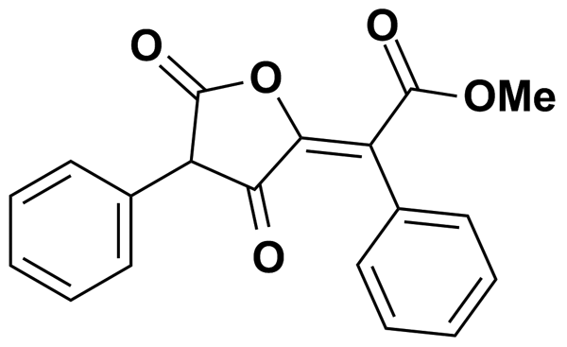
WY-14643 | 0.50 | Biomol International Inc. | BRD-K01902415 | 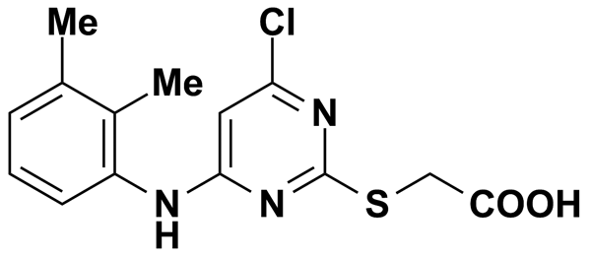
XYLAZINE | 4.54 | Prestwick Chemical Inc. | BRD-K21565985 | 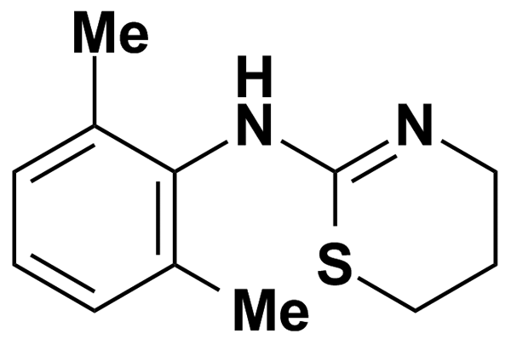
YOHIMBINE HYDROCHLORIDE | 5.00 | MicroSource Discovery Systems Inc. | BRD-A87445400 | 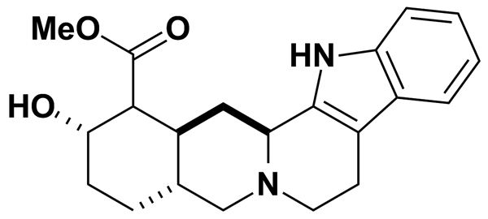
YS035 | 6.95 | Biomol International Inc. | BRD-K06208435 | 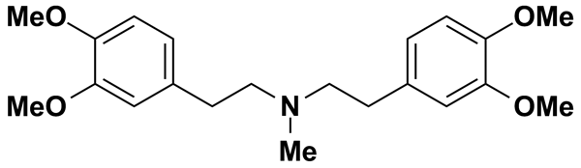
ZAPRINAST | 9.22 | Biomol International Inc. | BRD-K16542329 | 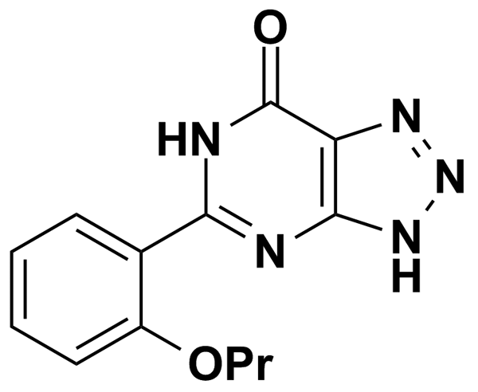
ZARDAVERINE | 9.32 | Biomol International Inc. | BRD-K37561857 | 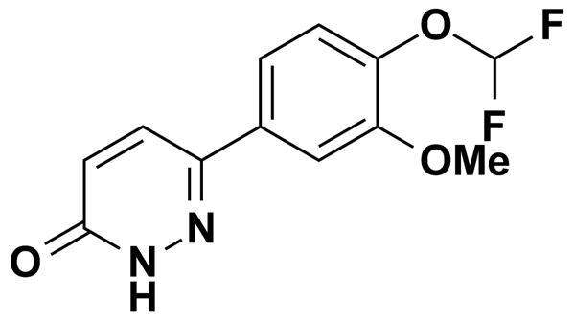
ZIDOVUDINE, AZT | 3.74 | Prestwick Chemical Inc. | BRD-K72903603 | 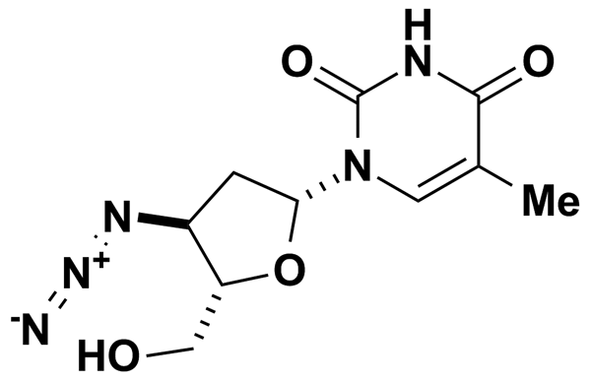
ZM336372 | 6.42 | Biomol International Inc. | BRD-K73789395 | 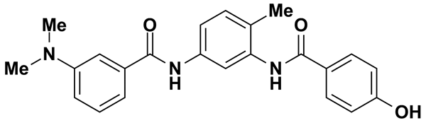
ZOLPIDEM | 5.00 | MicroSource Discovery Systems Inc. | BRD-K44876623 | 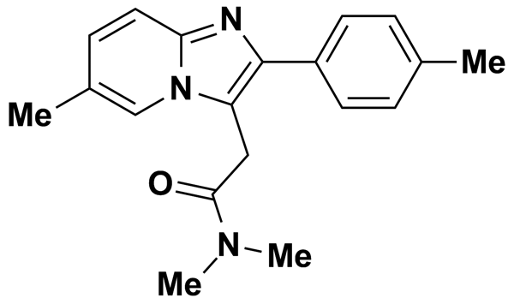
ZOMEPIRAC SODIUM | 5.00 | MicroSource Discovery Systems Inc. | BRD-K81326768 | 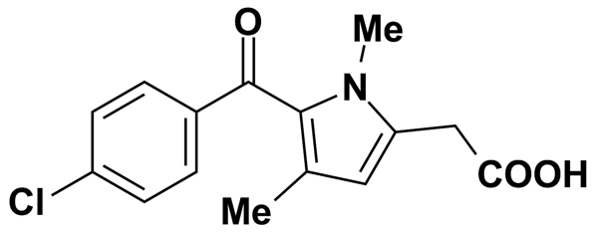
ZOMEPIRAC SODIUM SALT | 3.18 | Prestwick Chemical Inc. | BRD-K81326768 | 