Table S1. Unadjusted and adjusted models used to find cut-points.
 | BMI |  |  |  | Waist Circumference in Men |  |  |  | Waist Circumference in Women
 | Variable transformation | Coefficient | Standard error |  | Variable transformation | Coefficient | Standard error |  | Variable transformation | Coefficient | Standard error
Fasting glucose
Constant | None | 2.6738 | 0.0058 |  | None | 2.6555 | 0.0124 |  | None | 2.6907 | 0.0049
Migrant South Asian | None | 0.0114 | 0.0043 |  | None | -0.0144 | 0.0088 |  | None | 0.0015 | 0.0062
Indigenous South Asian | None | 0.0309 | 0.0106 |  | None | -0.0580 | 0.0238 |  | None | 0.0086 | 0.0162
Adiposityª | Ln(BMI/10) | 0.0602 | 0.0051 |  | None | 0.0008 | 0.0001 |  | (Waist/100)^2 | 0.0481 | 0.0045
Interaction | None | -0.00001 | 0.0001 |  | None | 0.0003 | 0.0001 |  | None | 0.0001 | 0.0001
Age | (Age/10)^-2 | -0.5488 | 0.0638 |  | (Age/10)^-2 | -0.3051 | 0.0979 |  | (Age/10)^-2 | -0.6228 | 0.0824
2-hour glucose
Constant | None | 2.5514 | 0.0115 |  | None | 2.4566 | 0.0266 |  | None | 2.4427 | 0.0202
Migrant South Asian | None | 0.0265 | 0.0229 |  | None | 0.0230 | 0.0575 |  | None | -0.0148 | 0.0373
Adiposityª | None | 0.0052 | 0.0004 |  | None | 0.0024 | 0.0003 |  | None | 0.0020 | 0.0002
Interaction | None | 0.0010 | 0.0008 |  | None | 0.0004 | 0.0006 |  | None | 0.0007 | 0.0004
Age | (Age/10)^3 | 0.0003 | 0.00002 |  | (Age/10)^3 | 0.0002 | 0.00003 |  | None | 0.0024 | 0.0002
Note: Fasting glucose and 2-hour glucose were transformed by adding 10 and then taking the natural logarithm.
ª Body Mass Index in the models to find Body Mass Index cut-points. Waist circumference in the models used to find waist circumference cut-points.

Figure S1. The age-adjusted relationship between body mass index (BMI) and fasting glucose by ethnic group.
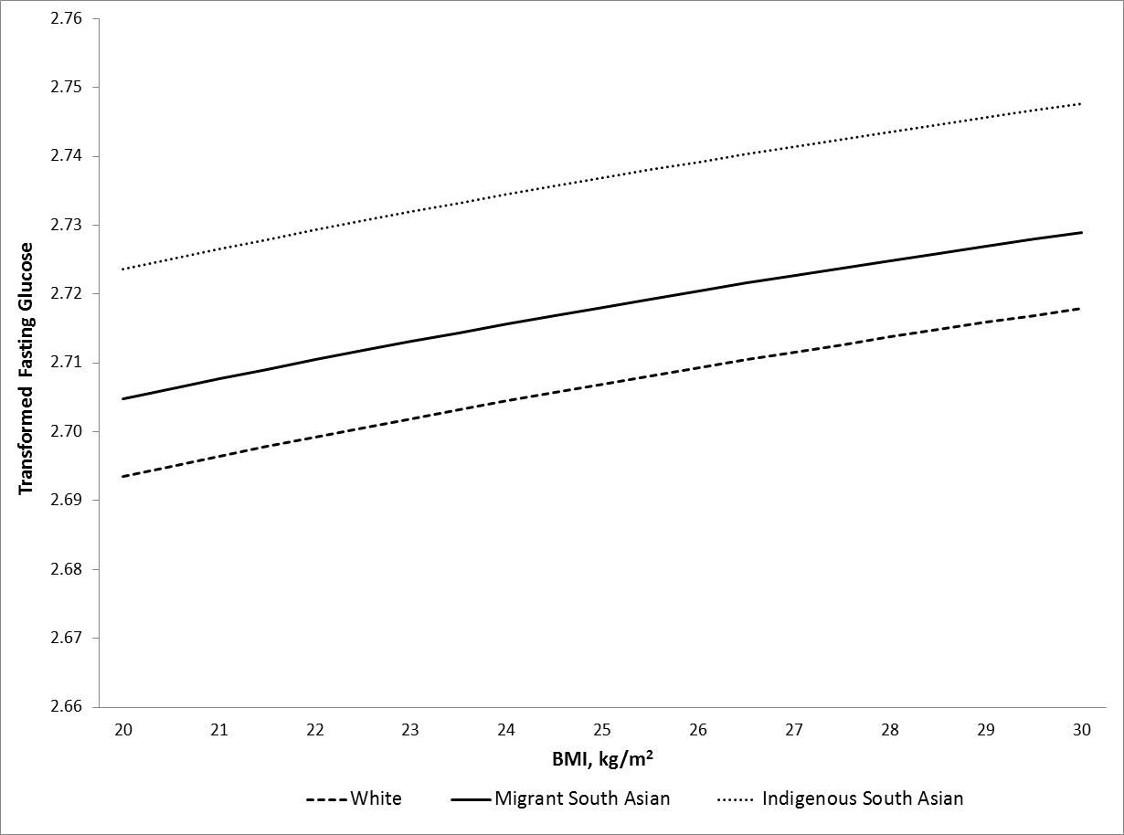

Figure S2. The age-adjusted relationship between body mass index (BMI) and 2-hour glucose by ethnic group.
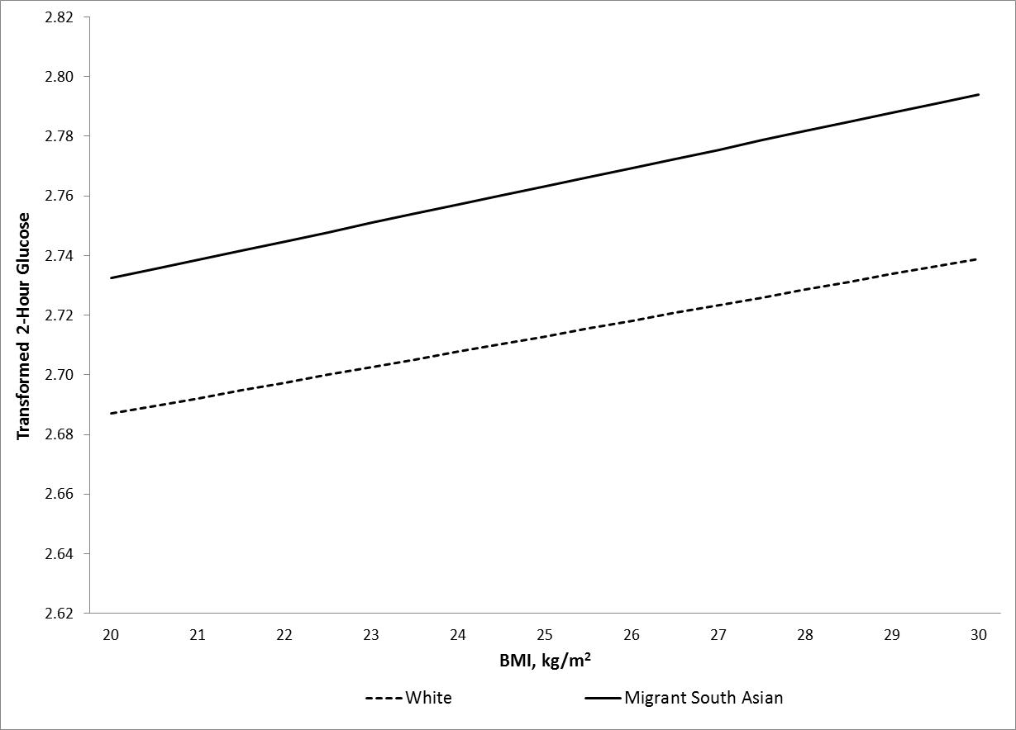

Figure S3. The age-adjusted relationship between waist circumference and fasting glucose by ethnic group in men.
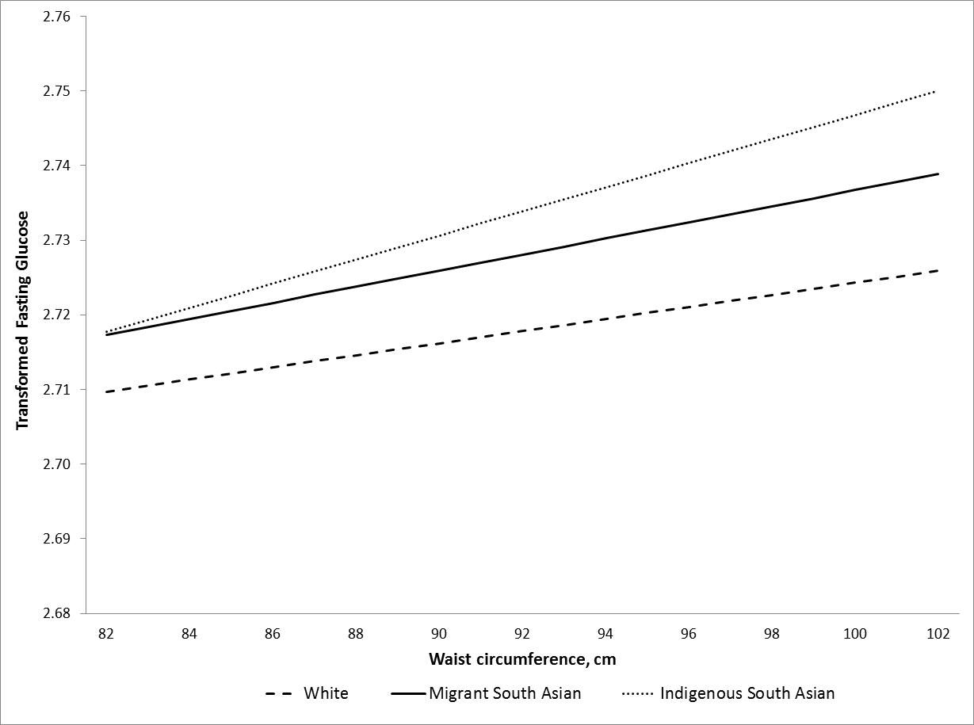
Figure S4. The age-adjusted relationship between waist circumference and 2-hour glucose by ethnic group in men.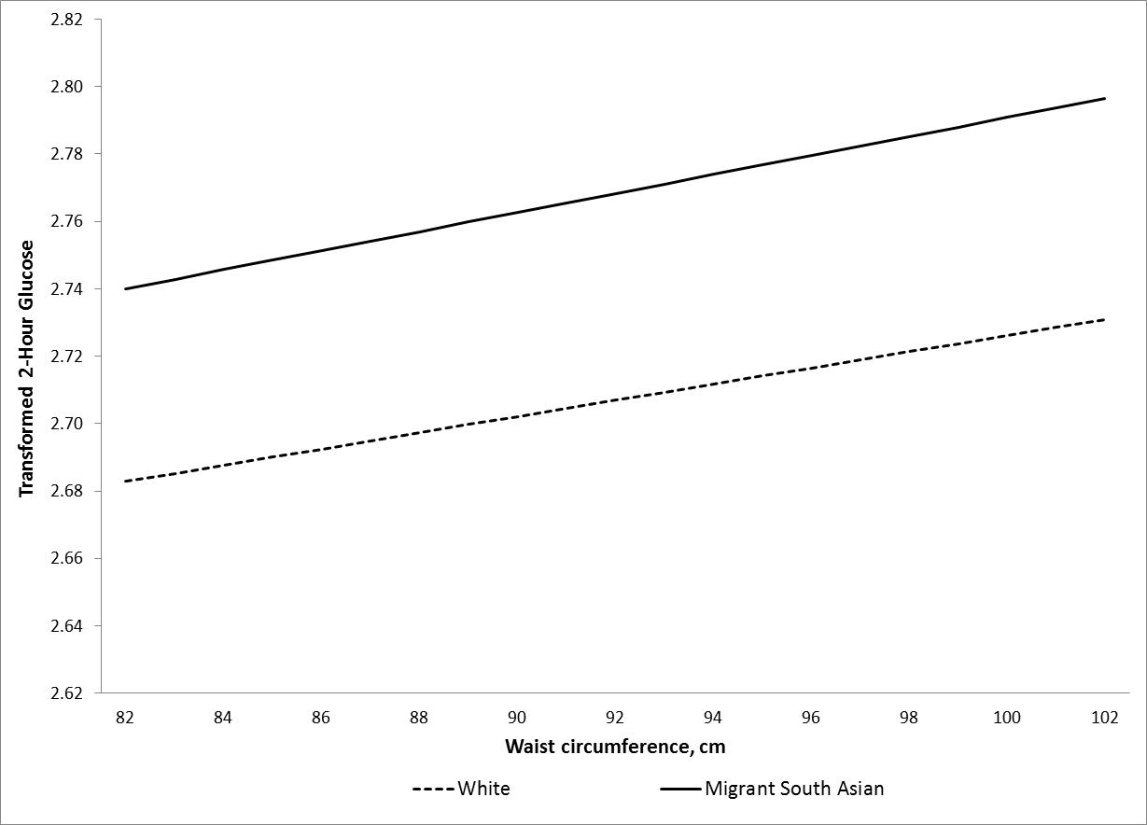

Figure S5. The age-adjusted relationship between waist circumference and fasting glucose by ethnic group in women.

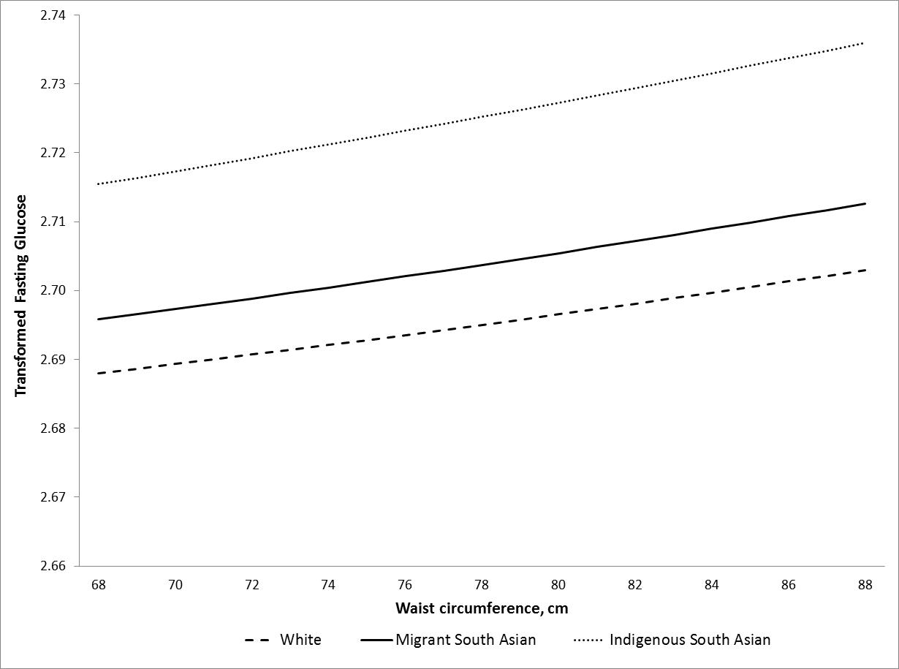
Figure S6. The age-adjusted relationship between waist circumference and 2-hour glucose by ethnic group in women.

