Supporting Information
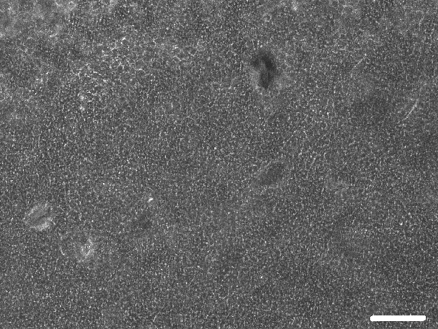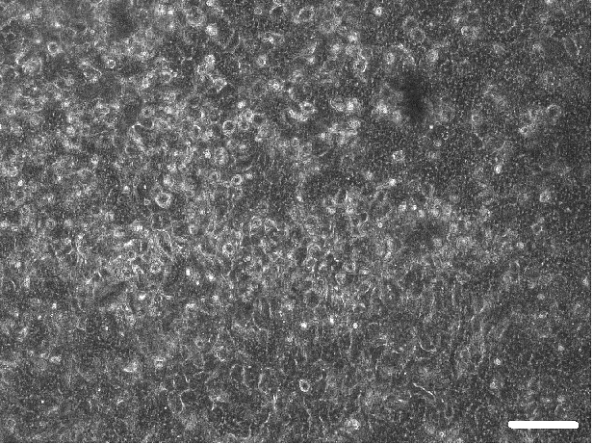
(A)
(B)
Fig S7. Phase contrast images of Caco-2 cells cultured in microchamber that was not functionalized with ECM. Images were taken at the same position of the microchamber. (A) Images of Caco-2 cells captured after 6hr of cell seeding; (B) Images of Caco-2 cells captured after 5 days of continuous perfusion. (Scale bar = 50µm)

