E-Appendix 2: MyDecisionQuality explanation and weightings items
MyDecisionQuality is a web-based instrument that can generate a patient-reported measure of the quality of a particular decision. It is grounded in multi criteria decision analysis. Using a simple expected value algorithm, it calculates a decision quality score based on eight criteria, (listed below), which are rated on a scale of 1 to 5. It can also be used prior to decision-making in order to ascertain which decision quality criteria are most important to participants.¹

Version presented to participants before completion of the decision aid
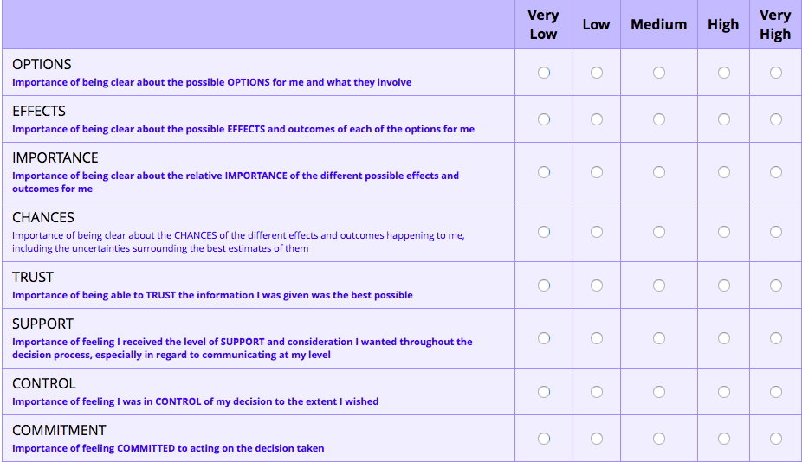

Version presented to participants after completion of the decision aid
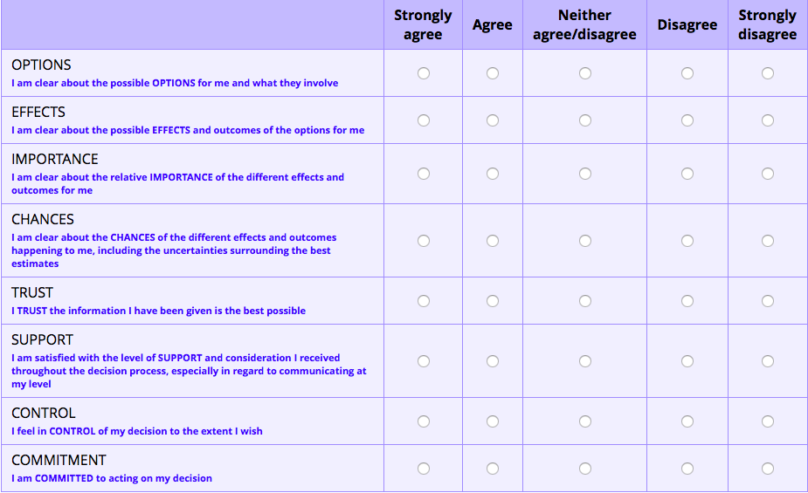
1. Kaltoft M, Cunich M, Salkeld G, Dowie J. Assessing decision quality in patient-centred care requires a preference-sensitive measure. J Health Serv Res Policy. Apr 2014;19(2):110-117.

